Lesson Plan

Title: What can we do in a bank?

Instructors:
Jessica
Sherry
Level:
Intermediate
(3~4th grade elementary student)
# of Students:
8
Length:
40mins

Materials:
markers & white board
picture of a bankbook, ID card, money, check, teller and customer
fake name cards,
work sheets : a dialogue in a bank, word puzzle for homework
CCQs

Aims:
Be aware of the vocabulary and expressions related to a bank
Ss will have confidence in speaking in a bank.
To practice and improve speaking, listening, writing and reading skills.

Language Skills:
- Listening: listening to teacher’s instructions and classmate’s idea
- Speaking: participating in an activity and sharing ideas in a group
- Writing: filling in blanks of CCQ worksheet
- Reading: reading the worksheet

Language Systems:

Assumptions:
Students already know:
Ss know how to distinguish between the various bills
Ss know simple vocabulary such as money and coins.
Ss have already been to a bank at least once.
Ss are familiar with role-plays and acting out.
Anticipated Errors and Solutions:
Students may not know how to spell some vocabulary words.
Allow Ss to use their dictionary.
Students may not know what an ID card, which is mentioned in a practicing dialogue, is.
Show them a picture of an ID card.
If time is short,
Choose only one or two groups to do the role-play instead of doing all.
If the lesson finishes early,
Do some SOS activities.
References:
www.manyshings.org/vocabulary/games
http://bogglesworldesl.com/bank_roleplay.htm
http://www.dltk-kids.com/crafts/miscellaneous/mcheck.html
http://www.bankingonourfuture.org/master.cfm/main/elementarymenu
http://endic.naver.com/

Lead-In
Materials: pictures
Time  1 min  3 min | Set Up  Whole class  Whole class |  | Procedure:  <Greeting>  (Hello song for ice-breaking)  Hello, Guys! How are you today? Did you sleep well?  <Eliciting and Prediction>  Before starting our lesson today, I’m going to ask you some questions.  If you have a hundred thousand won, what do you want to do?  (show them some pictures)  -Ss answer : Car! Nintendo!.. etc  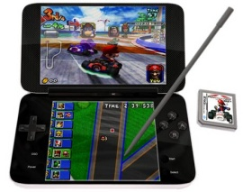  How are you going to make such a large amount of money?  You can beg parents for money, or you can get 100 points in the exam to make your parents happy.  But, the best way to have such a large amount of money is ‘saving money’  (Another teacher writes on the board  “A penny saved is a penny earned. -Benjamin Franklin-”)  Who can explain what this proverb means?  (If the students don’t answer, explain it.)  In Korea, we also have similar proverb “티끌 모아 태산”  It means, to keep saving little money becomes a large amount of money.  How many times have you been to a bank?  Okay~ Today we are going to talk about what we can do in a bank.
Pre-Activity
Materials: pictures, a CCQ worksheet
Time  3min  3min  10min  2min  1min | Set Up  Whole class  Whole class  Whole class  Individually  Whole class | Procedure:  <Instructions>  What do you do in a bank?  Let’s brainstorm some words that you use in a bank.  (Write on the board what students say.)  (If students say little, teacher writes more words on the board.)  (On the board : bankbook, ID card, cash, check, teller, customer, account, withdraw/deposit, borrow/lend, interest)  Okay, here are some words that we can use in a bank.  (Show them some pictures to explain the words.)  <Demonstration>  Let’s look at this first picture.  (show them a picture of a bankbook) 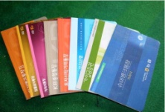  What do you think this picture means?  -Ss answer: A bankbook!  Right. A bankbook, a passbook, is a paper book used to record bank transactions.  Pictures to show Ss  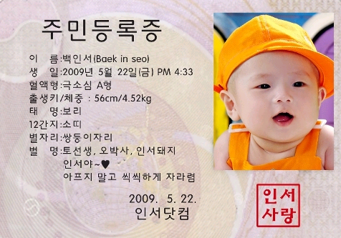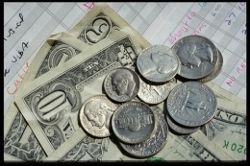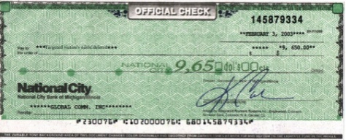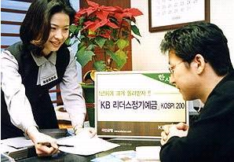  An identity card is a card with a person's name, photograph, date of birth, and other information on it.  Cash means the same as money.  A check is a printed form on which you write an amount of money and who it is to be paid to.  A teller is someone who works in a bank and who customers pay money to or get money from.  A customer is someone who buys goods or services, especially from a shop.  Things to explain  (Bank) Account n.  If you have an account with a bank , you have an arrangement to leave your money there and take some out when you need it  - Ex1> I had a savings account with Hanabank.  - Ex2> Some banks make it difficult to open an account.  <CCQs>  How many of you have an account in a bank?  Which bank do you have your account in?  Withdraw / Deposit v.  If you withdraw money from a bank account, you take it out of that account.  - Ex1>They withdrew 100 dollars from a bank account  If you deposit something somewhere, you put it where it will be safe until it is needed again.  - Ex1>The customer has to deposit a minimum of $100 monthly.  To let you guys understand more easily, we will make a role play.  I am a bank teller, and she is a customer.  Teller: How much money do you want to withdraw?  Customer: I want to withdraw 10 thousand won.  Customer: I want to deposit 10 thousand won.  Teller: May I have your bankbook and the money?  Borrow / Lend v.  If you borrow something that belongs to someone else, you take it or use it for a period of time, usually with their permission.  If you lend something that you own, you allow someone to have it or use it for a period of time.  (Choose one student and ask a question.)  A : May I borrow your pencil, please?  B : Sure, here it is.  A : I borrowed a pencil from B.  B lent a pencil to me.  Interest n.  Interest is extra money that you receive if you have invested a sum of money.  Interest is also the extra money that you pay if you have borrowed money.  - Ex1> Does your current account pay interest?  - Ex2> Interest is extra money you get when you save money in a bank.  <CCQs>  (Hand out the CCQ worksheet.)  I will give you 2 minutes to fill in the blank using the words in the box below.  1. In a savings account you're letting the bank keep your money until the time you might need it.  And for allowing them to hold on to it, instead of leaving it in a jar at home, they pay you a fee. That fee is called interest. Getting interest for the money you have put away is a way you can make your money grow.  2. Withdrawal means to take money out of the account while deposit means to put it in  Everybody done? OK, let’s check the answers together.  (Read the sentences slowly, and choose Ss to read their answers.)
Main Activity
Materials: a worksheet of dialogue
Time  5min  5min  5min | Set Up  Whole class  Work in pairs  Whole class | Procedure:  <Activity - practice dialogue with sample conversation>  A = Bank teller B = Customer  Let’s practice a short dialogue using the vocabulary we have learned.  (Have a role play between teachers)  Now, repeat after me.  (Read one sentence by one sentence and let the Ss repeat.)  <CCQs>  Who can explain what ‘receipt’ is?  A receipt is a piece of paper that you get from someone as proof that they have received money or goods from you.  (Ask CCQs and explain to make sure all the Ss have understood the dialogue.)  Ok guys, I’m going to put you in pairs.  Practice the dialogue with your partner.  Make sure you read out loud being a real bank teller or customer.  (practice time for 5 min)  OK, Julie and Yuri, why don’t you guys try first? Come up here.  Very good, excellent!  (Other pairs take turn to have a role play.)  <CCQs>  (Let Ss answer in full sentences.)  1. What do you say if you want to change a check to cash?  2. What do you say if you want to put money into your account?  3. What do you say if you want to take $500 out of your account?

Post-Activity
Materials: word puzzle worksheet
Time  1min  1min | Set Up  Whole class  Whole class | Procedure:  <Homework>  For homework, I will give you an interesting worksheet, a word puzzle~!!  (Hand out the worksheets)  Write down your names first.  Do your homework and bring it till the next class.  Today we talked about the vocabulary related to a bank, and what we can do in a bank.  Anything you remember about the words you use in a bank? (to get Ss’s idea)  Did you enjoy the class today?  I hope you guys do a great money management for your future!  See you in next class~!

