Grammar Lesson Plan

Much, Many, a lot of

Instructors:
Hana Jang
Level:
Intermediate
# of Students:
8
Length:
40 mins

Materials:
- Board & markers
- 8 students’ dialogue worksheets and 1 teacher’s answer sheet. (post activity)
- 1 ‘SOS test your knowledge’ handout for teacher (SOS1)
- 8 countable and uncountable worksheets (main-activity)
Aims:
- To solidify or understand the difference between the countable and uncountable nouns.
- To understand the uses of ‘much’, ‘many’ and ‘a lot of’ and its relationship with the countable and uncountable nouns.
- To communicate and discuss with the partner to solve the problem.

Language Skills:
Reading: Reading the board, worksheet questions and the dialogue worksheets.
Speaking: Answering teacher’s questions and discussing with a partner to answer the worksheet questions.
Listening: Teacher’s instructions, demonstration, and partner’s ideas.
Writing: Copy teacher’s explanation, chart and write the correct answer in the countable and uncountable worksheets and the dialogue worksheet.

Language Systems:
Function: Identify the difference between countable and uncountable nouns and its relationship with ‘much’, ‘many’ and ‘a lot of’.
Discourse: Discussion with a partner to answer the questions.
Lexis: countable and uncountable.

Assumptions:

- Most students know the meaning and the usage of ‘much’, ‘many’ and ‘a lot of’.

- Students know they should speak only English in the classroom.

- Most students know or have an idea of what the countable and uncountable nouns are.

- There are 8 students in the classroom.
Anticipated Errors and Solutions:

- There might be an extra time left in the 30 minutes lesson.
*SOS1- selects some questions from the ‘SOS1-quiz worksheet’ and asks students to answer those questions and discuss with a whole class.

- There may not be enough time to finish the lesson.
*SOS2- If students are still working on the 2nd page at 25 past, stop students and go through the questions together as a whole class.

- Some students might have difficulty in understanding some countable and uncountable nouns.
* In pre-activity, have a review time to define what countable and uncountable nouns are and elicit some examples from the students.
References:
http://www.eflnet.com/tutorials/muchmanyalotof.php
http://esl.about.com/od/grammarlessons/a/l_countable.htm
http://www.learn-english-online.org/Lesson37/Lesson37.htm
http://www.usingenglish.com/quizzes/210.html
http://www.onestopenglish.com/section.asp?catid=58134&docid=145089

Lead-In
Materials: no materials needed
Time  30 sec | Set Up  Whole class | Procedure:  <Greetings>  Hi, I’m Hana and this is a grammar lesson and today, we are going to talk about something which confuses a lot of students. ‘Much’, ‘many’ and ‘a lot of’.  It sounds very simple and too easy but actually a lot of students are still making these mistakes and it’s actually really important to learn the right usage of three.
Pre-Activity
Materials: board & markers,
Time  10 mins | Set Up  Whole class | Procedure:  <Pre-teach countable and uncountable nouns>  When we use the word ‘much’, ‘many’, and ‘a lot of’, it’s really important to know the difference between countable and uncountable nouns.  So, can anyone tell me what a noun is?  Ok, so noun is a person, a place, idea or a thing. And we can divide this noun further into 2 groups. Countable and uncountable nouns. Can anyone tell me what countable noun is? Yes, it’s pretty simple concept, it’s something that we can count. And can you give me an example? Yes, a cat, sister, etc. Then what about an uncountable noun? Yes, a noun that we can’t count, such as? Advice, homework, milk, water, etc. So these things are substances or concepts that we can’t qualify in terms of a number.  (Write on the board :)  Noun  -person, place, idea, thing  Countable noun  -can count  -cat  -sister  -desk  -book  Uncountable noun  -can’t count  -milk, advice  -substances or concepts.  Ok, so the word ‘much’ we use with uncountable nouns. So, for example, (write) “I drank too much milk. Our teacher gave us too much homework.” So, milk is liquid, it’s uncountable noun, so we can use ‘much’. And homework is an idea or concept and we never say homeworks, so it’s uncountable and therefore we use the word ‘much.’  If we want to use countable nouns, then we can’t use the word ‘much’ but we can use the word ‘many.’  For example, (student gives an eg.) So __ is countable noun, we can say one __, two __s, so we use the word ‘many’. And we will never use the word ‘much’ in front of a plural countable noun.  So, just a review, we can use ‘much’ with uncountable nouns and ‘many’ with countable nouns.  But, we can use ‘a lot of’ with both of them. This is an example, “I ate a lot of apples. Our teacher gave us a lot of homework”. ‘Apples’ is the countable noun and ‘homework’ is uncountable noun. but we can use ‘a lot of’ in front of both of them.  So, just a review, let’s draw a little chart together.  We can use the word ‘many’ in front of plural countable nouns but not to qualify uncountable nouns. And ‘much’ in front of uncountable nouns but not in front of plural countable nouns. And lastly, we can use ‘a lot of’ in front of both plural countable nouns and uncountable nouns.
   | Plural countable noun | Uncountable noun
  Many | Yes | No
  Much | No | Yes
  A lot of | Yes | Yes
Main Activity
Materials: 8 countable and uncountable worksheets and 1 handout for teacher
Time  20 mins | Set Up  Group work (2,2,2,2) | Procedure:  <countable and uncountable worksheet>  Instruction  Ok, now you are going to practice those ‘much’ ‘many’ and ‘a lot’ and also you are going to test your knowledge about countable and uncountable nouns. You are working with your partner, you two are together and so.  Demonstration  It’s quite straight forward. The first page is an example of countable and uncountable nouns which is just some information for you to know. But it doesn’t have any answers.  The question starts from the next page, and you are going to choose the right answers that fits in this sentence.  Let’s do one example together.  Question 1. The receptionist at the front desk gave me two_________. A. informations B.information C. pieces of information D. lots of information  What’s the answer? Yes, it’s B. So you will circle B and go to the next question.  You have plenty of time to answer these questions, you have 20 minutes.  CCQS  1. Who are you working with? (Partner)  2. Does this front page have the answer? (No)

Post-Activity
Materials: 8 students’ dialogue worksheets and teacher’s answer sheet.
Time  10 minutes | Set Up  Group work (2,2,2,2) | Procedure:  <practicing speaking using quantifiers>  Ok, now you will be working with your partner (divide them in to A,B)and you are going to practice speaking by using those ‘much’, ‘many’ and ‘a lot of’ and other quantifiers.  Instruction:  Here we have a dialogue but there is a blank and there are 3 words that you have to choose the correct answer and speak to your partner.  Demonstration:  For instance, the person A will start, ‘Hi, what are you up to?’ and the next person B will read, ‘Oh, I’m just looking for (A) many (B)some (C)any antiques at this sale. (write 3 words on the board) Which one do you think is the correct answer? Yes, it’s B. ‘Oh, I’m just looking for some antiques at this sale.  So throughout this dialogue, you have to choose the right word and then you can swap the role after you finish your dialogue.  CCQS:  - Please raise your hand if you are person B. Can you ask question A? (Answer. No)  - What do you do next if you have finished speaking the dialogue? (Answer. Switch the roll)  <Conclusion>  Thank you for today and I hope that this lesson makes using ‘a lot of’, ‘much’, and ‘many’ a lot more clear.

SOS1 - Test your knowledge!
Test your understanding of the English lesson by answering these questions.

1. I need _______________ advice.  1. Some  2. An  3. Many  4. All of the above | 2. I want ______________ oranges.  1. Two  2. Many  3. Some  4. All of the above
3. Can I borrow ____________ sugar?  1. Two  2. A lot of  3. Some  4. All of the above | 4. The dog drank a lot of _______________.  1. Milks  2. Milk  3. Some milk  4. All of the above
5. I don’t have _____________ money.  1. Some  2. Many  3. Much  4. All of the above | 7. ______________________ did Mary buy?  1. How many  2. How much
8. Why do you give _______________ advice?  1. So many  2. So much | 9. I bought a lot of __________________.  1. Furnitures  2. Furniture
10. I don’t know ____________________ information is on that desk.  1. How much  2. How many | 11. You need a lot of _______ to win the lottery.  1. Luck  2. Lucks  3. Ticket
13. Please don’t bother me. I have a lot of _____________________ to do.  1. Job  2. Work  3. Stuffs  4. experiment | 14. The teacher gives us a lot of ___________.  1. difficult homeworks  2. difficult assignments  3. difficult stuffs.

Students’ worksheet

Choose the correct answers in the following dialogue

A: Hi! What are you up to?
B: Oh, I'm just looking for ( A) many ( B) some ( C) any antiques at this sale.
A: Have you found ( A) something ( B) anything ( C) nothing yet?
B: Well, there seems to be ( A) a few ( B) few ( C) little things of interest. It really is a shame.
A: I can't believe that. I'm sure you can find ( A) a thing ( B) something ( C) anything interesting if you look in ( A) all ( B) each ( C) some stall.
B: You're probably right. It's just that there are ( A) a few ( B) a lot ( C) a lot of collectors and they ( A) every ( B) each ( C) all seem to be set on finding ( A) a thing ( B) anything ( C) much of value. It's so stressful competing with them!
A: How ( A) many ( B) much ( C) few antique furniture do you think there is?
B: Oh, I'd say there must be ( A) many ( B) several ( C) much pieces. However, only ( A) a few ( B) few ( C) little are really worth ( A) the high ( B) a high ( C) high prices they are asking.
A: Why don't you take a break? Would you like to have ( A) any ( B) some ( C) little coffee?
B: Sure, I'd love to have ( A) any ( B) little ( C) one. I could use ( A) some ( B) a few ( C) a little minutes of downtime.
A: Great, Let's go over there. There're ( A) a few ( B) some ( C) little seats left.

Teacher’s answer sheet

Choose the correct answers in the following dialogue

A: Hi! What are you up to?
B: Oh, I'm just looking for ( A) many ( B) some ( C) any antiques at this sale.
A: Have you found ( A) something ( B) anything ( C) nothing yet?
B: Well, there seems to be ( A) a few ( B) few ( C) little things of interest. It really is a shame.
A: I can't believe that. I'm sure you can find ( A) a thing ( B) something ( C) anything interesting if you look in ( A) all ( B) each ( C) some stall.
B: You're probably right. It's just that there are ( A) a few ( B) a lot ( C) a lot of collectors and they ( A) every ( B) each ( C) all seem to be set on finding ( A) a thing ( B) anything ( C) much of value. It's so stressful competing with them!
A: How ( A) many ( B) much ( C) few antique furniture do you think there is?
B: Oh, I'd say there must be ( A) many ( B) several ( C) much pieces. However, only ( A) a few ( B) few ( C) little are really worth ( A) the high ( B) a high ( C) high prices they are asking.
A: Why don't you take a break? Would you like to have ( A) any ( B) some ( C) little coffee?
B: Sure, I'd love to have ( A) any ( B) little ( C) one. I could use ( A) some ( B) a few ( C) a little minutes of downtime.
A: Great, Let's go over there. There're ( A) a few ( B) some ( C) little seats left.

Countable and Uncountable nouns (student)

Countable Nouns | Uncountable Nouns
Apples  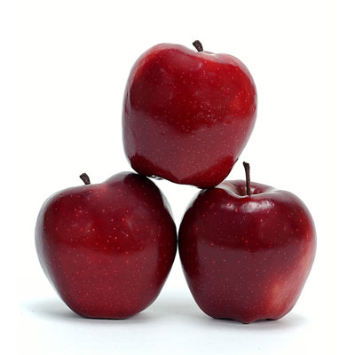  There are three apples. | Rice  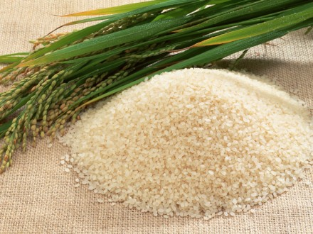  There is some rice.

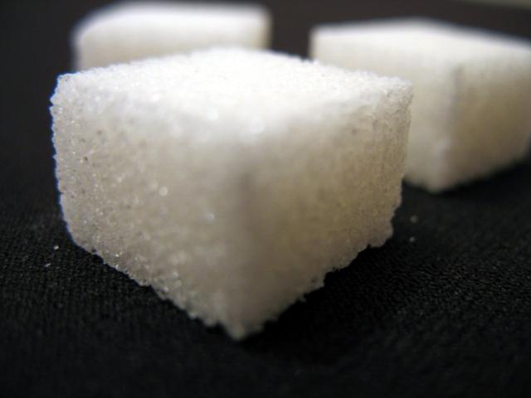 | 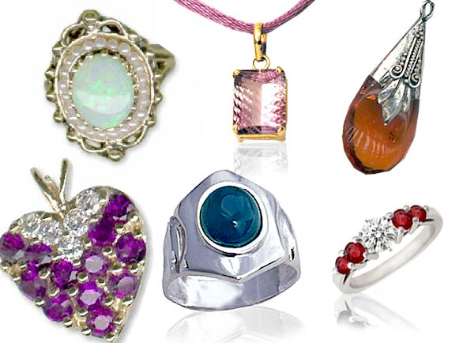 | 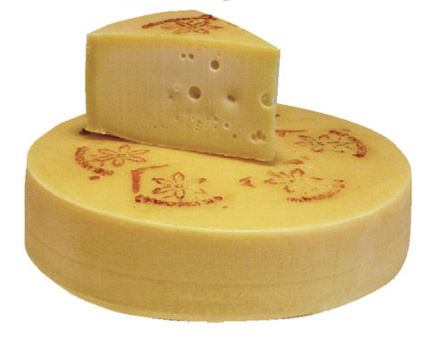 |  | 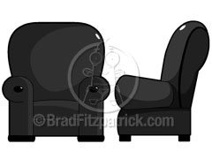 | 
Sugar | Jewelry | Cheese | Wine | Furniture | Money
How much sugar is there? | How much jewelry is there? | How much cheese is there? | How much wine is there? | How much furniture is there? | How much money is there?
There’s a lot of sugar. | There’s some jewelry. | There’s a lot of cheese. | There’s some wine. | There’s some furniture. | There’s a lot of money.

Containers
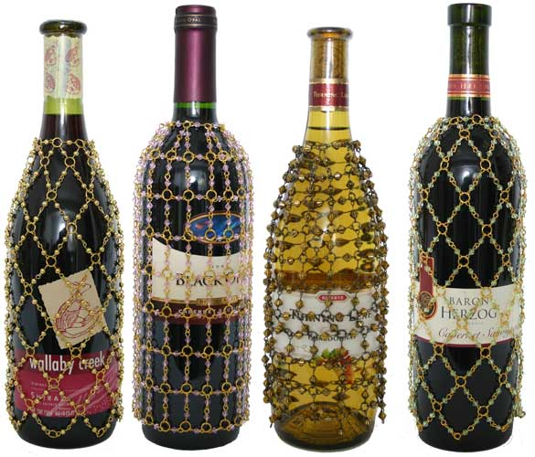 | 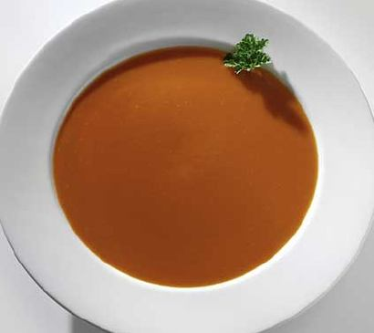 | 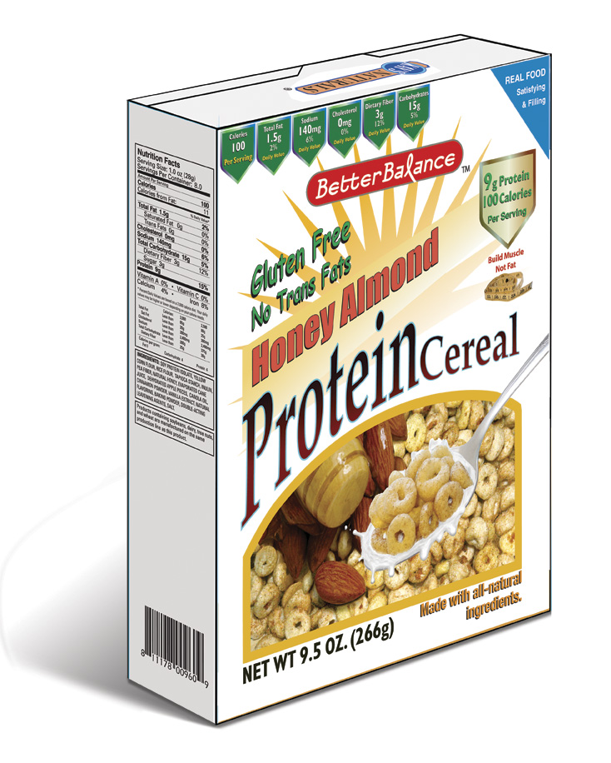 | 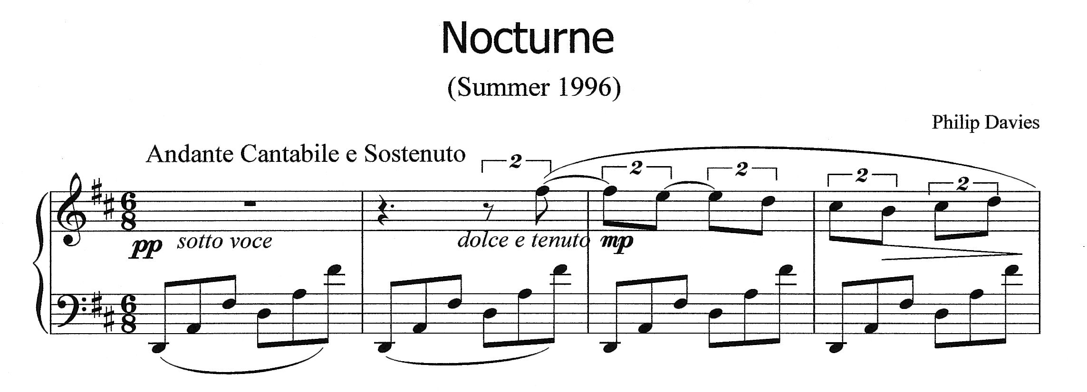
A bottle of wine | A bowl of soup | A bowl of cereal | A piece of music
 | 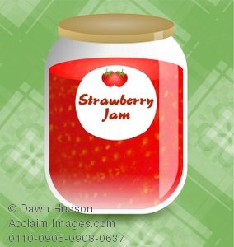 | 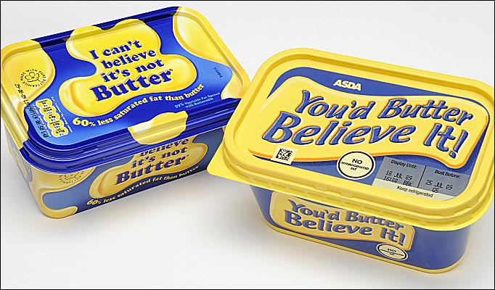 | 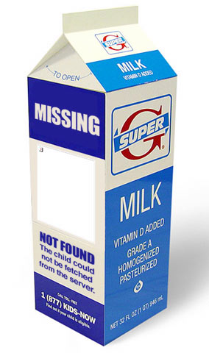
A glass of water | A jar of jam | A packet of butter | A carton of milk
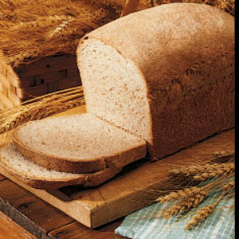 | 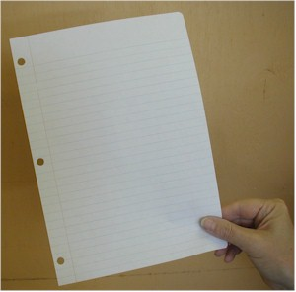 | 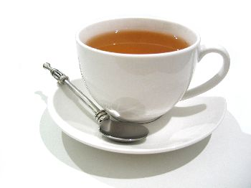 | 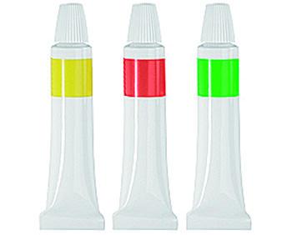
A loaf of bread | A piece of paper | A cup of tea | A tube of tube paste

In each sentence, choose the best phrase to complete the gap from the choices below (a,b,c or d).

1, The receptionist at the front desk gave me two __________________.
a). informations b). information c). pieces of information d). lots of information

2. My cousin is very beautiful. She has green eyes and ____________.
a). long hair b). long hairs c). a long hair d). a long length of hair

3. ____________ have you got in the bank? Is it enough to buy a house?
a). How many moneys b). How many money c). How much money d). How much moneys

4. On Saturday, my friend Paul went fishing and he caught __________.
a). three fish b). three fishes c). three items of fish d). three of fish

5. Can I borrow _______ from you? I’ve left mine at home and I want to write some notes.
a). paper b). a paper c). a slice of paper d). a piece of paper

6. How many __________ did the teacher give us today? He always gives us a lot to do.
a). homework b). homeworks c). a lot of homework d). pieces of homework

7. Every morning before I come to school, I spend thirty minutes doing _________. That’s how I say so slim.
a). exercise b). an exercise c). some exercises d). some pieces of exercise

8. Your sister is a great pianist. She played ___________ at the party.
a). a lovely music b). some lovely musics c). lovely musics d). a lovely piece of music

Complete with much, a lot of, any, some.

When we got to the beach, _________ people were already there and we couldn’t find a place to sit down. There weren’t ________ empty spaces near the beach, but there were ________ empty spaces a long way from the sea. We walked along the beach for a while, but we didn’t have ________ fun because we kept bumping into people. Finally, we decided to get back in the car and go down the coast to the next beach. This was _________ better; there were only _______ families on the beach, so there was enough room to spread out our things. Because we had eaten so _________ food in the car, all we wanted to do was lie down. | 

Complete with much or many and a word from the box.
children coffee fish furniture help housework luggage money news things time times wine women

1. “How _______________ ______________ are there in the pictures?”
“Two. A yellow and a green one.”

2. “How _______________ ______________ have you got on you?”
“One pound twenty.”

3. “How _______________ ______________ are there in your choir?”

4. “How _______________ ______________ has he got?
“Two. A son and a daughter.”

5. I do not have to do _______________ ______________. I only do the washing up.

6. “How _______________ ______________ do they have?”
“Six. But they don’t lay eggs.”

7. How _______________ ______________ have we got to finish the project?

8. The bedroom does not need _______________ ______________.

9. We do not need as ___________ __________ as last time. We will basically manage alone.

10. How _______________ ______________ have you been to France?

11. I have got so _______________ ______________ to tell you.

12. I won’t take too _______________ ______________ with me. Only a suitcase and a handbag.

13. He had so _______________ ______________ that he could not sleep.

14. I don’t drink much ______________. I prefer champagne.

Countable and Uncountable nouns

Countable Nouns | Uncountable Nouns
Apples  There are three apples. | Rice  There is some rice.

Sugar | Jewelry | Cheese | Wine | Furniture | Money
How much sugar is there? | How much jewelry is there? | How much cheese is there? | How much wine is there? | How much furniture is there? | How much money is there?
There’s a lot of sugar. | There’s some jewelry. | There’s a lot of cheese. | There’s some wine. | There’s some furniture. | There’s a lot of money.

Containers
A bottle of wine | A bowl of soup | A bowl of cereal | A piece of music
A glass of water | A jar of jam | A packet of butter | A carton of milk
A loaf of bread | A piece of paper | A cup of tea | A tube of tube paste

In each sentence, choose the best phrase to complete the gap from the choices below (a,b,c or d).

1, The receptionist at the front desk gave me two __________________.
a). informations b). information c). pieces of information d). lots of information

2. My cousin is very beautiful. She has green eyes and ____________.
a). long hair b). long hairs c). a long hair d). a long length of hair

3. ____________ have you got in the bank? Is it enough to buy a house?
a). How many moneys b). How many money c). How much money d). How much moneys

4. On Saturday, my friend Paul went fishing and he caught __________.
a). three fish b). three fishes c). three items of fish d). three of fish

5. Can I borrow _______ from you? I’ve left mine at home and I want to write some notes.
a). paper b). a paper c). a slice of paper d). a piece of paper

6. How many __________ did the teacher give us today? He always gives us a lot to do.
a). homework b). homeworks c). a lot of homework d). pieces of homework

7. Every morning before I come to school, I spend thirty minutes doing _________. That’s how I say so slim.
a). exercise b). an exercise c). some exercises d). some pieces of exercise

8. Your sister is a great pianist. She played ___________ at the party.
a). a lovely music b). some lovely musics c). lovely musics d). a lovely piece of music

Complete with much, a lot of, any, some.

When we got to the beach, __a lot_____ people were already there and we couldn’t find a place to sit down. There weren’t ___any__ empty spaces near the beach, but there were _some___ empty spaces a long way from the sea. We walked along the beach for a while, but we didn’t have __much_ fun because we kept bumping into people. Finally, we decided to get back in the car and go down the coast to the next beach. This was ___much_ better; there were only _some__ families on the beach, so there was enough room to spread out our things. Because we had eaten so _much__ food in the car, all we wanted to do was lie down.

Complete with much or many and a word from the box.
children coffee fish furniture help housework luggage money news things time times wine women

1. “How ____many_____ ____things____ are there in the pictures?”
“Two. A yellow and a green one.”

2. “How ___much_____ _____money______ have you got on you?”
“One pound twenty.”

3. “How ___many_____ ____women___ are there in your choir?”

4. “How ___many_____ ___children____ has he got?
“Two. A son and a daughter.”

5. I do not have to do ____much____ ____housework____. I only do the washing up.

6. “How ____many____ ____fish____ do they have?”
“Six. But they don’t lay eggs.”

7. How ____much______ ____time____ have we got to finish the project?

8. The bedroom does not need ____much_____ ___furniture_____.

9. We do not need as __much___ __help__ as last time. We will basically manage alone.

10. How ____many_____ ____times___ have you been to France?

11. I have got so ___much______ ___news_____ to tell you.

12. I won’t take too ___much___ ___luggage__ with me. Only a suitcase and a handbag.

13. He had so ___much____ ____coffee___ that he could not sleep.

14. I don’t drink much ___wine___. I prefer champagne.

