Grammar Lesson Plan

Superlative Adjectives

Instructor: Jen
Level: pre intermediate
Students: 15
Length: 20minutes

Materials:
- Example picture – 3 different sizes of bowl
- Flashcards - Grammar Explanations ‘How to make Superlative Adjectives?’
- Worksheet - ‘Mike’s Kitchen’ (15copies)
- Wall chart - ‘Choose & Complete’, Group game
- White board, board markers & tape

Aims:
Ss will know the rule of superlative adjectives and learn when to use one out of them according to sentence by worksheet practicing and group activity.

Language Skills:
- Reading: wall chart, worksheet activities
- Listening: T instructions & explanation, classmates
- Speaking: Sharing ideas on guessing the answers on worksheet & group game
- Writing: worksheet answers

Language Systems:
- Grammar: superlative adjectives
- Function: using superlative adjectives on expressing situation
- Phonology: listening to instruction & explanation

Assumptions:

- Most of Ss have already know how to use superlative adjectives
- Some of Ss are quite confusing with spelling rules for the superlative of adjectives
- Some of Ss are quite confusing with irregular comparisons of adjectives

Anticipated Errors and Solutions:

- Ss may be confused with some superlatives for irregular adjectives
: Give enough exercise examples
- If time is short
: Skip ‘WORLD RECORDS (2001)’ activity
- If students finish with their tasks earlier
: Let them exercise more examples of superlative adjectives usage by making sentences

References:
Fuchs, M. and Bonner, M. (2004). Grammar Express Basic. Pearson Education, Inc.
(Unit 32 ‘Superlative Adjectives’)

Lead-In
Materials: Flashcards, board
Time  2min | Set Up  Whole Class | Procedure:  Hello everyone.  Did you enjoy the Lunar New Year’s holiday?  All of you looked had an excellent holiday!  I went to one of the best French restaurants in town on Saturday night, which name was The Restaurant.  It’s on the most silent street in Samchung-dong. It’s the most expensive restaurant in Seoul.  The dishes I had were the most delicious food I’ve ever had in my life.  (stress on superlative adjectives when speaking)  Guys, am I speaking so weird?  Can anybody guess what are we learning today?  Good!  Yes, we’re going to learn superlative adjectives today.  Let’s just have fun!

Pre-Activity
Materials: Flashcards, example picture, board
Time  3 min |  | Set Up  Whole Class |  | Procedure:  - Superlative adjectives explanation wall chart  Ask Ss what is superlative & show the flashcards  :We use superlative adjectives to compare one person, place, or thing with other people, place, or things in group (a group = three or mores)  E.g.) (show example picture) C is the biggest bowl. (bigger than A and B)  2. Explain superlative formula (short & long adjectives / irregular superlatives)  How do we make superlative for short adjectives?  E.g.) (show formula chart) You need to put the + adjective + -est: old -> the oldest, fast-> the fastest (ask Ss for an example of this case)  Explain spelling changes when you add –est.  E.g.) nice-> the nicest, (ask Ss for answers of spelling changes on hot-> the hottest, salty-> the saltiest)  How do we make superlative for long adjectives?  E.g.) (show formula chart) You need to put the most + adjective: fabulous -> the most fabulous, glamorous-> the most glamorous (ask Ss for answers)  Explain irregular superlatives:  E.g) good, bad, far  We’ve learn through formulas of superlative adjectives.  Let’s move on to practice what we’ve learned.
Main Activity
Materials: Worksheet(15copies), wall chart, board
Time  4min  8min |  | Set Up  Whole Class  Whole Class |  | Procedure:  - Worksheet  Instructions  I’ll hand out individual worksheet. There is a picture in the bottom of the paper. What you need to do is look at the family picture and matches each name with the description. You will have 2 minutes for the worksheet and work on by yourself.  (hand out worksheet)  T: Can I have your attention?  (get Ss’ attention for CCQ before starting the worksheet)  CCQ  Does everyone have your worksheet?  How much time do you have?  Are you working with a partner?  Good! You may start now.  (check answers with Ss, pick Ss for answering each question)  Do you have any questions for this worksheet?  Excellent! Let’s move on to another activity.  - Wall Chart - ‘Choose & Complete’, Group Game  Instructions  I’ll put you in a group of 3 for the game (5 groups with 3 persons each). You will see some words in a box on top of the wall chart. You will complete each sentence with the superlative form of the words in the box. Then you can take the quiz and answer under each question. You have to get correct superlative form and correct answer for the quiz. If your group knows both answers, your group must raise up your group’s hand and shout your group name immediately. Don’t scream and keep shouting your group name. Only shout your group name once.  CCQ  Are you working by yourself?  Who’s in your group?  Can you take the quiz first?  When you know both answers, what do you have to do?  Let’s do the number 1 together as a warming up.  Now, is everybody clear how to do this game?  A group with the most scores will be the winner.  Okay, let’s start!
Post-Activity
Materials: Flashcards, board
Time  2min  1min | Set Up  Whole Class  Whole Class |  | Procedure:  Instructions  We’ve learned through superlative forms today.  How do we make superlative forms for short adjectives?  (if no Ss answers, show the formula on the poster  : the + adjective + -est)  Anyone can give me an example?  How do we make superlative forms for long adjectives?  (if no Ss answers, show the formula on the poster  : the most + adjective)  Anyone can give me an example?  There is some superlative for irregular adjectives; do you  remember what were they?  Also, you can use expression after superlatives.  (show the examples on the poster)  Do you have any questions about superlatives we’ve learned today?  Excellent!  Conclude lesson  Elicit today’s grammar: You guys did the most outstanding work today! Right?  Give Homework  Write a creative story with using of superlatives. You can write about anything and make sure to have 10 sentences in the story. You will hand-in your homework for the next class.  CCQ  What is the homework?  How many sentences you must have in your story?  When do you hand-in your homework?  Have you enjoyed today lesson? Excellent work today!  Next week we are going to learn about article. Try to read your textbook and have some idea what article is.  I’ll see you all next week.

Flashcard

‘How to make Superlative Adjectives?’

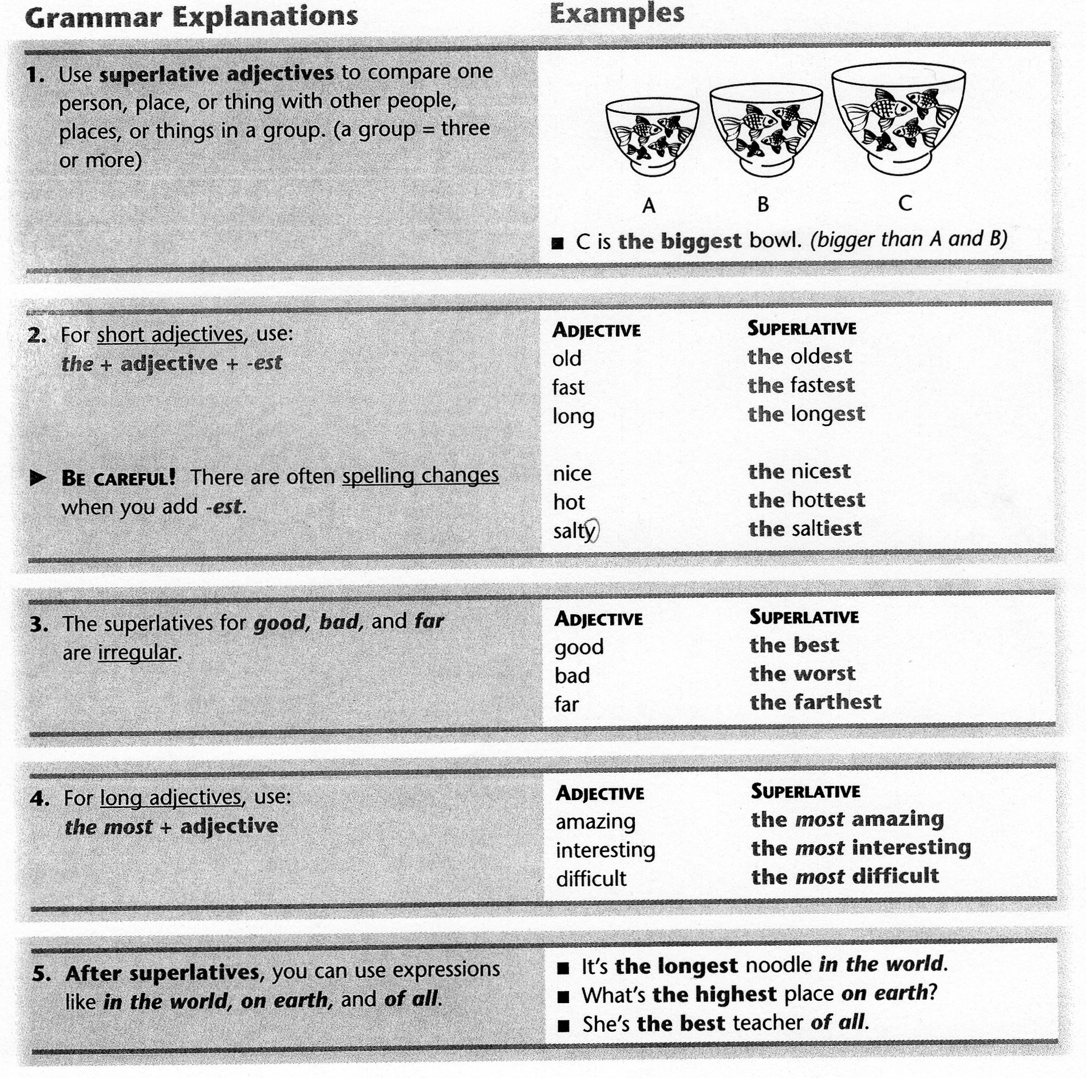

Worksheet

‘Mike’s Kitchen’

1. Look at this family picture. Match each name with the description.

Name Description
_________ 1. Jesse a. the tallest
_________ 2. Sharon b. the heaviest
_________ 3. Mike c. the oldest
_________ 4. Patty d. the most athletic
_________ 5. Ron e. the youngest
_________ 6. Doug f. the most serious

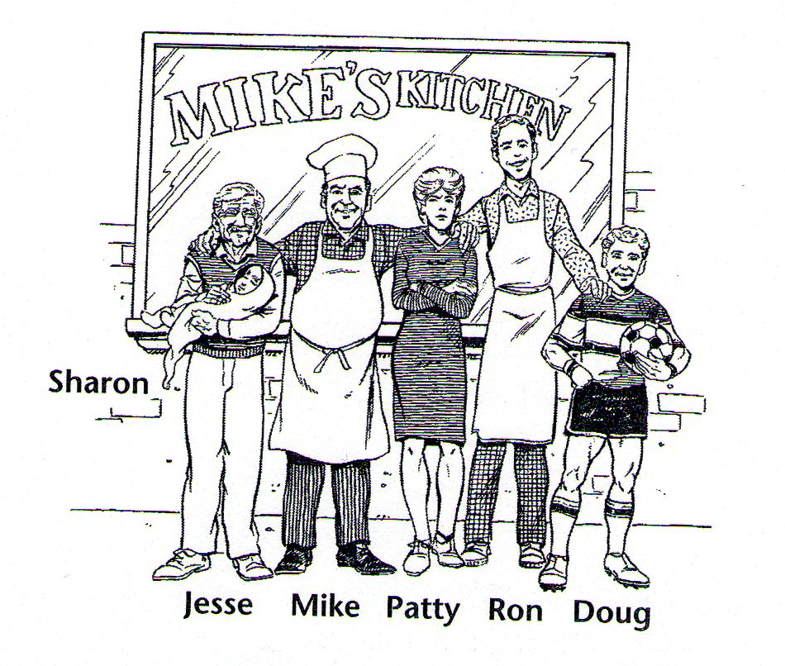
Wall chart

- Look at these pictures and complete the sentences. Use the superlative form of the correct word.

(2001)
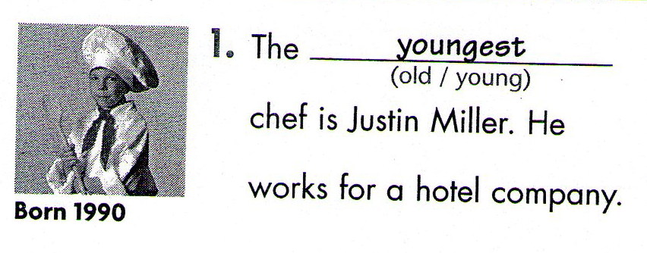
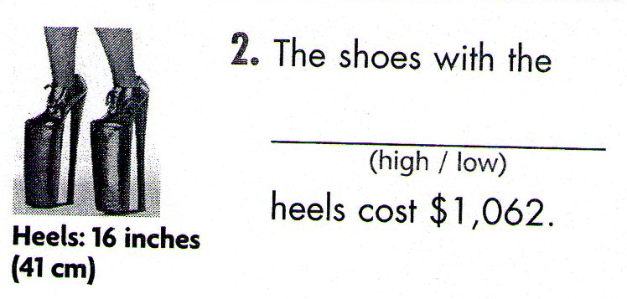
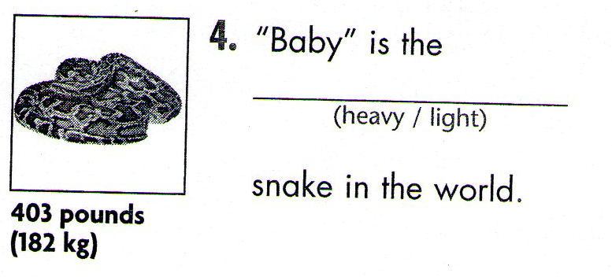
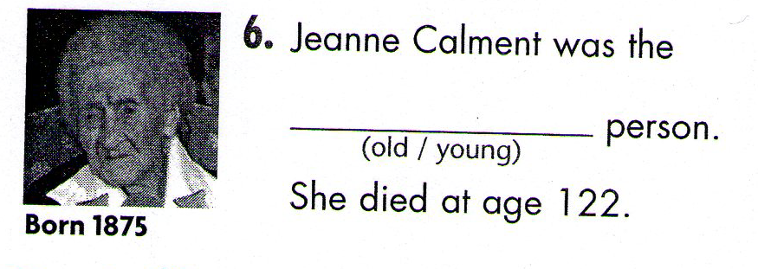

Wall chart

- CHOOSE & COMPLETE – Complete these sentences with the superlative form of the words in the box. Then you can take the quiz under each question.

big dry fast heavy high hot intelligent

1. __________________ piece of ice on earth is three miles thick. It’s in:
a. Antarctica b. Canada c. Russia

2. The Sahara is _______________ place in the world. Its highest temperature is:
a. 200℉ (93℃) b. 105℉ (41℃) c. 130℉ (57℃)

3. ____________ animals of all weight almost 200 tons (181 metric tons). They are:
a. blue whales b. elephants c. lions

4. Cheetahs are ___________________ animals in the world. They can run:
a. 40mph (64km/h) b. 100mph (161km/h) c. 70mph (113km/h)

5. At 29,035ft (8,850m), Everest is ____________________ mountain on earth. It’s in:
a. Australia b. Europe c. Asia

6. It isn’t as smart as us, but it is one of __________________ in the world.
a. a cat b. a monkey c. a tiger

7. The Atacama Desert is _________________ place on earth. It never rains. It’s in:
a. Africa b. South America c. North America

