Word | explanation
- Polio | - The older people leave their job and usually stop working completely.
- Found(past . Founded) | - She died.
- Massage | - She could walk again.
- Retire | - Synonym. establish
- They are all athletes | - This is a serious infectious disease which often makes people unable to use their legs.
- Wilma’s family helped Wilma walk again. | - This is the action of squeezing and rubbing someone's body, as a way of making them relax or reducing their pain.
- She didn’t give up. | - Thanks to her family, Wilma could walk again.
- She is no longer alive. | - She didn’t stop trying hard.
- She was able to walk again. | - They are all sports players.
Matching words

Write the letter that is related explanations
Guiding questions
Write the answer short.
When was she born? | She was born on June 23, 1940.
Where was she born?
When did Wilma get polio?
How far was the hospital from Wilma’s home?
When did she begin to walk again?
Which medal did she win at the Melbourne Olympics?
When did she retire?
What did she found to help poor young athletes?

Wilma, the Fastest Woman in the World
Wilma Rudolph was born on June 23, 1940, in America. She grew up in a poor family. Wilma had a big family. She was the twentieth of twenty-two children. When Wilma was four years old, she got polio, so she could not walk.
Wilma and her family did not give up hope. Several times a week, Wilma went to a hospital for African Americans with her mother. The hospital was about 50 miles away from her home, but Wilma and her mother went to the hospital for several years. Every night, Wilma’s mother massaged her legs, and her brothers and sisters also massaged them four times a day. Wilma tried hard to be able to walk again.
Thanks to her family and her strong will, Wilma was finally able to walk again at age twelve. After she was able to walk, Wilma began to play all kinds of sports and found a love for running. She was very slow at the beginning, but she did not give up. She tried very hard to succeed as an athlete.
Finally, at the 1956 Melbourne Olympics, she won a bronze medal in the 400-meter relay. Four years later, at the Rome Olympics, she won three gold medals for the 100-meter, the 200-meter, and the 400-meter relay.
After she retired from running in 1962, she became a teacher and school coach. Later, she founded the Wilma Rudolph Foundation to help poor young athletes. Wilma Rudolph is no longer alive, but she still lives in the hearts of many people.
Completing a chart
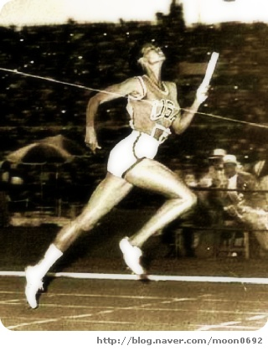 | 1940 | Wilma Rudolph  in 1940
 | 1944 | Wilma got ,  So she couldn’t walk.
 | 1952 | Thanks to her family and  Her strong will, she  again.
 | 1956 | She won a medal at the Melbourne Olympics.
 | 1960 | She won  at the Rome Olympics.
 | 1962 | She from running and become  a and school coach.

