SAMPLE (Planning Form) :

- Korean Travel Destination -

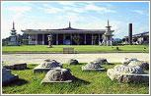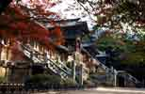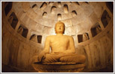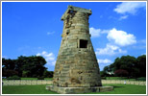

Gyeongju National Museum Bulguksa Temple Seokguram Grotto Cheomseongdae Observatory

(1) Recommended Destination : Gyeongju
(2) Food : ‘soft tofu stew’ is a common Korean dish enjoyed by many because of its soft texture in the mouth. It’s very delicious and healthy food. Enjoy your meal!
(3) Attractions : I’d like to recommend Gyeongju to you.
As the capital of the Silla Kingdom for almost a thousand years, Gyeongju preserves vast amount of significant and fascinating historical heritages. This is why Gyeongju is called a museum without walls. Along with Bulguksa Temple and Seokguram Grotto, the Gyeongju Historical District has been designated as a World Heritage by UNESCO. Due to the bountiful historical, natural and cultural attractions, this region has long been a major tourist destination in Korea. Welcome to Gyeongju!
- Korean Travel Destination -

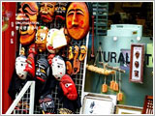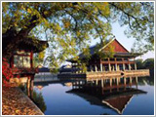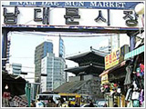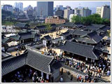

Insa-dong Gyeongbokgung Palace Namdaemun Market Namsangol Hanok Village

(1) Recommended Destination :

(2) Food :

(3) Attractions :

- Korean Travel Destination -

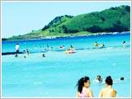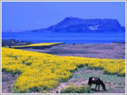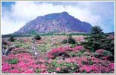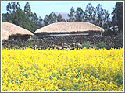

Hyeopjae Beach Seongsan Sunrise Peak Mt. Halla National Park Seongeup Folk Village

(1) Recommended Destination :

(2) Food :

(3) Attractions :

- Korean Travel Destination -

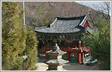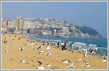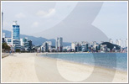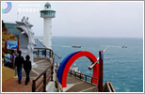

Beomoesa Temple Haeundae Beach Gwangalli Beach Taejongedae Resort

(1) Recommended Destination :

(2) Food :

(3) Attractions :

<Information Worksheet>

“Seoul” is the capital of Korea with over 600 years of history.
It is the heart of Korea’s culture and education as well as politics and economics. Seoul is unique in that historical sites such as Gyeongbokgung Place and modern cultural facilities coexist in harmony. Seoul is a world-class city with numerous amenities and shopping districts such as Myeong-dong and Apgujeong.

1. Refer to the information worksheet about Seoul and share your ideas with your group members.
2. Make your own ad poster. (In groups)
3. You need to choose the presenter(=tour guide) of your group.

*

*

*

*

*

*

*

<Information Worksheet>

“Busan” is a second largest city in Korea. As a major port city, there are myriad sea routes providing gateways to Japan and to the rest of the world. Busan also boasts scenic visions of nature with Nakdonggang River flowing in the west adjacent to the ocean at the south. Its landscape includes a coastline with pristine beaches, scenic islets and tall mountains. The Pusan International Film Festival(PIFF) is held annually and attracts movie buffs enthusiasts from all over the world.

1. Refer to the information worksheet about Busan and share your ideas with your group members.
2. Make your own ad poster. (In groups)
3. You need to choose the presenter(=tour guide) of your group.
*

*

*

*

*

*

*

<Information Worksheet>

“Jeju Special Self-Governing Province” is the premier tourist destination in Korea and has changed its name from Jeju-do into Jeju Special Self-Governing Province. Scenic beaches, waterfalls, cliffs and caves lie in harmony, and the mild weather makes Jeju an even more ideal tourist destination. Mt. Hallasan in Jeju has flora and fauna of both temperate and tropical varieties, coexisting on the mountain. The Jungmun Tourist Complex is a comprehensive tourist resort and provides top-quality accommodations and tourist facilities.

1. Refer to the information worksheet about Jeju and share your ideas with your group members.
2. Make your own ad poster. (In groups)
3. You need to choose the presenter(=tour guide) of your group.

*

*

*

*

*

*

# Paper for Drawing lots

---------------------------------------------------------------------------------------------

Seoul

---------------------------------------------------------------------------

Busan

Jeju

<# SOS Plan>

What is the best way to attract many foreign tourists to Korea? Share your ideas with your group members.

<Homework : Plan your own information leaflet>
- Traditional Korean Food –
Picture here

- Food :
- Spiciness :
- Description :
- Where to eat :
- Price :

