Speaking Lesson Plan

Instructor:
Song ja
Yang(so young)
Level:
Lower Intermediate
28 to 35 years old
Students:
8
Length:
45 minutes
Topic: A Basic Introduction about Weddings
Materials:
- Reading text (list of wedding vows handout), vocabulary flashcards
- (white gloves, veil, flowers, candles, cake, music, basket, black tie for men)
- Beam projector, computer with the Internet connection
- White board, board markers, board erasers, tape

Aims:
- To gain knowledge & practice using expressions related to Weddings.
- To practice reading and writing vocabulary related to wedding discussion.
- To practice speaking by sharing their knowledge about weddings, personal experiences & discussing vocabulary previously learned.
Language Skills:
Reading: the text of vows, notes on the board
Listening: group talk/discussion, class discussion, teacher’s instruction, partner discussion and presentation
Writing: Written vows shared with a partner,
Speaking: group talk/discussion, comprehension check, class discussion, presentation
Language Systems:
Lexis: (celebration, love, bride, groom, cake, candles, gloves, veil, bouquet)
Phonology: bride; emphasis on the B sound .Veil emphasis on the V sound.
Discourse: paragraphs/ dialogue
Grammar: Structure of “to __”

Assumptions:
- Ss know each other and are familiar with the teacher.
- Ss are familiar with learning through visual images
- Ss have learned the skills and strategies of reading.
- Ss are familiar with weddings.
- Ss have learned the rule of language order.

Anticipated Errors and Solutions:

- If there is a problem using the beam projector or the lap top,
  - Bring in a spare copy of a burned CD; bring in large photographs of a wedding, and let Ss share thoughts on it.
- (SOS) if time remains at the end of task-realization,
  - Give example invitation card for Ss to discuss who, when, where the wedding is located. Student will make their own wedding invitation card, using the example wedding card given by the teacher. It includes who, where, and when the wedding will be held. Ss will use their imagination for their own wedding card.

References:
http://www.youtube.com
http://www.weddingvows.seo-art.com
http://www.ourweddingsongs.com
http://www.answers.com/topic/veil
http://ftp.fortunaty.net/com/sacred-texts/mas/sof/sof22.htm
http://www.our-princess.com/images/flower_border_stationary_no_lines.jpg

Wedding Song - "Better Today" Coffey Anderson

Pre-Task
Materials: Brainstorm Wedding Vocabulary/Concepts
Time  5 minutes | Set Up  Whole class | Procedure:  *** Brainstorming: using Wedding vocabulary ***  <Greeting and Warm-up: Brainstorm Wedding Vocabulary>  Pictures: Ss will be shown some wedding pictures with music using the laptop. And discuss any ideas or words that come to mind when thinking about wedding.  Teacher will discuss vocabulary related to the wedding photo.  Discuss symbolism of different materials related to the wedding.

Task Preparation
Materials: vows sheet
Time  7 minutes | Set Up  Whole class | Procedure:  <Discussion: What are vows? How are they related to weddings?>  Allow students to share their thoughts about vows. Discuss how they relate to weddings.”Who writes the vows?  “What kind of things do you say?”
Task Realization
Materials: the reading text, white gloves, black tie, veil, candles.
Time  20 min | Set Up  Group  Individual  Partner work  Partner | Procedure:  Discuss what you will say to your fiancée at your wedding. Explain the lesson. Check students’ understanding of the sequences of the lesson.  Discuss the text, and go over reading/ pronunciation as a group.  <The Text Reading>  Hand out the text and have the Ss read it silently.  Students will choose 2 vows from the provided text to create a dialogue with a partner and attach the vows on to their worksheet with tape.  Also the students will add 1 vow in which they have created to compliment vows already chosen. Work with a partner to practice reading and presenting chosen vows.  Teacher’s Role  (Monitor and assist Ss if requested. Teacher will set up flowers, candles, juice, and cake on table. Teacher will pass out veil for women, and tie for men to wear when they present their dialogue.) Teacher will play the role of the priest during presentation.  < Presentation>  Students will come up to the front to present their vows. Students will wear provided materials when presenting their rehearsed dialogue.

Post-Task
Materials: Cake, Snacks, Basket, CD or laptop for music
Time  13 min | Set Up  Whole Class | Procedure:  <Language Focus> Do Action and Play!  Take flash cards and put them in the basket. Ss will pick up one card  . Ss will pick up one card with a vocabulary word labeled on it and create their own sentence using the word and action.  Example: If a student draws the word cake they can make a sentence  “I promise to give my friend some cake.” The student will go up to the cake, take cake and give a piece of cake to a classmate as the action. The rest of the class can respond: “Is it delicious? How does it taste? .  Each student will draw a different card from which they can perform a different action from each other.  Students will have the chance to win a prize from a drawing. If a student draws the card gift, they will get surprise gift from the teacher.  Homework  Teacher will hand out the sheet of paper with blank lines, Ss will fill out their own vows to teacher using ” I promise to ___” grammar form in their own words. .
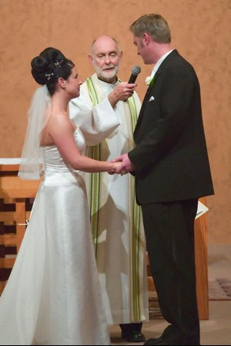
Example Photos for Wedding Discussion
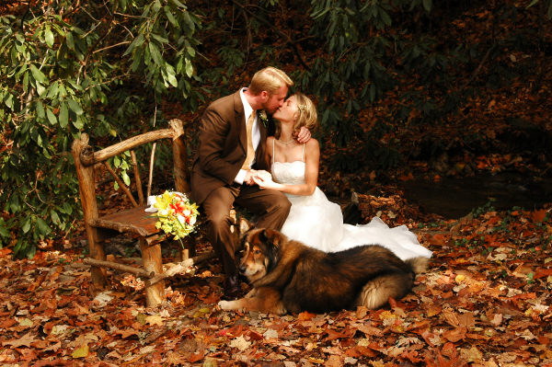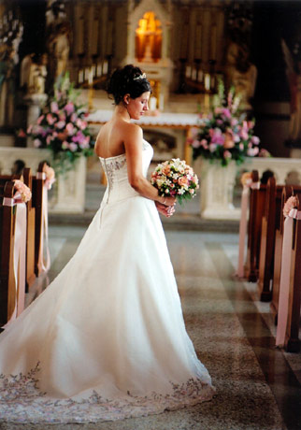

Photo example for Main Activity (vows)
(A couple reciting their vows)

♥♥♥♥♥♥♥♥♥♥♥♥♥♥♥♥♥♥♥♥♥♥♥♥♥♥♥♥♥♥♥♥♥♥♥♥♥♥♥♥♥♥
♥♥ ♥♥
♥♥Wedding Vocabulary ♥♥
♥♥ ♥♥

Bride
Groom
Priest
Wedding ring
Veil
Wedding dress
Wedding Tuxedo
Love
Candle
Hug
Tie
Vow
Flowers
♥♥♥♥♥♥♥♥♥♥♥♥♥♥♥♥♥♥♥♥♥♥♥♥♥♥♥♥♥♥♥♥♥♥♥♥♥♥♥♥♥♥

Wedding Vows
I promise to appreciate our friendship and love you today, tomorrow, and forever.
I promise to trust you and honor you.
I promise to laugh with you and cry with you.
I promise to love you through the best and the worst.
I promise to be there when you need me.
I promise to fill your days with sunshine.
I promise to comfort you and encourage you.
I promise to be your best friend forever.
I promise to always be there for you.

Wedding vows

I promise to_____________________________

I promise to_____________________________

I promise to_____________________________
(Add your own bow)

Dear Teacher,

I promise to _____________________________________

I promise to _____________________________________

(Make your own letter to teacher)

Signature:------------------------

Example Wedding Invitation Card: Who, When, Where

We request the pleasure
of your company at our wedding.
Bride: Miss Sarah Katherine
to
Groom: Mr. Michael John Williams
Where: St. Mary's Church, Knightsbridge
When: Saturday, September 11th at 2:00 p.m.
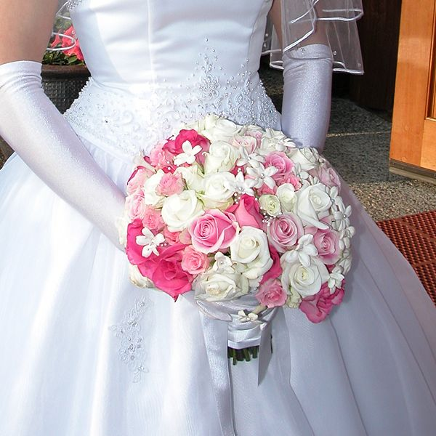

Wedding Invitation Card:

We request the pleasure
of your company at our wedding.

Bride:
Groom:
Where:
When:

