Shopping / Speaking Lesson Plan

Instructor:  Regina (Kim Kunhee) | Level:  Pre-intermediate | Students:  8 | Length:  25 minutes

Materials:
- White board, Board markers and magnet
- One image picture
- A flash card to explain one new word
- Worksheet #1 (questions / 8 copies + one extra)
- Worksheet #2 (board game for activity)

Aims:
- SS will know how to make various sentences about shopping
- SS will practice how express their opinion
- SS can improve speaking and listening by sharing group activity

Language Skills:
- - Reading : reading the sentences in the worksheet.
- - Listening : T’s instruction/demonstration/classmates’ ideas.
- - Speaking : Discussion within groups

Language Systems:
- Lexis : new words used in sentences
- Grammar : the past tense and present tense
- Phonology : pronunciation of new vocabularies
- Discourse : sharing each idea in groups

Assumptions:
Students already know
- SS have are willing to share their ideas using certain words
- SS know the teacher’s style of teaching and the pace of course
- All SS have experience to answer the worksheets
- SS enjoy group activity

Anticipated Errors and Solutions:
- Students may need more time to finish worksheets
Encourage SS to help each other
Answer the worksheets together. (T+SS)
Assign the worksheets as a homework assignment.
- Students may finish all the activities too early or time is short
Play game or make sentences using new vocabularies.
Cut post-activity discussion short.

References:
http://www.eslflow.com/speakingandcommunicativeicebreakeractivities.html
http://www.answerbag.com/q_view/47308
http://www.businessweek.com/bwdaily/dnflash/feb2005/nf20050214_9413_db_082.hht
http://knowledge.wharton.upenn.edu/article.cfm?articleid=1848
http://shetakesontheworld.net/2010/07/is-your-shopping-style-getting-you-the-best-professional.html

Lead - in
Materials: board & board markers
Time | Set Up | Procedure
5 min | Whole class | Hi everyone.  I believe that all of people have different hobby including me.  What is your hobby? (Can you tell me your hobby?)  Do you know common hobby of women?  Yes, that’s right. Women love shopping.  Of course some men like shopping as well.  If you have magic pocket which gives you a lot of money continually. What would you like to buy?  (let students tell their opinion freely)  <Eliciting and Prediction>  (paste picture)  (two women seem to enjoy shopping in the photo)  <CCQs>  Can you remember the hobby that all women like to do?  Do you enjoy buying something like clothes, bags and so on?  (paste one flash card : impulsive)  Is there anyone who knows the meaning of the word?  Sometimes we would regret when we buy stuff without plan. We find something interesting and then just buy it without concerning how much money we have.  (showing one lipstick)  Yesterday, I bought this lipstick impulsively. I don’t like this color.  <Introducing today’s topic>  We are going to talk about our experience of shopping. Isn’t it interesting topic is it?

Run-Activity
Materials: Whiteboard, Board markers, Worksheet#1((new words and idioms)
Time | Set Up | Procedure
15 min | Whole class  With partner  Group | <Instruction>  (Distribute Worksheet #1)  (talking about experience of shopping following questions)  Let’s share your opinions with your partner.  I will give you 4 min  <CCQs>  Are you working alone? (N)  How much time do you have? (4min)  (checking SS)  (Alert time limit)  Do you finish?  (Choose each SS and listen partner’s story)  Okay, let’s make two groups with 4 members.  (Distribute Worksheet #2)  (give one dice to two group)  As you can see, this is board game I will give you those money as well.  The person who keeps money as much as he or she can will be the winner today.  <ICQs>  Who can be the winner? (keep money as much as she or he can)  Can you use dice? (y)  I will give you 11min. let’s do this activity with your group member.  <CCQs>  How much time do you have? (11min)  Can you work with your group? (Y)  (monitoring)  (while listening SS’ answer, writing down some errors on white board)

Post-Activity
Materials: reading material, Worksheet #2, Whiteboard, Board Markers
Time | Set Up | Procedure
5 min | Whole Class | <instructions>  Who is the winner in this group?  How about this group?  Today’s winner is …………… let’s give him big hand.  How much money do you collect?  If the money would be real what do you wont to shop?  <Error correction and Feedback>  Correct wrong expressions which are written on white board.  Let SS know what would be wrong?  Are you having fun today?  Enjoy shopping everyone!!
Worksheet #1

* Before talking about questions, discuss with your partner the shopping words.
Shopping center, bargain, department store, window shopping Shopaholic, chain store, impulsive buy, discount, haggle

1. Do you enjoy shopping? Why / not?

2. Do you enjoy window shopping? Why / not?

3. Are you a bargain-hunter? Do you tent to wait for the Sales before buying things?

4. Have you ever shopped anything impulsively?

5. How do you usually shop when you buy items such as on-line shopping mall, catalogue, TV home shopping and department store and so on?

6. Do you prefer shopping in well-known chain stores or in little boutiques?

Worksheet #2

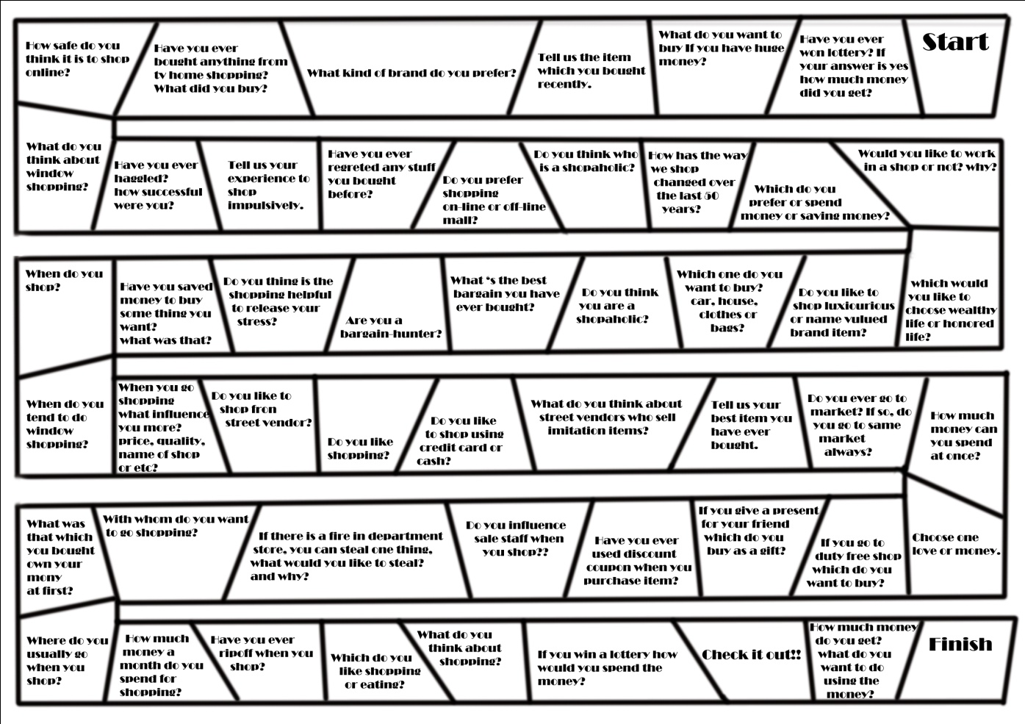

Image picture

Speaking Lesson Plan
25th Sep. 2010

Name / Regina (KIM KUNHEE) (32th WK)
Teacher’s name / Valerie

