Grammar Lesson Plan

Prepositions of place(between/next to/ in front of)

Instructor :  Charllene  (Seohyun Lee) | Level :  Pre-Intermediate | Students:  9 | Length :  30 minutes

Materials :
- Whiteboard, board markers
- Pictures-teacher’s use
- Worksheet #1 Finding prepositions : 9copies +1 extra
- A doll and Lego blocks- prepositions practice activity
- Worksheet #2 Production activity -A picture of empty living room
- Worksheet #3 Homework- Writing

Aims :
- To familiarize prepositions of place by teacher’s elicit explanations
- To practice prepositions of place through individual work and group activities
- To improve speaking and listening ability through group work
- To improve writing skill through writing homework

Language Skill :
- Reading : Reading the words from the worksheet
- Listening : Listening to teacher’s presentation, instruction, demonstration/ classmates’ ideas
- Speaking : Drilling/Sharing ideas in a group
- Writing : Answering worksheets /Homework writing

Language Systems:
- Grammar : prepositions of place( between/next to/ in front of )
- Phonology : Listening to instructions and explanations/drilling
- Function : Describing objects’ location through prepositions of place
- Discourse : Working in a group to share the ideas

Assumptions :
student already know :
- The teacher’s style of teaching and the pace of the course.
- How the class is set up and run (usually work individually and in a group)
- All students are adults
- They enjoy group work and discussion.
- All students know prepositions of place( in/on/under/behind)

Anticipated Errors and Solutions :
• Students may not able to understand the words
- Explain by eliciting
• Students may have hard time drilling
- Correct the error immediately and give Ss more chances to practice
• Students may need more time during activity
- Encourage them to help each other, answer the questions when monitoring them. And give time- warning
• Students may finish their tasks earlier than anticipated
- Ask students to describe classroom objects by using prepositions of place

References :
Worksheet and whole lesson plan by Seohyun Lee
Pictures- http://wordpress.com

present
Materials : Board & Maker/Realia/Pictures
Time | Set up | Procedure
2 min  8min | Whole Class  Whole Class | 〈Greeting〉  Hello, everyone. How are you today?  < Vocabulary>  Hare /tortoise –realia  < CCQ>  Checking the meaning by pictures  〈 Situational Drill〉 – pictures from the story ‘The hare and the tortoise’  By picture presentation- Elicit in/on/under/behind (prepositions Ss already know)  By picture presentation-Elicit between/next to/in front of(new prepositions)  e.g  Where is the tortoise? (It’s behind the hare)  Where is the hare? (It’s in front of the tortoise)  Where is the hare? (They are next to each other)  Where is the hare? (It’s between rocks and a tortoise)  Marker Sentences  1.It’s in front of the tortoise  -Add to the WB  <CCQ>  Is the hare behind the tortoise?  <Drill>  T- read X3(2nd time with fingers)  T-Ss repeats after teacher( 1or 2)  Ss –half-small groups-solo  2.It’s between rocks and a tortoise  -Add to the WB  <CCQ>  Is the hare on the rocks?  <Drill>  T- read X3(2nd time with fingers)  T-Ss repeats after teacher( 1or 2)  Ss –half-small groups-solo  .3.They are next to each other  -Add to the WB  <CCQ>  I s the hare behind the egg?  <Drill>  T- read X3(2nd time with fingers)  T-Ss repeats after teacher( 1or 2)  Ss –half-small groups-solo

practice
Materials : Worksheet #1(Writing prepositions)/ Lego blocks
Time | Set Up
4 min  2min | Whole Class  individually | Procedure :  1.<Controlled Practice>  -Worksheet #1(Finding prepositions)  <Instruction + demonstration>  Show picture #1. Look at the box.  Where is the dog? It’s on the chair.  Then what do you write next to letter A.? (on)  Do it alone. You have 2min  < ICQ>  Do you write the whole sentence?  Do you work with your neighbor?  How much time have you got?  -Worksheet #1 distributed and run the task  〈Feedback〉  Time-warning  If necessary, extra 30sec.  If not ,share the ideas in a pair  Share the answer with the class.  2. 〈Less Controlled Practice〉- Lego blocks  Locate the Lego dolls and speaking/writing practice  〈Instruction +Demonstration〉  Show how to locate the Lego dolls and elicit how to speak + write by using prepositions of place. Grouping of 3/5min to run the task  <ICQ+CCQ>  Do you only speak in a group?  How much time have you got?  -Lego blocks distributed and run the task  <Feedback>  Time-warning  If necessary, extra 30 sec.  Share the idea with the class
Produce
Materials : Worksheet#2(The empty living room)
Time | Set Up | Procedure
8 Min  2min | Whole Class  Whole Class | <Worksheet#2>-Drawing some furniture on the paper  -GROUPING  < Demonstration〉  Draw a sofa next to the bed and ask Ss where they are located.  < Instruction〉  Locate some furniture in the living room and practice prepositions of place  (between/next to /in front of )  You have 5min.  〈ICQs+CCQs〉  Do you write something? ( No, draw)  How much time have you got?  -Worksheet #2 distributed and run the task  〈Feedback〉  Time warning  Share the idea with the class  〈Closing〉  -Word “hare /tortoise”- who’s faster? Who’s slower?  -Grammar review (picture)  -Homework (writing) distributed

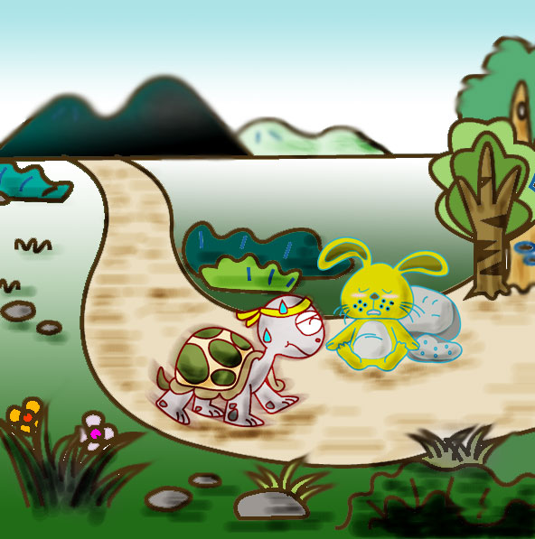

https://wordpress.com

https://wordpress.com

