Speaking Lesson Plan

Being Entrepreneurs

Instructor :  Charllene  (Seohyun Lee) | Level :  High-Intermediate | Students:  9 | Length :  25minutes

Materials :
- Whiteboard, board markers
- Picture:1 +2 Copy (Teacher’s use)
- Worksheet #1-Outline of a start-up company
- Sample Newspaper Ads
- Color Paper/color pens/scissors/glues

Aims :
- To practice a real-life English by creating an advertisement
- To understand the meaning of new vocabulary ’Entrepreneurs’ through elicitation
- To practice speaking through discussing with group members about how to create an advertisement

References :
Pictures-Goole.com/images
Worksheet- Seohyun Lee

Engage
Materials : Board & Maker, Pictures
Time | Set up | Procedure
4 min | Whole Class | 〈Eliciting and Prediction 〉  –Picture presentation (best- known examples of Entrepreneurs)  -Pair share/2min discussion/ICQ  <Vocabulary> Entrepreneurs

Pre-task
Materials : Worksheet #1 (outline of a start-up company)
Time | Set Up
10 min | Whole Class | 〈Demonstration〉  Product : Selling a territory of the Moon/CCQ  <Instruction>  Pair share/5min/ICQ  -Worksheet #1 (outline of a start-up company) distributed  -Run the task  -Monitor/Time-warning  -Feedback /class share
Main-task
Materials : Sample Ads+ color paper/color pen/scissor/glue
Time | Set Up | Procedure
10 Min | Whole Class | <Demonstration>  Show and explain an example ad on the newspaper/CCQ  <Instruction>  Creating an advertisement of their own company product  Pair share/10min/ICQ  -Sample Ads and color paper distributed  -Run the task  -Monitor/Time-warning  -Feedback/Class share

Close
Time | Set | Procedure
1min | Whole class | Error correction if necessary  Review-vocab ‘Entrepreneurs’  Round up

Worksheet # 1

<OULINE OF YOUR START-UP COMPANY>

- COMPANY TITLE

- CEO & PARTNER NAME

- PRODUCT CATEGORY

4. THREE STRONG POINTS OF YOUR PRODUCT IN COMPARISON TO YOUR COMPETETORS

*

*

*

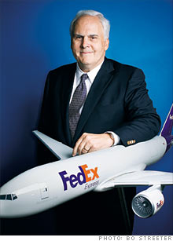

G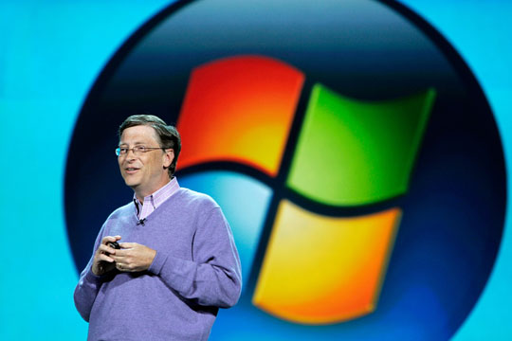

https://www.google.com/images

Frederick Wallace Smith (born August 11, 1944), or Fred Smith, is the founder, chairman, president, and CEO of FedEx, originally known as Federal Express, the first overnight express delivery company in the world, and the largest in the United States. The company is headquartered in Memphis, Tennessee.
Gates is one of the best-known entrepreneurs of the personal computer revolution

