Listening Lesson Plan

What is English?
Instructor:  Ji-Eun Shin  (Gloria)) |  | Level:  Lower Intermediate |  | Students:  9 |  | Length:  45 minutes

Materials:

- A picture for prediction : 1 copy (only put on the white board)
- Worksheet #1 : for vocabulary : 12 copies (9 copies for each Ss + extra three copy)
- Worksheet #2 : for comprehension of the passage : 12 copies (9 copies for each Ss + extra three copy)
- Worksheet #3 : for practicing pattern sentences : 11 copies (9 copies for each Ss + 3 extra copies)
- Worksheet #4 : for discussion: 5 copies ( 3 copies for each pair + 2 extra copy)
- Wall chart and beam projector for discussion.
- Worksheet #5 : for homework : 12 copies (9 copies for each Ss + extra three copies)
- Listening CD & CD player (a short story with a length of 100 seconds)
- Whiteboard, board markers, board erasers, tape,

Aims:

- To preview the subject they will be learning about (a picture with a key question is provided for prediction)
- To study integrated vocabularies through a passage by listening and answering questions on the worksheet #1 and worksheet #2
- To practice pattern sentences by speaking using worksheet #3
- To study each country and its language by discussion on worksheet #4
- To improve their comprehension of the context doing worksheet#5

Language Skills:

- Listening: listening to the recording, the teacher and students
- Speaking: talking to each other through the pair/group work for brain storming and discussion
- Reading: reading the definition of the new words on the worksheet #1 and for comprehension vocabulary check on worksheet #2
- Writing: writing vocabulary on the worksheet #1 & worksheet #2, dictation and the homework on the worksheet #5

Language Systems:

- Lexis: vocabulary which learned through the passage
- Function: practicing the pattern sentences on worksheet#3.
- Discourse: discussing to find out where English comes from and what countries use English?

Assumptions:
Students already know:
- Seats have already been arranged in a horseshoe.
- How the class is set up and run
- Ss already know countries’ name and several kinds of languages
- Ss are familiar with group work and discussion.

Anticipated Errors and Solutions:

- Ss may not be able to follow the passage easily
→ Follow the task-feedback circle: let them listen to the track again until they get the gist of the content.
- Ss may not be able to pick up details from listening
→ Chunk the listening (listen- -stop –listen-stop)
- or let them to work in pair or group.
- If time is short
→ Skip or cut the predict of main activities shortly.
- If students finish their tasks earlier than anticipated
→ Do the homework in the class or matching game (after making two sets cards, Ss have to match right country’s name and its language)

References:

- TESOL 33th Diane’s listening lesson plan
- All contents from New Speak Up1 Chapter 1(p10~15) published by GnB English Education Co., Ltd.
- Adapted all worksheets from New Speak Up1

Lead-In

Materials: board ,markers and board erasers

Time | Set Up | Procedure
3 min | Whole Class | <Greeting>  Good afternoon, everyone? How are you today?  How was your school today?  <Eliciting>  How do the international students communicate with each other?  (Elicit Ss’ thoughts and write them on the board?)  Okay, today we will listen to an interesting passage relating to what English is and where English comes from.  Before listening we will learn some vocabulary the speaker use.

Pre-Activity

Materials: board ,markers, board erasers, tape, wall chart and worksheet#1, a picture
Time | Set Up | Procedure:
8 min  4min | Whole Class  Individually  Whole Class  Whole Class  In Pairs | Ⅰ. Vocabulary  < Instructions>  Work in individually. Complete the words and write the correct words in the blank. You have 3 minutes.  <Demonstrations>  For Part A, look at the board and check the answer with me.  For Part B, read the definition first, if you are clear with the word’s meaning and then find the right word from the word box..  <Concept Check Qs>  What should you do first?  What should you fill in the blank with?  How much time do you have?  (Distribute the worksheet#1)  Monitor discreetly while Ss take the WS. If students ask some questions, answer them. If students don’t do well, help them with some more examples. Give time warning: 1minute left. Be flexible with time. Ask students if they are done then check up the answers when they say yes.  Go through the vocabulary one by one: let each S who wrote the answer read the sentences including the answer loudly. Explain the meaning if necessary.  Ⅱ. Prediction  <Instruction>  Look at this picture on the board. Who can you see? Can you guess where they are from? And what language do they use? Get in pairs 3. Share your ideas with your partner. I will give you 2 minutes.  <Concept Check Qs>  Who are you working with?  What should you do?  How much time do you have?  Compare your thoughts with your partner

Main Activity 1

Materials: CD & CD player, wall chart(beam projector) , worksheet #2, board, marker, tape and eraser
Time | Set Up | Procedure:
5 min  10 min | Whole Class  Individually  Whole Class  individually  In pairs | Ⅰ. Listening for the main idea (general understanding)  <Instruction>  Put your pens down. Close your eyes. Listen to the whole story. Think about what this story about. Try to figure out the main idea.  <Concept Check Qs>  What are you supposed to do?  Can you take notes?  (Play the CD player without stopping)  Would you like to listen again?  - Yes →Have them listen one more time.  - No →Have them share their thoughts.  Where does English come from?  What countries use English in the world?  (Give clear feedback to every response of students.)  Did you get some vocabulary what we learned?  Ⅱ. Listening for details  <Instruction>  Now, let’s listen to the story again. This time you should focus on finding out right answers and fill in the blanks.  <Concept Check Qs>  Are you working alone?  What should you do while listening?  (Play the recording three times without stopping)  Let Ss write answer as they listen.  Do you want to listen again?  - Yes →Have them listen one more time.  - No →Have them compare their answers in pairs of two or three.  Are you finished? compare the right answer with your partner.  Read loudly one sentences after another by turns.

Main Activity 2

Materials: worksheet #3, worksheet# 4, beam projector, board, marker, scissors, tape and eraser
Time | Set Up | Procedure:
6 min | Whole Class  In Groups | Ⅰ. Discussion to match countries with languages  <Instruction>  Make three groups of three students. And match the country with its language. .  <Concept Check Qs>  How many people are working together?  What should you match?  Monitor activity and participate within each group. Give time warning: 1 minute left the WB.  Check the right answer.

Post Activity

Materials: worksheet#5, homework handout
Time | Set Up | Procedure:
9 min | Whole Class  Whole Class | Ⅰ. Free Production  <Instruction>  What’s your favorite language?  Want language do you want to be the international language?  If you can invent any language, what language will you create?  After 100 years later, what language will be the international language?  Let’s talk with your partner. You have 5minutes.  <Concept Check Qs>  Who do you talk with?  What will you talk with your partner?  How much time do you have?  (Distribute worksheet#4 )  Monitor actively and participate with in each pair.  Ⅱ. Conclude Lesson  Elicit today’s vocabulary for Ss  <Give Homework>  Take this homework, fill in the chart and unscramble the sentences.  Homework is due tomorrow.  <Concept Check>  What do you have to do?  By when do you have to finish your homework?  (Distribute HW)  Let’s call it a day. You guys did a good job today. See you tomorrow. Bye!

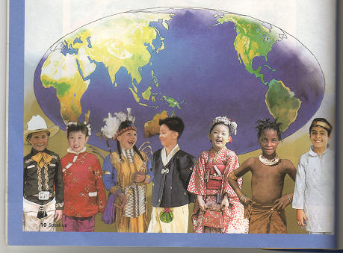

(a picture for prediction)

How do the international students communicate with each other?

The script of the listening passage

What is English?

Do you know where English comes from?
Long, long ago, many people in Europe used
Latin and German.

Most English words came from these two languages.
Later, some words from other languages were added.

Do you know what countries use English?
The US, England and Canada use English
As their first language..

Ireland, Scotland, South Africa, Australia,
and New Zealand can also be included.
English is a popular language and can be heard all over the world.

New Speak Up 1 Chapter 1 p10

Worksheet # 1

Vocabulary Skills

- Complete the words
- n. the words and grammar that people use to talk and write

( )

- n. a nation

( )

- Write the correct words in the blanks.

1. ______________ adj. the majority of

2. ______________ v. to have something as part of a group

3. ______________ adj. liked or enjoyed by many people

popular most country language include

Worksheet# 2

Listen and Answer

- Where do most English words come from?

: English came from _____________ and ______________.

- Which country doesn’t use English as their first language?

a. The Us b. France c. New Zealand

- What language do People use in Australia?

: They use _________________.

Worksheet# 3

Complete using the following patterns

Do you know / where English comes from?//

- (numbers)
Do you know where __________ comes from?

2. (a steak)
Do you know _________ ____ _________ _________ from?

3. (skates)
Do you know _________ __________ __________ ________?

4. (chopsticks)
___________________________________________________?

Do you know / what countries use / English?//

3. (French)
Do you know what countries use ________________________?

- (Chinese)
Do you know _________ ___________ _________ ___________?

Worksheet# 4
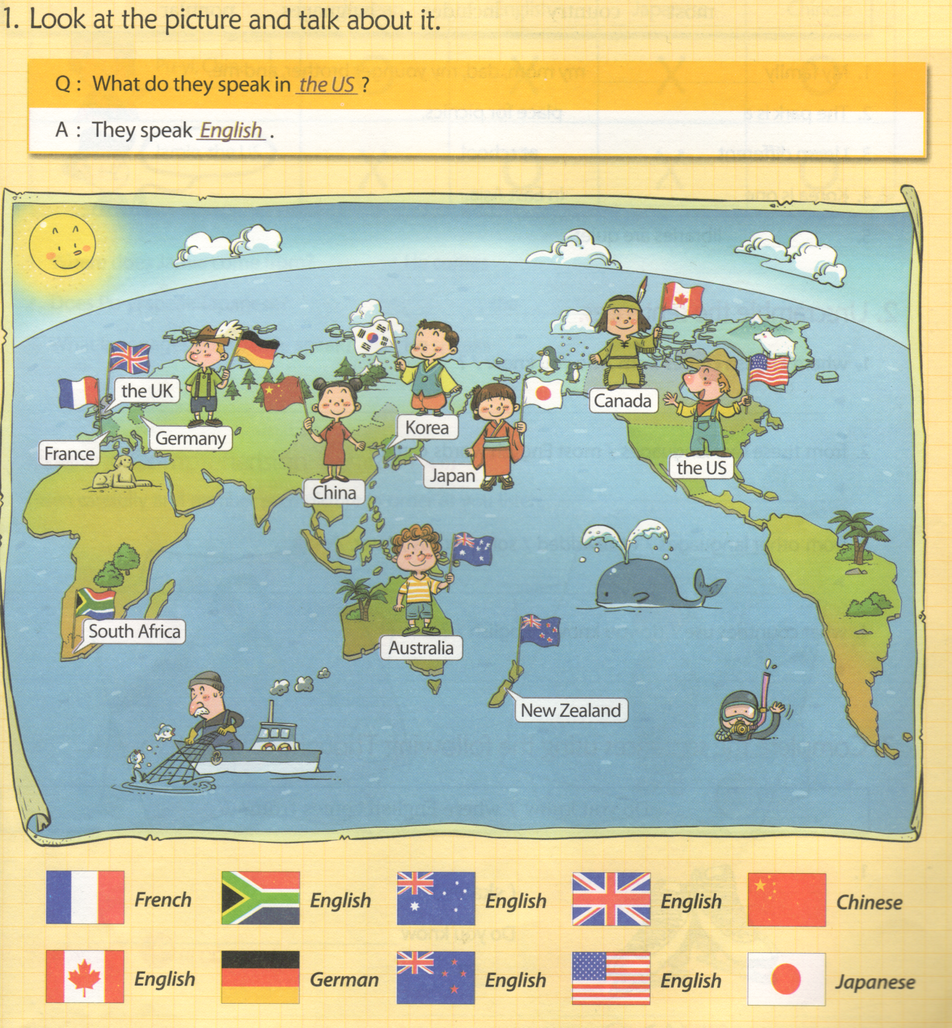

Worksheet #5

1.Look at the chart and fill in the blanks
 | Korean | English | Japanese | Chinese
Pu-yi,  China | O | X | X | O
Jamie,  The US | X | O | X | O

A. Where does Jamie come from?
> He comes _____________________________________.

B. Does Pu-yi speak Japanese?
> __________, she _______________________________.

- What language does Jamie speak?
- He speaks _____________ and ___________________.

- Unscramble the sentences.

- where English comes from / do you know /?
- _____________________________________________.

- from these two language / most English words came /.
- _____________________________________________.

- from other languages / were added / some words / later, / .
- _____________________________________________.

- what counties use / do you know / English / ?
> ______________________________________________.

