Listening Lesson Plan

Name : Olivia(Hong, Hyun Sin) Date : 26/March/2011 Length : 40 min
Class Profile : There are 8 intermediate level adult English learners. Mixed ages.
L1 language is Korean. Everyone is here to improve themselves in
English.
Materials : Board, markers, worksheets, pictures, CD player, CD
Main Aims
- To enable students to learn vocabularies and idioms in the article.
- To enable students to understand the situations about the article by listening to the story several times repeatedly.
Secondary Aim
- To better enable students to understand the story quickly through seeing
the pictures about the situation
Personal Aims
- I want my students to be interested in various idioms and how they are used in many situations.
- I hope my students can use them naturally.

Anticipated Problems  - Students might not be interested in the story.  - Students might have difficulties to pick up details from listening.  - Students might finish their task earlier than I expect. | Solutions  - I show students 6 pictures to make students be curious about the story.  - Students listen to the story again after learning the main idioms and vocabularies.  - Students make more sentences using the idioms.

Time  interaction | Stage | Objective | Procedure
5 min  T-WC | Lead-in | To enable the students to concentrate on what teacher say and what classmates say. | • Say Hello  • Ask how they were yesterday  • Ask what plan they have for  the weekend (by turns)  • Introduce today’s topic  • Attach 6 pictures on the  board
10 min  T-WC | Pre-Task | • To enable students to  find out what the  story is about  • To help students listen  to the story  • To elicit the idioms  and vocabularies  which will be used in  sentences they make | • Ask their thoughts about the  pictures  • Students listen to the story  twice  • Students write down any  words in the story as  possible as they can  • Hand out worksheets  • Students fill in the blanks in  the worksheet listening to  the story
20 min  T-S | Main Task | • Students understand  the story  • Students learn main  idioms and  vocabularies  • Students practice that  idioms and  vocabularies through  making sentences | • Write the main idioms and  vocabularies on the board  • Let them know the meanings  of that idioms and  vocabularies  • Students listen to the story  again  • Ask several questions about  the story  • Provide examples using that  expressions

Time  interaction | Stage | Objective | Procedure
S-S | Main Task |  | • Students work in pairs or  small group  (If somebody is absent)  • Students make a story  creatively in their own words  seeing the pictures  • Students make sentences  about their own stories using  that expressions  • Students talk to each other  with the sentences
5 min  T-S | Post Task | • Students will review  today’s class work | • Students listen to the story  once again  • Check up about what they’ve  just learned  • Extract the expressions which  were used in the story from  students  • Ask if they have any  questions

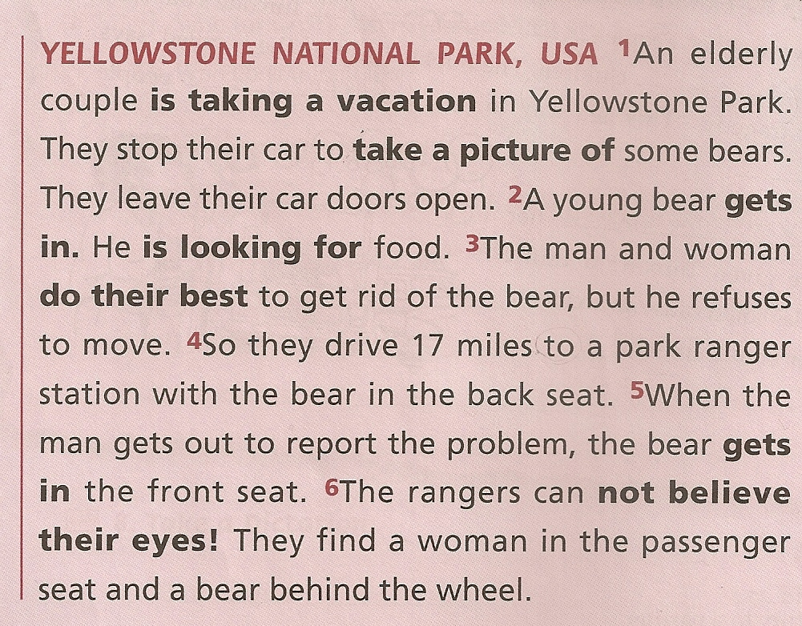

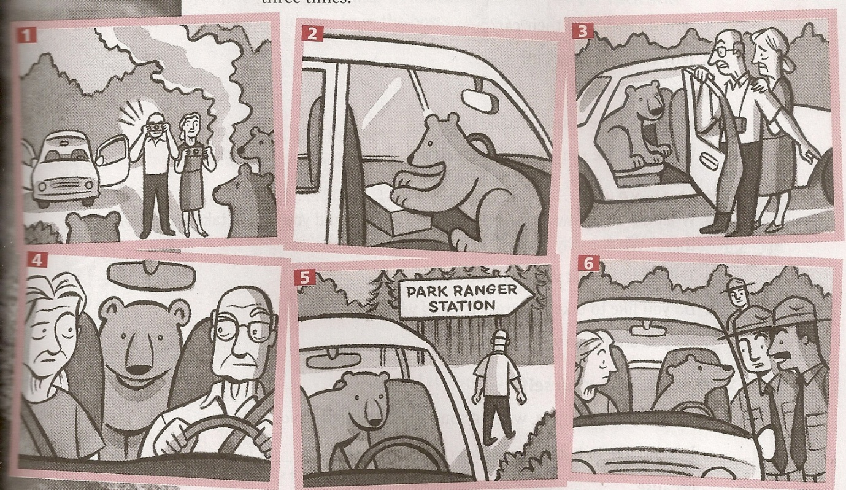

※ Reference : Jann Huizenga “Can You Believe It?”, Book1, OXFORD University Press, 2000

