Listening Lesson Plan

Cooking Class

Instructor:
Jenny
Level:
False Beginner
Students:
13
Length:
50 minutes

Materials:

- Listening CD & CD player (a story with a length of about 50 seconds)
- Words Worksheet : 14 copies ( 1 copy for each student + 1 extra copy )
- Dictation Worksheet : 14 copies ( 1 copy for each student + 1 extra copy )
- WorkSheets A,B,C : 14 copies ( 1 copy for each student + 1 extra copy )
- Scripts : 14 copies ( 1 copy for each student + 1 extra copy )
- Review Worksheet : 14 copies ( 1 copy for each student + 1 extra copy )
- Answer key for teacher
- White Board, Board markers

Aims:

- To Learn new vocabulary and expressions for cooking , ingredients and cookers by completing and matching worksheets.
- To Predict how to make pancakes by answering instructions in the correct order.
- To Practice speaking by discussing how to make their own recipes.

Language Skills:

- Listening : The speaker’s explanation how to make pancake.
- Writing : dictation, writing their own recipes.
- Speaking : explaining their own recipes, sharing ideas.
- Reading : Reading the script and vocabulary worksheet.

Language Systems:

- Lexis : vocabularies.
- Phonology: practicing new vocabulary.
- Discourse : discussion their own recipes.

Assumptions:

Students already know:
- How the class is set up and run (there will be pair work & group work).
- Most students know pancakes.
- Students are able to express their opinion in English.
- Students are teenagers (Age 14~15)

Anticipated Errors and Solutions:

- Students may not be able to follow the passage easily.
  - Let them listen to the tracks again until they get the gist of the content.
- Students may not be able to pick up details from the listening.
  - Chunk the listening (pause-play-pause-play).
- Students may have trouble to understand some of the terms.
  - Give explanation in their own language.
- If students finish their tasks earlier than anticipated,
  - Ask students about the food that they want to make for someone.

References:
- http://www.compasspub.com/book/book_view.asp?h_seq=1410
- ‘Listening Success 3’ Unit 5, listening 3 :cooking class, compass publishing.

Lead-In
Materials: Board & Board makers
Time  3 min | Set Up  Whole Class | Procedure:  1. Greeting & Introduce today’s topic  Hello everyone. How are you? Did you have good breakfast?  What is your favorite food for breakfast? What kind of food can you make?  Today we are going to listen to a cook’s recipe.  He is taking a cooking class. He teaches how to make pancakes.

Pre-Activity
Materials: Vocabulary Worksheet , Board & Markers
Time  7 min | Set Up  Whole Class  Individually  Whole Class  Whole Class | Procedure:  1. Pre-teach vocabulary  Instruction  Work individually. Match the words with the definition. And fill in the blanks. You have 4 minutes.  (hand out the worksheet)  CCQ  Are you working alone?  How much time do you have?  Did you understand each definition?  Monitor discreetly. Answer students if they ask questions.  Give time warning: 30 seconds left.  - Check the answers together: let students tell the answers in turns.  - Go through the words one by one and explain again if necessary.  2. Prediction  Instruction  Look at the pictures and What do you need to make pancakes?  (Elicit answers related to cooker expression)  Name cookers or ingredient to make pancakes.

Main-Activity
Materials: CD, CD player, Listening Worksheets
Time  5 min  5 min | Set Up  Whole class  In pairs  Whole class  Whole class  Individually  Whole class | Procedure:  1. Give guiding questions & listening for the general understanding  Instructions  First, you just listen to the script about pancake recipe. How does the speaker make pancakes.  CCQ  Are you working alone?  Can you take notes when you are listening?  Monitor discreetly. Answer students if they ask questions.  Give time warning: 30 seconds left.  (If they need more time, give 1 minute more.)  Check answers: ask questions to students.  2. Give detail questions & listening for Details  Instruction  Read the questions before you listened.  As you listened, answer the questions alone. You have 2 minutes for completing the worksheet.  (hand out the detailed question worksheet)  CCQ  Are you working in pairs?  How much time do you have?  Answer students if they ask questions.  Give time warning: 30 seconds left.  (If they need more time, give 1 minute more.)  Check answers: ask questions to students.

Post-Activity
Materials:
Time  5 min  20 min  5 min | Set Up  Whole Class  In pairs  Whole class  Groups  Whole class | Procedure:  1. Fill in the blank worksheet and Dictation.  Instructions  Read the sentences and fill in the blanks.  Work with your partner. You have 2 minutes for completing the worksheet.  (hand out the worksheet)  CCQ  Are you working alone?  For how long?  Answer students if they ask questions.  Give time warning: 30 seconds left.  (If they need more time, give 1 minute more.)  Check answers: ask questions to students.  2. Free Production  Now, we are going to have a discussion in groups.  Instruction  What is your own recipe? Do you know how to make it?  Tell it to the class.  You have 3 minutes.  CCQ  What do you have to do?  How much time do you have?  Answer students if they ask questions.  Give time warning: 30 seconds left.  Share students’ opinions.  3. Feedback  Elicit today’s vocabularies for Ss.  You did a great job. See you tomorrow.

# Dictation Worksheet

W: Good morning, everyone!
Welcome to .
You all , so I thought we .
A great way to start the day is with .
So, let’s . First, one cup of ,
one of , one of ,
and two of in a .
Second, in a ;
add one cup of milk and two teaspoons of .
After , into the .
And . Then, into a
and cook it for .
and for a minute.
Finally, from the pan and e
on . You should all try this for ! Enjoy.

# SCRIPT
W: Good morning, everyone! Welcome to our third cooking class. You all look very hungry, so I thought we should make breakfast. A great way to start the day is with pancakes. So, let’s get
started. First, mix one cup of flour, one tablespoon of sugar, one teaspoon of salt, and two teaspoons of baking powder in a bowl. Second, beat one egg in a separate bowl; add one cup of milk
and two teaspoons of vegetable oil. After mixing, pour the wet
ingredients into the dry ingredients and whisk them together. Then, pour some batter into a hot pan and cook it for two minutes. Turn it over and cook the other side for a minute. Finally, remove
it from the pan and put the pancake on your plate. You should all try this for your family! Enjoy.

#WORDS WORKSHEET
Match the word its right definition.
- Separate
- Beat
- Add
- Ingredient
- Whisk
- Tablespoon
- Teaspoon
- Flour

a) small spoon that you use to put sugar into tea or coffee
b) to beat food with a special utensil in order to add air and make the food light
c) to set or keep apart from something else
d) a mixture of flour, eggs, and milk that is used in cooking.
e) an item in a recipe
f) white or brown powder that is made by grinding grain
g) to make a regular movement
h) a fairly large spoon used for serving food in cooking.

# Listening Worksheet A, B, C

- Listen and mark (X) that do NOT belong.

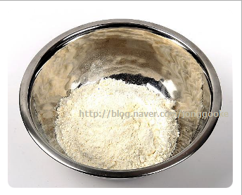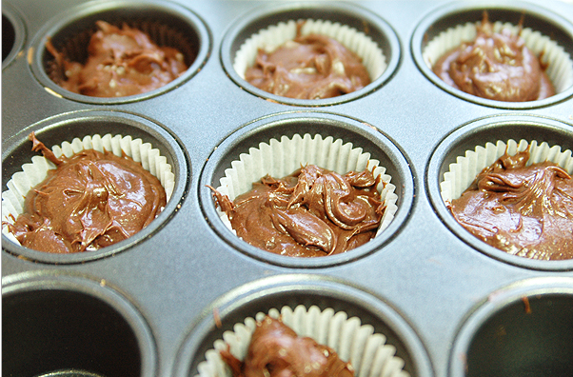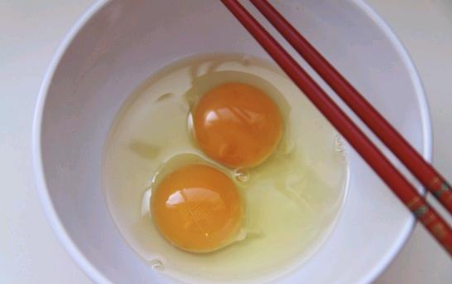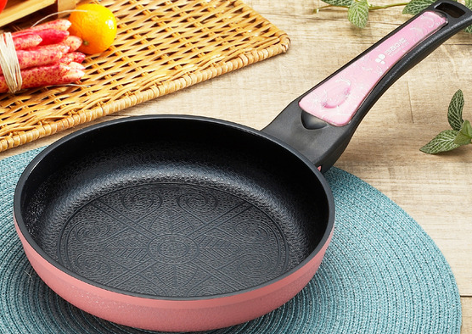
( ) ( ) ( ) ( )

- Put the instructions in the correct order from 1-5.
- Mix the dry ingredients. ( )
- Pour some batter into the pan. ( )
- Beat the egg. ( )
- Mix the wet ingredients. ( )
- Pour the wet ingredients into the dry ingredients. ( )

- Match the parts that go together.
- First, mix (a) batter into a hot pan.
- Second, beat (b) milk and oil to the egg.
- Next, add (c) the egg.
- Then, pour (d) the flour, sugar, salt, and baking powder.

# Review worksheet
Let’s discuss your own recipes. What kind of food can you make?

# Answer Sheet (Dictation Worksheet)

W: Good morning, everyone!
Welcome to our third cooking class .
You all look very hungry , so I thought we should make breakfast .
A great way to start the day is with pancakes .
So, let’s get started . First, Mix one cup of flower ,
one tablespoon of sugar , one teaspoon of salt ,
and two teaspoons of baking powder in a bowl .
Second, beat one egg in a separate bowl ;
add one cup of milk and two teaspoons of vegetable oil .
After mixing , pour the wet ingredients into the dry ingredients .
And whisk them together . Then, pour soem batter into a
hot pan and cook it for two minutes .
turn it over and cook the other side for a minute.
Finally, remove it from the pan and put the pancake.
on your plate . You should all try this for your family ! Enjoy.

# SCRIPT
W: Good morning, everyone! Welcome to our third cooking class. You all look very hungry, so I thought we should make breakfast. A great way to start the day is with pancakes. So, let’s get
started. First, mix one cup of flour, one tablespoon of sugar, one teaspoon of salt, and two teaspoons of baking powder in a bowl. Second, beat one egg in a separate bowl; add one cup of milk
and two teaspoons of vegetable oil. After mixing, pour the wet
ingredients into the dry ingredients and whisk them together. Then, pour some batter into a hot pan and cook it for two minutes. Turn it over and cook the other side for a minute. Finally, remove
it from the pan and put the pancake on your plate. You should all try this for your family! Enjoy.

# Answer Sheet (WORDS WORKSHEET)
Match the word its right definition.
- Separate
- Beat
- Add
- Ingredient
- Whisk
- Tablespoon
- Teaspoon
- Flour

a) small spoon that you use to put sugar into tea or coffee
b) to beat food with a special utensil in order to add air and make the food light
c) to set or keep apart from something else
d) a mixture of flour, eggs, and milk that is used in cooking.
e) an item in a recipe
f) white or brown powder that is made by grinding grain
g) to make a regular movement
h) a fairly large spoon used for serving food in cooking.

- C 2)d 3) g 4)e 5)b 6)h 7)a 8)f

# Answersheet ( Listening Worksheet A, B, C)

- Listen and mark (X) that do NOT belong.

( ) ( X ) ( ) ( )

B. Put the instructions in the correct order from 1-5.
(a) Mix the dry ingredients. ( 1 )
- Pour some batter into the pan. ( 5 )
(c) Beat the egg. ( 2 )
(d) Mix the wet ingredients. ( 3 )
(e) Pour the wet ingredients into the dry ingredients. ( 4 )

C.Match the parts that go together.
1.First, mix (a) batter into a hot pan.
2.Second, beat (b) milk and oil to the egg.
3.Next, add (c) the egg.
4.Then, pour (d) the flour, sugar, salt, and baking powder.

1.d 2. C 3.b 4.a

# Review worksheet
Let’s discuss your own recipes. What kind of food can you make?

