Speaking Reading Grammar Listening

Topic: Home exchange for a holiday

Instructor:  Aimie | Level:  High Intermediate | Students:  14 | Length:  50 Minutes

Materials: Board and marker
Vocabulary Matching Worksheet (14 copies)
Writing work sheet (14 copies)
Reading articles1.2(14 copies each)
Pictures1.2 (14 copies each)

Aims:
- Ss will learn listening Skills by listening to group debating and discussion.
- Ss will learn speaking skills by discussing in groups or during pair work, debating, responding to teacher CCQs & questions.
- Ss will learn new vocabulary by completing the Vocabulary Matching Worksheet.
- Ss will learn reading Skills by reading the Vocabulary Matching work sheet and articles.
- Ss are able to debate about home exchange for a holiday.
- Ss can write about the advantages and disadvantages of home exchange for a holiday.

Language Skills:
Listening –Discussion and debating.
Writing skills - Writing work sheet.
Reading Skills –Reading the articles and vocabulary matching work sheet.
Speaking Skills - Debating, discussing, responding to teacher CCQs & question.

Language Systems:
Phonology – Discussion, Debating
Lexis – New vocabulary,
Function - Persuasion and Debating
Discourse - Discussion and Debating

Assumptions:
- Ss already know the teacher’s teaching style and how the classroom works.
- Ss are high intermediate level.
- Ss already know about the movie.
- Ss already have some idea of exchanging homes for a vacation.
- Ss will enjoy debating and sharing opinions.
- Ss are comfortable in the class.
- Ss can express ideas freely.

Anticipated Errors and Solutions
- Ss may confuse which side they will debate.
    - Solution: - Teacher can help to divide them for Pros and Cons.
- Ss may not be able to write about advantages and disadvantages of the topic.
    - Solution: - Teacher gives examples of the topic.
- Activity takes too long.
    - Solution: - Reduce the time for remaining activity or give time warning
- Activity finishes too soon
    - Solution: – additional questions or extend remaining activities
- Ss don’t know how to proceed debating.
    - Solution: – Teacher demonstrates how to start.
- Ss don’t understand the new vocabularies
    - Solution:-Draw it on the board or use L2 if it is needed.
erences:
YBY Taking club from Edubox.

Lead-In
Materials: Pictures
Article 1(romantic holiday)

Time | Set Up | Student Activity | Teacher Talk
4min | Whole Class  Whole class  Whole class | Ss observe and respond  Ss observe and respond  Ss observe and respond | Enter the classroom and greet students.  Hi everyone, how are you today?  It’s very hot today, isn’t it?  Summer vacation is coming up, right? Are you all having a holiday? Are you all excited about it?  Where do you go for a vacation? Where do you stay during the vacation? In a hotel or in a cottage? In the country or in the City?  How much do you normally spend for the accommodation? How do you feel if you pay so much for a hotel?  What would you do if there is a chance to save your accommodation fees and still enjoy your holiday?  Show them the picture of houses and say  “Do you want to stay this place for free? I guess everyone does”.  What do you think our topic will be today?  (Let them think about what will be the topic and let them guess for a while, and Ss answers will vary.)  That’s right. It is about Home exchange for a holiday.  Lets’ find out more about home exchange and how to get free accommodation and enjoy your holiday.  Show them the first article which is about “Romantic holiday.”

Pre-Activity
Materials: Vocabulary Matching Worksheet.
Articles 1.2 and picture
Board and markers

Time | Set Up | Student Activity | Teacher Talk
3 min  3min  3min | Whole Class  Individually  Whole class  Pairs  Whole class  Whole class | -Ss listen and respond  -  -Ss match the vocabulary  Ss respond  Ss discuss with their partner  Ss respond  -Ss answer the questions from the worksheet and correct them if necessary  Ss respond | So did anyone see this movie “Romantic holiday?”  Did you like the movie?  Today unfortunately we are not focusing on their romantic love story but we will talk about the idea of exchanging homes for a holiday.  Who watched this movie?  (Talk about this movie for a while and let Ss talk freely about the movie).  Did you like it? I guess some people don’t know about the movie, so I brought an article.  But before we read this short article we will learn new vocabulary to help you understand.  Distribute the work sheet and 2 articles.  Instruction  Ok. First you have a vocabulary work sheet to complete individually in 3 minutes. Match the left side of the words to the right side of meanings. Find the best answers. After you finished the paper you will discuss about the answers with your partner and then read the articles.  -CCQ  “How much time do you have?”  “What do you have to do with the paper?”  “Are you working with someone?”  “What do you have to do after completing your answer?’  Monitor discreetly and answer students if they ask questions. Give time warning before 30seconds left  - Now work as a pair to share the answers and discuss why they choose these answers.  -CCQ:“Who is your partner?”  “How much time do you have?”  “What are you going to do with your partner?”  Write new vocabulary on board and go over the worksheet and Ss answers and correct the answers  Exchange  Hospitality  Unfaithful  Impulsively  Destination  Legendary  Inspiration  Condominium  Automobile  Unfamiliar  Nomadic  Conceivably  CCQ:Have you exchanged something with your friend? What was that?  Can you buy destination in the store?  Did you have anyone unfaithful to you?  Do you have an automobile.

Main activity
Materials: Board and markers
Work sheet 2 (14copies)
Articles 1.2

Time | Set Up | Student Activity | Teacher Talk
7min  3min  5min  1 min  10min  5min | Whole class  Individually  Whole class  Pairs  Whole class  Groups  Groups  Groups  Whole class  Groups  Whole class | Ss listen, response and questions as they need.  Ss listen  Ss respond  Ss discuss their answers with the partners  Ss respond one by one  Ss divided as a group  Ss respond  Ss form three groups  Ss respond  Ss meet with their group and discuss reasons to support their team’s opinion, write down their opinions; each one has chance to debate and support the debate.  Two groups debate actively and  Juries listen carefully and take notes.  Debate concludes.  Students listen and respond.  J  Juries speak out their opinion one by one.  Congratulate the winning team | Teacher reads the articles (romantic holiday and home exchange) and does the “pop corn” to the Ss, talk about the reading articles for a while and distributes writing work sheet.  Instruction  Now, here is writing paper. In this paper you have to write the answers individually and write about advantages and disadvantages of exchanging homes for a holiday at least 3 points each. You have 6 minutes to write.  CCQ:  How many minutes do you have?  Are you working alone?  What are you going to do?  Can you write two points for the advantages and the disadvantages?  Monitor discreetly and answer students if it’s necessary  And give them time warning.  Now everyone, discuss with your partner and check your answers. You have 2 minutes.  CCQ  How many minutes do you have?  Are you working alone?  What are you going to do?  Instruction  Teacher asks answers to students and writes down on the board.  Students answer one by one.  What is home exchange?  What are the two types of home exchange?  Student A, what is the advantage of exchanging homes for a holiday?  Student B, what is the disadvantage of exchanging homes for a holiday?  Divide Ss into three groups  Teacher writes the statement on the board.  “The best way to save money and enjoy your holiday is home exchange”  One group is for Pros, another group is for Cons and the other team is for Juries (5 students are for pros, 5 students are for cons, and 4 students and the teacher is a judge). If it is necessary teacher form a group to save time)  CCQ: What team are you in?  What do you have to do?  Instruction  Give 4 minutes for teams to meet and discuss reasons to support their team’s opinion. Encourage them to write down their opinions. Each member has to support their team and debate actively; each member decides when is their turn to debate. But on the other hand the juries’ team will sit down, watch and listen, take notes and scores while the debates are on.  CCQ: What will you write down?  How much time do you have?  What will you discuss?  Set up for argumentative style debate.  Conduct debate. Pro side goes first then con side. Each team has 5 minutes to support their position and convince the juries.  Teacher monitor and give time warning as needed.  Congratulate and thank students for their active participation.  Did you enjoy debating? Now it is time to finalize which team is the winner?  CCQ:  How much time do you have?  What are you going to do?  Now it’s time for juries speak out.  Based on the debate juries speak their opinion one by one.  Figure out which group is the winning team and congratulate the winning team,

Post Activity
Materials: Board and Marker
Picture of home exchange

Time | Set Up | Student Activity | Teacher Talk
5min | Whole class  Whole class | Students listen and response  Students listen and response | Conclude lesson  Distribute picture  This is information about home exchange.  There is a website you can have a look at it if you are interested in.tak about the copy of the website.  Talk about the Ss’ summer vacation plan freely.  Would you exchange your homes for a holiday? Why or why not?  Elicit today’s vocabulary for Ss  Give homework:  Ss write about your plan for this summer vacation.  “Ok, everyone did so well for the class, how do you feel about debating? How did you feel when someone has opposite opinion from you? Was it fun?  See you guys tomorrow, Bye  Close the class.
Vocabulary Matching Worksheet

Exchange |  | Give to one another, give to each other, and swap.
Hospitality |  | Friendly welcoming behavior towards guests or people you have just met.
Unfaithful |  | Have a relationship with someone else.
Impulsively |  | Do things suddenly without thinking about them carefully first.
Destination |  | The place to which they are going or to be sent.
Legendary |  | Someone people are very famous and that many stories are told about them.
Inspiration |  | Feeling of enthusiasm you get from someone or something.
Condominium  Alternative |  | An apartment in building which each apartment is owned by the person who lives there.  The first can be found, used or done instead of second.

Automobile |  | A car.
Unfamiliar |  | You know nothing or very little about it, because you have not seen or experienced before.
Nomadic |  | People travel place to place rather than living in one place at all time.
Conceivably |  | You can imagine it or believe it.

Article 1
In Nancy Meyer' The Holiday, a romantic comedy from the director of Something's Gotta Change and What Women Want, two women trade homes only to find that a change of address can change their lives.
Iris (Kate Winslet) is in love with a man who is about to marry another woman. Across the globe, Amanda (Cameron Diaz), realizes the man she lives with has been unfaithful. Two women who have never met and live 6000 miles apart, find themselves in the exact same place. They meet online at a home exchange website and impulsively switch homes for the holiday. Iris moves into Amanda's L.A. house in sunny California as Amanda arrives in the snow covered English countryside. Shortly after arriving at their destinations, both women find the last thing either wants or expects: a new romance. Amanda is charmed by Iris' handsome brother Graham (Jude Law) and Iris, with inspiration provided by legendary screenwriter Arthur (Eli Wallach), mends her heart when she meets film composer Miles (Jack Black).

I

I

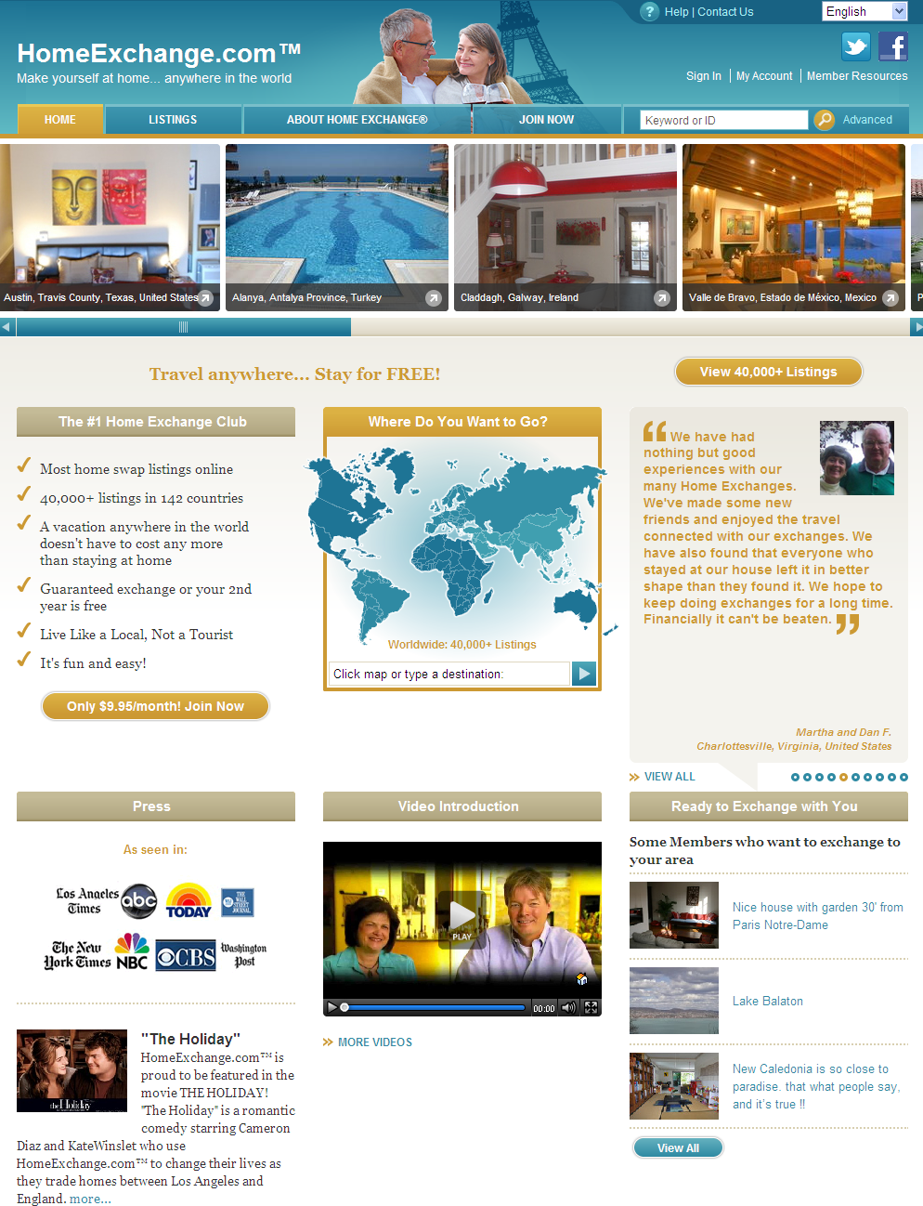
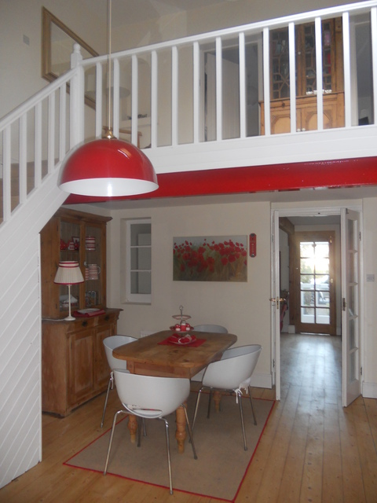

Article 2

What is Home Exchange?
Home Exchange is the vacation alternative where you stay in my house and I stay in yours.
There are two types of exchanges: home exchange and hospitality exchange.
Home exchangers trade their homes, condominiums or apartments at a time that is convenient to both parties, but these are not the only types of accommodations that one gets to choose from. For example, one exchanger traded his home for a 40-foot yacht. Another couple swapped their villa in Italy for a RV in Oregon because they had always wanted to tour the U.S. in true nomadic style. Often, home exchangers will include their automobiles as part of the package.
Hospitality exchangers, on the other hand, host each other in their homes at designated times. Your home exchange partners stay with you as guests and then you go and stay with them as their guests. There is a social aspect to this kind of exchange that some exchangers particularly enjoy. Conceivably, you also get a built-in tour guide with this mode of exchange.
If the idea of home exchange is unfamiliar to you, or even a bit frightening, rest assured -- there are 250,000+ successful home exchanges every year. Swapping homes can bring many unexpected rewards. Just consider the following benefits:
- You get a much closer look at other cultures. You get a "feel" for the places you visit
- The connections you make with your home exchange partners can turn into friendships
- If you're doing a home exchange, your home is being cared for while you're away
- More flexibility and freedom. You can prepare meals at home, and come and go as you please
- It's a free place to stay
- You've got more privacy
Every exchange is unique and the whole concept of home exchange relies on building
Work sheet 2
- Have you ever thought about exchanging your home for a holiday just like the movie romantic holiday?

- What is home exchange?

- What are the two types of exchange?

- Which do you prefer to stay and why?

- Please write about the advantages and the disadvantages of exchanging homes for a holiday.

