Listening script

First Paragraph: Snorkeling
Snorkeling is an easy and fun swimming activity that can be done at just about any beach or coastal area in the world. The equipment is inexpensive and portable, the skills required minimal, and the activity very safe. Furthermore, snorkeling serves as a good gateway activity for SCUBA diving.
Snorkeling is a popular recreational activity that allows a swimmer to observe sea life with a minimum of equipment and training, and the same degree of safety as regular open sea swimming.
The minimum basic equipment for snorkeling is a dive mask, swimming fins, and a snorkel.
Snorkeling basically consists of swimming on the surface, using the mask to look down and see what is going on in the waters below while breathing through the snorkel. An intrepid snorkeler can combine this with skin diving, quickly kicking down to depths of up to 5 meters for a brief closer look. Snorkeling is also employed by scuba divers when on the surface, and search and rescue teams may snorkel as part of a water-based search.

Second Paragraph: Flowboarding
Never heard of flowboarding before? That's okay! Not a lot of people have. That's why I'm here to tell you all about it. Have you ever been skateboarding, snowboarding, surfing, or skiing? Well, this sport is nothing like those other ones, but at the same time, a combination of them all! Flowboarding involves riding a bodyboard on an artificial wave and doing tricks. It is becoming an increasingly popular sport and is quite fun!
Flowriding is a sport for everyone.
Although it may look quite simple at first glance, the sport is more difficult than you think. It took me quite a few times before I was capable of staying on the wave, and many times more than that before I could do a trick. You may not get it your first time, but it's crucial that you keep practicing so that you can find the right balance that keeps you on the wave.

Third Paragraph: Underwater Hockey
The British Navy invented underwater hockey in the 1950’s. Underwater hockey also called Octopush and it is a global non-contact sport in which two teams compete to maneuver a puck across the bottom of a swimming pool into goals.
Underwater hockey is played in a pool and the game consists of 15 minute halves and a three minutes half time. Two teams of up to ten players compete, with six players on each team in play at once. The remaining four players are continually substituted into play from a substitution area, which may be on deck or in the water outside the playing area, depending on tournament rules.
Players wear a diving mask, snorkel and swimfins, and carry in one hand a short stick for playing the puck.
Picture 1

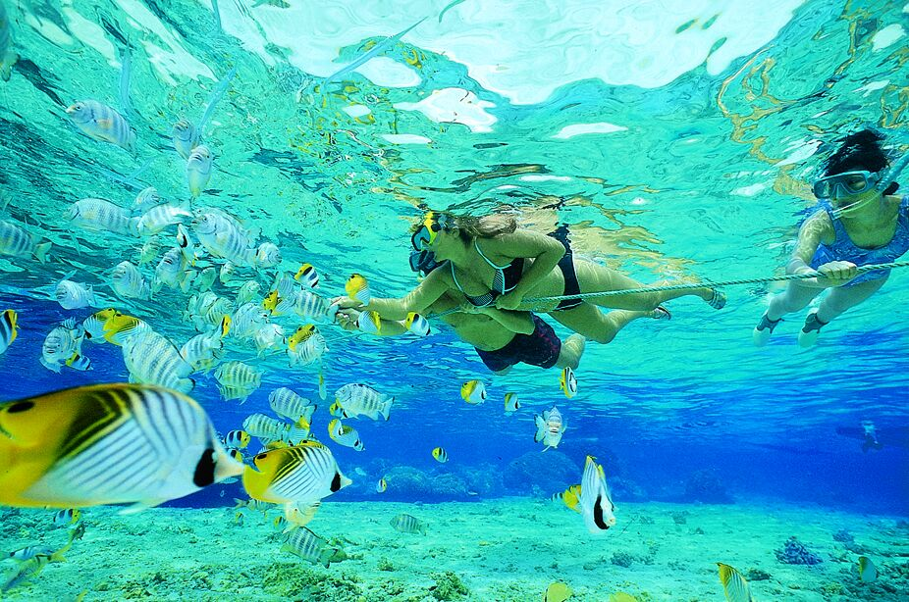

Picture 2

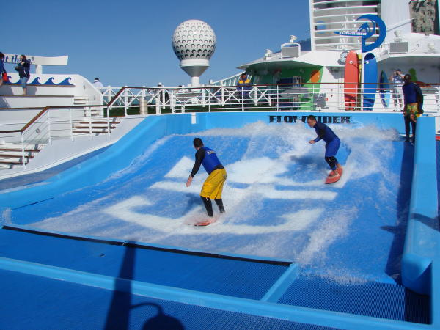
Picture 3

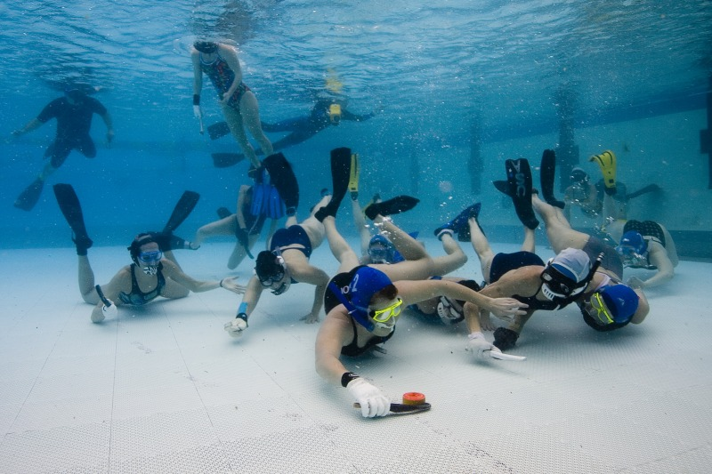

WORKSHEET #1

1.)
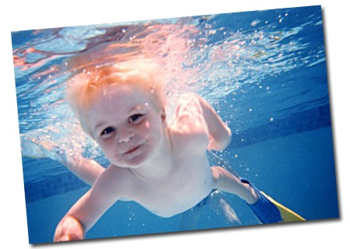

2.)

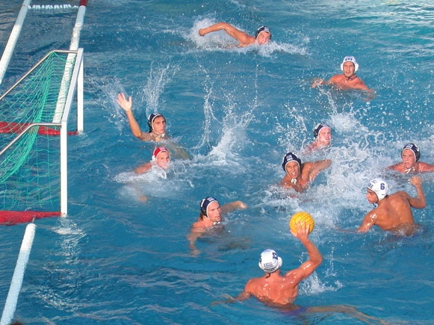

3.)

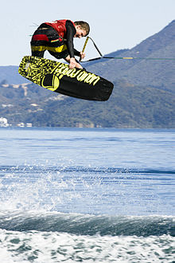

4.)

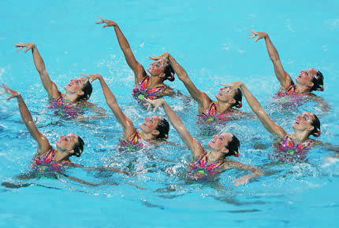

5.)

6.)

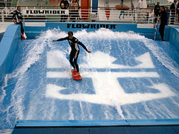

7.)
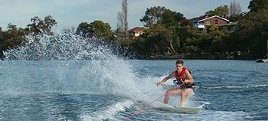

8.)

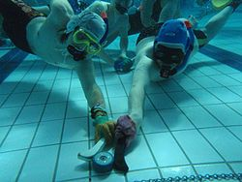

9.)

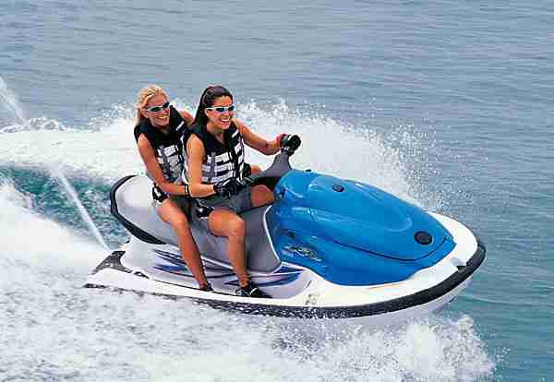

10.)

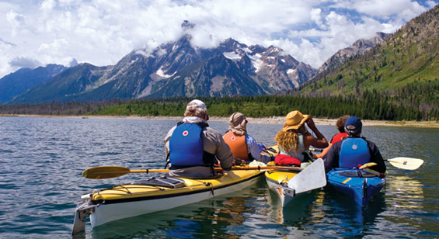

11.)

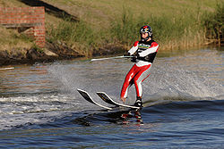

12.)
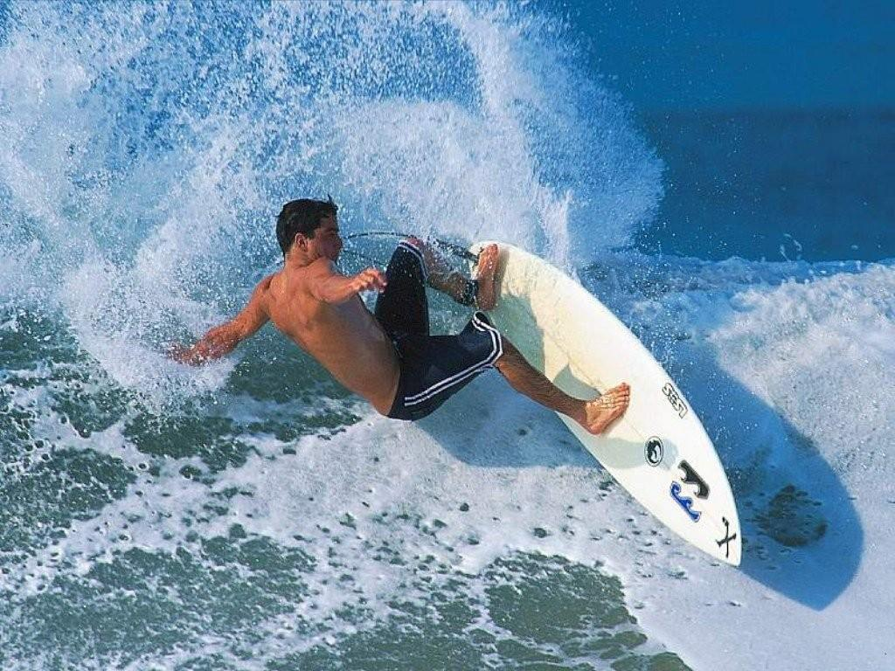

NAME LIST OF WATER SPORTS

- DIVING
- UNDERWATER HOCKEY
- JET SKING
- KAYAKING
- SURFING
- FLOWBOARDING
- WATER POLO
- SYNCHRONIZED SWIMMING
- SWIMMIMG
- WAKEBOARDING
- SKURFING
- WATER SKIING

WORKSHEET #2
First Paragraph:

Question 1: Where can people enjoy this activity?

Question 2: What basic equipments are necessary?

Question 3: what basic skills do people need this activity?

Question 4: who can be a guide of this activity?

Question 5: what is the name of this sport?

Second Paragraph:

Never heard of flowboarding before? That's okay! Not a lot of people have. That's why I'm here to tell you all about it. Have you ever been skateboarding, snowboarding, surfing, or skiing? Well, this sport is nothing like those other ones, but at the same time, a combination of them all! Flowboarding involves riding a bodyboard on an artificial wave and doing tricks. It is becoming an increasingly popular sport and is quite fun!
Flowriding is a sport for everyone.
Although it may look quite simple at first glance, the sport is more difficult than you think. It took me quite a few times before I was capable of staying on the wave, and many times more than that before I could do a trick. You may not get it your first time, but it's crucial that you keep practicing so that you can find the right balance that keeps you on the wave.

Third Paragraph:
The British Navy invented underwater hockey in the 1950’s to keep their divers fit and to improve their ability to move and work efficiently under water. The game came to Australia shortly after and has evolved into a fast dynamic sport played in more than 20 counties.
Underwater hockey is played in a 25m x 15m pool that is between 1.8 and 3 m deep. The game consists of 15 minute halves and a three minute half time. Each team is allowed 1 60 second time out per half. The game clock stops for any infringements in the last 2 minutes of the game.
Each side has 12 players, 10 of who can play in any one game. During the game 6 players are in the pool with 4 interchange players on the side who can sub at any time. The players wear large fins, a diving mask and snorkel and a thick glove made from latex to protect the hand from the pool bottom and the puck. The bats are made of wood and are about 25cm long, they usually have one straight edge for flicking the puck and the back edge is usually curved for hooking the puck. The top players can flick the puck well over 3m and it comes off the bottom enough to go over another player.

