Speaking Lesson Plan
Topic: Giving advices

Instructor:  Hannah | Level:  Upper Intermediate | Students:  8 | Length:  40 Minutes

Materials:
Board& board marker, tape
Realia (news article, picture of Alcatraz)
Worksheets
grouping (paper, cup)

Aims:
Main Aim: To enable Ss to improve their speaking ability by discussing and doing a role-play about “giving advices”
Secondary Aim: Ss learn modal through the worksheets.
Personal Aim: I want to give an energetic and interesting lesson.

Language Skills:
Listening: listening to the teacher’s instructions, discussion, role-play
Reading: reading the worksheets
Speaking: sharing ideas with partners, discussion, role-play
Writing: writing on the worksheets

Language Systems:
Phonology: listening to the new words and practicing
Lexis: learning new vocabularies ( act one’s age, cruel, qualification)
Grammar: modal (should, must)
Function: give advices, suggestions
Discourse: none to discuss.

Assumptions:
Ss might have seen counseling section in the newspaper, magazine.
Ss might have some problems and want to get advices.

Anticipated Errors and Solutions:
If Ss do not understand key vocabularies
- Tell Ss synonyms, antonyms and check through CCQ.
If Ss need more time to finish their activity (cut-off plan)
- Be flexible with the time. Give Ss more time to finish their activity and cut off the time of post activity and assign that as homework.
If Ss finish their activity early (SOS plan)
- Give Ss more time for the discussion and role-play.

References:
http://www.usatoday.com/
Headway books.

Lead-In
Materials: realia(news article)
Time | Set Up | Student Activity | Teacher Talk
3min | Whole class | San Francisco.  Alcatraz. | Procedure:  Greeting:  Hello, everyone.  How are you feeling?  Last night, I read some articles on the newspaper.  Do you know where the movie ‘The rock’ background is?  Yes, there’s also a prison where a lot of notorious criminals were imprisoned.  The article said there were night tours in Alcatraz. It sounds spooky, isn’t it?

Pre-Activity
Materials: worksheet, board& board marker, tape
Time | Set Up | Student Activity | Teacher Talk
4min  4min  2min | individually  mingle  individually | Ss respond. | Procedure  Demonstration  I have some problem.  My car is making funny noise.  What should I do?  Yes. I have to send my car for repairs.  (tape the worksheet on the board)  Instruction  Write your 7 problems on your paper.  You have 3 minutes.  ICQ  What are you going to do?  How many problems do you have to write?  How many minutes do you have?  (monitoring & time management)  You have 1 minute.  Ok. Please, stand up with your paper  and pencil, and get some advices  from your friends.  You have 4 minutes  ICQ  What are you going to do?  Are you working alone?  (monitoring & time management)  Ok. Can you tell us what advice your friends give you?  Ok. Good job, everybody.

Main Activity
Materials: worksheets, grouping (paper, cup)
Time | Set Up | Student Activity | Teacher Talk
2min  8min  10min | Whole class | Act one’s age  Cruel  1minute | 1.Eliciting  It is an idiom.  To behave in a manner appropriate to one’s maturity. Suitable for one’s age.  What do we call it?  CCQ  Does ‘act one’s age’ mean acting unreasonable? = no  Reasonable? = yes  This word start with c, its synonyms are brutal, barbarous, bitter, ferocious, evil, harsh, etc.  CCQ  Is cruel kind to others? = no  unkind = yes  2.role-play  Instruction  In the newspapers, magazines there were counseling section. People write in with a problem, and other members of the public give their advices. Read the problems. You have I minute.  ICQ  How many minute do you have?  (grouping& arrange seating)  What advice would you like to give?  Think about your partner and make some role-play. You have 8 minutes.  ICQ  What are you going to do?  How many minutes do you have?  Ok. Who goes first?  (role-playing)  Very good, everybody did a good job.

Post Activity
Materials: worksheet, board& board marker
Time | Set Up | Student Activity | Teacher Talk
3min  3min | In pairs | Read and answer. | Instruction  (hand out worksheets)  (grouping with advice)  Read and then answer the questions  with your partner. You have 3minutes.  ICQ  What are you going to do?  Are you working alone?  How many minutes do you have?  (monitoring & time management)  Now, can you write down answers on the board?  Good job, everybody.  What did we learn today?  (error correction)  Do you have any questions?  Goodbye to Ss  This is it for today. Everybody did good job.  I hope you enjoyed this class.  See you tomorrow. Bye.

PROBLEMS, PROBLEMS

Problems | Suggestions
You have these problems……… | Your friends give some advices.

Realia

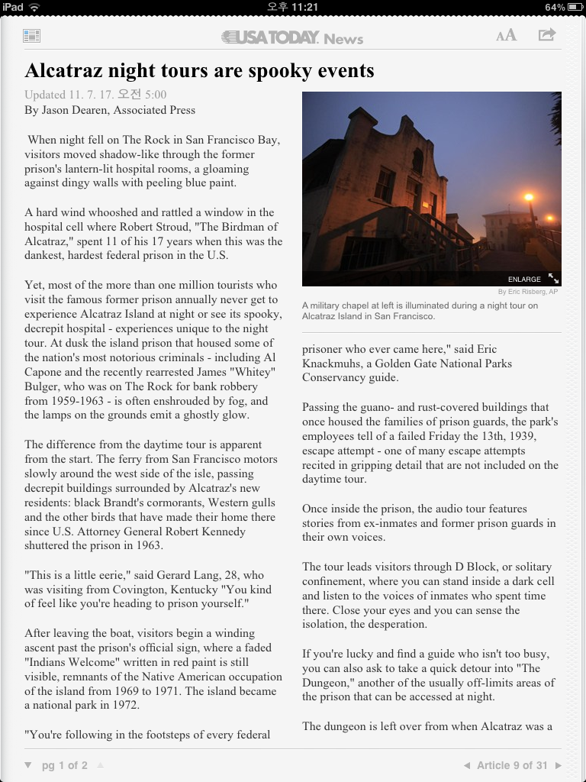
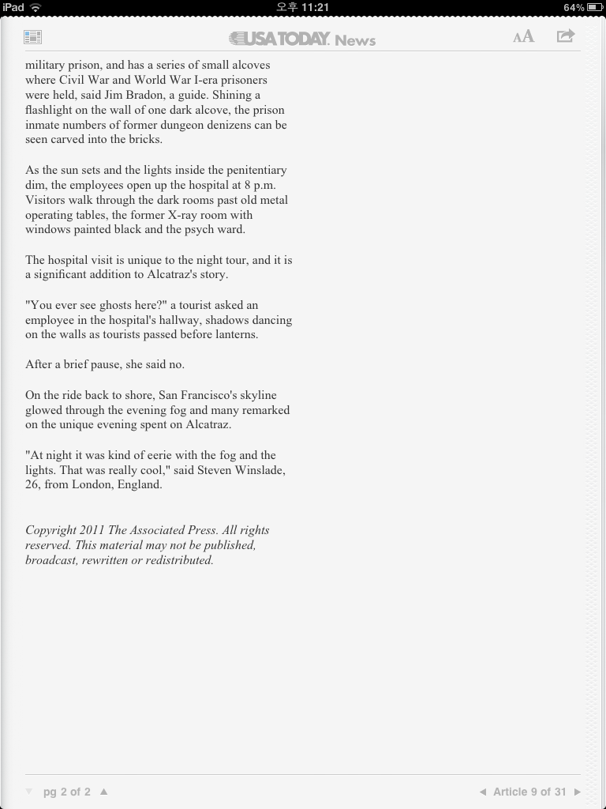

Worksheet

