Name: Jin Suk Choi Date: 07/30/11 Length of lesson: 20/30/40/50/60

Zoo and Animals
Class Profile: There are five advanced level adult English learners. Mixed ages.  L1 language is Korean. Everyone is here earning their TESOL certification. | Lesson Fit: This is the reading lesson which students will improve their reading skills by reading a text and understand some new vocabularies through teacher’s explanation.
Materials: Board, markers, worksheet. Reading texts.
Main Aim: To enable students to read fluently and learn new concepts through the poem prepared.

Secondary Aims: To enable students to learn new words and apply to their daily English through learning from teacher by CCQs and elicitation.

Personal Aims: I want to time manage better and be a little bit more serious when teaching a class.
Anticipated Problems:  The class might have a hard time understanding the poem  Students might have trouble filling in the worksheets.  Activities might take too long than I expected.  Language Skills:  - Listening: Ss will listen to the teacher’s instructions and their classmates’ speaking.  - Speaking: Ss will practice their speaking by reading the poem given.  - Reading: Ss will read out loud the poem and understand the context.  -Writing: jot down notes about the words they didn’t understand.  Language Systems:  - Phonology: None to discuss  - Lexis: elk, caribou, vine lasso, gander, etc.  - Grammar: none to discuss  - Function: none to discuss  -Discourse: Animal and zoo. | Solutions:  Teacher will go over it together and explain the parts Ss don’t understand while reading.  Teacher will give time to share answers by group works after filling in the worksheet alone.  Teacher will give time warning to students.  Assumptions:  Students already know:  - Ss have basic knowledge of animal.  - Ss have basic knowledge of poem that the author has a internal meaning to the context.

References
- Falling Up: Shel Silverstein
Time  Interaction  2 Min  T-Whole Class  or T-WC  5 Min  T-WC  2 Min  T-S  4 Min  S-S  5 Min  T-WC  5 Min  T-WC  5 Min  T-WC  3 Min  T-WC |  | Stage  Lead-in  (Pre-Activity)  (Main-Activity)  Pre-teach  Controlled Practice  Controlled Practice  Post-Task)  Controlled  Practice  Feedback  Error Corrections  Wrap up | Objective  To activate the Ss schemata. Ss will grasp today’s lesson topic.  Eliciting: Teacher will elicit the topic of today’s lesson  Students will share their favorite animal each other.  Teacher will hand out some passage related to today’s topic  Teacher will teach some lexis in the passage that Ss might not understand  Ss will read the passage together with the teacher  Ss will answer some questions related to the poem that they just read.  Ss will be grouped in pairs and discuss what they would like to be if they are animals.  Teacher will provide feedback | Procedure  Teacher greets everyone.  “Hello, how was everyone’s weekdays?”  The teacher will start the class by asking students about their favorite animal starting with the teacher’s favorite animal.  “My favorite animal is polar bear because…”  Teacher will elicit the word ‘zoo’ by showing some pictures that relate to zoo.  “What is the place called which is related to these pictures? The hint is that a lot of children go and see their favorite animals.”  “What is your favorite animal?”(pointing at few people)  The teacher hand out a poem related to animals and zoo to improve their reading skills  The teacher will use the whiteboard and jot down some words that Ss might not know and try to elicit the meaning of those words. For vocabularies that are names of animals, teacher will explain with a picture.  (elk, caribou, vine lasso, gander)  Lasso: a rope to tie cows or horses/cowboy rope  Gander at ~: to look at ~  Teacher will start off with the first line and each student reads one line each.  Teacher will write down some questions related to the poem and let Ss answer the questions in pairs.  What teacher will write on the board.  “What is the topic of the poem?”  “What does the first two lines on the last paragraph mean?”  Ss will be discussing about what they want to be if they become an animal and share with other mates and explain why they want to be that specific animal.  (ICQs)  “What are we doing now?”  “Are we working individually?”  “How many minutes do we have?”  Teacher will provide feedbacks and if any, have some error correction time and wrap up.
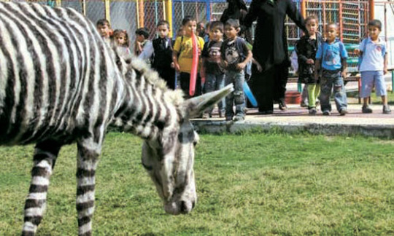

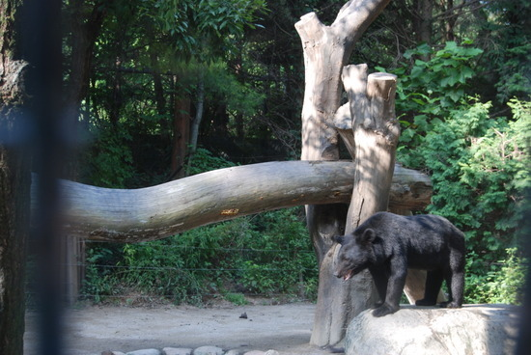
Elk (moose
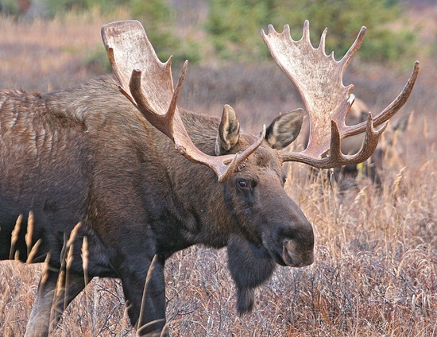

Caribou
