Grammar Lesson Plan
Topic: I am going to….

Instructor:  Hannah | Level:  Upper Intermediate | Students:  8 | Length:  30 Minutes

Materials:
Picture, tape, cue cards
board& board marker
wall chart
worksheets

Aims:
Main Aim: To enable Ss to improve their grammar ability by practicing future tense “be going to”.
Secondary Aim: Ss learn future tense through the variations of drills.
Personal Aim: I want to improve time management.

Language Skills:
Listening: listening to the teacher’s instructions, other Ss’ presentation
Reading: reading the worksheets
Speaking: practicing variations of drills, sharing ideas with partners
Writing: writing on the worksheets

Language Systems:
Phonology: listening to the new words and practicing
Lexis: learning new vocabularies (intention, arrange)
Grammar: future tense (be going to….)
Function: asking future plans
Discourse: none to discuss

Assumptions:
Ss might want to know how to express future plans.

Anticipated Errors and Solutions:
If Ss do not understand key vocabularies
- Tell Ss synonyms, antonyms and check through CCQ.
If Ss need more time to finish their activity (cut-off plan)
- Be flexible with the time. Give Ss more time to finish their activity and cut off the time of post activity and assign that as homework.
If Ss finish their activity early (SOS plan)
- Give Ss more time for the discussion and practicing drills.

References:
Headway books.
Essential Grammar in Use

Lead-In
Materials: pictures, board& board marker
Time | Set Up | Student Activity | Teacher Talk
2min | Whole class | . | Greeting  Hello, everyone.  How are you feeling today?  Last night, I made reservation for a hotel. Because I am going to go to the Cebu to get a skin scuba license.  (point out Cebu on the map)  Cebu is a city in Philippine.  (show Ss pictures of skin scuba)  (write on the board “ skin scuba”)  After vacation, I am going to get a job.  Actually I am worried about that, but carpe diem!!  I will enjoy at the moment without concern for the future.

Pre-Activity
Materials: board& board marker, wall chart
Time | Set Up | Student Activity | Teacher Talk
5min | Whole class | Ss tell about their plans.  no  yes | Instruction  We only have 5 classes left.  We will finish this TESOL course next  Week. I am already so sorry about  that.  And I wonder what you are going to do  after this course.  Could you tell us your plans after this  course?  (write on the board  I am going to _____ )  Ok. Thanks for sharing your plans.  Did you tell about what you did?  Then did you tell what you will do?  (draw time line on the board)  (elicit “future”)  Today we are going to learn about future tense especially be going to.

Main Activity
Materials: wall chart, board& board marker, cue cards
Time | Set Up | Student Activity | Teacher Talk
5min  12min | Whole class | He is going to drive the car.  He is going to drive the bus.  She is going to have breakfast.  She is going to drink a cup of coffee.  We are going to go to school.  We are going to go to the library. | 1. Meaning  “be going to” is used when we decided to do it, my intention is to do it  but perhaps not arranged to do it.  Intention means a carefully calculated plan.  Intention’s synonym is purpose.  CCQ  Does intention act instantly  (by accident)? = no  Does intention have in mind something to do? = yes  Arrange means to prepare or plan.  2. Drill  1) substitution drill  Here are some sentences. Listen and repeat.  He is going to drive the car.  Can you change the car into the bus?  She is going to have breakfast.  A cup of Coffee.  We are going to go to school.  Library.  2) making sentences  (grouping with be going to)  (gesturing)  Be is here.  Going is here.  To is here.  We can use infinitive form to tell why.  For example,  I am going to France because I want to learn cooking.  we can change this sentence to  I am going to France to learn cooking.  Instruction  Make some sentences with your partners. You have 5minutes.  ICQ  What are you going to do?  Are you working alone?  How many minutes do you have?  (monitoring & time management)  Now tell the sentence what you wrote.  Ok.good.

Post Activity
Materials: worksheet
Time | Set Up | Student Activity | Teacher Talk
5min | In pairs |  | Instruction  (hand out worksheets)  (grouping )  Read and then answer the questions  with your partner. You have 2minutes.  ICQ  What are you going to do?  Are you working alone?  How many minutes do you have?  (monitoring & time management)  Now, tell the answers of the questions.  Good job, everybody.  (error correction)  Do you have any questions?  Be going to = gonna  In the movie “Kungpu panda”  Master ugway said  “Yesterday is history, tomorrow is mystery, today is gift.”  Goodbye to Ss  This is it for today.  I hope you enjoyed this class.  See you tomorrow. Bye.

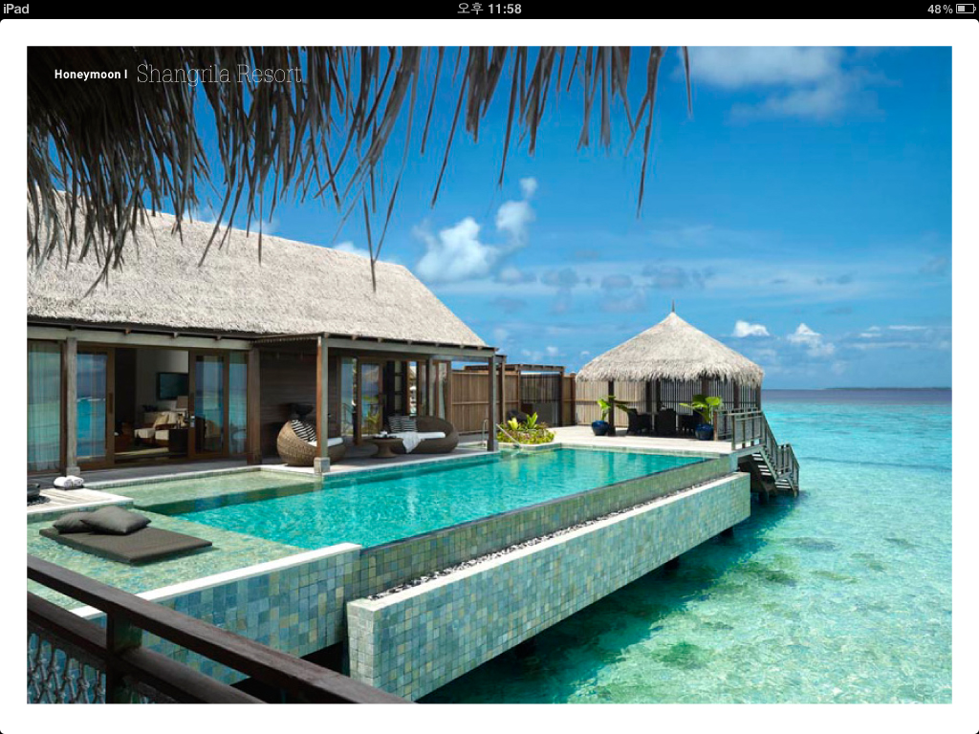

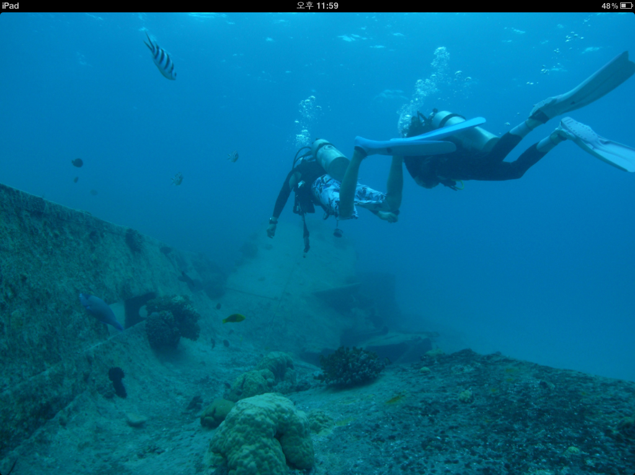

Make sentences using infinitive.

I am going to go to the toilet to____________________________________________.

She is going to turn on ____________ to ___________________________________.

He is going to borrow _____________ to ____________________________________.

I am going to go shopping to ______________________________________________.

I want to see the world!

- Match the places and activities.

Nepal fly over the Grand Canyon

Brazil climb Mount Everest

The Great Barrier Reef take photograph of the lions

China walk along the Great Wall

Hawaii go scuba diving

Alaska visit the rainforest

The USA watch whales

Kenya go surfing

drive the car

bus

have breakfast
a cup of coffee

go to school

library

