Reading Lesson Plan
Topic: Compulsory cooking classes in UK

Instructor:  Hannah | Level:  Advanced | Students:  8 | Length:  30 Minutes

Materials:
Pictures, tape,
board& board marker
worksheets
wall chart

Aims:
Main Aim: To enable Ss to improve their reading ability by reading a news report about “compulsory cooking classes in UK”
Secondary Aim: To enable Ss to improve writing ability by writing a recipe.
Personal Aim: I want to give a professional and passionate lesson.

Language Skills:
Listening: listening to the teacher’s instructions, other Ss’ presentation
Reading: reading a short news report
Speaking: sharing ideas with partners
Writing: writing a recipe

Language Systems:
Phonology: listening to the new words and practicing
Lexis: learning new vocabularies
Grammar: the imperative mood ( for example, chop the onions)
Function: none to discuss
Discourse: none to discuss

Assumptions:
Ss might have their own recipes.
Ss might think healthy food is important for their health.

Anticipated Errors and Solutions:
If Ss do not understand key vocabularies
- Tell Ss synonyms, antonyms and check through CCQ.
If Ss need more time to finish their activity (cut-off plan)
- Be flexible with the time. Give Ss more time to finish their activity and cut off the time of post activity and assign that as homework.
If Ss finish their activity early (SOS plan)
Give Ss more time for the discussion and practicing drills.

References:
http://www.bbclearningenglish.com/newsenglish

Lead-In
Materials: pictures, board& board marker
Time | Set Up | Student Activity | Teacher Talk
2min | Whole class |  | Greeting  Hello, everyone.  How are you feeling today?  This is our last micro teaching!! Yea.  So let’s enjoy our last micro teaching!  Couple of weeks; I saw that Edward kwon, a famous chef, appeared on a talk show.  I thought he is very gentle, but he is known for his biting tongue in the kitchen. He is equal to Gordon Ramsay  of hell’s kitchen.  (show the pictures)  Biting tongue means malicious, stinging, and venomous (poison).  (write words on the board)  CCQ  Does biting tongue mean generous?  = no  Does biting tongue mean bitter, harsh? = yes  He was yelling at cooks, most shocking scene was he took out a pepper in the trashcan and ate it as he scolded for wasting ingredients.

Pre-Activity
Materials: board& board marker, worksheet
Time | Set Up | Student Activity | Teacher Talk
5min | In pairs |  | Instruction  These days people more concern about healthy life: like well being, organic, slow food.  What makes you healthy?  What are the good things for health?  I will give you worksheets; write good or bad things for health with your next person. You have 3 minutes.  ICQ  What are you going to do?  Are you working alone?  How many minutes do you have?  (monitoring & time management)  Now, can you tell us what you think?  (write what Ss tell on the board)  Thanks for sharing.

Main Activity
Materials: worksheets, board& board marker
Time | Set Up | Student Activity | Teacher Talk
3min  5min  10min | individually |  | (hand out worksheet)  1. Read the text quickly, and circle the words you don’t know.  I will give you 2minutes.  ICQ  What are you going to do?  Are you working alone?  How many minutes do you have?  (monitoring & time management)  Now, come out and write 3 words you don’t know the meaning of the words.  lexis  Compulsory means mandatory, obligatory.  CCQ  Does compulsory mean optional?  = no  Does compulsory mean force to do something?  = yes  Obesity means extremely fat.  (show the picture)  CCQ  Does obesity mean slim? = no  mean heavy? = yes  Cookery means style of cooking.  Hands on means practical, making or doing something with your hands.  2. (grouping – organic)  Read the text again, and answer the comprehension questions with your partner. I will give you 5 minutes.  ICQ  What are you going to do?  Are you working alone?  How many minutes do you have?  (monitoring & time management)  Let’s check the answers.  Do you have any questions?

Post Activity
Materials: worksheet, wall chart
Time | Set Up | Student Activity | Teacher Talk
5min | individually |  | Instruction  Actually I am a bad cook; more correctly speaking I haven’t even tried.  All I can cook is fried rice, ramen, spaghetti, and gimbap, if my mom cook rice.  But these days I take an interest in cooking. Because I am old enough to cook, to be honest too old.  Are you good at cooking?  Do you have your own recipe?  We are going to write a recipe.  You have 4 minutes.  (hand out worksheets)  ICQ  What are you going to do?  Are you working alone?  How many minutes do you have?  (monitoring & time management)  Now, come out and tape the worksheet on the wall chart.  After class, check your classmates’ secret recipes.  (error correction)  Unscramble this letters. i c e p r e  Yes, right, it is a recipe.  Goodbye to Ss  This is it for today.  I hope you enjoyed this class.  Thanks for your participation.
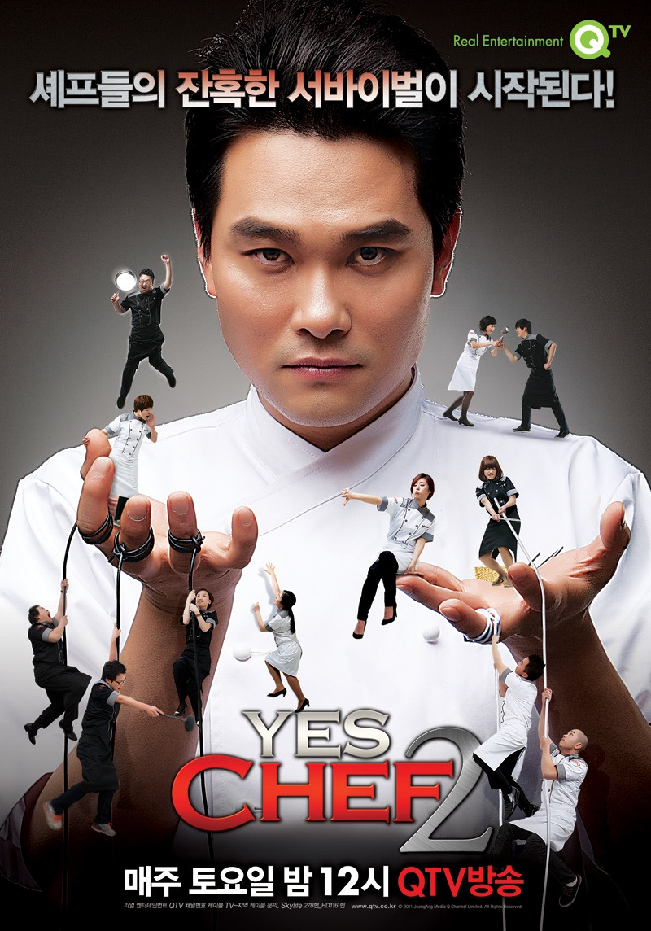

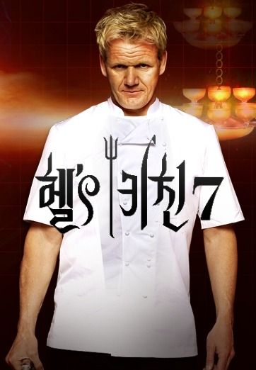

Compulsory cooking classes
English teenagers are to receive compulsory cooking lessons in schools. The idea is to encourage healthy eating to combat the country's obesity rate.
Cooking was once regarded as an essential part of education in England - even if it was mainly aimed at girls. In recent decades cooking has progressively become a minor activity in schools. In many cases the schools themselves have given up cooking meals in kitchens on the premises. But the rising level of obesity, has led to a rethink about the food that children are given and the skills they should be taught.
"What I want is for young people to be taught how to do basic, simple recipes like a tomato sauce, a bolognaise, a simple curry, a stir-fry - which they can use then at home and in their later life, experiment with, discover the joy of food, having got the basics under control." – Ed balls, minister in charge of schools.
The new lessons are due to start in September but some schools without kitchens will be given longer to adapt. There is also likely to be a shortage of teachers with the right skills, since the trend has been to teach food technology rather than practical cooking. Also the compulsory lessons for hands on cooking will only be one hour a week for one term. But the well known cookery writer, Pru Leith, believes it will be worth it.
"If we'd done this thirty years ago we might not have the crisis we've got now about obesity and lack of knowledge about food and so on. Every child should know how to cook, not just so that they'll be healthy, but because it's a life skill which is a real pleasure and we deny children that pleasure."
The renewed interest in cooking is primarily a response to the level of obesity in Britain which is amongst the highest in Europe, and according to government figures half of all Britons will be obese in 25 years if current trends are not halted.
Jon Devitt, BBC News

For your health

Good things | Bad things

My secret recipe

