**<worksheet>**

|  |  |  |  |  |  |
| --- | --- | --- | --- | --- | --- |
| Subject | English | Age | 6-7 | Name | / |

**\*Practice these sentences and put correct words in the blanks.**

**How does it feel?**

**This feels ……… .**

feeling

object

**This feels .**

feeling

**<objects>**

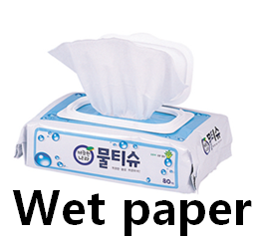 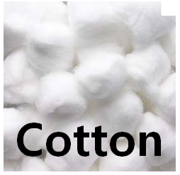 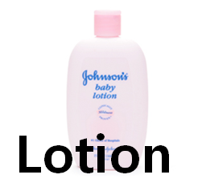 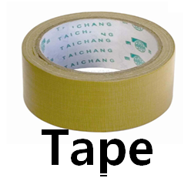

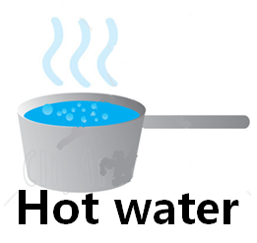 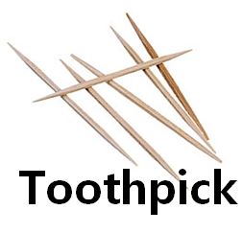 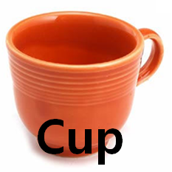

**<words>**

|  |  |  |  |
| --- | --- | --- | --- |
| hard | soft | hot | wet |
| slippery | sticky | sharp |  |