Worksheet-wrap up
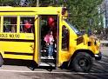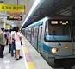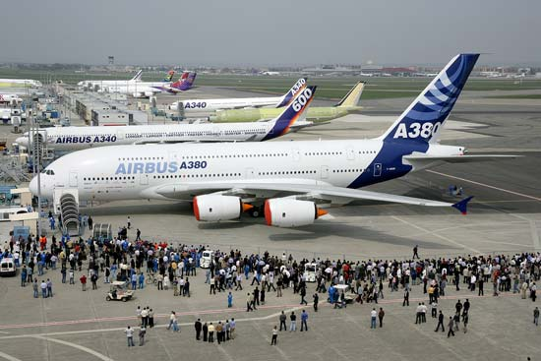

1. She will the 2. They will the train 3. They will the airplane

Complete the sentence.
4. get off, will, I, the bus

5. Will, the ship, on, we, get

6. at the airport, I, the airplane, on, will, get

7. in the Seoul station, off, he, get, will, the train

- Airport: you can get on/off the airplane in the airport.
- Seoul station: you can get on/off the train in the Seoul station.

