Topic - Colors

Instructor:  Kim, Sung Eun (kate) | Level:  Age 5-6  intermediate | Students:  8 | Length:  25min

Target Vocabulary:
- red, blue, yellow, orange, green, purple

Target Sentences:
- What color is it / fruit ?
- This color is color .
- This fruit is color .

Materials:
- color circles(big, small)
- flash cards (fruit)
- color cards
- watercolors(red, blue, yellow), water, cups, sticks
- 8 copies of worksheets

Aims/Objectives:
- Be aware of vocabulary and expressions related to colors.
- To learn new grammar structure by activities.
- To practice and improve speaking, listening skills.
- Be aware of fruits have their colors.

Assumptions:
- Ss are at an intermediate level and have known fruit names.
- Ss can understand and match words and their meanings.
- Ss can handle water and watercolors.
- Ss are mostly active. The class will work in pairs and team.

Anticipated Errors and Solutions:
- Ss may not know vocabulary words.
: Encourage Ss to guess from activities.
- Ss may spill water during activity.
: prepare waste paper and spare materials.
- If Ss finish their task earlier than expected.
: do worksheet in class.
- If time is short
: reduce the number of Ss engage in an activity.

References:

Warm-Up
Materials: Mp3 , color song, color circles(small)
Time | Set Up | Student Activity | Teacher Talk
3min | Whole  class | ->I’m good.  Sing ‘color’ song together. | Good morning!  How are you, today?  Today, kate teacher come here with beautiful color friends.  (introduce colors with color song)  *Lyrics:  What color, what color, what color is it? It’s blue, it’s blue, blue, blue, blue

Presentation
Materials: color circles(small), color cards
Time | Set Up | Student Activity | Teacher Talk
5min | Whole  class | Students learn about colors and their pronunciation.  ->What color is this?  ->This color is red.  ->r-r-red, r-r-red  ->It’s an apple!  ->What color is apple?  ->This apple is red. | Today we are going to learn about these colors.  I prepared many circles and fruits.  These circles and fruits have each color and name.  What color is this?  This color is red.  Could you repeat after me?  What color is this?  This color is red.  r-r-red, r-r-red  what is this?  What color is apple?  This apple is red.  (continue until explain six colors.)  Good job, everyone!

Practice
Materials: color circles(big), flash cards
Time | Set Up | Student Activity | Teacher Talk
5min | Team  work | <Play ‘color game’>  Listen to explain.  ->hands and feet.  ->on the correct circle.  Play ‘color game’ | It’s game time!!  We are going to do color game.  This game is team work.  <Instruction>  There are many colorful circles on the floor. And I have color cards. You will choose one of them. You should put your hands and feet on correct colors what you chose. You should speak your colors and go back. Next person comes to play game.  <Demonstration>  <CCQs>  Which body part can you use?  Where should you put your hands and feet on?  That’s right.  Let’s play ‘color game’!!

Production
Materials: watercolors(red, blue, yellow), water, cups, sticks
Time | Set Up | Student Activity | Teacher Talk
10min | Pair  work | <Making color>  Students listen and answer.  ->Yes, purple, green, yellow!  ->Yes.  ->This color is orange. | We are going to make colors!!  <Instruction & Demonstration>  I prepared three colors-red,blue,yellow.  Do you know what colors are not here?  We will make purple, green, orange colors with these three colors.  I already gave you red, blue, yellow colors in the cups.  You should mix two colors (red and yellow) and then stir them with stick.  Does your color change?  What color is it?  (I will mix other colors-red&blue, blue&yellow. They can get purple, green colors)
Wrap-Up
Materials: worksheets
Time | Set Up | Student Activity | Teacher Talk
2min | Whole  class | Students listen and answer.  ->red, blue, yellow, green, purple, orange | <CCQs>  Today, What did we learn about?  How many colors do you learn?  Good job.  I will give you homework that color picture with correct color pencils.  Did you enjoy this class?  Thanks.  See you tomorrow!! Have a nice day!

<flash cards>
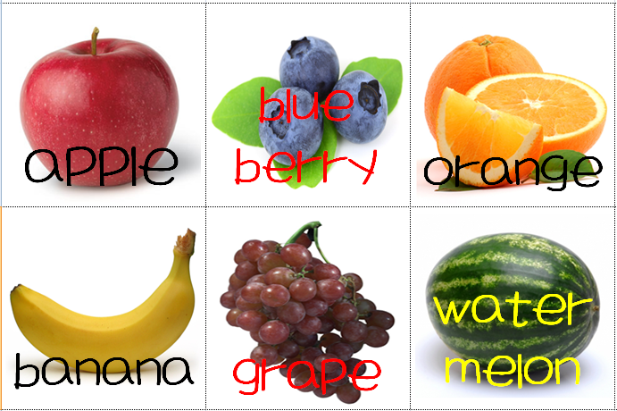

<worksheet>
Subject | Art English | Age | 5-6 | Name

- Color this picture correctly with colored pencil.

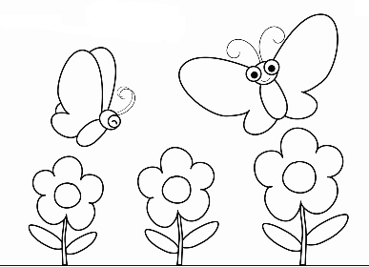
Purple
Red
Green
Red
Blue
Green
Green
Blue
Purple
Yellow
Blue
Orange
Yellow

<color cards>
