Listening Speaking Reading Grammar Writing

Topic: Several Articles

Instructor:  Gloria | Level:  Intermediate | Students:  13 | Length:  30 Minutes

Materials:
- Whiteboard, board markers, board erasers
- Worksheet #1
- Worksheet #2
- Worksheet #3

Aims:
Main Aim:
Students will develop their reading abilities by reading several articles.

Secondary Aims:
Students will practice reading through having Ss use worksheets.

Personal Aims:
I want to reduce my TTT and encourage STT.
I want to make a good atmosphere for quality time after the class.

Language Skills:
- Listening: Ss will listen to the instruction, classmate presentation.
- Speaking: Ss will tell other people for the group discussion.
- Reading: Ss will read the worksheets.
- Writing: Ss will fill in the blank.

Language Systems:
- Phonology: [v]very, [r]relaxing
- Lexis: monument, Insomnia
- Grammar: None to grammar
- Function: Answering to comprehension questions
- Discourse: Share their own opinions for fill out the blank

Assumptions:
Students already know:
- All students are adult.
- Students are familiar with group work and discussion.
- Most students have interests in movie.

Anticipated Errors and Solutions:
Anticipated Problems | Solutions
Students might not understand some lexical words related to today’s lesson. | Teacher will elicit the meaning of the words from students and give an explanation.
Students might have trouble filling in the worksheets. | Teacher will give time to share answers by group works after filling in the worksheet alone.
Activities might take too long than I expected. | Teacher will notify them with time-management word.
Activities might be end earlier than expected. | Teacher will do SOS activities.

References:
http://ecademy.co.kr/
http://www.naver.com
http://www.google.co.kr/

Lead-In
Materials:
Board, markers, board eraser
Time | Set Up | Student Activity | Teacher Talk
1min | Whole Class | Answer to the teacher's questions proactively. | [Greeting]  - Good afternoon everyone, How are you today?  - Today topic is ‘several articles’. It isn’t one topic, so we learn through several articles.

Pre-Activity
Materials:
Pictures
Time | Set Up | Student Activity | Teacher Talk
3min | Whole Class | Show the pictures.  Some students answer it.  Students don’t know the  answer. | Ⅰ. Talking about pictures.  [Pre-teaching of vocabulary]  monument  A monument is a large structure, usually made of stone, which is built to remind people of an event in history or of a famous person.  Insomnia  Someone who suffers from insomnia finds it difficult to sleep  [CCQ]  - Can we see the monument? -> Yes  - Is monuments in everywhere? -> No  - Is insomnia means sleep well? -> No  - When we are in insomnia, can we so tired? -> Yes

Main Activity
Materials:
Worksheet #1, Worksheet #2, Board, marker, board eraser
Time | Set Up | Student Activity | Teacher Talk
11min  5min  6min | In Group  In Group  In Group | Read the article in group for 5 minutes and answer it.  Discuss the instruction with the group.  Present the result of discussion. | Let’s make 3 groups. “A”, “B”, “C”. We’ll have some activities in groups, and I’ll give goods for winner team.  Ⅰ. A Far Countries  [Instruction]  I will give you worksheet #1.  You’ll read it for 5 minutes and then I will ask you 4 questions in group.  [ICQ]  What are you going to do?  How much time do you have?  - Move around the classroom and monitor quietly  - Time warning : 2 minutes. 1minute  OK. Time’s up.  Ask to each group.  Who is from Mexico?  Where is Shanti from?  Who is from Rovaniemi?  What color is the Mexican flag?  Where is Finland?  Which flag is orange?  What color is the Finnish flag?  Where is Tokyo?  Where are Mayan pyramids?  Where is Santa's village?  Which is the Indian monument?  Which flag is white and red?  OK. You guys did great job.  Ⅱ. Enjoy Dinner Often with Your Family!  [Instruction]  Now, we’re going to make a right order for 3 minutes with your group.  [ICQ]  Are you working alone?  How long will it take to do this activity?  What’re you going to do?  - Time warning : 2 minutes  - Move around the classroom and monitor quietly.  Now, let’s share your answer. Come out here one of your group, and write the answer on white board.  Ⅲ. When You Can’t Fall Asleep...  [Instruction]  Now, we’re going to match the text and title for 2 minutes with your group.  [ICQ]  Are you working alone?  How long will it take to do this activity?  What’re you going to do?  - Time warning : 2 minutes  - Move around the classroom and monitor quietly.  Now, let’s share your answer.  Error correction.  Now, you’ll speak the article one by one.  Well done everybody.  Let's sum points as groups. The winner team is ______! Congratulations! I'll give goods for winner team, and then everyone good job!

Post Activity
Materials:
Worksheet #3, Board, marker, board eraser
Time | Set Up | Student Activity |  | Teacher Talk
4min | In pairs | Answer to the teacher's questions proactively. |  | Ⅰ. This is my grandfather  [Instruction]  Group in pairs.  Now, we’re going to read an article and fill in the blank for 5 minutes with your partner.  [ICQ]  Are you working alone?  How long will it take to do this activity?  What’re you going to do?  - Time warning : 2 minutes  - Move around the classroom and monitor quietly.  Now, let’s share your answer.  I hope you enjoyed this Lesson.  Everyone did really great job today.
SOS Activities
Materials:
SOS worksheet
Time | Set Up |  | Student Activity | Teacher Talk
00min | In Group |  | Read the article with the group. | Give the SOS worksheet to the students.  Match the questions and answers.

< Worksheet #1 >

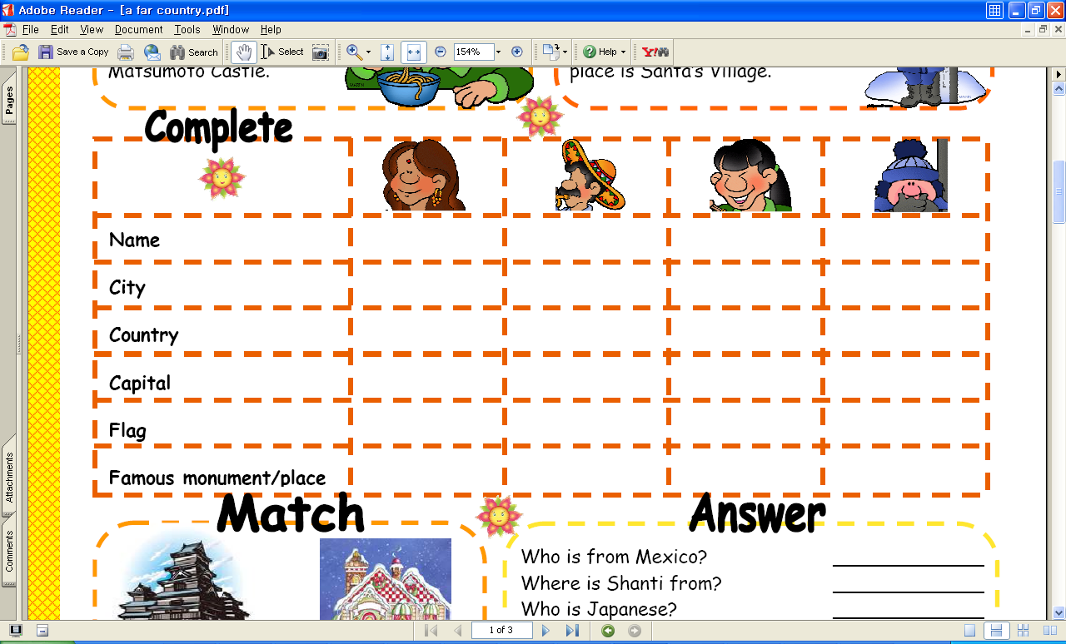

< Worksheet #2 >
Enjoy Dinner Often with Your Family!
Spending time with your family is very important. Enjoying dinner together is a perfect way to talk about your daily lives with your family members. You feel happier if you get along well with your parents, brothers or sisters. Sadly, however, many families spend more time watching television than eating dinner with their loved ones these days.
According to a new study, TV is destroying quality family time in Britain. Researchers found millions of British families now spend more time relaxing in the living room in front of the television than they do sitting at the dining room table chatting about their day. “Watching box sets has become a popular past time in the UK over the past 5 years,” they said. The study found most families spend only five hours a week to eat with their family members. On the other hand, the average Briton spends more than double that watching television with their family members.

More than half of the 3,000 adults who were polled said the television was the central factor in their lives. “Watching the same show with my family gives me something to talk about with them,” one of the respondents said. However, spending too much time in front of the television has many negative effects. Many people actually treat the TV characters as part of their daily lives. Some people even start acting like characters on television. In fact, many families in Korea also watch TV shows together instead of enjoying talking to each other.

Well, of course there are many useful and fun TV programs we can enjoy with our family members. But why don’t you turn off the television sometimes and enjoy dinner with your family while talking about your day at school? Ask your parents about their days, too. You will be able to understand each other better simply by enjoying dinner together!
< Worksheet #3 >
Enjoy Dinner Often with Your Family!
Spending time with your family is very important. Enjoying dinner together is a perfect way to talk about your daily lives with your family members. You feel happier if you get along well with your parents, brothers or sisters. Sadly, however, many families spend more time watching television than eating dinner with their loved ones these days.

According to a new study, TV is destroying quality family time in Britain. Researchers found millions of British families now spend more time relaxing in the living room in front of the television than they do sitting at the dining room table chatting about their day. “Watching box sets has become a popular past time in the UK over the past 5 years,” they said. The study found most families spend only five hours a week to eat with their family members. On the other hand, the average Briton spends more than double that watching television with their family members.

More than half of the 3,000 adults who were polled said the television was the central factor in their lives. “Watching the same show with my family gives me something to talk about with them,” one of the respondents said. However, spending too much time in front of the television has many negative effects. Many people actually treat the TV characters as part of their daily lives. Some people even start acting like characters on television. In fact, many families in Korea also watch TV shows together instead of enjoying talking to each other.
Well, of course there are many useful and fun TV programs we can enjoy with our family members. But why don’t you turn off the television sometimes and enjoy dinner with your family while talking about your day at school? Ask your parents about their days, too. You will be able to understand each other better simply by enjoying dinner together!
SOS Activities
DEAR ABBY:
I am in dire need of your help. I have four brothers and one sister. My oldest brother stays with his girlfriend. My sister stays out of town. My second-oldest brother goes to college during the week and comes home on weekends. This leaves me, my third-oldest brother and my little brother at home.

We have certain chores that have to be done when we get home from school, and they must be completed before Mom comes home. The problem is, my third-oldest brother goes up the street and my little brother goes somewhere else, leaving me at home to do all the work.

When Mom gets home and the work isn't done, she blames me, even though there are two more people here that could have helped me. Abby, please tell my mother that if three people are meant to do chores, she shouldn't blame just me! -- MAD AND CONFUSED SISTER, BIRMINGHAM, ALA.

DEAR MAD AND CONFUSED:
Please clip this column and share it with your mother. It's unfair that your brothers run off, leaving you with all the chores, while your mother chooses to ignore their lack of responsibility. She should make a chart that defines specifically which jobs are to be done by each member of the household and when. And if the chores are not completed when your mother gets home, the guilty parties should be reprimanded _ not you. To do otherwise shows sexist and antiquated logic.

DEAR ABBY:
Is it appropriate for my husband's mother to take him alone to dinner to celebrate his birthday? We have been married for 13 years and have two children, yet she did not include the rest of us. My husband thinks it's because she can't afford dinner for all of us, but I think she should then just order a pizza and have us to her house.

This is the third or fourth time she has invited him to dinner without including us, and I am hurt that I am excluded. Should I not take this personally?

LEFT OUT ON THE LEFT COAST

DEAR LEFT OUT:
If his mother wants alone time with her son, she could invite him to join her for lunch that day so they could talk privately. As it stands, I agree, you are being excluded _ and I'm curious about why your husband would go along with it.

DEAR ABBY:
How do you make yourself like somebody if you don't like them, but want to like them?

Here's the situation. I am 15 and have a stepsister the same age. We have been stepsisters for two years. We have never gotten along and have never liked each other. Usually, when you won't like somebody you can just avoid the person, but we have to be together and share a room every other weekend when I go to my dad's for visitation, and it would be a lot nicer if we liked each other.

It's not that either of us is a bad person _ it's more of a personality conflict. How can I get myself to like her and get her to like me?

KANSAS CITY STEPSISTER

DEAR STEPSISTER:
You are asking about the art of diplomacy and negotiation. Here's how it works. First, you find something the two of you can agree on. (Example: I love my father. You love your mother. We both want them to be happy, don't we?) And work from there. Anything you can agree on, you take off the table. What you can't agree on, try to compromise. This takes practice, but it is a valuable tool once you master it and will serve you well all your life.

DEAR ABBY:
I'm curious to know what makes men of any age sleep on couches and easy chairs in the daytime? I don't know of any women who do it.

MARISA C., ONTARIO, CANADA

DEAR MARISA:
Men nap on couches and easy chairs because they are sleepy (or perhaps bored). However, this trait is not quite gender-specific. In fact, I am sure there are also women who do it, too. You just don't happen to be acquainted with any who admit it.

DEAR ABBY:
My husband and I are the parents of two small children. We have started writing our wills to help plan for our children's future should anything happen to us.

I was wondering, would it be appropriate to request that should one or both of us predecease our children, that people donate money to an educational trust for our children in lieu of flowers? I know that people often request donations to charity and philanthropic groups, but I'm wondering if our request would be considered "tacky" or inappropriate.

CURIOUS IN CALIFORNIA

DEAR CURIOUS:
Although the loss of a parent is tragic, I'm reluctant to endorse that kind of request. Please take into consideration that an education costs far more than flowers for a funeral. The best way to ensure that your children can complete their education would be to start a college fund for them now and also make sure you have adequate life insurance.

DEAR ABBY:
We have two beautiful little boys. The older boy is 3, the younger one an infant. People always comment on how much they look alike _ as if they could be twins three years apart.

The problem is, my husband and I (close family, too) do not think they look anything alike, so we don't know how to respond. If we disagree, people go so far as to argue with us. But to agree seems silly when they really do not look alike. What is the polite way to disagree without an argument?

PROUD MOTHER OF TWO DIFFERENT BOYS

DEAR PROUD MOTHER:
Say something noncommittal _ such as, "Yes, there is a strong family resemblance." (But only if they look like they could be related.) To disagree, regardless of how politely you do it, will only generate more conversation on a subject you would prefer to avoid.

[ Vocabulary ] – insomnia, monument



