Listening Speaking Reading Grammar Writing

Topic: “An invitation to show or the party”

Instructor:  FuYu Chiu | Level:  Intermediate | Students:  12 students | Length:  30 Minutes

Materials:
- Board, markers
- 3-4 pictures
- Invitation card (example)
- Reading articles
- Worksheet (12 copies)

Aims:

- Main Aim: To enable improve students to their reading skills through reading an article related to invitation.

- Secondary Aim: Students will get an opportunity to creative an invitation card by their own ideas.

- Personal Aim: I want to reduce my TTT and increase STT
I want students can be engaged in the lesson
I want to speak louder and increase my teaching
confidence

Language Skills:
- Listening: Ss will listen to the teacher’s explanation and practice with other Ss
- Speaking: Ss will do an activity and work in a pairs
- Reading: Ss will discuss and share their opinions
- Writing: Ss will write answer about their ideas on the worksheets

Language Systems:
- Phonology: Students will learn the unknown vocabularies
- Lexical: invitation cards
- Functional: creation
- Discourse: none to discuss
- Grammatical: none to discuss

Assumptions:
- Students already have knowledge and experience of the article
- Students needs to design their own invitation cards
- Students share their own ideas and discuss with a pairs

Anticipated Errors and Solutions:
- Students may need more time to make their own sentences
Give Ss more time to finish the sentence
- Students may need more time to think of the situation by relate to invitation activity
Give Ss more time to make their own invitation card
- The lesson might finish earlier than I expected
Do SOS activity

Problems  - Students may need more time to make their own sentences  - Students may need more time to think of the situation by relate to invitation activity  - The lesson might finish earlier than I expected | Solution  - Give Ss more time to finish the sentence  - Give Ss more time to make their own invitation card  - Do SOS activity

References:
- Times Media work book
- www.google.com

Lead-In
Materials: Board

Time | Set Up | Student Activity | Teacher Talk
1min | Whole Class | Ss answer to teacher’s question | Procedure:  Hello everyone! How are you today?  Have anyone ever received an invitation card?  Today, we will talk about “An invitation to a show or the party”  (Write down today’s topic on the board)  (Elicit response from the students & write them on the board)

Pre-Activity
Materials: Board, 3-5 example pictures of invitation cards

Time | Set Up | Student Activity | Teacher Talk
2min  3min  3min | Whole Class  Pairs  Whole Class | Ss listen to teacher’s instruction carefully and follow  Ss work in a pairs of two | Procedure  Here are 3-5 examples of invitation cards, and I am going to give you each of the picture, you can read through and tell the class if you are going to attend the party then what will you need to prepare for present, if you don’t want to go please tell why  Demonstration  I have got an invitation card which is wedding ceremony, I am going to attend and I am going to buy a pairs of coffee cups to present my friend  CCQ’s  Does ‘invitation’ mean that you can only stay at home? No  Does ‘invitation’ mean that you can possible go to join somebody’s party? Yes  I am going to divide you into pairs, you have 3minutes  ICQ  Are you working in pairs? Yes  What are we going to do?  How many minutes do you have? 3minutes  Let’s begin  Monitoring Ss pairs work  - Give Ss reminding of the left time: 1minutes left, 30seconds left, times up  Ask each pairs go over the sentences and present to the whole class  Give Ss some attention: all you guys did a good job

Main Activity
Materials:
Board, Reading articles about “invitation cards”, Worksheet

Time |  | Set Up |  | Student Activity |  | Teacher Talk
2min  5min  3min  2min |  | Whole Class  Individually  Pairs  Whole Class |  | Following instructions |  | Instruction  I’ll give you an article about 4 invitations, Goldy has received 4 invitations, but it’s all on the same day and similar timing, if you were Goldy which invitation would you go and attend?  Example of the article:  - NANTA Show  - Seoul Motor Show 2011  - Wedding Ceremony  - Baby’s First Birthday  Please read it individually, you have 5minutes  ICQ  Are you working in pairs? No  What are we going to do?  How many minutes do you have? 5minutes  Let’s begin  Monitoring Ss individual work  - Give Ss reminding of the left time: 1minutes left, 30seconds left, times up  I’ll arrange you guys in pairs Invitation & Card (grouping Ss by Invitation, Card, Invitation, Card …etc) and I’ll give you a worksheet, you have 2minutes  ICQ  Are you working in pairs? Yes  What are we going to do?  How many minutes do you have? 3 minutes  Let’s begin  Monitoring Ss pairs work  Give Ss reminding of the left time: 1minutes left, 30seconds left, times up  When each pairs have finished then write answers on the worksheet and share answers to other Ss  Give Ss some attention: all you guys did a good job
Post Activity
Materials:
Board, Markers, Color papers
Time | Set Up |  | Student Activity |  | Teacher Talk
1min  3min  3min  2min | Whole Class  Individually  Whole Class  Whole Class |  | Following instructions  Ss speak their own feeling and opinions |  | Instruction  I am going to give you a paper, and please design your own invitation card, you can also create with frames or with any characters that you want to add in (Ss can decide the topic by themselves)  I am going to give you the worksheet, you can reference with it  Demonstration  Here is my own designed invitation card, and it’s about “Movie Invitation”  Please work individually  You have 3minutes  ICQ  Are you working in pairs? No,  What are we going to do?  How many minutes do you have? 3minutes  Let’s begin  Monitoring Ss individual work  Give Ss reminding of the left time: 1minutes left, 30seconds left, times up  Please go around and invite 2 or 3 students to your party and if you find out something interesting or special  Please write down Ss name and answers, you have 3minutes  ICQ  Are you working in pairs? No  What are we going to do?  How many minutes do you have? 2minutes  Let’s begin  Monitoring Ss individual work  Give Ss reminding of the left time: 1minutes left, 30seconds left, times up  Students share answers to other Ss  Error Correction & Feedback  Do you have any questions?  All you guys did a good job today!  I hope you enjoyed today’s lesson  See you tomorrow
SOS Activities
Materials: Board, Markers

Time | Set Up |  | Student Activity |  | Teacher Talk
2min | Whole Class |  | Ss think about and answer the question |  | Instruction  Please think about what things are going to prepare for your party?  Example:  Balloon, crafts, candy, cake, food…etc

Worksheet * 1 *

Making invitations
Here are some common expressions you can use when making or responding to invitations

Giving Invitations:
- What are you doing on (day/date)?
- Would you like to. . .?
- How about. . .?
- Do you want to. . .with me?
- I'd like to invite you to. . .
Accepting Invitations:
- Thanks! That sounds like fun.
- Sure. Thank you for the invitation.
- When is it?
- What time does it start/end?
- Let's meet at. . .
- What date/day is it?
Refusing invitations:
- No, thank you.
- I'm sorry, but I have to. . .
- Thanks, but I have another appointment at that time.
- I can't. I'm sorry.

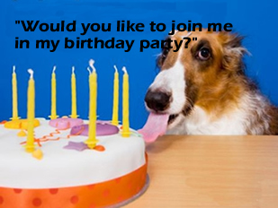

Reading (Four Articles)

- NANTA Show (Invited by best friend and have bought the ticket in advance)

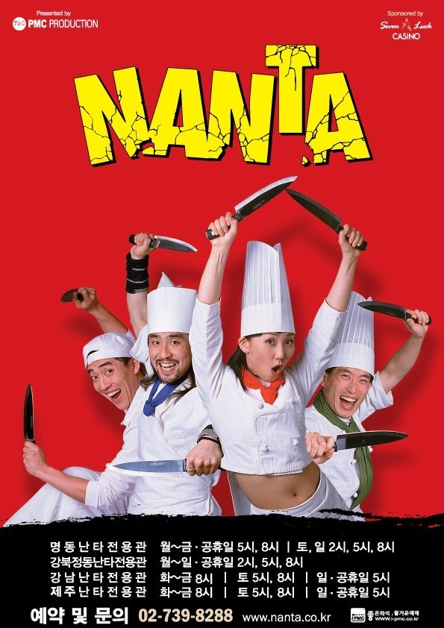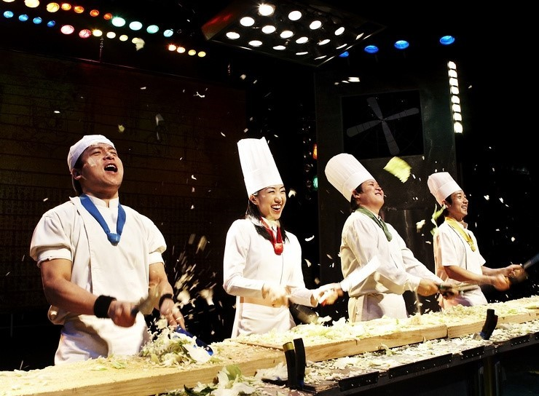

Since the first performance on the 10th of October in 1997, this world famous NANTA has been drawing the largest number of audience in Korean stage history.

In NANTA, Knives and other kitchen utensils are transformed into musical instruments in the hands of the performers. The haunting and heart-stirring music based upon Korean Samulnori rhythms of Jajinmori, Utdari, Puneori, etc, combined with five distinctive characters! Comic explosion!

Synopsis
An excellent cook, but the unmanly HEAD CHEF, a very sexy, masculine SEXY GUY, and the powerful, sassy, the only woman cook, HOT SAUCE, a cute, attractive, handsome ill-natured manager’s little Nephew! Washing vegetable, carrying meat loafs, setting fire, and cook at NANTA kitchen is about to begin their busy job as always and to start their daily work.

Date: Sunday, October 30th, 2011
Time: 5pm
Location: HONGDAE NANTA THEATRE (HongDae Station of subway line2, exit 9)

- Seoul Motor Show 2011 (invited by husband, because Goldy’s husband wants to try a daily lottery ticket)



The long-awaited Seoul Motor Show 2011 has finally commenced here at Seoul, on the 30th of October.

Seoul Motor Show 2011, the biggest ever automobile exhibition with 139 companies from 8 countries (111 national businesses and 28 overseas businesses) introducing total 300 models including 54 brand-new cars, 23 concept cars and 32 environmentally friendly green cars, is now held at Coex.

Here at Coex, family visitors, close friends and others are waiting in an orderly fashion to procure tickets at the ticket office. Anyone who purchased the entrance ticket shall be offered a daily lottery ticket, which we grant a car per day from each automobile company.

Any ticket holder is obliged to fill in the personal information and put it into the designated box. The winner of each day will be drawn at 6:30 p.m. every afternoon at the stage in front of the Coex exhibition center.

We hope many of you to visit and enjoy more of Seoul Motor Show 2011 held here at Coex.

Date: Sunday, October 30th, 2011
Time: 3pm
Location: Coex (Samsung Station of subway line2, exit 12)

- Wedding Ceremony (invited by very close colleague)

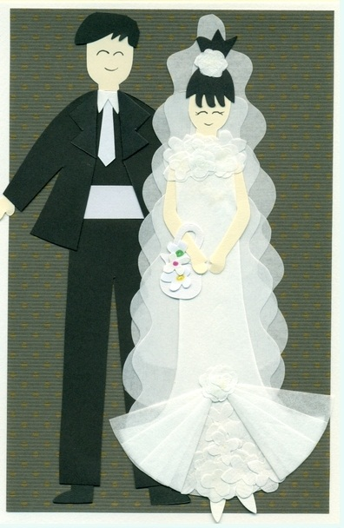
My Love,
I'm so grateful to have you in my life; I am able to share my minutes of precious life with you.
You carry special warmth. A special love that begins in your heart, so each time you smile you are able to light a room with the beauty of your smile.
You listen to me when I speak whether what I say makes sense or not. You listen to my hopes and my dreams and you empower with your belief, so I may reach them one day. You are such a special person; I will always love you and admire all that you do
No body is more wonderful than you, I am lucky to have you, and I am blessed each day with your presence. This is why I love you.
We Alex and Jessica together with our parents invite you to share in the celebration of our marriage on Sunday, the thirtieth of October. Two thousand and eleven at three thirty in the afternoon.

Date: Sunday, October 30th, 2011
Time: 3:30pm
Location: BANGBAE WEDDING HALL (BangBae Station of subway line2, exit 3)

- Baby’s First Birthday (invited by cousin sister, it’s cousin sister’s son Kelsey’s first birthday)



It’s a birthday party celebrating Kelsey’s 1st birthday!
A year’s gone by. How time has flown, we can’t believe how Kelsey’s grown. He’s such a joy and so much fun. I learned to laugh and squeal, then sit and stand, and I can walk now if you hold my hand. But the fun has only just begun, lookout world, Kelsey’s is turning one!

Date: Sunday, October 30th, 2011
Time: 6pm
Location: VIPS Restaurant (KangNam Station of subway line2, exit 2)

Worksheet * 2 *

Discussion

1. If you were Goldy which party or show invitation will you join, and why?

2. When was the first performance of NANTA show? What are the special points of the NANTA show?
3. What kind of special event that heading at the first day in the Seoul Motor Show?

4. The winner of each day will be drawn at what time and in where?

5. Who, what time and where is the wedding celebration?

6.Who is going to have the first birthday party?

