**Worksheet #2**

Boracay is a island about an hour's from [Manila](http://wikitravel.org/en/Manila) in the . Its long white sand rival the best of more popular destinations such as the [Caribbean](http://wikitravel.org/en/Caribbean), the South Pacific as well as neighboring [Thailand](http://wikitravel.org/en/Thailand), [Malaysia](http://wikitravel.org/en/Malaysia) and [Indonesia](http://wikitravel.org/en/Indonesia). are available to suit levels of activity. For those wanting to just lounge around and take in some rays, beach-front hotels usually have lounge chairs set up just a few away from the hotel entrances. Facilities for the usual water activities such as sailing, wind surfing, snorkeling, diving and jet skiing are also widely available for those in search of more active pursuits. The fun in Boracay also doesn't end when the sun sets. Boracay nightlife is with many bars and restaurants serving food, drink and fun until the very late evening.

Partly because of its wind and weather , [tourism](http://en.wikipedia.org/wiki/Tourism) in Boracay is at its peak during the [Amihan](http://en.wikipedia.org/wiki/Amihan) . During Amihan, the prevailing wind blows from the east. Boracay's main tourism area, White Beach, is on the western side of the island and is from the wind. During the Amihan season, the water off White Beach is often glassy-smooth. On the eastern side of the island, hills on the northern and southern ends of the island channel the Amihan wind from the east onshore, onto [Bulabog Beach](http://en.wikipedia.org/w/index.php?title=Bulabog_Beach&action=edit&redlink=1) in the central part of the island's eastern side. This makes the [reef](http://en.wikipedia.org/wiki/Reef)-protected waters off that beach ideal for [windsurfing](http://en.wikipedia.org/wiki/Windsurfing) and [kiteboarding / kitesurfing](http://en.wikipedia.org/wiki/Kitesurfing). In June of 2011, it was reported that a real estate development group led by [Andrew Tan](http://en.wikipedia.org/wiki/Andrew_Tan) had earmarked P20 billion to develop tourism estates "featuring an integrated, master-planned layout and world-class resort offerings and amenities" in Boracay and [Cavite](http://en.wikipedia.org/wiki/Cavite). The planned Boracay project, Boracay Newcoast, four hotels with 1,500 rooms, a plaza and entertainment center.

|  |
| --- |
| tropical, flight, beaches(x2), patterns, season(x2), involves, Philippines, sheltered, pulsating, facilities, different, steps, sports |

**Boracay** is a tropical island about an hour's flight from [Manila](http://wikitravel.org/en/Manila) in the [Philippines](http://wikitravel.org/en/Philippines). Its long white sand beaches rival the best beaches of more popular destinations such as the [Caribbean](http://wikitravel.org/en/Caribbean), the South Pacific as well as neighbouring [Thailand](http://wikitravel.org/en/Thailand), [Malaysia](http://wikitravel.org/en/Malaysia) and [Indonesia](http://wikitravel.org/en/Indonesia). Facilities are available to suit different levels of activity. For those wanting to just lounge around and take in some rays, beach-front hotels usually have lounge chairs set up just a few steps away from the hotel entrances. Facilities for the usual water sports activities such as sailing, wind surfing, snorkeling, diving and jet skiing are also widely available for those in search of more active pursuits. The fun in Boracay also doesn't end when the sun sets. Boracay nightlife is pulsating with many bars and restaurants serving food, drink and fun until the very late evening.

Partly because of its wind and weather patterns, [tourism](http://en.wikipedia.org/wiki/Tourism) in Boracay is at its peak during the [Amihan](http://en.wikipedia.org/wiki/Amihan) season. During Amihan, the prevailing wind blows from the east. Boracay's main tourism area, White Beach, is on the western side of the island and is sheltered from the wind. During the Amihan season, the water off White Beach is often glassy-smooth. On the eastern side of the island, hills on the northern and southern ends of the island channel the Amihan season wind from the east onshore, onto [Bulabog Beach](http://en.wikipedia.org/w/index.php?title=Bulabog_Beach&action=edit&redlink=1) in the central part of the island's eastern side. This makes the [reef](http://en.wikipedia.org/wiki/Reef)-protected waters off that beach ideal for [windsurfing](http://en.wikipedia.org/wiki/Windsurfing) and [kiteboarding / kitesurfing](http://en.wikipedia.org/wiki/Kitesurfing). In June of 2011, it was reported that a real estate development group led by [Andrew Tan](http://en.wikipedia.org/wiki/Andrew_Tan) had earmarked P20 billion to develop tourism estates "featuring an integrated, master-planned layout and world-class resort offerings and amenities" in Boracay and [Cavite](http://en.wikipedia.org/wiki/Cavite). The planned Boracay project, Boracay Newcoast, involves four hotels with 1,500 rooms, a plaza and entertainment center.

**Worksheet #1**

Facility

are buildings, pieces of equipment, or services that are provided for a particular purpose

Water sports

various sports, such as swimming, water-skiing, or windsurfing, that take place in or on water

Flight

a journey made by flying, usually in an aeroplane.

Wind surfing

is a sport in which you move along the surface of the sea or a lake on a long narrow board with a sail on it.

Snorkeling

is a tube through which a person swimming just under the surface of the sea can breathe.

Pursuit

usually activities that you enjoy when you are not working.예문예문

Nightlife

is all the entertainment and social activities that are available at night in towns and cities, such as nightclubs and theatres.예문예문

Pulsating

it beats, moves in and out, or shakes with strong, regular movements.

Shelter

it is protected by that thing from wind and rain.

Amihan

refers to the season dominated by the trade winds, which are experienced in the Philippines as a cool northeast wind

Onshore

means happening on or near land, rather than at sea.

Kiteboarding

A specialized light weight wakeboard used for kiteboarding

Kitesurfing

the sport of sailing standing up on a surfboard while being pulled along by a large kite

Amenity

are things such as shopping centres or sports facilities that are provided for people's convenience, enjoyment, or comfort.

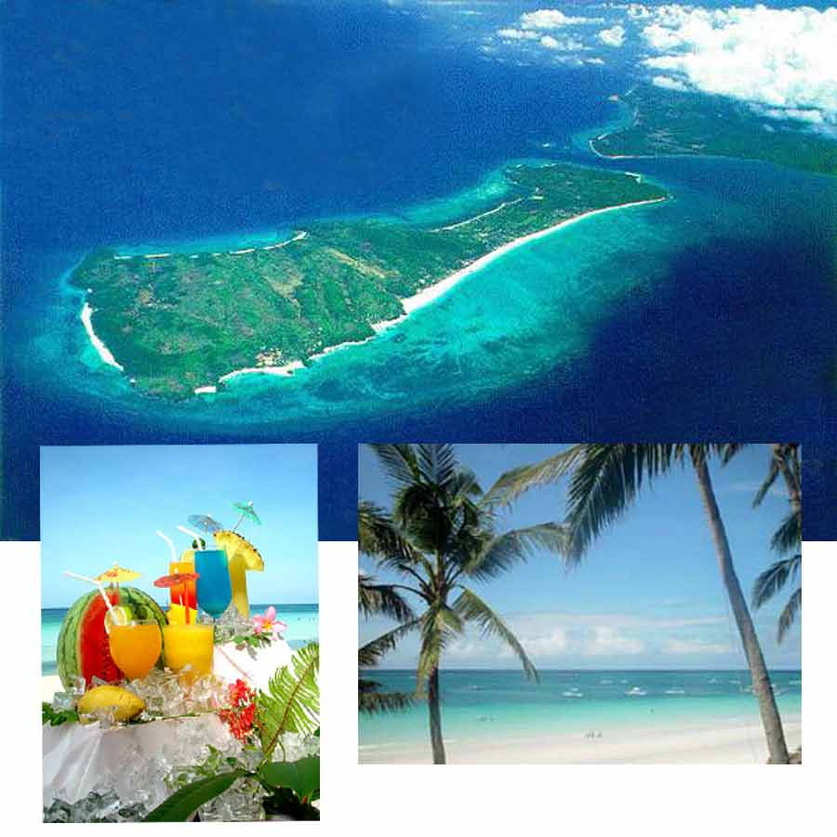예문예문예문예문예문예문예문예문