Topic: “Help me, please.”

Instructor:  Kim, Sung Eun  (Kate) | Level:  Age 10-11  intermediate | Students:  20 | Length:  35min

Target Vocabulary:
- Noun : rabbit, cat, monkey, squirrel, fox, bee
- Verb: twist, struggle, fall, roll, take a nap, whirl

Target Sentences:
- The rabbit has twisted ears.
- The cat struggles in the water.
- The monkey falls from the tree.
- The squirrel picks up the rolling acorns.
- The fox takes a nap.
- The bees whirl.

Materials:
- Story book :“Help me, please”
- Pictures, flash cards
- Animal mask pictures, Color pencils, Scissors, Lamination, Laminate film,
Rubber bands
- 20 piece of worksheets

Aims/Objectives:
- To understand target vocabulary and sentences’ meaning.
- To review target vocabulary (nouns, verbs) and sentences with pictures and storybook.
- To practice and improve speaking and listening skills.
- To get massage from the story and be aware of cooperation with friends.

Assumptions:
- Ss already learned about target vocabulary (nouns, verbs).
- Ss can understand and match up new sentences with pictures.
- Ss can concentrate on time in reading.
- Ss can use scissor to make a mask.

Anticipated Errors and Solutions:
- Ss may not know vocabulary words
: Encourage Ss to guess from pictures in storybook.
- If Ss finish their task earlier expected.
: Do role play with mask
- If time is short
: Making a mask will be continued in next time.

References:

Lead-In
Materials:
Mp3, Hello song
Time | Set Up | Student Activity | Teacher Talk
2min | Whole  class | Sing a ‘Hello’ song and dance together. | Good morning~!  Let’s sing ‘Hello’ song.  How are you today?  How is the weather outside?

Pre-Activity
Materials:
Pictures, flash cards
Time | Set Up | Student Activity | Teacher Talk
10min | Whole  class | Students talk and review about target vocabulary what they learned.  Students express the verb with theirs body. | Last time we learned about animals and new verbs.  Do you remember that?  We are going to review some words and sentences.  Can you see these pictures?  Who is this?  Yes, this animal is rabbit.  How are the rabbit’s ears?  The rabbit’s ears are twisted.  Can you twist your arms?  (continue until explain and talk about all pictures)

Main Activity
Materials:
Story book “Help me, please”
Time | Set Up | Student Activity | Teacher Talk
10min | Whole  class | Students talk about target sentence with book.  Students listen and answer.  ->Help me, please~  ->They are fox and cats.  ->The cat is struggling in the water. The fox is just laughing.  Students listen to storytelling.  Students listen and answer.  ->Five animals.  ->fox, rabbit, monkey, cat, squirrel.  ->Help them. | Today I am going to tell you interesting story.  This book’s title is “Help me, please”  When do you say “Help me”?  We usually say “Help me”, when we need someone’s help.  Can you repeat after me?  “Help me, please”  <talk about book’s cover>  Who are they?  What are they doing?  Now, I’ll tell you this story.  You listen to carefully what happened to them.  Are you ready?  <Read book>  <CCQs>  Did you enjoy this story?  How many animals came out in this story?  Do you remember what animal is?  That’s right.  If someone needs your help, what should you do?

Post Activity
Materials:
Animal mask pictures, Color pencils, Scissors, Lamination, Laminate film,
Rubber bands
Time | Set Up | Student Activity | Teacher Talk
10min | Whole  class | Students listen how to make an animal mask and do it.  ->animal mask!  ->color and cut a mask. | <Make a animal mask>  We are going to make animal’s mask.  I prepared animals’ pictures.  You should color this mask with color pencil.  You cut along this line and cut this eyes and mouth out.  After complete your mask, you should laminate your mask with laminate film.  You’ll tie this hole with rubber bands.  <CCQs>  What should we make?  What should we do?  Good job!  Let’s make a mask!
Wrap-Up
Materials:
20 piece of worksheets
Time | Set Up | Student Activity | Teacher Talk
3min | Whole  class | Students listen and answer. | Next time we are going to act a play with these masks.  You have to bring your mask tomorrow.  This is homework.  You will circle the correct answer.  Did you enjoy this class?  See you tomorrow! Have a nice day!

Subject | English | Age | 10-11 | Name

*circle the correct picture.

- The rabbit has twisted ears.
⒜ 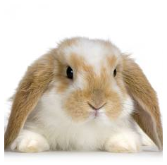 ⒝ 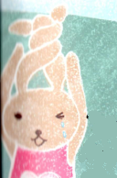 ⒞ 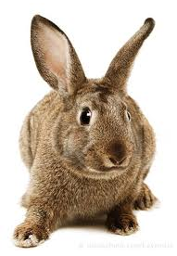
- The cat is struggling in the water.
⒜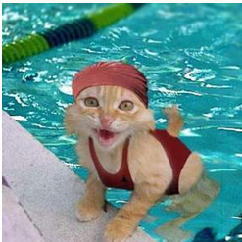 ⒝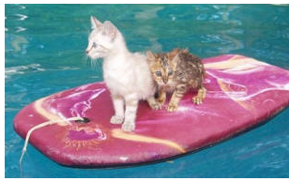 ⒞ 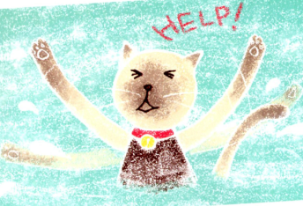
- The monkey falls from the tree.
⒜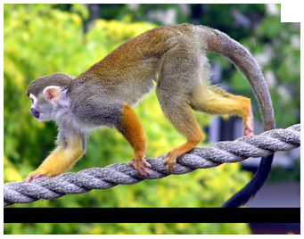 ⒝ 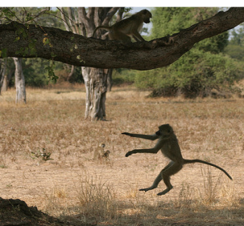 ⒞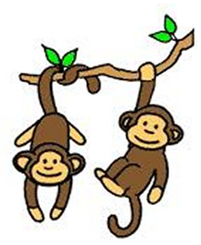
- The squirrel picks up the rolling acorns.
⒜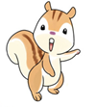 ⒝ 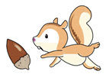 ⒞ 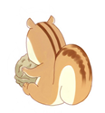
- The fox takes a nap.
⒜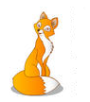 ⒝ 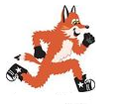 ⒞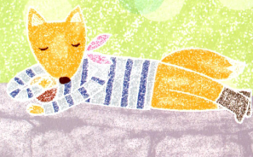
- The bees are whirling.
⒜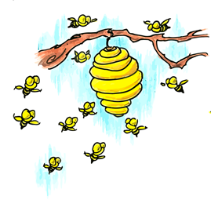 ⒝ 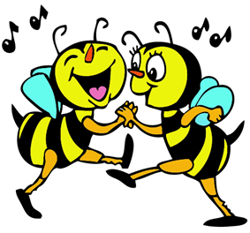 ⒞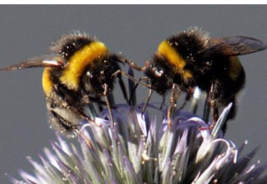
<Animal mask>
Color this picture with color pencil and cut it out.
Complete to make a mask.
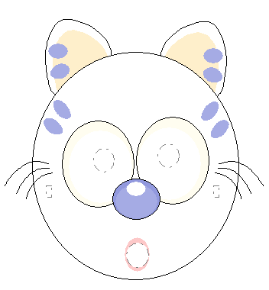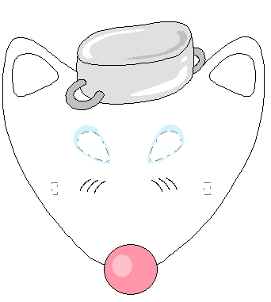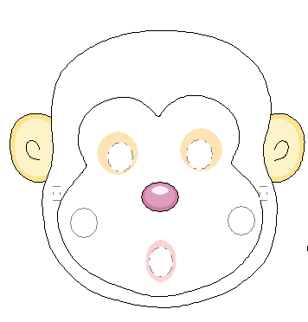
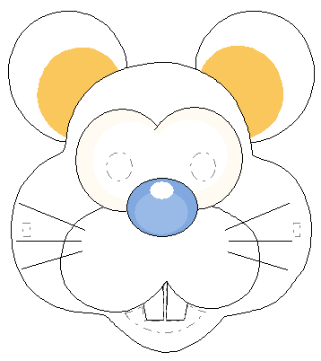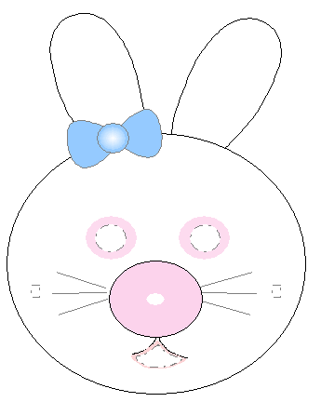

<Pictures>
