Grammar Lesson Plan
Superlative: Best of the Best, Worst of the Worst
Instructor:  Anne | Level:  Upper Intermediate | Students:  9 |  | Length:  30 minutes
Materials:
- White board, board markers
- Pictures of the best and the worst dressers
- Superlatives word search puzzles (9)
- 9 pieces of paper with two different questions
- Blank sheets of paper (9)

Aims
-Main
: To enable Ss to improve their grammar on superlative adjectives through various activities
-Secondary
: Ss will learn how to make superlatives in different occasions
-Personal
: I want to manage the pace by speaking more slowly

Language Skills:
- Reading: Ss will read each other’s answers
- Listening: Ss will listen to what others say
- Speaking: Ss will talk about their own experiences
- Writing: Ss will write down answers about different questions

Language Systems:
- Lexis: superlative adjectives
- Function: none to discuss
- Structure: none to discuss
- Phonology: superlative
- Discourse: none to discuss

Assumptions:
- Ss know most of the adjectives that are used
- Ss learned comparative adjectives

Anticipated Problems:  - If time is short  - If students finish their tasks earlier than anticipated  - If there are odd numbers of Ss when doing pair-work activity |  |  | Solutions:  - Cut post-activity discussion short and only ask 2~3 Ss to share their experiences.  - Do SOS activity  - Make one group with three people
References:
- www.google.com
- http://blog.naver.com/gogzone
- http://blog.naver.com/slrkanjsepdi
- www.eslpuzzles.com

Lead-in
Materials: Board
Time  1 min | Set Up  Whole class | Procedure:  Hey everyone. How are you guys doing?  This afternoon, I am going to hang-out with my best friend. It’s been a month since I haven’t seen her. Does everyone have a best friend? Why is a best friend special?

Pre- Activity
Materials: Pictures, Board
Time  1 min  5 min  3 min  2 min |  | Set Up  Whole Class  Whole Class  Group  Whole Class | Procedure:  I. Eliciting  T: Look at these pictures. What do you see? (Ss answer)  Does she look good? How about her?  (Ask them several times with a number of pictures)  Can you guess what this is about? You often see these pictures in the magazines or in online articles.  Yes. They are the best or the worst dressers.  Today, we are going to learn superlative adjectives such as the best or the worst.  II. Chart  T: It is quite simple to make superlatives.  (Go through the chart and explain the four rules to make superlative adjectives.)  There are some irregular conjugations though. Do you know what word is going to be in the blanks?  (Go through all the blanks: best, worst, most, most, least)  Great job!  Now let me explain a difference between the latest and the last.  (Explain using the chart: latest=recent/ last=final)  CCQ  Does best mean something that’s negative? (N)  Does worst mean something that’s negative? (Y)  III. Word Search Puzzle  T: Here are the first handouts. (Give Ss the puzzle)  Don’t look at the paper until I say go.  (Make two groups by letting them say Fri, Day, Fri, Day in turns)  Instruction  Find the listed words as soon as possible. Work in groups. When your group is done searching, say “done.” The group who finishes the task earlier wins. You have the maximum of 3 minutes.  ICQ  When you finish searching, what do you say? (done)  How many minutes do you have in maximum? (3)  Are you working as a group? (yes)  Monitor discreetly.  T: Okay, so the winner is the Fri team (or the Day team).  Now can you say a sentence using the listed superlative adjectives? Let me start. My best friend is the funniest girl I have ever met.  (Ask at least 5 Ss)
Main Activity
Materials: 9 pieces of paper with two different questions, Board
Time  5 min  6 min |  | Set Up  Individually  Whole Class | Procedure:  I. Superlative Q&A  T: Now, I will give you two different questions.  Instruction  Write down your answers in full sentence using superlative adjectives. You have 5 minutes. Work individually.  CCQ  Does the scariest thing mean something you want to be with? (N)  Does the most favorite mean something you like the best? (Y)  ICQ  What are you doing?  How many minutes do you have?  Are you working individually?  T: Now, give the paper back to me.  (Put them in a cup)  Pick one of these. Young, can you read the questions and the answers? Everyone guess who the person is.
 | Post- Activity
Materials: Blank sheets of paper
Time  3 min  3 min  1 min |  | Set up  Individual  Whole Class  Whole Class | Procedure  I. Free Production  T: Now let’s talk about the best and the worst experiences of our life.  Instruction  Write down your story about the best and the worst memory. You have 3 minutes. Work individually.  CCQ  Does best mean something that’s negative? (N)  Does worst mean something that’s negative? (Y)  ICQ  What are you writing?  Are you working in pairs? (no)  How many minutes do you have? (2)  T: Young, can you share your story?  (Ask other Ss checking time)  II. Conclude Lesson  Error Correction  T: I didn’t hear any mistakes today. You guys did a great job.  Feedback  How was today’s class? Did you have any difficulties?  See you guys tomorrow!

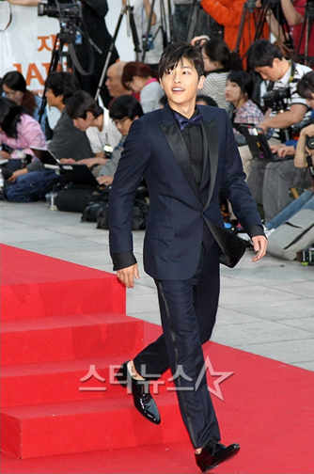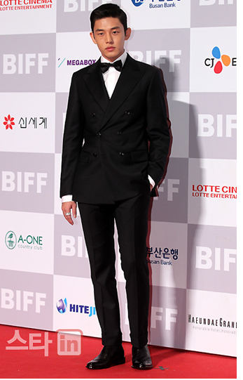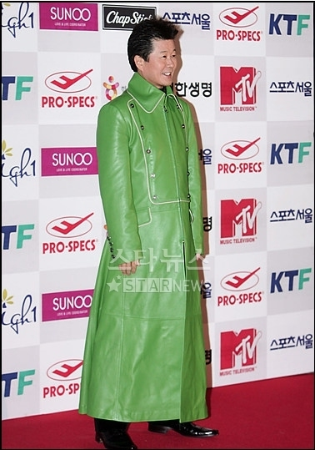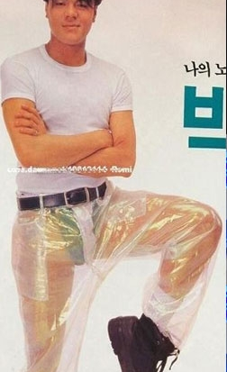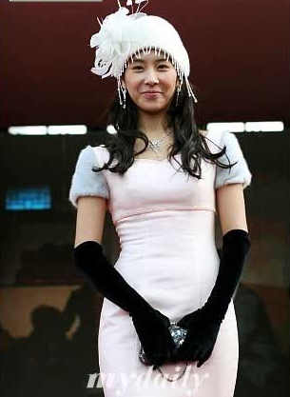

Superlatives Word Search Puzzles

- BEST
- CLEVEREST
- FUNNIEST
- HIGHEST
- HOTTEST
- KINDEST
- QUICKEST
- SILLIEST
- TALLEST
- WORST

I | Q | R | E | D | L | O | C | H | T | T | T | K | H | G
V | N | K | M | E | D | T | Q | G | S | Q | B | K | A | C
L | Q | Y | S | Z | D | S | W | E | E | X | R | M | R | M
L | K | R | E | T | T | E | B | S | T | Q | C | E | D | F
K | T | S | E | K | C | I | U | Q | T | L | D | T | E | R
F | U | L | P | I | M | T | N | O | E | I | S | R | R | X
T | S | E | L | L | A | T | R | V | W | E | E | F | K | W
F | R | E | I | S | A | E | E | J | G | G | U | I | O | T
A | U | Z | H | Z | C | R | F | N | N | N | N | B | A | S
T | E | N | U | I | E | P | O | O | N | D | C | K | I | E
T | S | S | N | S | I | L | L | I | E | S | T | Z | B | H
E | R | V | T | I | L | M | E | S | X | V | H | N | M | G
S | O | F | A | R | E | R | T | B | D | A | T | R | X | I
T | W | O | R | S | T | S | G | T | S | E | T | T | O | H
R | E | H | T | R | A | F | T | W | X | V | X | T | V | X

Superlative Questions

Young
*A part of your face (eyes, ears, nose, mouth, etc) that you like the most

*The best celebrity ever

Su
*A person who is the most trustworthy

*A thing or skill that you want to achieve or learn the most heartily

Min
*A person who you send the most text messages (friend, mom, dad, sister, brother, etc)

*The scariest insect or animal

Grace A
*The worst memory in your life

*The best memory in your life

Hyun
*The closest family member

*The most favorite teaching style

Miki
*A fashion style that you like the most for your boyfriend (casual, suit, etc)

*The most regrettable thing in your life

Dwann
*The worst thing you have ever done until you graduated the college

*The most precious thing or person

Sunny
*A thing that you want to invent or to create the most

*The most desired superpower (fly, transparent, etc)

Grace Park
*Your most favorite hair style for yourself

*The most dislikable person in your entire life

