Listening Lesson Plan

The interview about Bridget Jones’s Diary

Instructors | Level | Students | Length
Joung eun Kim  (Rian) | Advanced | 13 students | 50 minutes

Materials:
- Warming up Quiz sheet(15 copies)
- Dictation sheet(15 copies) & Pop Quiz sheet(15 copies)
- Bridget Jones’s Diary poster
- Listening CD & CD player
- White board & Board markers

Aims:
- To learn vocabulary and expressions for social conversations by listening the passage and dictate the sheet
- To practice speaking by discussing what your favorite movies
- To practice hearing by listening British accents
- To be able to pick up the fact from the listening passage by answer the pop quiz

Language Skills:
- Reading: warming up sheet
- Speaking: discus what is your favorite movie or movie star within groups
- Writing: dictation sheet and pop quiz sheet
- Listening: main actor and actress’s interview about the movie behind stroy

Language Systems:
- Lexis: words from the passage
- Discourse: guessing the meaning of the words from students
- Phonology: repeating words and correcting pronunciation

Assumptions:
- All students are girls in 20~30s
- Most students know what Bridget Jones’s Diary is and have watched it.
- Students have high abilities of listening and speaking in English
- Most students have had experiences with men.

Anticipated Errors and Solutions:
- Students may not be listen British accent
-> Keep play the CD and let them listen and listen again
- Students may not be able to answer the warming up quiz
-> Explain the words meaning at the first before hand out the sheet
- Students may not understand what the story in listening goings on
-> belief what the passage is after listening
- Students may need time to do each tasks
-> be flexible with time

References:
- “CNN the world’s news leader.” 2008. Published by 시사실용연구팀
- www.chonghab.co.kr/book
- movie.naver.com/movie

Lead-In
Materials: White board, Bridget Jones’s Diary poster
Time  5min | Set Up  Whole class | Procedure:  Hello everyone. How is today? (Ask each students)  Before we start, we are talking about this poster first. What do you think? (Show the poster)  (Elicit some information about the poster and write them on the board)  Ok, we are going to listen to some interview about this movie and talk about it. But before listen, we are going to go warming up first.

Pre-Activity
Materials: Warming up Quiz sheet, White board
Time  7min  3min | Set Up  Whole class  Pairs  Whole class | Procedure:  1. Pre-vocabulary  Instruction  Work with your partner. Read each sentences and Find right words from the box and I’ll give you 7min.  ( Hand out : Warming up Quiz)  Demonstration  Kelly Read #1 pleases. “If people like this, they suffer greatly from lack of food which sometimes leads to their death.” What think about it is ladies? Find the word in the box. Yes, right “Starve”  CCQ  Where get the words from?  How much time do you have?  Are you working with your partner?  Answer students if they have questions  Monitor and let them know how much time left  Check the answer together  Explain the meaning of the words  Elicit and guess what is about the interview from students

Main-Activity
Materials: CD & CD player, Dictation sheet, Pop Quiz sheet, White board
Time  5min  5min  5min  2min  3min | Set Up  Whole class  Individually  Whole class  Pairs  Whole class | Procedure:  1. Listening to the interview (get general ideas)  Instruction  This listening is about main actor and actress’s interview. They talk about some behind story of Bridget Jones’s Diary. And I’ll give you Dictation sheet. You listen and fill in the blank on your sheet. Pay full attention to listen it.  CCQ  Are you ready to listen and dictate?  What are you going to listen?  (Hand out: Dictation sheet)  (Play CD track#2)  Monitor and check what they have full attention  (Finish listening)  Ok, ladies. Let’s fill in the blank together. Jess Could you read the first sentence? And what’s the answer? Right! And next..  2. Listening for detail  Instruction  Listen the interview again and check the blank you filled. And understand whole story goings on.  (Play CD track#2 again)  (After listening)  I’ll give you POP Quiz and work with your partner. You have 2min  CCQ  Are you ready to listen?  Who is your partner for pop quiz?  How much time do you have?  Monitor  Help Students to get the answer when they have problems  Share the answer

Post-Activity
Materials: White board
Time  10min  5min | Set Up  Whole class  Groups  Whole class | Procedure:  1. Free Production – Discus about favorite movies  Instruction  Talking about what your favorite movies or movie star is?  And why are you like? Discuss within your group(3people)  CCQ  Are you working in a group?  What are you going to discus?  How long does it take?  Monitor actively  Share student’s opinions  Correct some errors(words or sentences) students made when they spoken  2. Closing  Elicit what was about the interview  Give homework  Make sentences using the words in the warming up sheet  Good job ladies. See you tomorrow

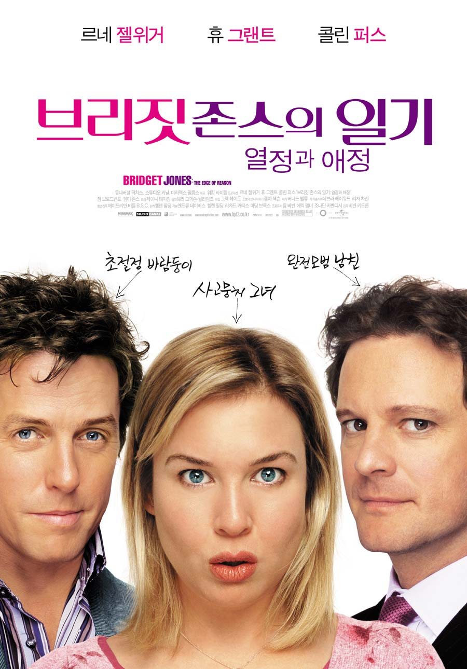

A. Warming up Quiz

Starve | gravy | chronicle
lousy | Real-life author | disrobe
Six-pack | Write ~ down | Play extras
Storm off

1. [ ]
If people like this, they suffer greatly from lack of food which sometimes leads to
their death.

2. [ ]
To write something on paper so that you do not forget it

3. [ ]
To leave a place or a person suddenly because you are very angry

4. [ ]
Remove someone’s clothes or position

5. [ ]
A box is divided by six spaces

6. [ ]
The person who really wrote books

7. [ ]
Play a role who is not main person.

8. [ ]
A sauce made from the juices that come from meat when it cooks.

9. [ ]
A series of events means to write about them or show them in broadcasts in the order in which they happened

10. [ ]
If you describe something as this word, you mean that it is of very bad quality or that you do not like it.

B. Dictation
Imagine a scenario in which a film’s male stars ( ) themselves on salads while its leading lady is tanking on the pounds. That’s what happened on Bridget Jones’s Diary, a ( ) of one woman’s struggle with alcohol, cigarettes, self-help books and a ( ) love life.  Renee Zellweger gained an English accent and 17 ( ) to bring Helen Fieding’s bestseller to the big screen. The Texan is proud of her celluloid cellulite.  Zellweger: The worse it was the better. We went to the first ( ) fitting and I was elated. I was elated! I thought, “Look at that. You know. Can we make it a little tighter so it scrunches up a little bit right there?”  CNN: How close was the ( ) to your b…. Did you have to…  Zellweger: It was constantly.. butt cam.. We had jokes about it, ( ) we called it. Yeah, they had a… It looked like a Chinese rickshaw, you know, where the cameraman would sit on it, seriously, with the camera here and they would, you know, be pulling the ECU on my rear.  Hugh Grant(costar): I found her sexy, but I like that. I like a bit of meat with my gravy. | The script called for Hugh Grant and Colin Firth to disrobe as well, going shirtless. That prompted their diets.  Golin Firth(costar): I do remember an absurd day where Hugh, Renee and I, all three of us, compared ( ). There was some challenge came from some quarter to lift up the shirts and finally put our money where our mouth is and display what we had achieved with all this ( ) – you know, whether there really was a six-pack in any body. Renee had a very impressive one-pack, I seem to remember.  There were many Dear Diary Moments on the set, including the day real-life authors Jeffrey Archer and Salman Rushdie played extras in a Publishing party scene.  Grant: Lord Archer ( ) the set after the first day when he realized that he didn’t have any lines – had to be offered lots of money to come back, and.. But Salman, I learned to love. And I made him play Pick an Extra, where you have to have sex with an extra. And he loved that game.  Grant apparently ready to joke about his sexual ( )… Is anyone writing this down?  Sherri Sylvester, CNN Entertainment News, Hollywood.
C. POP Quiz

1. Does she like getting a fat?

2. What joke did they make for the camera?

3. Where the movie story comes from? What’s the name of it?

## Listening Script ##

Imagine a scenario in which a film’s male stars starve themselves on salads while its leading lady is tanking on the pounds. That’s what happened on Bridget Jones’s Diary, a chronicle of one woman’s struggle with alcohol, cigarettes, self-help books and a lousy love life.  Renee Zellweger gained an English accent and 17 pounds to bring Helen Fieding’s bestseller to the big screen. The Texan is proud of her celluloid cellulite.  Zellweger: The worse it was the better. We went to the first wardrobe fitting and I was elated. I was elated! I thought, “Look at that. You know. Can we make it a little tighter so it scrunches up a little bit right there?”  CNN: How close was the camera to your b…. Did you have to…  Zellweger: It was constantly.. butt cam.. We had jokes about it, Butt cam, we called it. Yeah, they had a… It looked like a Chinese rickshaw, you know, where the cameraman would sit on it, seriously, with the camera here and they would, you know, be pulling the ECU on my rear.  Hugh Grant(costar): I found her sexy, but I like that. I like a bit of meat with my gravy. | The script called for Hugh Grant and Colin Firth to disrobe as well, going shirtless. That prompted their diets.  Golin Firth(costar): I do remember an absurd day where Hugh, Renee and I, all three of us, compared abdominals. There was some challenge came from some quarter to lift up the shirts and finally put our money where our mouth is and display what we had achieved with all this training and working – you know, whether there really was a six-pack in any body. Renee had a very impressive one-pack, I seem to remember.  There were many Dear Diary Moments on the set, including the day real-life authors Jeffrey Archer and Salman Rushdie played extras in a Publishing party scene.  Grant: Lord Archer stormed off the set after the first day when he realized that he didn’t have any lines – had to be offered lots of money to come back, and.. But Salman, I learned to love. And I made him play Pick an Extra, where you have to have sex with an extra. And he loved that game.  Grant apparently ready to joke about his sexual exploits… Is anyone writing this down?  Sherri Sylvester, CNN Entertainment News, Hollywood.

