Grammar Lesson Plan

Present Continuous

Instructors | Level | Students | Length
Joung eun Kim  (Rian) | High Beginner | 13 students | 40 minutes

Materials:
- White board & Board markers
- Vocabulary sheet (15 copies)
- Practice1 sheet (15 copies) & Practice 2 sheet (15copies)
- Discussion sheets (6 different copies)

Aims:
- Let students know how to express actions at the moment by using present continuous
- To practice speaking by repeating words and sentences
- To improve students integrated skills by discussion activity
- To learn vocabulary by basic vocabulary activity

Language Skills:
- Reading: drill (repetition) sample sentences
- Speaking: discussion sheet
- Writing: practice 2 sheet (fill in the blank)
- Listening: discussion in post activity

Language Systems:
- Lexis: explain meaning of words from vocabulary activity
- Discourse: explain a picture using present continuous
- Phonology: repeat words and sentences

Assumptions:
- All students know about present simple.
- All students know how the class is going
- Seats in the class are arranged horseshoes shape.
- Most students can find out the pattern of sample sentences easily.

Anticipated Errors and Solutions:
- Students may not understand what present continuous is.
→ Try to show actions more which could be explained by present continuous.
- Students may feel difficult “Practice 2 sheet”
→ Let them read sentences step by step and solve some of questions together.
- Students may not make present continuous sentences in discussion section.
→ Give them some clue or discuss pictures together.
- Students may not pay attention well during class.
→ Let them speak to more and more by reading sentences together.

References:
- http://www.eslflow.com/grammarlessonplans.html
- Grammar in use, by Raymond Murphy
- http://dic.naver.com/
- http://www.english-test.net/toeic/listening/waste_disposal.html

Lead-In
Materials: White board & Board marker
Time  5min | Set Up  Whole class | Procedure:  Hello everyone. How is today?  It’s a grammar class today. We are going to study present continuous.  Does anybody know about present continuous?

Pre-Activity
Materials: White board & Board markers, Vocabulary sheet
Time  5min | Set Up  Whole class | Procedure:  1. Pre – vocabulary  Instruction  Before we study present continuous, we are going to study vocabulary first. Look at the board. Repeat after me.  (Read vocabularies and then explain meaning)  I’m going to hand out vocabulary sheet. It’s going to be your homework. I’ talk to it later.  ( Hand out : Vocabulary sheet )

Main-Activity
Materials: White board & Board markers, Practice Sheet1 ,2,
Time  10min  10min | Set Up  Whole class  Individually  Whole class  Group  Whole class | Procedure:  1. Get general ideas  Instruction  Look at the board. Let’s read the sentences together.  Ok. Can you see a pattern in these sentences?  Good. These sentences mean about the action at the moment. (Show Teacher’s action) what am I doing? (Point a student out) What is she doing?  OK. I’m handing out practice sheet. Match pictures and sentences. I’ll give you 3min and you work it alone.  CCQ  What are you going to do?  Are you working alone or together?  How much time do you have?  ( Hand out : Practice sheet1 )  Monitoring  Time’s up. Let’s check it together  Feedback  Was it fun?  Was it difficult?  You did great job.  2. Get detail ideas  Instruction  Look at the board. You can see the pattern of present continuous. You can express an action at the moment by using ING. Let’s make sentences together. ( to do with all students and each student)  Ok, I’m handing out practice sheet. Doing with your group. (make a group) I’ll give you 5min  CCQ  What are you going to do?  Are you working alone or together?  How much time do you have?  ( Hand out : Practice 2 sheet )  Monitoring  Ok, Ladies. Let’s check the answer together  Feedback  Was it fun?  Was it difficult?  You did great job.

Post-Activity
Materials: Discussion sheet
Time  10min | Set Up  Whole class  Group  Whole class | Procedure:  1. Free production  Instruction  Now, you are going to discuss about a picture that I’ll give. Working with your group and talk about this picture using present continuous. I’ll give you 5min.  CCQ  What are you going to do?  Are you working alone or together?  How much time do you have?  ( Hand out : Discussion sheet each group )  Monitoring  Ok. Time’s up. Let’s share the ideas.  Feedback  Was it fun?  Was it difficult?  You did great job.  2. Conclusion  Review:  We studied present continuous today. It expresses the action at the moment. I hope you can use that expression to your friends, family whoever.  Homework  You’re going to have a vocabulary test tomorrow so today homework is write down the vocabularies we did today 10times on your note.  Good Job, ladies. See you tomorrow

## Write down on white board ##

- Today vocabulary (vocabulary sheet)

- Sample Sentences (for Main activity 1)
1) The teacher is not sitting at the moment. He is standing.
2) Look! The baby is smiling.
3) Are you drinking tea? No, I am not. I am drinking coffee.
4) What is he reading? He is reading a navel.

- Substitution Table (for Main activity 2)
l | am | go  make  buy  sell  drink | Ing | home  cup cakes  coat  shoes  tea
You  They  We | are
She  He  It  Sam  Lily | is

A. Vocabulary

Locate | Assign a location to  Ex) Where is North Pole located?  The house is located by the river.
Charge | The price charged for some article or service  Ex) What is the charge for this room?  He charged two dollars.
Review | A new appraisal or evaluation; examinaion  Ex) The committee is reviewing its decision.
Refuse | Show unwillingness towards; refuse to accept  Ex) He refused to meet her.  We refused to discuss to the question.
Complain | Express complaints, discontent, displeasure, or unhappiness  Ex) He never complains about the pain.  She complained to me of his unkindness.

B. Practice 1
Match the sentences and the pictures

A boy is riding a bicycle.
The old lady is holding an umbrella.
Your girlfriend is having a bath in a tub.
My mother and brother are watching TV.
A man is listening to the music.

C. Practice 2

1. Complete this telephone conversation with the present continuous. Use the verbs in brackets.

Sam:  Lily:  Sam:  Lily:  Sam:  Lily:  Sam:  Lily:  Sam:  Lily:  Sam: | Hi, Lily. It’s Sam  Hello, Sam.  What (do) you ? Are you busy?  Well, actually, I (prepare) for the meeting this afternoon.  Me too! I (finish) my report for it now. The other thing is that I (write) an up-to-date contacts list for everyone at the meeting. Do you remember Mayu Kajima?(work) she still for Landmark International?  No. I think she (sell) for chocolate these days.  Yes. Do you have her number?  I don’t, but Anna’s here. Let me ask her. Hold on a moment.  She (find) just it now. Here it is. It’s a mobile number. It is 077….  Hold on Lily. I (look) for a pen. OK. Go ahead.  07780 567 3784  Great. Thanks, Lily. See you later.

2. Put the verb into the correct form. Sometimes you need the negative (I’m not doing, etc)

1. Laura phoned me last night. She’s on vacation in France. She (have)
a great time and doesn’t want to come back.

2. I want to lose weight, so this week I (eat) lunch.

3. I think Dave and Amy had an argument. They (speak) to each
other

Discussion
WHAT ARE THEY DOING ?

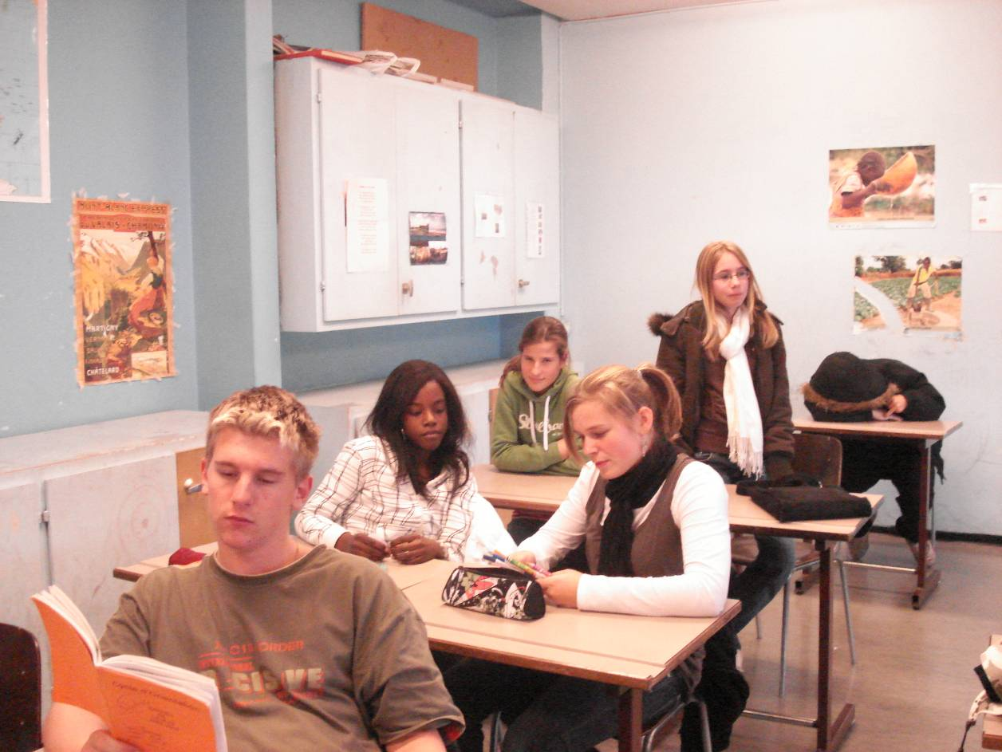

D. Discussion
WHAT ARE THEY DOING ?

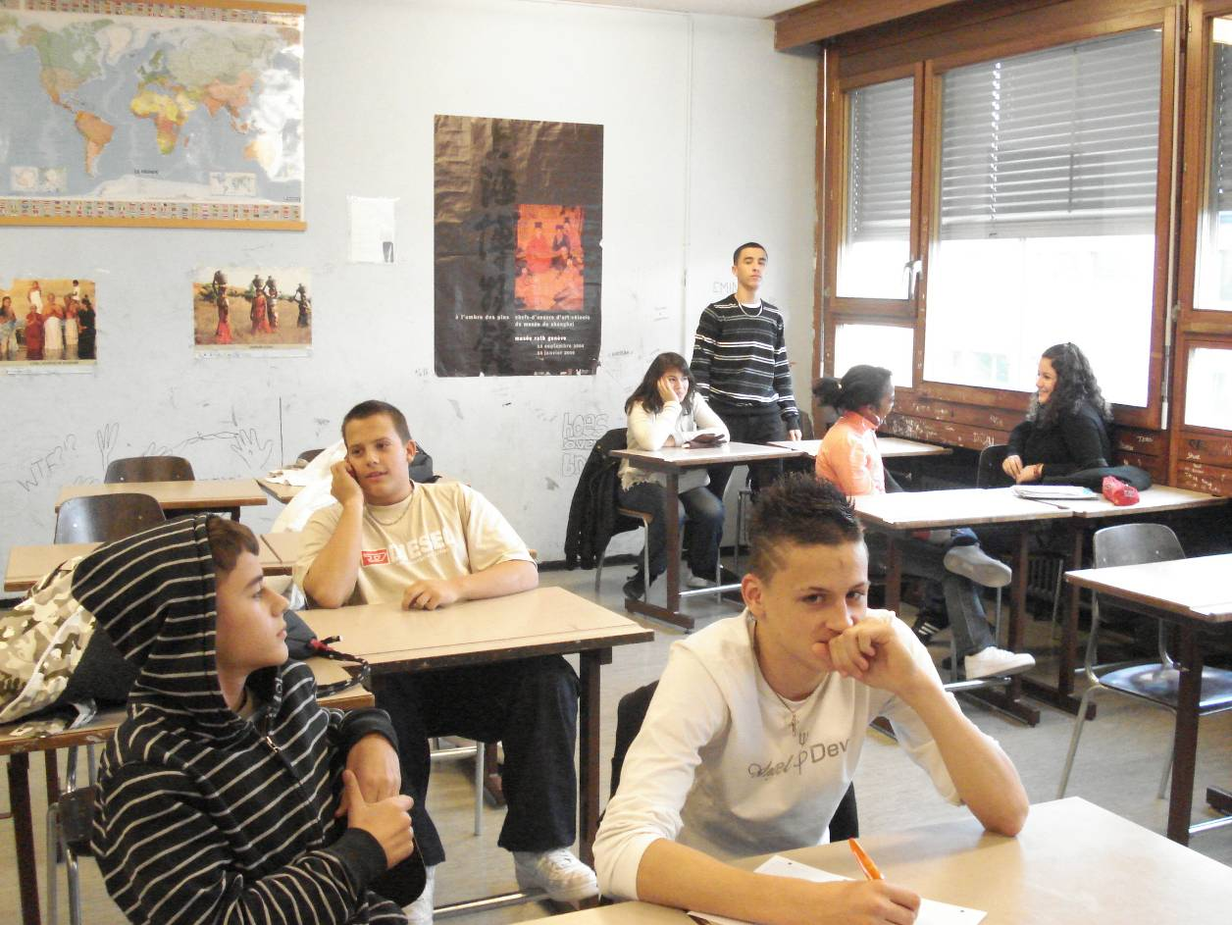

D. Discussion
WHAT ARE THEY DOING ?

D. Discussion
WHAT ARE THEY DOING ?

D. Discussion
WHAT ARE THEY DOING ?

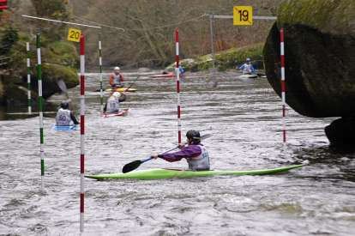

D. Discussion
WHAT ARE THEY DOING ?

