Speaking Lesson Plan

What do you think about having relationship with foreigner?

Instructors | Level | Students | Length
Joung eun Kim  (Rian) | Advanced | 13 students | 40 minutes

Materials:
- White board & Board markers
- Vocabulary sheet (15copies)
- Discussion sheet (15copies)
- Note taking sheet (15copies)

Aims:
- To practice speaking by debate activity
- To improve students’ expression by discussion activity
- To learn words related interracial relationship by vocabulary activity
- To develop students’ ability which respond immediately by debate activity

Language Skills:
- Reading: case 2 in discussion sheet
- Speaking: discussion & debate sheet
- Writing: note taking sheet
- Listening: students share the ideas during discussion and debate activity

Language Systems:
- Lexis: explain meaning of words from vocabulary activity
- Discourse: discuss and debate about interracial relationship
- Phonology: repeat words

Assumptions:
- The seats are set 3 groups.
- All students’ speaking ability is high.
- Most students had a relationship with foreigner or had met them.
- All students are women and most students are in 28-31 (general marriage age)

Anticipated Errors and Solutions:
- Students may have trouble during debate activity.
→ Let them cool down and make other student to speak.
- Some students speak too fast so other students can’t get a chance to talk.
→ Ask less talk students about their opinion.
- Teacher may talk too much during the class.
→ Try not to talk teacher’s opinion.
- Students may talk about only one side of the matter.
→ Introduce various case of the matter.

References:
- http://cyhome.cyworld.com/?home_id=a4043015&postSeq=7846681
- http://www.cyworld.com/anasmile/3388705
- http://endic.naver.com/

Lead-In
Materials: White board & Board markers
Time  5min | Set Up  Whole class | Procedure:  Hello everyone. How are you today?  This TESOL course will be done next week. What are you going to do after this course?  (Give Students chance to speak each )

Pre-Activity
Materials: Vocabulary sheet, White board & Board markers
Time  5min | Set Up  Whole class | Procedure:  1. Pre – vocabulary  Instruction  Before we’re going to the main study, we’ll have quick vocabulary. Look at the board.  (Explain words on the board )  This is your today vocabulary sheet. Study yourself.  ( Hand out : vocabulary sheet )

Main-Activity
Materials: Discussion sheet, Note-taking sheet
Time  10min  10min | Set Up  Whole class  Group  Whole class  Group | Procedure:  1. Discussion  Instruction  Today our main subject is “What do you think about having relationship with foreigner?”  I’m going to give you some cases of Interracial marriage.  (Quickly introduce the cases)  Share your opinion with your group and I’ll give you 5min.  CCQ  What are you going to do?  Are you working alone or together?  How much time do you have?  ( Hand out : discussion sheet )  Monitoring  Time’s up. Let’s share it together  Feedback  Was it fun?  Was it difficult?  You did great job.  2. Find advantage & disadvantage  Instruction  Ok. Now let’s find what is advantage and disadvantage of the interracial relationship.  Work with your group and I’ll give you 5min.  CCQ  What are you going to do?  Are you working alone or together?  How much time do you have?  ( Hand out : Note-taking sheet )  Monitoring  Ok, Ladies. Let’s share it together  Feedback  Was it fun?  Was it difficult?  You did great job.

Post-Activity
Materials: No materials needed
Time  10min | Set Up  Whole class  Group | Procedure:  1. Free production  Instruction  Ok. Let’s image you have a non-Korean boyfriend and you have to decide to get married him or not. What will you do?  I want you to debate.  ( Set who are positive and negative)  Work with your group and I’ll give you 5min.  CCQ  What are you going to do?  Are you working alone or together?  How much time do you have?  Monitoring  Ok. Time’s up. Let’s share the ideas.  Feedback  Was it fun?  Was it difficult?  You did great job.  2. Conclusion  Review:  Today, we talked about the interracial relationship. It was nice talk and you did god job.  Homework  No homework today.  Thank you all. See you tomorrow

A. Vocabulary

Interracial marriage | conducted, involving, or existing between different races or ethnic groups
majority | People or things in a group are more than half of them.
rural area | A place is far away from large towns or cities.
evidence | Anything that you see, experience, read, or are told that causes you to believe that something is true or has really happened.
phenomenon | Something that is observed to happen or exist.

B. Discussion

Case 1

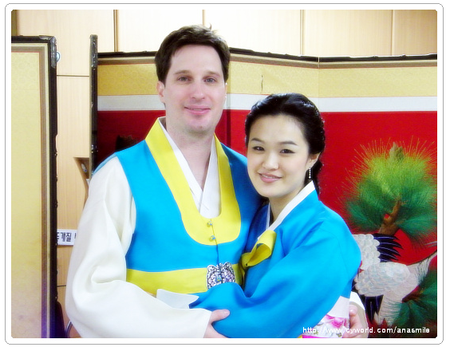

Case 2

There were 43,121 international marriages between Koreans and non-Koreans in 2005, up 21.6 percent from a year earlier, according to Korea National Statistics Office data published in the Korea Times newspaper on March 30, 2006. 11% of couples who married in 2007 were international couples. The majority of them involve South Korean males married to foreign females, from China, Japan, Vietnam, the Philippines, United States, Mongolia, Thailand, and Russia. However, majority of these brides are Han Chinese and Vietnamese. The most common explanation for this phenomenon is that there is a lack of South Korean women who are willing to marry men living in rural areas.

In recent times, about one third of South Korean men in rural areas married women from abroad, according to Korea National Statistics Office data published in the Chosun Daily newspaper on March 30, 2006.Chosun Ilbo Marriages between South Korean men and foreign women are often arranged by marriage brokers or international religious groups. There is mounting evidence to suggest that there is a statistically higher level of poverty, violence and divorce in the Korean men married to foreign women cohort.

From Wikipedia, the free encyclopedia

C. Note taking

What do you think about having relationship with foreigner?

Advantage

Disadvantage

