Listening Lesson Plan

Titanic

Instructor:  Tina |  | Level:  Intermediate |  | Students:  12 |  | Length:  50 minutes

Materials:
- White-board &Maker & Remover, Stopwatch
- A CD Player and MP3 Files (Track 1~2; about 4min each)
- Worksheet #1 for Sentence and pictures Matching(13 copies)
- Worksheet #2 for Eliciting (13copies)
- Worksheet#3 ,#3-1 for listening and filling the gap(13 copies)
- Worksheet#4 ,#4-1 for Expression drills, listening and filling the gap(7 copies)
- Let’s do Quiz #5, for teacher to test Ss’s listening comprehension (1 copies)
-BBC Reference sheet #6 for materials of roleplay (4 copies)

Aims:
- To practice listening, vocabulary and expressions by doing gap-fills
- To predict situations by several pictures which is related to the cruise ship disaster
- To learn reading and writing by doing a matching worksheet, listening to a teacher's
explanation
- To be able to complete sentences by practicing words and chunks repeatedly.

Language Skills:
-Listening : listening to the music, presentation and what the teacher says to the student and
listening Ss saying through activities
-Reading : read the worksheets , the script and Articles
-Speaking : prediction, answer to T question, talking with classmates by using expression points.
- Writing: To practice role play, writing script

Language Systems:

- Lexis: gap-fills & vocabulary used in music and listening script.
- Function: The use of words in common expressions and common topic of articls
- Discourse: Using pictures and expressions talking
- Phonology: When the CD player is being played, Ss listen to the speaker

Assumptions:

- Ss have seen the movie ‘Titanic’ on TV or Internet. etc.
- Ss already know the teacher's style of teaching and the pace of the course
- Ss can generally communicate effectively using complex sentence forms.
- Most Ss are more than 20 years old and know about Cruise ship disaster in the world.

Anticipated Errors and Solutions:
- Some Ss will have a difficulty in doing the comprehension question worksheet.
→ Have Ss do themselves first and give some help to get the gist of the context
- Ss may need more time to work on doing activity
→ If it takes longer than 5 minutes, quit the job and sharing the answers
- If total time is too short or done earlier than planned;
→ the former : Cut pictures for eliciting and reduce Answering time.
→ the latter : Do extra roleplay or use extra worksheet or listen the today’s song
- If there are no active communications or interactions;
→ Teacher can monitor and give questions directly to the group or individually
- Some Ss have never seen or heard about Titanic .
→Give a chance to Ss who can explain about Titanic, and T gives some additional Information if it is necessary.

References:
- http://www.eslnotes.com/movies/html/titanic.html
- http://clien.career.co.kr/cs2/bbs/board.php?bo_table=image&wr_id=3680330
- http://www.koreaherald.com/pop/NewsFlashRight.jsp?newsMLId=20120115000198
- http://www.bbc.co.uk/news/world-europe-16564789

Lead - In
Materials: white board
Time | Set Up | Teacher Activity
3min | Whole class | Procedure:  Hello everyone? Welcome to my class again. How are you?  What did you guys do last weekend?  (Ss answer “watched movie, visited somewhere, etc.").  Then, how was it? Was it good? If not, then what do you want to  Do, if you are allowed to enjoy the vacation with enough money.  (Ss answer “travel around the world, going on shipping, etc.”)  -Write them on the board  [instruction]  you know that, there are some luxury cruise ships in the word,  (Ss answer “Yes I have heard about it, and seen it on the TV .”)  If I someone who want to take a cruise ship, please pay attention on today’s topic.  Today, we will listen to the music and learn about the recent  Cruise ship disaster.

Pre - Activity
Materials: Pictures(for Prediction) sentences worksheet #1, Board
Time | Set up | Teacher Activity
10min | Whole class  Individually  Whole class | Procedure:  Ⅰ. New Sentences matching & Prediction  [instruction]  Before we listen to an article, we are going to learn about some important  sentences for this chapter! I will give you a hand out which is related today‘s  topic. and you will see the box including several sentences the bottom of  a paper.  You are going to watch the pictures, read the sentences and find the  matching sentence from the listed below box.  Then write the sentence under the each picture. You will work individually  and have 3 minutes to do this.  (Distribute the “ Pictures sentences worksheet #1” )  [Eliciting]  Look at these pictures, what do you think about these pictures?  (Ss answer “ship disaster, sinking the ship , etc. )  Once again, there are two things that you have to do with this worksheet,  First, Match the sentences to the pictures.  Second, Find what these pictures stand for.  [Demonstration]  For example, (with pointing the first picture) and ask like that “What is it? “  “Can you make a sentence? “  -Wait for Ss’s answer.  Yes, you’re correct. The answer is ‘The ship was near the tiny Tuscan island of Giglio, off the west coast of Italy’.  Now let us find this sentences from the below box and write it next to  the definition.  [CCQ]  Who are you working with?  How much time do you have?  What do you do with these pictures?  -Monitor the Ss carefully, check if they write the answers  -Answer if they ask question  -Give time warning: “You have_____Minutes left “, if Ss need more time , T can  give 1 or 2 minutes flexibly  -Check the answers: Make different students to read each questions and answer.  -Make Ss Elicit the meaning Teacher can choose Ss  -If all students are struggling, T should give more explanation  for the pictures if necessary  [Feedback]  How was it ?  Do you feel difficult to do this activity?  If then what makes you feel that?
Main Activity
Materials: MP3 Player, worksheet #2, worksheet #3,#3-1(answer),#4,#4-1(answer),#5
Time | Set Up | Teacher Activity
13min | Whole class  Individually  whole class | Procedure:  Listening Audio –Clip Main Activity 1  [instruction]  Here is one music video, Before we listen the music, look at this  pictures  (Showing the “Titanic’s movie poster and Celine dion photo / worksheet # 2)  [Eliciting]  Do you know who is she? Can you guess the title of this song?  (Ss answer “Titanic, celine dion, My heart will go on”, etc, )  Yes, It is the Titanic soundtrack “My heart will go on”, the singer is Celine Dion.  Now you are going to listen to music. Listen carefully and fill the gap.  [CCQ]  What are you doing now?  Do you have to work in pair?  Do you have enough time to fill the gap after the music quit?  What do you have to do with listening the music?  -Distribute worksheet #3  (about for 4 minutes),  - Monitor Ss answering and decide to give chance to the Ss to listen the Audio-  Clip again. If Ss don’t answer the worksheet, play the Audio-Clip with Chunk.  (After listening the Audio-clip)  -Check the answers :  -Let’s check the Ss Answer on by one. How was the presentation? If Ss need  the answer sheet #3-1, T should give it to them.  [Feedback]  OK, let’s move to the next Activity 2, before we finish it,  How was it ?  Do you feel difficult or easy to do?  Do you think that it helps you improve your listening skill?

8min  2min  4min | In Pair  Individually  In Pair  Whole class | Ⅱ. Fill the blank –Main Activity 2  [instruction]  Ok Guys good job,  Let’s take a seat as a pair. You may have a student next to you as a partner.  (“you two, you two “, T can help Ss grouping by showing the gesture )  You can work in pair!  Does anybody remember cruise ship disasters in the world?  (Ss answer that Cheon an battleship sinking, the artificial oil spill in the coastal areas in Taean)  Last month, there was horrible cruise ship disaster that took place off Italy.  Here are some articles related Cruise ship disaster.  -Distribute Worksheet #4  Each pair has to fill the gap the article with your partner while listening it. Then you are going to explain the meaning of the words to your partner. It’s ok to use worksheet #1, if it is needed  You will have 4 minutes.  [CCQ]  Are you working alone?  What are you supposed to do?  Which sheet can help you to find answer?  How much time do you have?  -Give time warning: “You have_____Minutes left “, if Ss need more time ,  T can give 1 or 2 minutes flexibly  (4 minutes later)  Ok Times up, I will give you the answer sheet, pls check the answer with your partner. You will have 2 minutes.  -Distribute answer sheet #4-1,  -Give 2 minutes to Ss to check answers.  -While Ss checking it, T should prepare the Quiz sheet#5(not distribute it).  -After Ss done it, T opens the Quiz sheet #5 and asks to all Ss the question so  that Ss can feel free to answer the questions.  (for example, ok guys now I am going to ask something related this article,  anyone answer for my question feel freely.)  -If Ss can’t answer well, T can write the answer on the whiteboard.  -T can point out Ss who seems knowing the answer but cant speak loudly.  Good job everyone, I think most of you can understand this article well,  if you have any questions, raise your hand and ask me.  [Feedback]  OK,Good job everyone  How do you think working together with your partner?  Which prefer do you like when you do activity just alone or with  your partner?  Do you think that it helps you improve your listening skill?

Post - Activity
Material: BBC news article sheet #6, pencil, note
Time | Set Up | Teacher activity
10min | Group  Whole Class | Procedure:  Ⅰ. Free production  [instruction]  - T should write the title on the white board  “CNN Live TV show”  -T ask Ss to be grouped 3.  Let’s take make 3 groups.  (“you five, you five “, T can help Ss grouping by showing the gesture )  You can work in Group!  The title of this activity is Let’s Roleplay :CNN ~ !  -T pointed the title written on the white board.  Let’s imagine that your group is in the CNN TV Studion in London.  Some Ss are interviewers and others are reporter or announcer  or anchor. The others are one of the following people.  Today’s interview is about “ Cruise ship disaster off Italy”.  - A passenger who survived  - A locall ferry captain  - A helicopter pilot who assisted the rescue.  - A Korean who rescuded.  Each group will have 5minutes.  -Distribute reference #6.  If you want, you can refer the article by BBC, but if you don’t need it,  There is no problem whether you produce the script by yourselves.  [CCQ]  Are you working alone?  How long you have to work?  Should you follow the article?  -T let Ss know if the time left one minute,  -Share Ss’s activity, if running out of time, take 1 groups as volunteers .  [Feedback]  How do you feel when you did roleplay ?  How was it ?  Do you think which activity is good for you to improve english skill?  II. Conclude lesson.  (Give a homework).  Did you enjoy today’s lesson?  Tomorrow’s assignment is as follows.  Find some articles related the cruise ship disaster.  Good job today, See you tomorrow!

Picture sentences worksheet #1
Match the Sentence to the appropriate pictures. What this pictures stands for?
- 2)
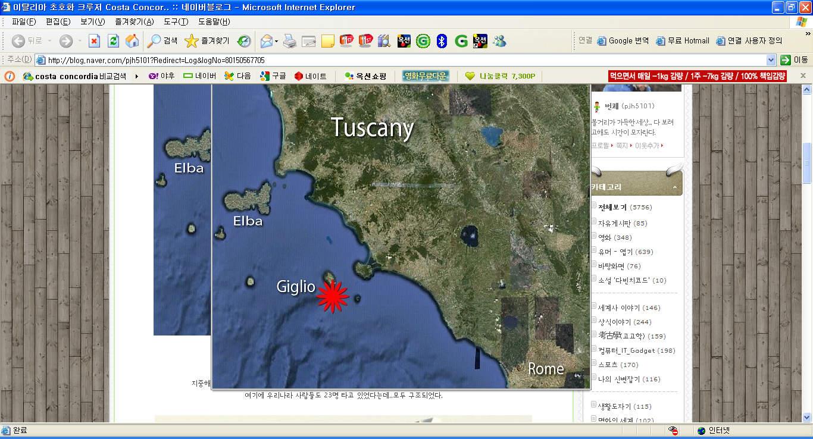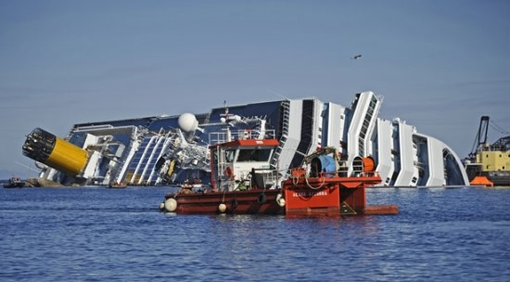

3) 4)
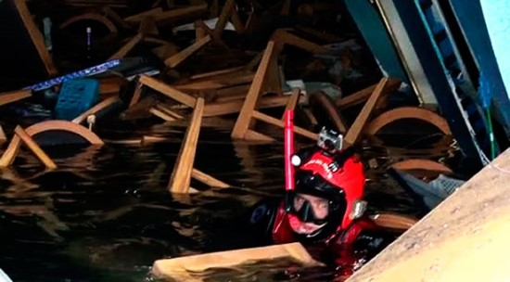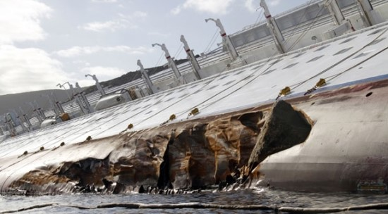

5) 6)
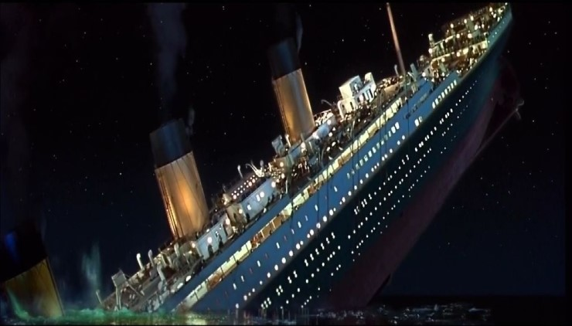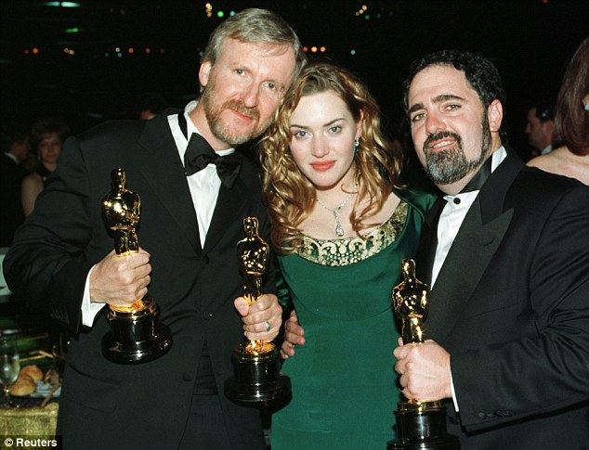

Ship lists to starboard, The lower side of ship is damaged.
Divers continue to look for survivors.
The ship was near the tiny Tuscan island of Giglio, off the west coast of Italy.
Titanic was nominated for 14 academy awards and won 11 Oscars..
The Titanic is going to sink soon.
Worksheet # 2
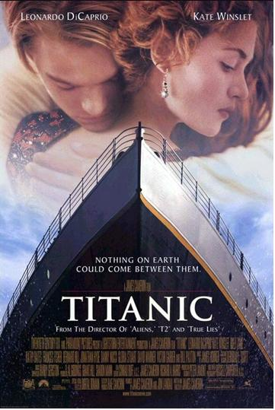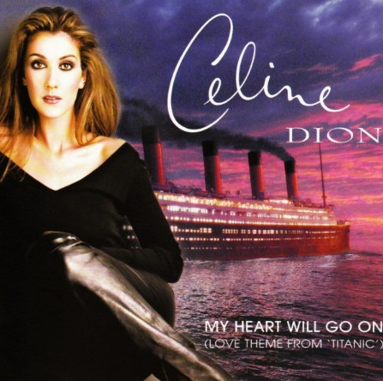
worksheet #3
Listen to the Music and fill the gap
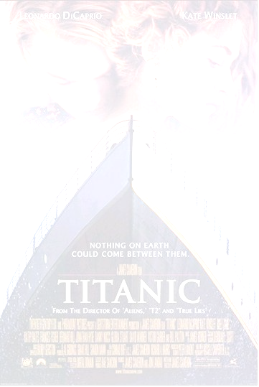
My heart will go on / Song by: Celine Dion
Every night in my dreams
I see you, I feel you,
That is _I you go on

Far _______ the distance and ________ between us
You have come to show you go on

Near, far, wherever you are,
I believe that the heart _____ go on.
Once more, you open the door
And you`re _____ in ____ _______,
And my heart will go on ____ ___

Love ____ _______ ___ one time and last for a lifetime
And never let go ____ we`ve ______
Love was when I loved you
one true time I hold to
In my life we`ll _________ go on.

Near, far, wherever you are,
I believe _____ ____ ________ does go on
Once more, you open the door
And ___________ _______ in my heart,
And my heart will go on ____ ____

You`re here, there`s nothing ___ ______

And I know that my heart will go on.
We`ll _____ forever this way
You are ______ in my heart
And my heart will go on and on
Answering for worksheet #3-1
.
Every night in my dreams
I see you, I feel you,
That is how I know you go on

Far across the distance and spaces between us
You have come to show you go on

Near, far, wherever you are,
I believe that the heart does go on.
Once more, you open the door
And you`re here in my heart,
And my heart will go on and on

Love can touch us one time and last for a lifetime
And never let go till we`ve gone
Love was when I loved you
one true time I hold to
In my life we`ll always go on.

Near, far, wherever you are,
I believe that the heart does go on
Once more, you open the door
And you`re here in my heart,
And my heart will go on and on

You`re here, there`s nothing I fear

And I know that my heart will go on.
We`ll stay forever this way
You are safe in my heart
And my heart will go on and on
Main Activity worksheet #4

It was like the Titanic!

In the Mediterranean, a luxury cruise Costa Concordia as the giant -tonne
hit rocks .
The cruise ship was near the Tuscan island of Giglio, off the west coast of Italy,
North of Rome on Friday evening. The lower side of it was damaged by the rocks.
The Survivors among the passengers said, “It was like the Titanic”.

When the ship hit the rocks, the ship soon listed to . There were terrible
scenes on board as people to survive.
At first passengers it was an electrical . Passengers rapidly realized
it wasn’t. To make things worse, some lifeboats were not for 45 minutes .
Many survivors told how the chaos resembled a scene from the 1997 film “Titanic “.

Passengers complained there was no instruction on to the ship.
This included a South Korean couple on their honeymoon! Another 40 are still missing.
Divers continue to look for survivors. The Captain has been .

Note: It is 100 years since the Titanic hit an iceberg in the Atlantic and sunk in 1912.
On April 15th, 1912, the Titanic, the largest and most luxurious passenger ship built until that time, struck an iceberg in the North Atlantic Ocean while on its maiden voyage from South hampton, England to New York City. 1,517 of the ship’s 2,207 passengers died when the great ship---which was generally thought to be unsinkable---went down to the bottom of the ocean floor just two hours after striking the iceberg. Among the dead were some of the richest people alive, but in fact the majority of those who died were relatively poor people who were trapped in the bottom of the ship, in what was called the ‘steerage’ quarters.
In 1997, this titanic disaster was re-created by Hollywood director James Cameron was created as a film. James Cameron’s epic romance won 11 Academy Awards out of 14 nominations.

Answering worksheet #4-1

It was like the Titanic!
In the Mediterranean, a luxury cruise Costa Concordia as the giant 114,500-tonne
hit rocks .
The cruise ship was near the tiny Tuscan island of Giglio, off the west coast of Italy,
North of Rome on Friday evening. The lower side of it was damaged by the rocks.
The Survivors among the 4,000 passengers said, “It was like the Titanic”.

When the ship hit the rocks, the ship soon listed to starboard. There
were terrible scenes on board as people fought to survive.
At first passengers were told it was an electrical fault. Passengers rapidly realised
it wasn’t. To make things worse, some lifeboats were not launched for 45 minutes .
Many survivors told how the chaos resembled a scene from the 1997 film Titanic.

Passengers complained there was no instruction on how to evacuate the ship.
This included a South Korean couple on their honeymoon! Another 40 are still missing.
Divers continue to look for survivors. The Captain has been arrested.

Note: It is 100 years since the Titanic hit an iceberg in the Atlantic and sunk in 1912.
On April 15th, 1912, the Titanic, the largest and most luxurious passenger ship built until that time, struck an iceberg in the North Atlantic Ocean while on its maiden voyage from South hampton, England to New York City. 1,517 of the ship’s 2,207 passengers died when the great ship---which was generally thought to be unsinkable---went down to the bottom of the ocean floor just two hours after striking the iceberg. Among the dead were some of the richest people alive, but in fact the majority of those who died were relatively poor people who were trapped in the bottom of the ship, in what was called the ‘steerage’ quarters.
In 1997, this titanic disaster was re-created by Hollywood director James Cameron was created as a film .
James Cameron’s epic romance won 11 Academy Awards out of 14 nominations.

Let’s do Quiz # 5 –For Teacher

Don’t distribute this sheet, T can use this questions at the end of Main Activity 2.

- Name the Seas ?
- Name the ship in the disaster?
- Name the island ?
- Name the other famous ship ?
- What happened in 1912?

Think of five things you know about the Cruise ship Costa Concordia disaster.
Then add five things you know about
Titanic Sinking. What similarities are there?

Cruise ship Costa Concordia  1.  2.  3.  4.  5. | Titanic  1.  2.  3.  4.  5.

BBC Reference Sheet # 6

15 January 2012 Last updated at 13:55 GMT
http://www.bbc.co.uk/news/world-europe-16564789

Costa Concordia: Italy cruise ship survivors found

Three survivors have been found on the stricken cruise ship Costa Concordia, more than 24 hours after it ran aground off the Italian coast. An Italian crew member with a serious leg injury has now been airlifted to the mainland, hours after a South Korean couple were rescued. Three people are confirmed dead.
The captain has been arrested on suspicion of causing deaths. He denies claims by prosecutors that he left the ship before evacuation was complete.
First officer Ciro Ambrosio has also been detained The number of people unaccounted for has now fallen to 17, Tuscan regional official Enrico Rossi said. In all, more than 4.000 people were on the cruise ship when it got into difficulties on Friday night.
The ship's operator, Costa Crociere, said the vessel had been following its regular course when it hit a submerged rock.
Captain Francesco Schettino insisted he had been last to leave the ship, and said the rock was not marked on his nautical chart. "It indicated that there was water deep below," he told Italian TV. "There shouldn't have been such a rock." Police are investigating why the accident happened in calm conditions.
The honeymooning South Korean couple were located after rescuers heard voices from a cabin two decks down on the half-submerged ship late on Saturday. They were reached a few hours later.The couple, both 29 years old, were both in good health when they were brought ashore.

