Seasons

Instructor:  Ji hye, park | Level:  5~7years old | Students:  13 | Length:  30 minutes

Target Vocabulary:
spring, summer, fall, winter
warm, hot, cool, cold

Target Sentences.
It’s__________. (spring, summer, fall, winter)
It’s__________. (warm, hot, cool, cold)

Materials:
Worksheet, Season’s flash cards, Dice.

Objectives/ Aims of Lesson:
Students will learn about four seasons.
Students will learn about weathers.

Assumptions:
Students know vocabulary and expression related seasons.
Students know vocabulary and expression related weathers.
Students can play a board game.

Anticipated Errors and Solutions:
Students may not clearly understand
→ Show flashcard directly and then explain more easier.
Students finish their task earlier than expected.
→ Review the seasons and weathers
→ Let them talk about foods in each season.

References:
<Video clip>
http://www.youtube.com/watch?v=T12MIAXroqY&feature=related

<Song>
http://www.youtube.com/watch?v=1o7IQseU43c
<worksheet>
http://www.teacherplus.co.kr/resource/worksheet/

Lead-In
Materials: Rainbow picture
Time | Set Up | Student Activity | Teacher Talk
5 min | whole class | <Greeting>  Saying hello each other  <Elicitng>  Sing a song | Good morning, everyone!  How are you today?  (Show video clip to students for eliciting)  Look at the screen, please.  “Do you know what it is?”  (Students will answer)  There are four seasons in a year.  Let’s talk about seasons and weathers.

Pre-Activity
Materials: Flash cards about color,
Time | Set Up | Student Activity | Teacher Talk
3 min | Group Work | Show flash cards | .Look at these cards.  What season is this?  (Students will answer.)  It’s spring.  What season is this?  (Students will answer.)  It’s summer.  What season is this?  (Students will answer.)  It’s fall.  What season is this?  (Students will answer.)  It’s winter..  And then ask questions while showing the flash cards.  How’s the weather in spring?  -It’s warm.  How’s the weather in summer?  -It’s hot.  How’s the weather in fall?  - It’s cool.  How’s the weather in winter?  -It’s cold.  And then ask questions while showing the flash cards.

Main Activity
Materials: Worksheet, dice.
Time | Set Up | Student Activity | Teacher Talk
15 min | Group Work | Board game | It’s game activity!  We will play board game!  Make a partner.  <Demonstration>  I will show you how to do.  First,  Roll the dice and make some steps number of dice.  And then another friend roll the dice.  The person who first get finish line is winner.  Let’s start.

Post Activity
Materials: worksheet
Time | Set Up | Student Activity | Teacher Talk
5min | Whole Class | Matching the Pictures and seasons.  Matching the Pictures and seasons. | Here are some pictures in worksheet.  Look at the worksheet.  Can you match the picture and each season?  And then Matching the picture and each weathers.  Let’s check the answers.  What picture is it?  Yes, it is winter.  Draw the line to winter.  (check the all answers)  Ok, great!
Wrap-Up
Materials:
Time | Set Up | Student Activity | Teacher Talk
2 min | Whole class | Guide next lesson and say goodbye to class. | Did you have a fun today?  Great!  Everyone did good job today!  We will Study about foods in each season next class.  It will be fun!  See you next class!

Worksheet-1
Please, cross the line correct picture and word.

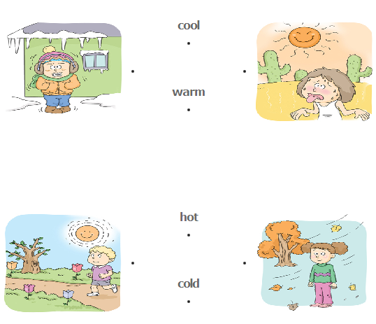

Worksheet-2
Please, cross the line correct picture and word.

