Listening Lesson plan

Topic: Blind date

Instructor: JIYE | Level: intermediate | Students:8 | Length:  40 Minutes

Materials:
Worksheet(8),
CD player
Wall chart
Pictures(4),
Blindfold
Nametags(8)

Aims:
-Main aim: Ss will be able to vocalize their own character by role-playing.
-Secondary aim : Ss will be able to comprehend some expressions for describing one’s character by matching worksheet.
-Personal aim: I want to help Ss improve their language skills.

Language Skills:
-Reading: Ss will read sentences on worksheets and letters of self-introduction.
-Listening: Ss will listen a pop song and speeches of other students.
-Speaking: Ss will answer or ask some questions and Ss will do self-PR.
-Writing: SS write own self-introduction.

Language Systems:
-Lexis: expressions used in describing people’s characteristics
-Function: self- PR and advertisement for a partner
-Structure: relative clauses
-Phonology: non to discuss
-Discourse: non to discuss

Assumptions:
-Ss already know what blind date is.
-Most Ss have already experienced a blind date.
-Ss already know what script is.

Anticipated Problems and Solutions:
-Ss may not know various expressions for describing one’s character
Ss will use some expressions written on the worksheet.
- Ss may not be able to pick up words from song at once.
Ss will listen the song twice.
-The lesson finishes earlier than I expect.
Listen the pop song one more or Do SOS activity

References:
https://www.google.com/search

http://blog.naver.com/PostView.nhn?blogId=meerikim&logNo=40093714501&redirect=Dlog&widgetTypeCall=true

Lead-In
Materials:
Time | Set Up | Student Activity | Teacher Talk
2min. | Whole class | -Saying Hello  -Answer the question | Greeting: Saying hello with eye-contact and smile: Hi, everyone! What a pretty day!  I think Spring is the best day for date.  (write “blind date” on the board)  CCQ: Who wants tell me the meaning of blind date?  (eliciting from Ss)  (Pick on student) ___ have you been blind date? Can you tell me how it was?

Pre-Activity
Materials: worksheet
Time | Set Up | Student Activity | Teacher Talk
5min. | Individual | Doing worksheet. | Before we go regular lesson, we will learn some expressions about characters.  So, now we are going to do worksheet!  This worksheet has several sentences and some pictures.  You should match them.  Do it as best you can!  You should do this worksheet individually for 3 minutes.  ICQ: -What should we do?  -How many minutes do we have?  -Are you working individually?  (Monitoring)  (after worksheet)  Time’s up! Let’s check the answers.  - My face is oval  - I have blond hair  - I wear hair bobbed  - You have a dark-skinned  - I wear hair in braid  - My face dimples with a smile  Excellent!

Main Activity
Materials: a cover, pictures with nametags, paper, pens

Time | Set Up | Student Activity | Teacher Talk
10min.  15min. | Whole class  Pair work | Asking  Answering  Listening  Writing  Listening  Answering | Then, we will do ‘guessing game’.  (show the blindfold)  CCQ: Does anyone know what it is? (eliciting from Ss)  Yes, right! It is used to cover someone’s eyes.  So, we will pick one student and she should cover her eyes with this blindfold.  We have 4 different pictures, choose one picture for her.  She will be that person in the picture what we selected.  But! She won’t see this picture.  So, we will describe about her appearances.  Each person will have one sentence.  She should guess who she was after takeoff this cover.  I will demonstrate for you.  (..Demonstrating..)  ICQ: - What should we do for selected student?  - How many sentences each person should say?  Right! Let’s start!  Then, who wants to be a volunteer?  (doing activity)  Nice work, guys!  Then, we will do second activity!  What we are going to do is ‘Roll play’.  We will work this activity in pairs.  (pairing up)  One person will be a woman; the other will be a man.  So, imagine you are doing blind date.  First, Make a script and then show your performance.  Before we start, I will give an example.  (reading a script)  Ok guys, make your script for 10minutes.  ICQ: - Are you working individually?  - What should we do?  - How many minutes do we have?  Ok let’s start!  (Monitoring)  Time’s up! Which group wants to be first?  (presentation)  (with clapping)  Everyone did very well!

Post Activity
Materials: CD player, paper of lyrics

Time | Set Up | Student Activity | Teacher Talk
7min.  1min. | Individual  Whole class | Listening  Answering | Lastly! Now, we are going to listen a popular song!  The song title is ‘pretty woman’  Everyone already know this song, right?  Ok, we will listen this song twice.  I will give you lyrics.  (Write on the board ‘lyrics’)  CCQ: Who can tell me the meaning of lyrics?  Yes, it is words of song.  (handing out lyrics)  This lyrics have four blanks.  Listen carefully and fill the blanks individually.  And check the answers written on the bottom by yourself.  (Listen the song twice)  Finish! Did you have fun today?  Everyone did very well!  I am so proud of you!  see you tomorrow~
SOS Activities
Materials:
Time | Set Up | Student Activity | Teacher Talk
3min. | Whole class | Answering | Close your eyes please.  Think about today’s lesson.  For example, what you learned today, what do you want to learn more, what was fun and so on.  I will give you 1 minute.  (thinking)  Open your eyes please.  Let’s share our opinions.  (Pick student and then listen.)

Worksheet

I am wearing glasses * *

My face dimples with a smile *
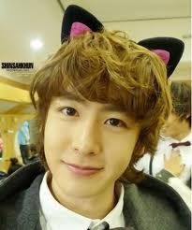
I have a fair-skinned * *

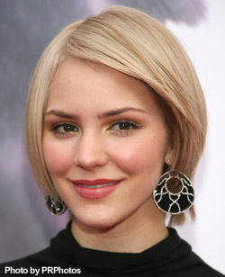
You have a dark-skinned *

My face is oval * *

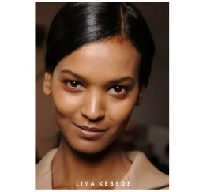
Your face is rather round *
*
I am tall and slender *
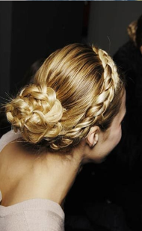
I wear hair bobbed * *

I wear hair in braid *
I have blond hair *

I am left handed * *
Pretty Woman - Roy Orbison
Pretty woman, _ _ the street
Pretty woman, the kind I like to meet
Pretty woman
I don't believe you, you're not the truth
No one could look as good as you
Mercy
Pretty woman, won't you pardon me
Pretty woman, I couldn't help but see
Pretty woman
That you look _ as can be
Are you lonely just like me
Wow
Pretty woman, stop a while
Pretty woman, talk a while
Pretty woman, give _ to me
Pretty woman, yeah yeah yeah
Pretty woman, look my way
Pretty woman, say you'll stay with me
'Cause I need you, I'll treat you right
Come with me baby, be mine tonight
Pretty woman, don't walk on by
Pretty woman, don't make me cry
Pretty woman, don't walk away, hey...okay
If that's the way it must be, okay
I guess I'll go on home, it's late
There'll be tomorrow night, but wait
What do I see
Is she _ _ to me
Yeah, she's walking back to me
Oh, oh, Pretty woman
1.walking down 2. lovely 3. your smile 4. walking back

