One Source Multi-Use

“One Source Multi-Use” (OSMU) is a content strategy for increasing profit returns by recreating the same content across diverse media. For example, the same story can be made into a book, movie, TV show, game, character products, and so forth. This strategy owes much to the development of IT, the diversification of media forms, and the growth of the content industry. In Korea as well, there are increasing numbers of cases of OSMU being used with books. Even in the past, it was not uncommon to base movies or TV shows on novels. But most of those were limited to classics. In contrast, there are now many cases of recently published works being made into movies or TV shows. This includes comic books as well as novels. Examples of this are Hur Youngman’s comic books Le Grand Chef and The Tricksters. Le Grand Chef, whose theme is Korean cuisine, was made into a popular movie in 2007 and a TV show in 2008. The Tricksters, which depicts the world of gambling, was also made into a movie and TV show. Among novels, Jung Yi-hyun's My Sweet Seoul and Lee Jungmyung’s The Painter of Wind were made into TV shows, and Park Hyun-wook's My Wife Got Married was made into a movie. This OSMU trend will likely become stronger in the future. Many Korean publishers are showing an interest in this strategy, and movie and television producers are looking to books for quality content
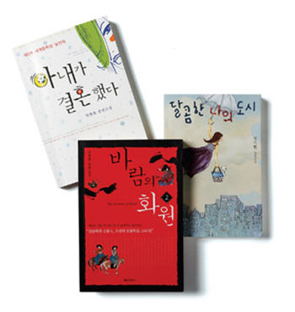
The Painter of Wind, My Wife Got Married, My Sweet Seoul
[Words]
- So forth = and so on
- Diversification : The act of introducing variety(especially in investments or in the variety of goods and services offered

