Worksheet _ ①[Pre-activity/bilingual,trilingual,multilingual]

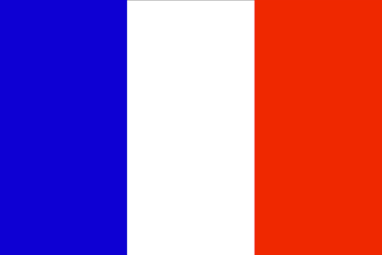

Bilingual
Trilingual
Multilingual

Worksheet _ ②[Pre-activity/early childhood language education]
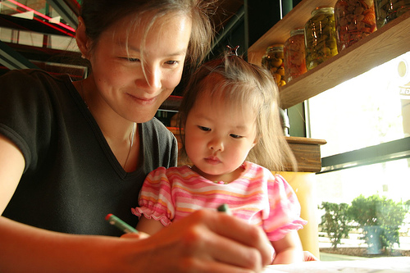
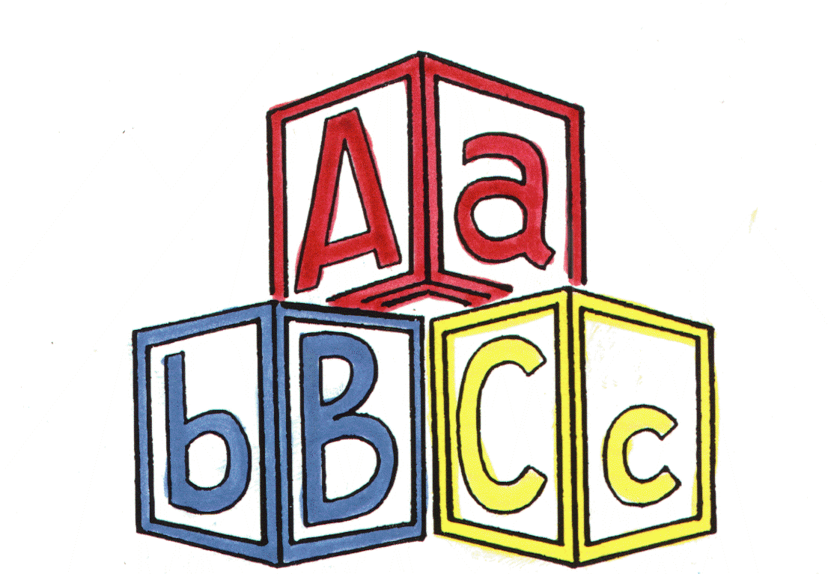

Worksheet _③ [Pre-activity/Back up ideas]
The Pros & Cons ideas about early childhood language education
Pros | Cons
-children can express themselves easily with different language  -children can talk to foreigner without hesitation  -It boost up children’s self-esteem  -children can read and listen to the original book or a song.  -children can describe fluent language  -children can do a multi task  -children can get more chance when choosing a career  -It help children to expand their learning horizons | -children might not catch up with their L1  -children might get confused on languages  -children might get confused on their identity  -children might not adjust themselves in to society  -children might get confused on their values  -children might get distracted on their studying  -children might end up hating the language after all  -It might cause children a lack of problem solving skills.

Worksheet _④ [Main-activity/agree or disagree]

DISAGREE

AGREE
Worksheet _⑤ [S.O.S-activity]-cut & distribute to the Ss.
I can speak ________________________________________________________________
(languages that you can speak, you can write as many as you can).
I started learning __________________ when I was ______________ years old from __________________
(language) (age) (place/country)
I started learning __________________ when I was ______________ years old from __________________
(language) (age) (place/country)
I started learning __________________ when I was ______________ years old from __________________
(language) (age) (place/country)

I can speak ________________________________________________________________
(languages that you can speak, you can write as many as you can).
I started learning __________________ when I was ______________ years old from __________________
(language) (age) (place/country)
I started learning __________________ when I was ______________ years old from __________________
(language) (age) (place/country)
I started learning __________________ when I was ______________ years old from __________________
(language) (age) (place/country)

I can speak ________________________________________________________________
(languages that you can speak, you can write as many as you can).
I started learning __________________ when I was ______________ years old from __________________
(language) (age) (place/country)
I started learning __________________ when I was ______________ years old from __________________
(language) (age) (place/country)
I started learning __________________ when I was ______________ years old from __________________
(language) (age) (place/country)

I can speak ________________________________________________________________
(languages that you can speak, you can write as many as you can).
I started learning __________________ when I was ______________ years old from __________________
(language) (age) (place/country)
I started learning __________________ when I was ______________ years old from __________________
(language) (age) (place/country)
I started learning __________________ when I was ______________ years old from __________________
(language) (age) (place/country)

I can speak ________________________________________________________________
(languages that you can speak, you can write as many as you can).
I started learning __________________ when I was ______________ years old from __________________
(language) (age) (place/country)
I started learning __________________ when I was ______________ years old from __________________
(language) (age) (place/country)
I started learning __________________ when I was ______________ years old from __________________
(language) (age) (place/country)

