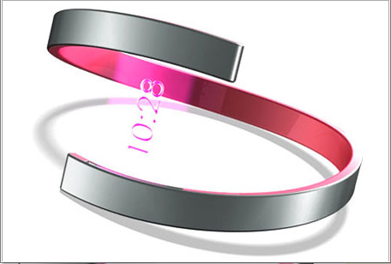

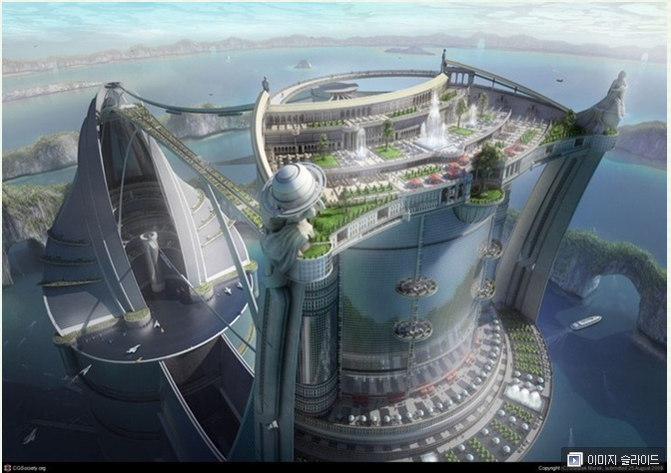

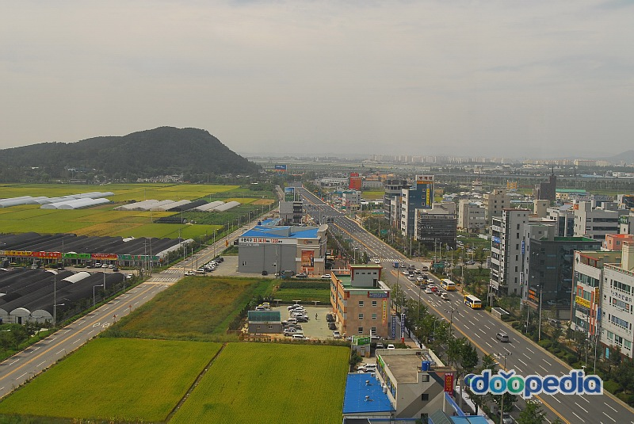

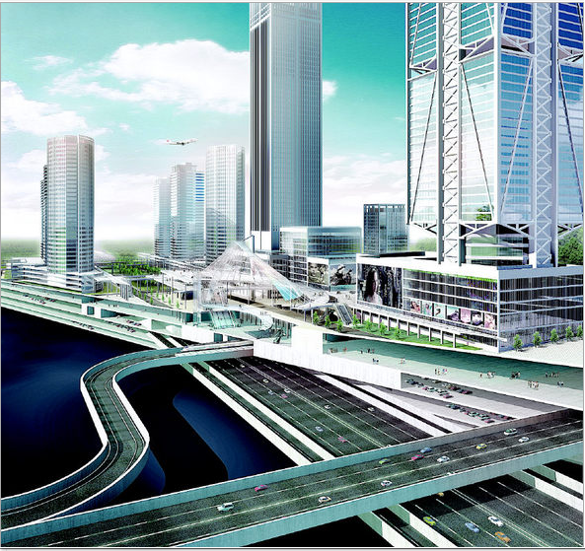

1) The train at 11:45.
2) I you with your homework after class.
3) It in the mountains tomorrow evening.
4) I am Languages at university next year.
5) The English lesson at 8:45.
6) Wait! I you to the station.
7) Watch out! You are that car!
8) The plane at 6 o'clock.
9) Listen! There's someone at the door. I the door for you.

