<Toy Story 3>

- Script -

Woody: (voice box) I’d like to join your posse, boys, but first I’m gonna sing a little song.
Bonnie: A sheriff..!! Move over, Mr. Pricklepants! We have a guest! You want some coffee?
It’s good for you! But don’t drink too much or you’ll hafta…hafta…. Be right back!
Woody: Psst! Hey! Hello? Hi! Excuse me!
Mr. Pricklepants: Shhhhhh!
Woody: Can you tell me where I am?
Mr. Pricklepants: Shhhhhh!
Unicorn: The guy’s just asking a question.
Mr. Pricklepants: Well, excuse me, I’m trying to stay in character!
Unicorn: My name’s Buttercup.
Mr. Pricklepants: Shhhhhh!
Triceratops: I’m Trixie!
Mr. Pricklepants: Shhhhhh!
Trixie: Shhhhhhh!
Both: Shhhhhhhhhhhh!
Woody: Guys, hey! I don’t know where I am!
Trixie: We’re either in a café in Paris, or a coffee shop in New Jersey.
I’m pretty sure I just came back from the doctor with life-changing news!
Buttercup: We do a lot of improv here. Just stay loose, have fun, you’ll be fine.
Woody: No, no, no, I….
Bonnie: Who wants lunch? Beep! Beep! Beep! It has a secret ingredient……. Jellybeans!
Woody: (voice box) Somebody’s poisoned the water hole!
Bonnie: Poison?!
Who would do such a mean thing?!
The scary witch!! Look out!! She’s using her witch powers!
I know where to hide! She’ll never find us in here! What’s wrong….?
She found us! We need a spaceship to get away from the witch!
Trixie: you’re doing great!
Mr. Pricklepants: Are you classically trained?
Woody: Look, I just need to know how to get out of here…!
Buttercup: There IS NO WAY OUT!! Just kidding. Door’s right over there.
Doll: Well, cowboy, you just jumped right in, didn’t you? I’m Dolly.
Woody: ….Uh, Woody.
Dolly: “Woody”? Really? You’re gonna stick with that? ‘Cause now’s your chance to change it,
new room and all. That’s coming from a doll named “Dolly”.
Pea #1: Who’s the new guy?
Pea #2: Are you a real cowboy?
Woody: Well, actually, I……
Pea #3: ‘Course he’s not, pea-brain! He don’t even have a hat!
Woody: I do too have a… My hat?!
Pea #3: Told you!
Bonnie: I found the spaceship!
Mr. Pricklepants: Showtime!
Bonnie: Quick, get in! Fasten your seatbelts! Close your tray tables!
Hold on, it might get a little bumpy! 3, 2, 1! BLAST-OFF!
Yeeeee- haaaaaa! You saved us, cowboy! You’re our hero!

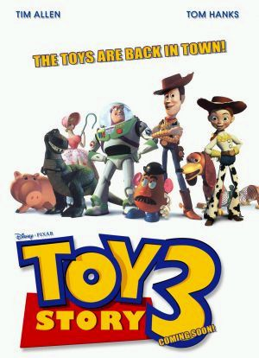
Scene # Bonnie’s Bedroom
Woody: (voice box) I’d like to join your posse, boys, but first I’m sing a little song.
Bonnie: A sheriff..!! Move , Mr. Pricklepants! We have a guest! You want some coffee?
It’s good for you! But don’t drink too much or you’ll hafta…hafta…. Be back!
Woody: Psst! Hey! Hello? Hi! Excuse me!
Mr. Pricklepants: Shhhhhh!
Woody: Can you tell me I am?
Mr. Pricklepants: Shhhhhh!
Unicorn: The guy’s just asking a question.
Mr. Pricklepants: Well, excuse me, I’m trying to in character!
Unicorn: My name’s Buttercup.
Mr. Pricklepants: Shhhhhh!
Triceratops: I’m Trixie!
Mr. Pricklepants: Shhhhhh!
Trixie: Shhhhhhh!
Both: Shhhhhhhhhhhh!
Woody: Guys, hey! I don’t know where I am!
Trixie: We’re either in a café in Paris, or a coffee shop in New Jersey.
I’m sure I just came back from the doctor with life-changing news!
Buttercup: We do a lot of improv here. Just stay loose, have fun, you’ll be fine.
Woody: No, no, no, I….
Bonnie: Who wants lunch? Beep! Beep! Beep! It has a secret ……. Jellybeans!
Woody: (voice box) Somebody’s poisoned the water hole!
Bonnie: Poison?!
Who would do such a mean thing?!
The scary !! Look out!! She’s using her witch powers!
I know where to hide! She’ll never find us in here! What’s wrong….?
She found us! We need a spaceship to get away from the witch!
Trixie: you’re doing great!
Mr. Pricklepants: Are you classically trained?
Woody: Look, I just need to know how to get here…!
Buttercup: There IS NO WAY OUT!! Just . Door’s right over there.
Doll: Well, cowboy, you just jumped right in, ? I’m Dolly.
Woody: ….Uh, Woody.
Dolly: “Woody”? Really? You’re gonna stick with that? ‘Cause now’s your chance to change it,
new room and all. That’s coming from a doll “Dolly”.
Pea #1: Who’s the new guy?
Pea #2: Are you a real cowboy?
Woody: Well, actually, I……
Pea #3: ‘Course he’s not, pea-brain! He don’t have a hat!
Woody: I do too have a… My hat?!
Pea #3: Told you!
Bonnie: I found the spaceship!
Mr. Pricklepants: !
Bonnie: Quick, get in! your seatbelts! Close your tray tables!
Hold on, it get a little bumpy! 3, 2, 1! BLAST-OFF!
Yeeeee- haaaaaa! You saved us, cowboy! You’re our !

- Vocabularies and idioms–

life-changing | get away from
improv | classically trained
stay loose | jump right in
have fun | stick with
mean | hold on
scary | bumpy
look out | blast-off

Tag question

Tag question is a brief question with the general meaning “Is it not so?”, added to a declarative or imperative sentence: it is negative in construction when the original sentence is affirmative, and vice versa (Ex.: It isn't raining, is it? Hurry now, won't you?)

LOOK AT THE PICTURE! – complete the blanks with a short answer
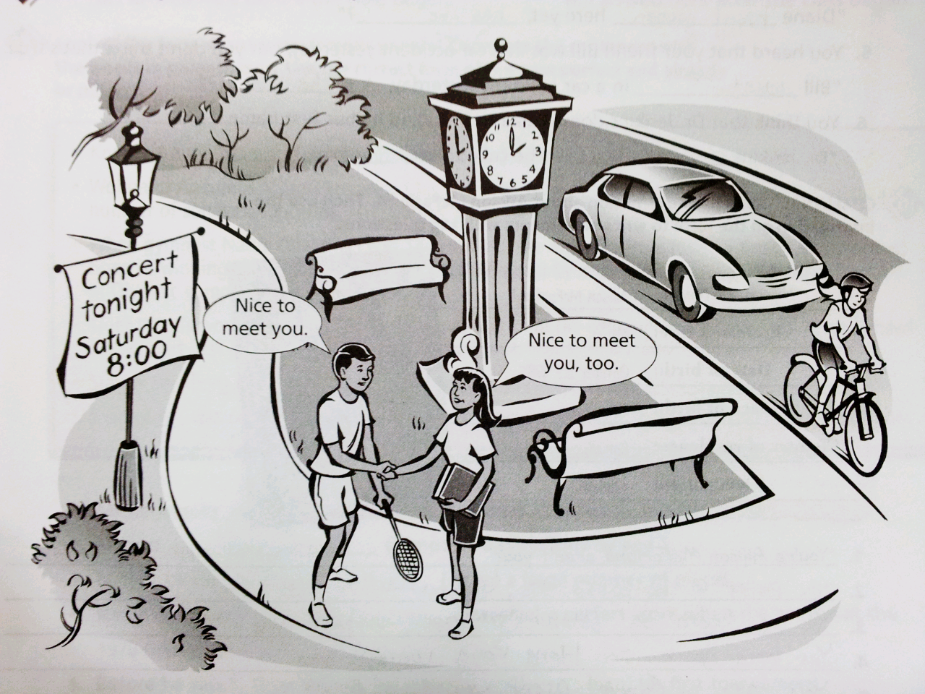
1. Is it very good weather today, isn’t it? Yes, it is.
2. It’s not 2:30 yet, is it? .
3. It’s a good day to ride a bike, isn’t it? .
4. There isn’t a lot of traffic, is there? .
5. Yesterday wasn’t Sunday, was it? .
6. The people haven’t met before today, have day? .
7. They’re not cold, are they? .
8. The man plays tennis, doesn’t he? .

Will or Going to?
When we want to talk about future facts or things we believe to be true about the future, we use 'will'.
- The President will serve for four years.
- The boss won't be very happy.
- I'm sure you'll like her.
If we are not so certain about the future, we use 'will' with expressions such as 'probably', 'possibly', 'I think', 'I hope'.
- I hope you'll visit me in my home one day.
- She'll probably be a great success.
- I'll possibly come but I may not get back in time.
If you are making a future prediction based on evidence in the present situation, use 'going to'.
- Not a cloud in the sky. It's going to be another warm day.
- Look at the queue. We're not going to get in for hours.
- The traffic is terrible. We're going to miss our flight.
At the moment of making a decision, use 'will'. Once you have made the decision, talk about it using 'going to'.
- I'll call Jenny to let her know. Sarah, I need Jenny's number. I'm going to call her about the meeting.
- I'll come and have a drink with you but I must let Harry know. Harry, I'm going to have a drink with Simon.

Complete the sentences!

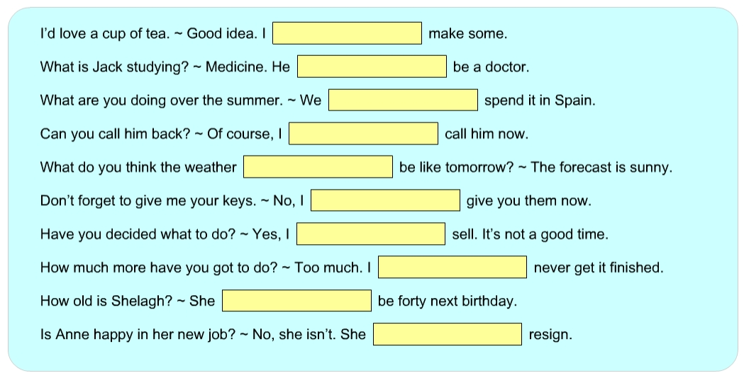
My Movie!

< Fill in the speech bubbles and make your own story using today’s expressions! >

