**TESOL NEWS**

|  |  |  |
| --- | --- | --- |
| **14th March, 2012** | **THE WORLD’S FAVORITE NEWSPAPER** | **Since 2012** |

**Breath-Powered Phone Charger Invented**

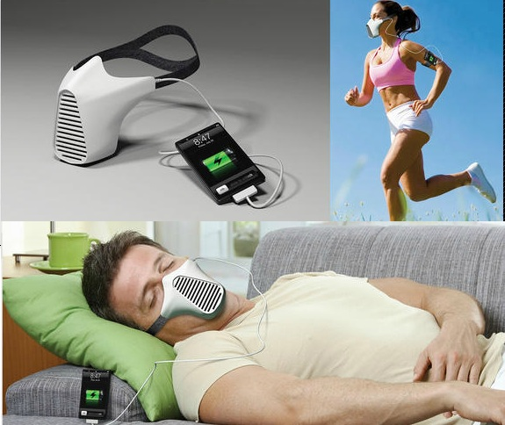A Brazilian inventor has come up with a new gadget that converts your breath into electricity. This means breathing has become a source of renewable energy – at least while you are alive. Joco Paulo Lammoglia, from Rio De Janeiro, won the Red Dot design award for his AIRE device. His invention uses the wind flow created by breathing and changes it into energy that can power mobile phones and iPods. Tiny turbines in the AIRE charger create the electrical power from your breath. The device is worn like a mask and can be used while exercising or even when sleeping. Mr. Lammoglia hopes his new creation will help protect the environment.

Lammoglia explained how useful he hopes the AIRE will become. He said: “I hope to bring the concept into production and reduce the carbon footprint. It can be used indoors or outdoors, while you’re sleeping, walking, running or even reading a book.” He also said his invention encouraged people to exercise as well as saving energy and the environment. He explained why he thought the AIRE was so useful, saying: “Though many of our modern gadgets offer benefits, they tend to use a high amount of electrical energy. Harnessing energy from human activities and transforming it into electricity is possible and is a great solution.” The product is not yet on sale but is sure to be a big seller when it does hit the shelves.

|  |
| --- |
| **C:\Documents and Settings\혜연\Local Settings\Temporary Internet Files\Content.IE5\0TFNCDUR\MC900437851[1].pngCHECK IT OUT** |

**1. TRUE / FALSE: Read the headline. Guess if a-h below are true (T) or false (F).**

|  |  |  |
| --- | --- | --- |
| a. | An inventor has harnessed the power of our breath. | T / F |
| b. | The inventor’s gadget was runner-up in a design competition. | T / F |
| c. | The inventor’s device has no moving parts – it’s all chemical. | T / F |
| d. | The inventor says his device will help protect the environment. | T / F |
| e. | The inventor said the device can only work inside. | T / F |
| f. | The inventor warns we should turn the gadget off when we sleep. | T / F |
| g. | The gadget is not yet for sale in stores. | T / F |
| h. | The writer of the article believes the device will sell well once available. | T / F |

**2. SYNONYM MATCH: Match the following synonyms from the article**.

|  |  |  |  |
| --- | --- | --- | --- |
| 1. | come up with | a. | miniature |
| 2 | gadget | b. | prompted |
| 3. | flow | c. | idea |
| 4. | tiny | d. | movement |
| 5. | creation | e. | produced |
| 6. | concept | f. | make use of |
| 7. | encouraged | g. | answer |
| 8. | harness | h. | C:\Documents and Settings\혜연\Local Settings\Temporary Internet Files\Content.IE5\0Q543FX0\MC900286444[1].wmfgizmo |
| 9. | solution | i. | go on sale |
| 10. | hit the shelves | j. | invention |

C:\Documents and Settings\혜연\Local Settings\Temporary Internet Files\Content.IE5\ZEX9MK7Y\MC900355065[1].wmfC:\Documents and Settings\혜연\Local Settings\Temporary Internet Files\Content.IE5\ZEX9MK7Y\MC900355065[1].wmf

|  |
| --- |
| **C:\Documents and Settings\혜연\Local Settings\Temporary Internet Files\Content.IE5\0TFNCDUR\MC900437851[1].pngTHINK MORE** |

**1. BODY POWER :** **Invent some crazy gadgets? Choose one from the list and invent your own gadget.**

|  |  |  |  |
| --- | --- | --- | --- |
| **Power from…** | **Name** | **Function** | **How it works** |
| □ your heartbeat |  |  |  |
| □ blinking |
| □ body temperature |
| □ chewing |
| □ thinking |
| □ talking |
| □ other: |

**2. DISCUSSION :** **Talk about the article with your partner. Use the questions below for reference.**

a. What did you think when you read the headline?

b. What do you think of the AIRE?

c. Would you sleep with the AIRE to recharge your mobile phone?

d. Do you think it will be too uncomfortable to wear?

e. Will you buy one when it hits the shelves?

f. What do you think of breath power as a source of renewable energy?

g. Do you think this is the first of many gadgets that harness our body’s

movements?

h. How much energy (electrical, gas…) do you think you use every day?

i. What will we do when the oil runs out?

j. Is the AIRE a great solution?

k. Which sources of renewable energy do you think is most effective?



|  |
| --- |
| **C:\Documents and Settings\혜연\Local Settings\Temporary Internet Files\Content.IE5\0TFNCDUR\MC900437851[1].pngCROSS WORD** |

|  |  |  |  |  |  |  |  |  |  |  |  |  |  |  |
| --- | --- | --- | --- | --- | --- | --- | --- | --- | --- | --- | --- | --- | --- | --- |
|  |  |  |  |  | 1 |  |  |  |  |  |  |  |  | 2 |
|  |  |  |  |  |  |  |  |  |  |  |  |  |  |  |
|  | 3 |  |  |  |  |  |  |  |  |  |  |  |  |  |
|  |  |  |  |  |  |  |  |  | 4 |  |  |  |  |  |
|  | 5 |  |  |  |  |  |  |  |  |  |  |  |  |  |
|  |  |  |  |  |  |  | 6 |  |  |  |  |  |  |  |
|  | 7 |  |  |  |  |  |  |  |  |  |  |  |  |  |
|  |  |  |  |  |  |  |  |  |  |  | 8 |  |  |  |
|  |  |  | 9 |  |  |  |  |  |  |  |  |  |  |  |
|  |  |  |  |  |  |  |  |  |  |  |  |  |  |  |
| 10 |  |  |  |  |  |  |  |  |  |  |  |  |  |  |
|  |  |  |  |  |  |  |  |  |  |  |  |  |  |  |
|  |  |  |  |  |  |  |  |  |  |  |  |  |  |  |
|  |  |  |  |  |  |  |  |  |  |  |  |  |  |  |
|  |  |  |  |  |  |  |  |  | 11 |  |  |  |  |  |

<**DOWN>**

1. An idea or invention

2. Control and make use of natural resources to produce energy.

4. Energy or resources that do not run out.

7. Machines that produce continuous power from fast-moving water, steam, air, gas, etc.

8. Advantages or profits gained from something.

**<ACROSS>**

1. Think of something new or a new idea.

3. Somebody who designs or makes something a totally new device, machine or process.

5. A small mechanical machine or tool, especially one that helps us in our life.

6. Changes one thing into another.

7. Regularly or frequently behave in a particular way.

9. Gave support to someone to do something.

10. Start to be sold in the stores.

11. A covering that is worn over the nose and mouth.

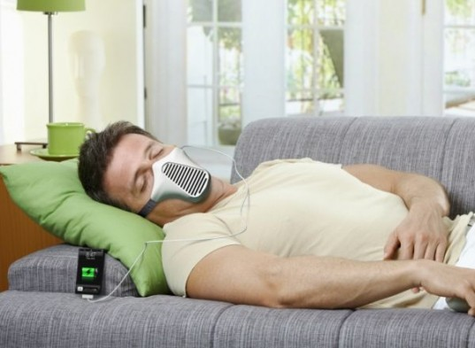

**Answers**

**TRUE / FALSE:**

|  |  |  |  |  |  |  |  |  |  |  |  |  |  |  |  |
| --- | --- | --- | --- | --- | --- | --- | --- | --- | --- | --- | --- | --- | --- | --- | --- |
| a. | F | b. | F | c. | F | d. | T | e. | F | f. | F | g. | T | h. | T |

**SYNONYM MATCH:**

|  |  |  |  |
| --- | --- | --- | --- |
| 1. | come up with | a. | produced |
| 2 | gadget | b. | gizmo |
| 3. | flow | c. | movement |
| 4. | tiny | d. | miniature |
| 5. | creation | e. | invention |
| 6. | concept | f. | idea |
| 7. | encouraged | g. | prompted |
| 8. | harness | h. | make use of |
| 9. | solution | i. | answer |
| 10. | hit the shelves | j. | go on sale |

**CROSS WORD**

