Listening Speaking Reading Grammar Writing

Topic: The Present Tense & The Present Continuous

Instructor:  Wendy | Level:  Intermediate | Students:  14 | Length:  30 Minutes

Materials:
- Board, 7 Board Markers
- Pictures of some actings
- The 1st worksheet - (14 copies)
- The 2nd worksheet - (14 copies)
- The 3rd worksheet - (7 copies -bingo)
- 2 kinds of worksheet ( 7copies each )

Aims:
- Main Aim: Ss will improve their grammar skills through discussions of The Present Tense & The Present Continuous through 4 activities.
- Secondary Aim: Ss will improve their speaking by working on a worksheet with making expressions about The Present Tense & The Present Continuous , and will also improve their writing, listening skills through writing, discussing and practicing with a partner.
- Personal Aim: I want to deliver better instructions, speak in a louder and clearer voice, and make a more enjoyable learning environment.

Language Skills:
- Listening: Ss will practice listening by listening to other classmate’s dialogues.
- Speaking: Ss will practice speaking by practicing through activities with their partners in pairs.
- Reading: Ss will practice reading by working on matching worksheet.
- Writing: Ss will practice writing by writing with activities with their partner and filling out the worksheet.

Language Systems:
- Phonology: none to discuss
- Lexis: words or expressions the present tense & the present continuous
- Grammar: Students can create and answer the sentences using the present tense
&the present continous
- Function: expressing the present tense & the present continuous
- Discourse: none to discuss

Assumptions:

- Ss already know the teacher’s style of teaching and the pace of the course.

Anticipated Problems and Solutions:

Problems | Solutions
- Ss may need more time to work on the worksheet.  - If time is short.  - If students finish their tasks earlier than anticipated. | - If it takes longer than 5 minutes, cut answer-checking short by verbally sharing the answers instead of having students come up and write on the board.  - Cut post-activity discussion short and only ask 1~2 Ss to share how they would spend their prize money.  - Ask Ss what they would do if they can make time long or short.

References:
- Worksheet 1 : Excellent English (p.92)
- Worksheet : Talk Time(p.21, p.74)
- www.sinplees.com.
- www.esl-galaxy.coml
- http://www.google.com

Lead-In
Materials:
- Board, Board Markers
- Topic cards

Time | Set Up | Procedure
2 min | Whole  class | Greeting  “Hello, everyone? Nice to see you again. And welcome to my class again.  Did anything special happen last night? OOO, what did you do last night? Thank you for telling us. And OOO, what did you do last night? Thank you for telling us.  Last night, I thought about our class. Two months seems to be long, but it is getting closer to the end. So I want all of us to be cheerful till our class finishes.  Introduction the topic  What is the difference between those “He is sleeping”, and “ He sleeps.”  (Put the topic cards on the board)  Ok, today’s topic is The Present Tense & The Present Continuous

Pre-Activity
Materials:
- Pictures of some actings(eating, sleeping, smiling, taking a picture)
- A paper streamer
- The 1st Worksheet - (14 copies)
- Board, 7 Board Markers

Time | Set Up | Procedure
7min | Whole  Class  Pairs | Using visual & explaining  (Put the visuals on left side of the board. On top of the left side of the board , write “now” first.)  “Now, I’ll show you some pictures.  What is she doing? Right! She is eating now.  What are they doing? They are taking a picture now.  Next, what is she doing? Yes, she is sleeping now.  The last one, what about them? They are smiling now.”    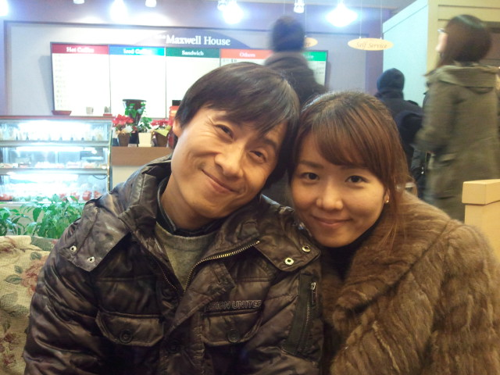  (Carry the visual onto the right side of the board. On top of the right side of the board, write “ ) “  Past Now Future  “Now, How I should change the sentences? Right! She eats.  (Carry other visual onto the right side )  What about this? Right! They take a picture.  (Carry other visual onto the right side )  How I should change the sentences? Ok! She sleeps.  (Carry other visual onto the right side )  I should change the last one, too. They smile.  We can use the word “now” when we want to express doing something right now. But we can use adverbs of frequency with every day, daily, usually and repetitive acting.”  CCQ’s  Can we say “He is uaully going to school at 7 every morning”?  Can we say “They usually goes to school every morning”?  Grouping  “You are Present and you are Continuous . You are Present , you are Continuous ….  All Present s sit on, but All Continuouses stand up and move 2 spaces to right.”  After All Ss sit down.  “O and O are one pair, O and O are one pair, O and O are one pair…”  Instructions  Here are some worksheets. We’ll match the questions with the nswers on these worksheets. I’ll give you these worksheets now. But I want you to start when I say “start”. I’ll give you 2minutes.  ICQ’s  1) What are you going to do?  2) How much time do you have?  3) Are you working individually or in pairs?  (After ICQ’s, give Ss worksheet 1.  After giving, “start”)  Timing  “1minute more.  30 second more.  Time’s up!”  Checking answers  “One person of each pair come up. And write your answers on the board.”  (Ss come and write their answers on the board.  Then check the answers.  After Checking,)  “This pair is a winner time!!. Good job.”

Main Activity
Materials:
- The 2nd Worksheet(14copies)
- The 3rd Worksheet(cut out paper)

Time | Set Up | Procedure
10min | Pairs  Pairs | Grouping  “O and O are a pair. And O and O are a pair “  Instructions  I’ll give you worksheet. Then you should make sentences for each picture. But please use adverbs of frequency. I’ll give you 3minutes.  I hope you to start when I say “start”  ICQ’s  1) What are you doing to do?  2) How much time do you have?  3) Are you working individually or in pairs?  4) Can you start when you got the paper?  (After handing out the worksheets, say “start”)  Timing  “2minutes more  1minute more.  30 second more.  Time’s up!”  STT  “O, can you tell us your sentences? Good job. And O, can you tell us your sentences?”  (After STT)  “Good job!!”  Instructions  All student! Tap your desk!! We’ll play BingGo gaim!!  I’ll give you some worksheet.  By order, you can rub out the space, but please say as a sentence using Present Continuous. We’ll make 4 lines Bingo. Whoever makes 4 bingo first, shout please “Present Continuous”  demonstration  For example, (showing the BingGo sheet) she is buying something.  You ‘ve got it?  ICQ’s  1) What are you doing to do?  2) Are you working individually or in class?  3) Can you start when you got the paper?  4) How many lines bingo we’ll make?  5) The pair that makes 4 line first, what should they shout?  (After ICQ’s hand out the BingGo sheet, then say “start”)  “O and O, do Rock, paper, scissors.  Ok, you win. You first.”  STT  (All Ss say one sentence by order.  When somebody shout Present Continuous)  Congratulation!!  (After finishing the activity)  Good job! Thank you.

Post Activity
Materials:
- 2 kinds of worksheet ( 7copies each )

Time | Set Up | Procedure
5 | Pairs  Whole class | Grouping  (TTT)“O and O, you are one pair, O and O are one pair….”  Ss.  Instructions  Now, I’ll give you worksheets. Here are two kinds of worksheets. Each worksheet has a picture that is different from the other worksheet. So  you should find some differences between your picture and your partner’s picture without looking each other’s.  you’ll have 3 minutes to find differences between two pictures.  I want you to start when I say “start”  ICQ’s  1) What are you doing to do?  2) How much time do you have?  3) Are you working individually or in pairs?  4) Can you show your partner’s picture?  (After asking ICQ’s, hand out worksheets Ss. All Ss get worksheets.  Say “ start”)  Timing  2 minutes more.  1 minute more  Time’s up!  Checking answers & STT  Let’s check answers. O, can you tell us, one thing that you found?  Good job. O, can you tell us, one thing that you found?  OK!! Good job. The best student!!  Error correction  Review any errors.  Closing  Thany you all student. Good jod to day. Have a very very good weekend!!

The Present Tense
The Present Continuous

Worksheet - The 1st
1.What are you doing? a. yes. I often cook dinner at 4:00.

2. At 4:00 in the afternoon? b. Yes. I usually go to work at 7:00,
So, I cook in the afternoon.

3. Really? c. I’m cooking dinner.

4. What’s Ali doing? d. He works from 2:00 p.m.
to 10:00p.m, so he cleans
in the morning.

5. At 7:00 in the morning? e. He’s cleaning the apartment.

6. Really? Why? f. Yes. He usually cleans
in the morning.

