Listening Speaking Reading Grammar Writing

Topic:
Superlatives

Instructor:  LEE | Level:  Upper-intermediate | Students:  14 students | Length:  30 Minutes

Materials:

Board and marker
picture#1, picture#2, wall chart#1, worksheet#1 (15) for pre-activity

picture #3, picture #4, picture #5, picture #6, worksheet #2(3) for main activity

Texts & one paper cup for post activity

Aims:
- Main aim:
- Students will improve their grammar skills by having students practice expressing superlative forms.

- Secondary aim:
- Students will be better able to understand and use the superlative forms of adjectives through worksheets and activities on Guinness World Records.

- Personal aim:
- I want to reduce my TTT
- I want to improve my demonstration techniques.
- I want to improve more ICQs and CCQs skill.
- I want to go with the lesson more smoothly and more quickly.

Language Skills:
- Reading: Ss will practice their reading skills by reading descriptions of Guinness Worlds Records.

- Listening: Ss will practice their listening skills by listening to other’s idea during activities.

- Speaking: Ss will practice their speaking skills by sharing their ideas in group and individually.

- Writing: Ss will practice their writing skills by filling in the blank during working on the worksheets.

Language Systems:
- Phonology: Ss will be able to pronounce several superlatives.

- Lexis: Ss will learn several superlatives forms of adjectives.

- Grammatical: Ss will be able to create and use the superlatives

- Functional: Ss will be able to discuss their idea during group activities.

- Discourse: None to discuss

Assumptions:
- Ss already know each other and how the class works.
- Ss already know teacher’s style of teaching and the pace of course.
- Ss already know how to make and use comparison forms of adjective.
- Most Ss need to improve their skills for using superlative forms.

Anticipated Problems and Solutions:

Students may take long time to finish their tasks.
- Monitoring and help them if needed.
- Make them hurry by timing.

Students may feel difficulty to create new sentence by using superlative forms
- Show them good example sentences.

If time is short
- Cut post-activity short by asking only 1~2 students to share their sentences.

If students finish their tasks earlier than expected
- Use S.O.S activity

References:
-http://www.google.com/
- http://www.cnngo.com/explorations/life/22-travel-world-records-039346
- www.macmillanenglish.com/inspiration.
- http://choppasenoel.blogspot.com/2012/04/guinness-book-of-records-for-2012.html

Lead-In
Materials:

Time | Set Up | Student Activity | Teacher Talk
2min | Whole class | <Greeting> | Greeting  Hello, Hi, Good morning~!!  How are you guys??  Today is Friday!!  I think every Friday is the happiest day in the week, because it’s the day before weekend.

Pre-Activity
Materials: board, marker, picture#1, picture#2, wall chart#1, worksheet#1

Time | Set Up | Student Activity | Teacher Talk
5min  4min  4min | Whole class  Whole class  Individual | <learning about the concepts of superlatives>  <learning about how to make the superlative forms>  <working on the worksheet> | Eliciting  (Show the picture # 1)  What do you see in this picture?  “4 Boxes.!!”  Right, there are 4 boxes.  What is difference among those boxes?  “size!!”  And then, how different is box A from box B??  “Box A is bigger than box B.!!”  And then, how different is box A from all the other boxes  “Box A is bigger than all the other boxes.!!”  Right!! We can say this sentence with another adjective form.  (boarding and saying)  Box A is the biggest box!!  (Show the picture # 2)  What do you see in this picture?  “Motel price in Jamestown.!!”  Right, Which motel is more expensive than all the other motels in town?  “Best West Motel!!”  Right!! So…  (boarding and saying)  The Best West Motel is the most expensive motel in town.  (underline the biggest and the most expensive)  CCQs  The biggest is very small?  The biggest is very large?  The most expensive is very cheap?  The most expensive is high-priced?  Right!! We can call these kind of adjective form as superlatives.  Today, We are talking about superlative forms of adjectives.  (show the wall chart #1)  Can anyone tell me the superlative forms of these adjectives??  (Fill in the blank for 5 adjectives among 15 adjectives. 10 other superlatives were already written on the wall chart.)  (point out the the rules of superlative on the wall chart)  In general, we use –est for short words and most… for longer words to make superlative forms.  (also point out some irregular adjectives such as good and bad)  I’ll give you the worksheet. What you are going to do is filling in the blank.  You are working alone, and you have 1minute to complete it  ICQs  What are you going to do?  How many minutes do you have?  Are you working alone?  I don’t want you to start until I say go!!  Will you start as I give you the paper?  Will you start as I say go??  (hand out worksheet#1)  OK. Ready? Go!  (Timing 1min/ 30sec/10sec)  Times up!  (ask Ss to answer)  Good! Good job, guys.

Main Activity
Materials: picture #3, picture #4, picture #5, picture #6, worksheet #2

Time | Set Up | Student Activity | Teacher Talk
3min  5min  2 min | Whole class  In group  Whole class | <guess the title of pictures>  <matching the titles to the pictures>  <Speaking their opinion> | Prediction  (show picture #3)  Can anybody tell me what it is?  That’s right.  The Guinness World’s Record 2012.!!  In this book, I found some interesting pictures  (show picture #4)  What can you see in the picture?  “a dog!!”  Can anyone guess…  What makes this dog special enough to be in the Guinness World’s Records?  This dog is the smallest dog in the world.!!  (show picture #5 and picture #6, do the same like picture #4)  Instruction  Now, we are talking about the world’s records in the book, Guinness World’s records.  Before we start, let me group you guys!!  (group Ss into 3 groups including “Guinness”, “World’s”, and “Records”)  What we are going to do is finding the the best title for each pictures in group.  You have 3 minutes to do it.  ICQs  - What are you going to do?  - Are you working individually?  - How many minutes do you have?  I don’t want you to start until I say ‘go’.  - Will you start when I give you a paper? →No  - Will you start when I say ‘go’? →Yes  (Distribute worksheets#2)  OK. Ready? Go!  (Timing 1min/ 30sec/10sec)  Times up!  (have Ss say their idea)  OK. Group “Guinsess”, Can you tell me the title for picture 1~3?  What is the most strange thing in these 12 pictures to your group?  (do the same for picture 4~12 with other groups )  Good! Excellent!!  There are lots of weird things right?  Please get back to your seat.!!

Post Activity
Materials:
Texts & one paper cup

Time | Set Up | Student Activity | Teacher Talk
2min  3 min | Whole class  individually | Speaking a sentence | Instruction  Now, I want you to pick one piece of paper in this cup. You are going to make a sentence by using a superlative.  (pick a piece of paper and make a sentence with a superlative on the paper.)  I’ll give you 30 seconds to think about the sentence.  ICQs  - What are you going to do?  - Are you working individually?  - How much time do you have?  - Can you see your paper?  (Distribute papers)  I’ll ask Ss to share their sentences.  OK, good job.  Error Corrections  I didn’t hear any mistake today.  case1) So, can you unscramble this?  (ptsiveealr)  case2) If any,  It is the most biggest box  Is it correct?  No, you have to pick “most” out of the sentence.  Closing  OK, Thank you for the participation today. You did a great job. Does anyone have a question? Well, If there are no further questions, this concludes my grammar microteaching.
SOS Activities
Materials:

Time | Set Up | Student Activity | Teacher Talk
5 min | Whole class |  | Instruction  (write “kindest”, “cutest”, and “smartest”)  Now, We are going to board the kindest, the cutest, and the smartest person in our class. You need to write 1 name under each superlative  ICQs  What are you going to do?  Okay. And Go!  Monitor discreetly  (After boarding, ask 2~5 Ss for sharing their idea)

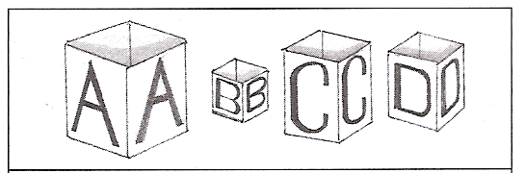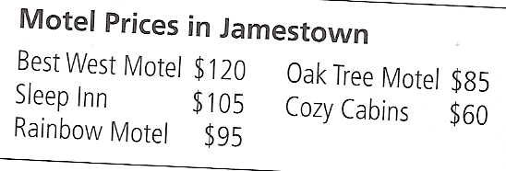



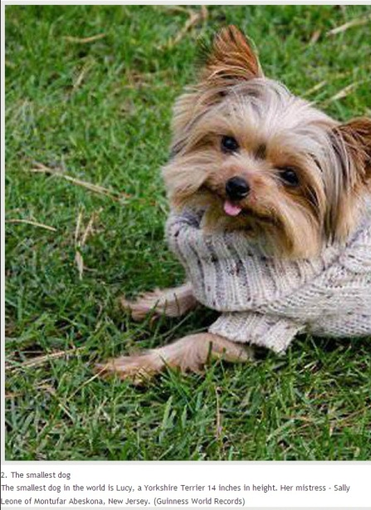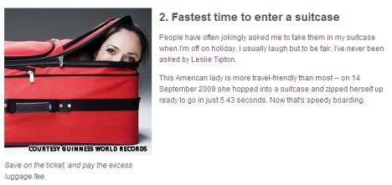
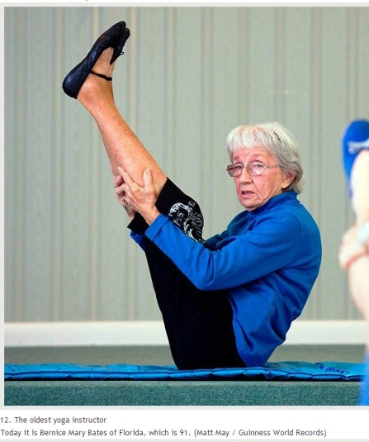

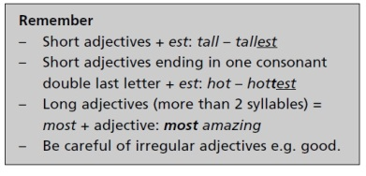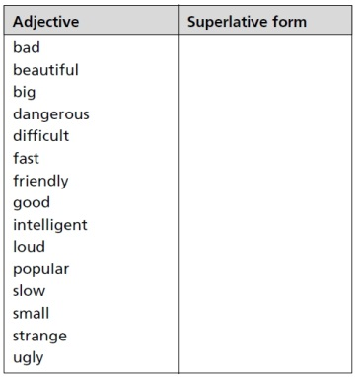

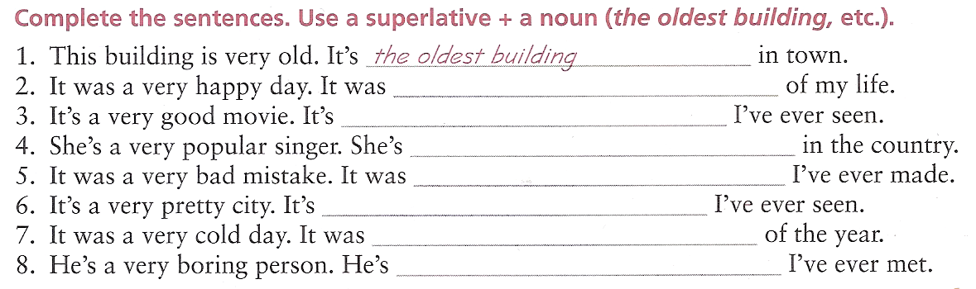

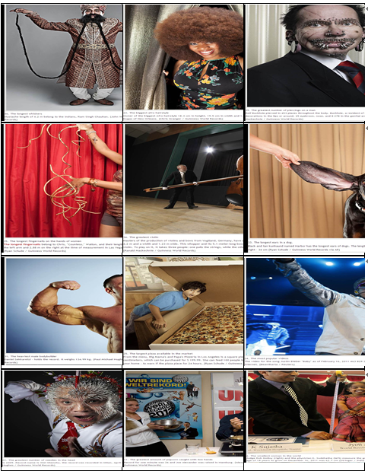

- The longest whiskers

- The greatest amount of popcorn caught with two hands

- The longest finernails on the hands of women

- The longest ears in a dog

- The largest pizza available in the market

- The greatest number of piercings on a man
- The smallest woman in the world

- The biggest afro hairstyle

- The greatest violin

- The greatest number of needles in the head

- The most popular videos

- The heaviest male bodybuilder

1.
Mustache lengths of 4.2m belong to the Indians, Ram Singh Chauhan.

2 .
Owner of the biggest Afro hairstyle 18.3cm in height, 19.5cm in width and 1.31m in diameter is Evin Dugas of New Orleans

3 .
Rolf Buchholz pierced in 453 places throughout the body. Buchholz, a resident of Dortmund has 94 decorations in the lips or around, 25 eyebrows, nose, and 8,278 in the genital area.

4 .
The longest fingernails belong to Chris, "Countess," Walton, and their length is 3.09m in the sum on the left arm and 2.88m on the right at the time of measurement in Las Vegas, February 21, 2011

5 .
Masters of the production of violins and bows from Vogt land, Germany, have created a violin length of 4.2m and a width and 1.23m wide. This whopper and its 5.1-meter-long bow, seven times the normal violin. To play on it, it takes three people: one pulls the strings, while the other two move the bow

6 .
Black and tan kunhaund named Habor has the longest ears of dogs. The length of the left 31.7cm and right-34cm

7 .
Daniel Sekkaretsi - holds the record, It weighs 134.99kg

8 .
From the menu, Big Mama's and Papa's Pizzeria in Los Angeles is a square pizza with a side of 123cm, which can be purchased for $199.99. She can feed 100 people to order and delivered to your home - to warn if the pizza place for 24 hours.

9 .
The video for the song Justin Bieber "Baby" as of February 16, 2011. 463,829,304 gathered views on the Internet

10 .
In 2009, Record-name is Wei Shenchu, the record was recorded in Milan, April 11, 2009

11 .
Record for one minute was 26 and joe Alexander was raised in Hamburg

12 .
Judge Rob Molloy and the physician K. Sudzhatha measure the growth jyotih Amge. At the age of 18 years to grow on December 16, 2011 was 62.7cm.

