Listening Speaking Reading Grammar Writing

Topic:
Solar System & Pluto

Instructor:  LEE | Level:  Upper-intermediate | Students:  13 students | Length:  30 Minutes

Materials:

Board and marker
picture#1, picture#2, picture#3, picture#4, picture#5 (Vocabulary), worksheet#1 (15) for pre-activity

Reading passage(15), worksheet #2(15), worksheet#3(2) for main activity

Planet’s pictures and names for post activity

Aims:
- Main aim:
- Students will improve their reading skills by having students practice reading the passage about the solar system and Pluto.

- Secondary aim:
- Students will be better able to understand the passage about the solar system through worksheets and activities on the solar system.

- Personal aim:
- I want to reduce my TTT
- I want to improve my demonstration techniques.
- I want to improve more ICQs and CCQs skill.
- I want to go with the lesson more smoothly and more quickly.
- I want to try to speak my English more fluently.

Language Skills:
- Reading: Ss will practice their reading skills by reading the passage of Pluto and by reading descriptions of planets.

- Listening: Ss will practice their listening skills by listening to other’s idea during activities.

- Speaking: Ss will practice their speaking skills by sharing their ideas in group and individually.

- Writing: Ss will practice their writing skills by filling in the blank and writing the answer during working on the worksheets.

Language Systems:
- Phonology: Ss will be able to pronounce the name of the planets on the solar system.

- Lexis: Ss will learn the name of planets.

- Grammatical: Ss will be able to use present tense when they describe planets

- Functional: Ss will be able to discuss their idea during group activities.

- Discourse: None to discuss

Assumptions:
- Ss already know each other and how the class works.
- Ss already know teacher’s style of teaching and the pace of course.
- Ss already know what solar system is, but Ss are confused with the name of different planets..

Anticipated Problems and Solutions:

Students may take long time to finish their tasks.
- Monitoring and help them if needed.
- Make them hurry by timing.

Students may feel difficulty to understand new words related to solar system.
- Show them a picture or good examples about those words.

If time is short
- Cut post-activity short by asking only 1~2 students to share their sentences.

If students finish their tasks earlier than expected
- Use S.O.S activity

References:
-http://www.google.com/
- http://www.cnngo.com/explorations/life/22-travel-world-records-039346
- www.macmillanenglish.com/inspiration.
- http://choppasenoel.blogspot.com/2012/04/guinness-book-of-records-for-2012.html

Lead-In
Materials:

Time | Set Up | Student Activity | Teacher Talk
2min | Whole class | <Greeting> | Greeting  Hello, Hi, Good morning~!!  How is the weather today??  It is nice, isn’t it??  When I was young, I lived in rural area. So I used to enjoy see beautiful srars in the sky. Tonight, I am looking forward to seeing the beautiful stars in the night sky, because the sky is very clear these days.

Pre-Activity
Materials: board, marker, picture#1~#5, worksheet#1

Time | Set Up | Student Activity | Teacher Talk
3min  2min  2min | Whole class  Whole class | <Vocabulary for reading>  <working on the worksheet>  <sharing Ss’ answer> | Eliciting  (Show the picture # 1-telescope)  What do you see in this picture?  “telescope.!!”  (boarding and saying)  Right, there is a telescope.  What is the telescope?  “It makes distant things seem larger”  (showing picture#2 – astronomer)  Who is he??  “astronomer”  (boarding)  What is he studying??  “Astronomy, stars…..”  (show picture#3-solar system)  What is it?  “solar system”  (boarding)  (show picture#4-orbit)  What can we call this kind of path??  “orbit!!”  Right so.. we are talking about solar system today  CCQs  Solar system is in my body?  Solar system is in outer space?  I’ll give you the worksheet. What you are going to do is filling in the blank.  You are working alone, and you have 1minute to complete it  ICQs  What are you going to do?  How many minutes do you have?  Are you working alone?  I don’t want you to start until I say go!!  Will you start as I give you the paper?  Will you start as I say go??  (hand out worksheet#1)  OK. Ready? Go!  (Timing 30sec/10sec)  Times up!  (ask Ss to answer)  Good! Good job, guys.

Main Activity
Materials: picture of Pluto, reading passage, worksheet#2, worksheet#3

Time | Set Up | Student Activity | Teacher Talk
1min  5min  4 min  5min | Whole class  individually  In a group  In a group | <guess the title of pictures>  <reading the passage and answer the questions>  <matching pictures with description>  <traveling around a certain planet> | Prediction  (show the picture of Pluto)  Can anybody tell me what it is?  That’s right.  The planet, Pluto.!!  But there were some controversial opinions and dramatic changes on Pluto.  Let’s figure it out.!!  Instruction  I will give you a passage about Pluto. After You are reading it, solve some questions on the worksheet. You can have 3minutes to complete it. And you are working alone.  ICQs  What are you going to do?  How many minutes do you have?  Are you working alone?  I don’t want you to start until I say go!!  Will you start as I give you the paper?  Will you start as I say go??  (hand out the passage and worksheet)  OK. Ready? Go!  (Timing 1min/ 30sec/10sec)  Times up!  (ask Ss to answer)  Good! Good job, guys.  (grouping Ss into two group, “solar”, “system”  Ok, before we start another activity, let’s group you guys.  “solar”, “system”  (pointing the exact area where they can gather together)  All “solar” here, all “system” here.  Instruction  We have 8pictures and descriptions of planets in the solar system.  You are going to match each picture with the best description of it.  You can have 2 minutes to complete it. And you are working in a group.  ICQs  What are you going to do?  How many minutes do you have?  Are you working alone?  I don’t want you to start until I say go!!  Will you start as I say go??  OK. Ready? Go!  (Timing 1min/ 30sec/10sec)  Times up!  (ask Ss to answer)  (have the tallest Ss board the answer)  Good! Good job, guys.  Instruction  (show the brochure of traveling around Saturn)  What is it?  It’s brochure for the trip to the Saturn.  Now, we can easily travel our solar system with spaceship.  So you are planning to go on a trip to outer space for this weekend.  Which planet would you like to go?  Please, choose two planets and think about what features attract you.  In my case, I would like to go to Mars. Because I want to know if there exists a living creature or not.  You can have 2minutes to think about it and you are working in a group.  You can choose two best plans in your group.  ICQs  What are you going to do?  How many minutes do you have?  Are you working alone?  OK. Ready? Go!  (Timing 1min/ 30sec/10sec)  Times up!  (ask the answers of the group)  Good! Excellent!!  I’m looking forward to the trip on the solar system

Post Activity
Materials:

Time | Set Up | Student Activity | Teacher Talk
5min | Whole class  i |  | Instruction  Now, 000!! 000!!  I want you to do rock scissors paper!!  Ok, 000 is winner.  Please, come up here and sit down here.  I will show the picture of certain planet and then you answer.  If you are saying the right answer, it goes to next person.  You can have 1minute for whole questions.  ICQs  - What are you going to do?  - How much time do you have?  Ready. Go!!  (do the same for the other group.)  OK, good job.  Error Corrections  I didn’t find any mistake today.  case1) So, can you unscramble this?  (sssoarlyemt)  Closing  OK, Thank you for the participation today. You did a great job. Does anyone have a question? Well, If there is no further question, this concludes my reading microteaching.
SOS Activities
Materials:

Time | Set Up | Student Activity | Teacher Talk
5 min | Whole class |  | Instruction  (board “do you believe there exsists a living creature in outer space?  Now, you are going to board your name under “yes” or “no”.  (have Ss board their names under “yes” or “no” )  ICQs  What are you going to do?  Okay. And Go!  Monitor discreetly  (After boarding, ask 2~5 Ss for sharing their idea)

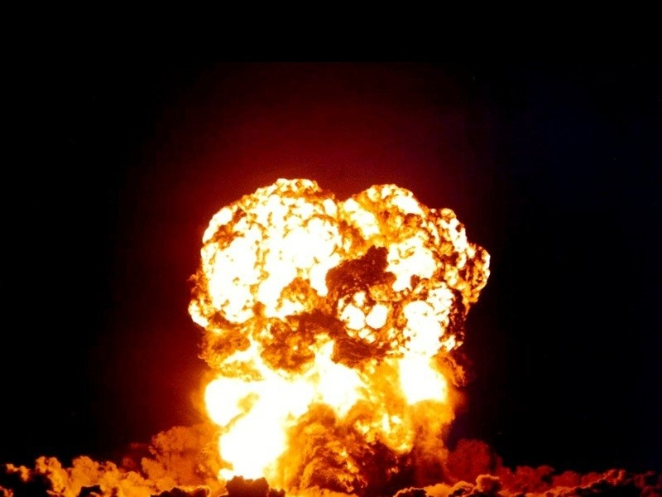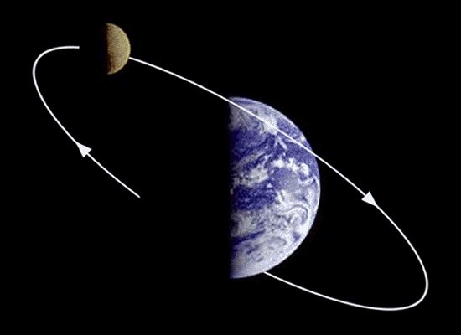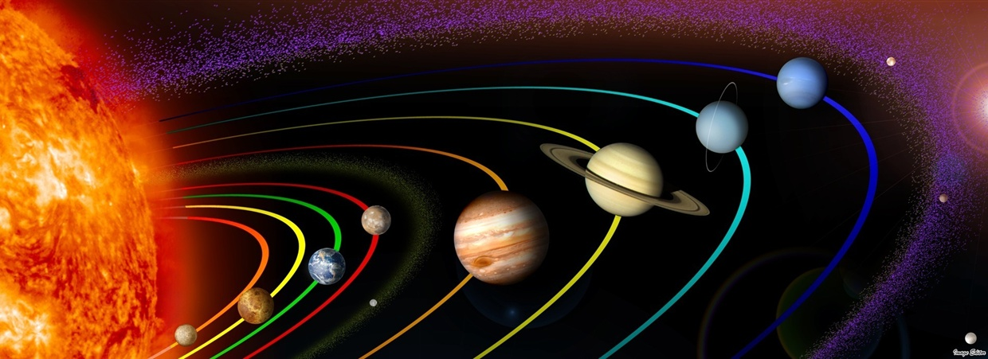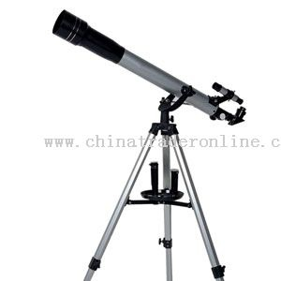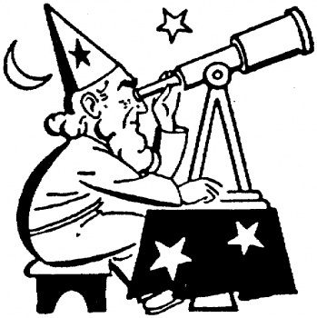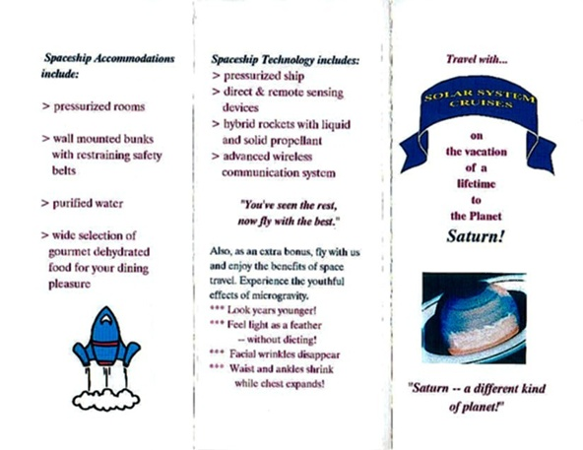

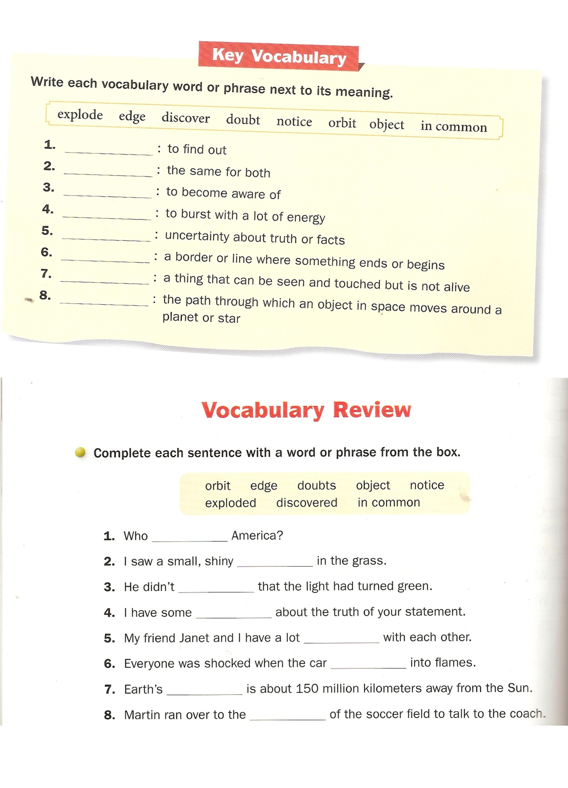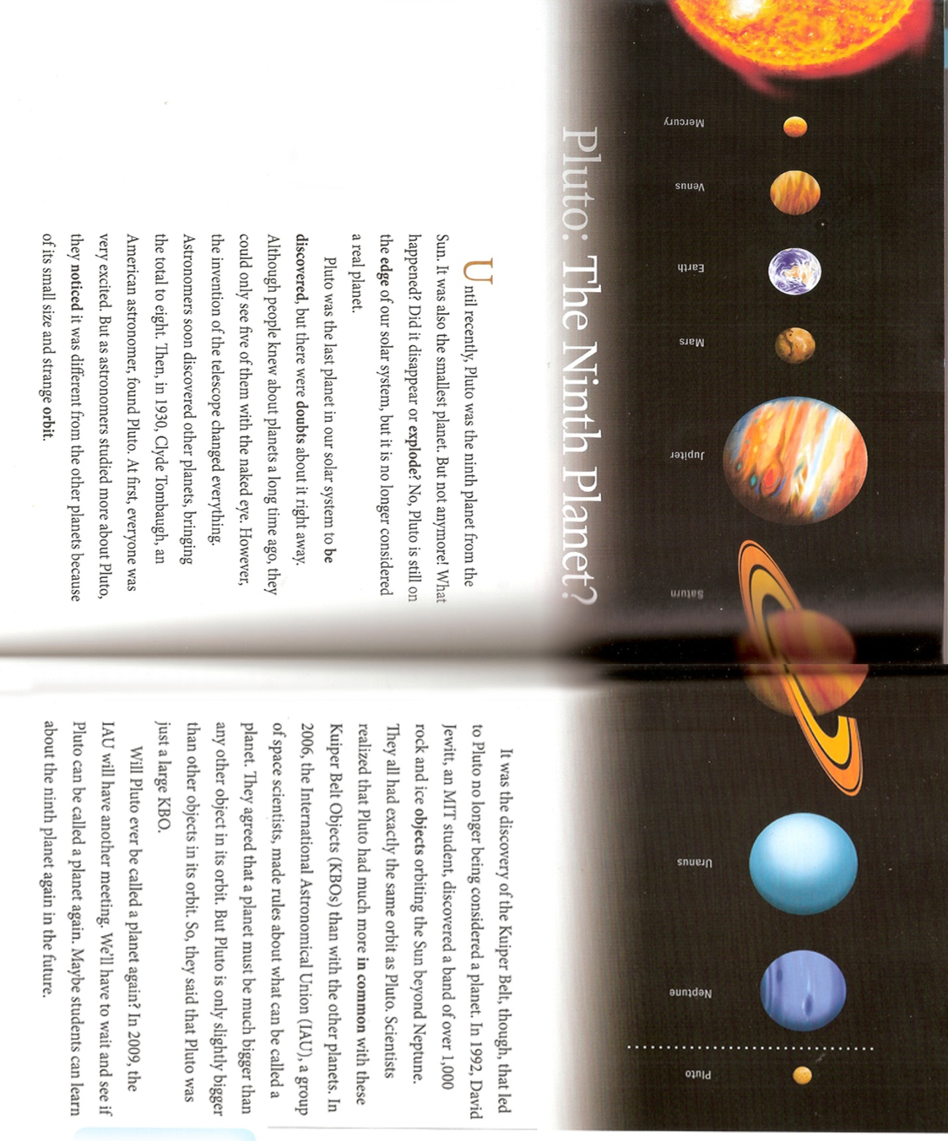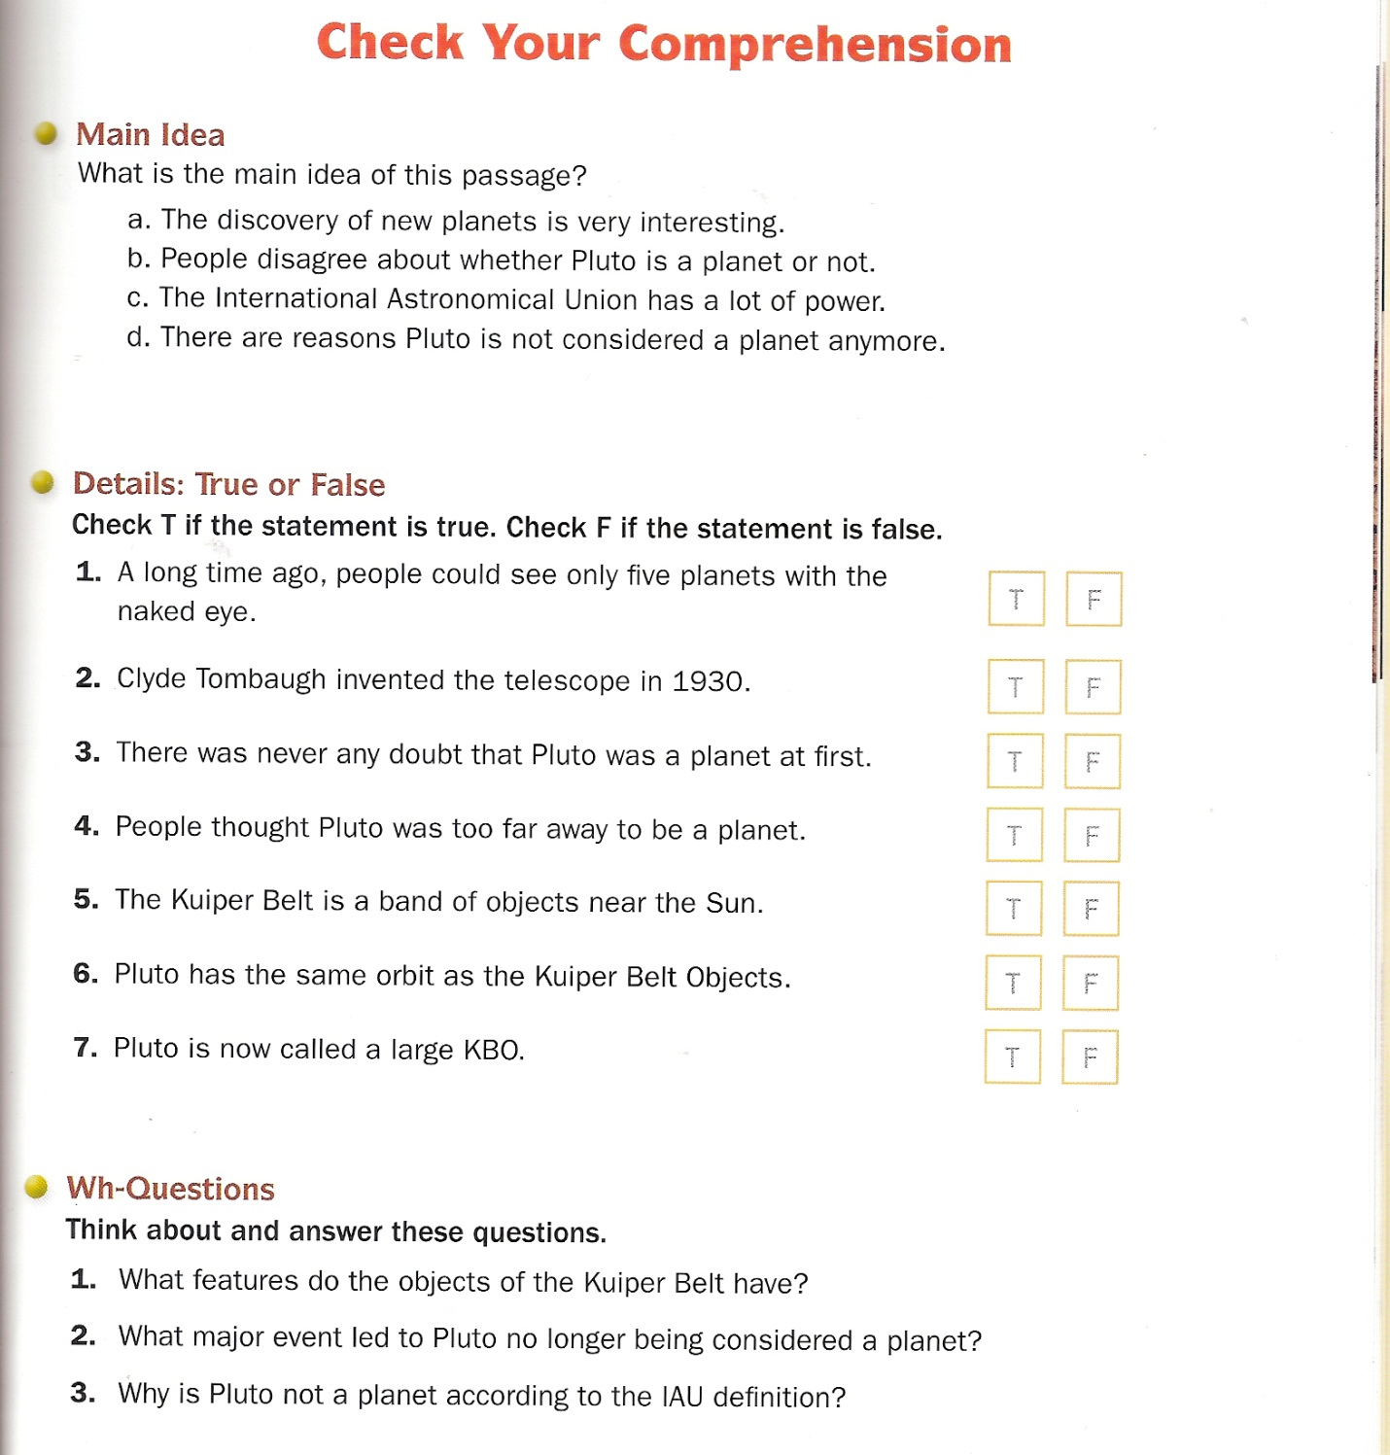

Mercury
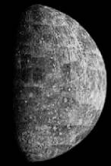
Diameter | Distance from sun | Rotation-time around sun | Moons
4 800 km | 58 Mio km | 88 days | -
It is the nearest planet to the sun and it is the smallest planet with a diameter of 4800 kilometers. The temperatures fluctuate from +400 degree celsius (dayside) to –100 degree celsius (nightside).
Venus
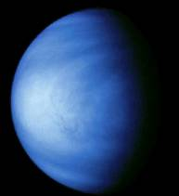
Diameter | Distance from sun | Rotation-time around sun | Moons
12 300 km | 108 Mio km | 225 days | -
This planet is the brightest star in the sky and he seems like a „morning- and evening star“. It is surrounded by a cloudy and dull atmosphere which makes it unable to see its surface.
Mars
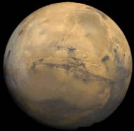
Diameter | Distance from sun | Rotation-time around sun | Moons
6 800 km | 228 Mio km | 1 year 322 days | 2
Mars is a „neighbor-planet“ of the earth and it shines with a red light. His surface was photographed from the very near from an American spacecraft for the first time in July 1965.
Jupiter
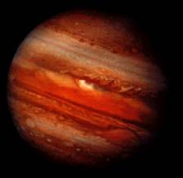
Diameter | Distance from sun | Rotation-time around sun | Moons
142 700 km | 778 Mio km | 11 years 317 days | 11
It is „the giant of the planets“. 12 moons rotate around it. It is surrounded by a huge atmosphere.

Saturn
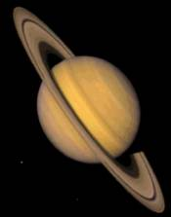
Diameter | Distance from sun | Rotation-time around sun | Moons
120 800 km | 1 Mia 428 Mio km | 29 years 174 days | 10
It has 10 moons and one of them has even an own atmosphere. its ring consists of very small dust-parts which rotate around him.
Uranus
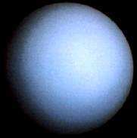
Diameter | Distance from sun | Rotation-time around sun | Moons
49 700 km | 2 Mia 872 Mio km | 84 years 28 days | 5
He is accompanied by 5 moons and needs about 84 earth-years to rotate one time around the sun.

Neptun
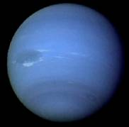
Diameter | Distance from sun | Rotation-time around sun | Moons
53 000 km | 4 Mia 500 Mio km | 164 years 321 days | 2
He has two moons and a rotation around the sun takes him 165 earth-years. His weight his 17 times higher than the weight of our planet.

Pluto
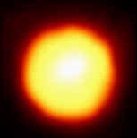
Diameter | Distance from sun | Rotation-time around sun | Moons
5 000 km | 5 Mia 900 Mio km | 250 Jahre | -
He is the planet with the biggest distance to the sun and he was discovered in 1930 as a very small star. We don’t know anything

