Listening Lesson Plan
How can I get to the city hall?

Instructor:  Sol | Level:  Beginner | Students:  10 | Length:  60 Minutes

Materials:
- Pictures of location words
- Idioms worksheets (10 copies)
- Maps with various destinations (5 copies each)
- Listening CD & computer
- Listening worksheets (10 copies)
- White board, board markers & tape or magnets

Aims:
- To learn location words and vocabularies and expressions for describing direction by completing an idioms matching worksheet
- To be able to pick up details from the real-life talk by answering details questions on a work sheet.
- To practice listening to real-life conversation of fast talkers.
- To practice speaking by reading sample dialogue

Language Skills:
- Reading: Idioms work sheet
- Listening: Short conversation recorded on CD about asking for direction and answering with location words
- Speaking: Practicing various dialogue
- Writing: Dictation, making sentence using vocabularies and expressions

Language Systems:
- Phonology: Pronunciation of location words and direction expressions
- Lexis: Location words and vocabularies, expressions for describing direction
- Grammar: Usage of how and location words
- Function: Understanding the direction to get to the destination
- Discourse: Conversation about finding destination

Assumptions:
Students already know:
- How the class is set up and run (pair work)
- The teacher’s style of teaching and the pace of the course
- All students are 7th ~ 9th grade (Age 14~16)
- Most students see the map
- Most students have never met stranger asking direction on the street

Anticipated Errors and Solutions:
- If students need more time to work on the idioms,
- Induce them to find the answers by suggesting clues.
- If students are not able to follow the passage easily,
- Follow the task-feedback circle: let them listen to the tracks again until they get the main idea of the conversation.
- If students are not able to pick up details from the listening,
- Make them listen to small chunk. (pause-play-pause-play)
- If time is short,
- Have them just verbally answer instead of writing.
- If speakers are too fast for students to understand,
- Play the CD little slowly.
- If students finish their tasks earlier than anticipated,
- Review for more time and ask as many students as possible about today’s idioms.

References:
- Text book Unit 7 “How I get to the city hall?”
- Activity book Unit 7

Lead-In
Materials: Board, Board markers, Pictures of location words, Tape or Magnet
Time | Set Up | Procedure
5 min | Whole  class | T: Good afternoon, class. How was your lunch? Today, we are going to look at a map and find the way with the map. Before we get to our lesson, I’d like to know if there is anybody who has met a stranger asking for the direction in English. Nobody? Then let’s learn today!  (Elicit the expressions, vocabularies and location prepositions and write them on the board.)  T: Ok, good job. Now we are going to listen to some people who want to know how to get to their destination. But first, we are going to learn some idioms the speakers use in conversation.

Pre-Activity
Materials: Board, Board markers, Idioms worksheets
Time | Set Up | Procedure
10 min  5 min | Whole  class  Whole  class | 1. Idioms  Instruction  (Tape the big pictures of location words on the board and teach students.)  T: Everybody look at the board, please. First picture represents ‘on’....  Second picture represents ‘next’…. Ok, great.  (Remove the pictures from board and distribute idioms worksheets.)  T: Take your seats and take out the handout please. Now you can write the correct location propositions under the pictures on the handout. Work individually. You have 3 minutes.  Demonstration  T: Let’s do #1 together. Look at the picture #1….  CCQ  Who are you working with?  How much time do you have?  What do you write in the empty box?  (Monitor discreetly and answer students if they ask question. Give time warning. Be flexible with time. Give 1 more minute if they need.)  T: Let’s check the answers. We did #1 so look at the picture #2. The dog is between the boxes. Right? Are you correct? And #3….  Instruction  T: Everyone, now look at the below 6 expressions of direction and 3 vocabularies. Please listen and repeat after me.  (Listen and repeat.)  Demonstration  T: So first expression is used when you….  (Finish explaining, elicit the meaning from students.)

Main Activity
Materials: Board, Board markers, Map, Listening worksheets, CD & Computer
Time | Set Up | Procedure
15 min  15 min | Whole  Class  Pairs  Individually  Pairs | 1. Listening for the Main Idea (general understanding)  Instruction  T: Now we listen to the short conversation about finding destination. It’s a pair work. Put your pens down and close your eyes. Listen to 3 situations carefully.  (Distribute maps and listening worksheets.)  CCQ  How many situations?  Is this an individual work, pair work or group work?  (Play tracks 1 thorough 3 without stopping.)  T: Do you want to listen again?  (S: Yes -> Have them listen on more time.  No -> Have them share their thoughts with your partner.)  T: Where does the first speaker want to go?  Where does the second speaker want to go?  Where does the third speaker want to go?  (Don’t tell students the answers yet.)  T: Now let’s listen again and draw the way to the destinations on the map following the speakers’ conversation. I’ll give you 1 minute after each track and you can discuss with your partner. Oh, please use different color pens for three different destinations.  (Play tracks 1 and give students time to check the directions.  Same for tracks 2 and 3)  T: Do you finish drawing? Which team can present its opinion?  (Check the answers with students by discussing together.)  2. Listening for Details  Instruction  T: Now look at the listening worksheet. There are 3 texts and 5 blanks for each text. You will listen to the speakers one by one this time. Fill in the blanks on the worksheet as you listen. Work individually.  CCQ  How many are total blanks?  Are you working with your partner?  (Play track 1 and let students fill in the blanks.)  T: Do you need listen again?  (S: Yes -> Play track 1 again.  No -> Play track 2.)  (Follow the same cycle until finished with track 3.)  T: Now compare the answers with your partner. You have 2 minutes.  (Finished discussion, check the answers with teacher and other students.)  Instruction  T: Are you correct many answers? Now practice these three dialogues. First left side students are A and right side students are B. If you practice all dialogues, change the role. Left side students are B and right side students are A. You have 4 minutes.  CCQ  Who is A at first?  How many dialogues are you practicing?  (Walk around the class and monitor students actively.  Finish practicing dialogues.)

Post-Activity
Materials: Board, Board markers
Time | Set Up | Procedure
6 min  4 min | Whole  Class  Whole  class | 1. Free Production  Instruction  T: All speakers in conversations went to the destination on foot. When you go somewhere, which transportation can you use? Let’s share the opinions.  (Discuss with students and have all students present one transportation.)  2. Conclude Lesson  (Elicit today’s idioms for students and give them homework.)  T: All of you did such a nice job today. Now look at the map again. Please write the way to get to the theatre. Next class I’ll check your homework. See you tomorrow!
#1 Pictures of location preposition

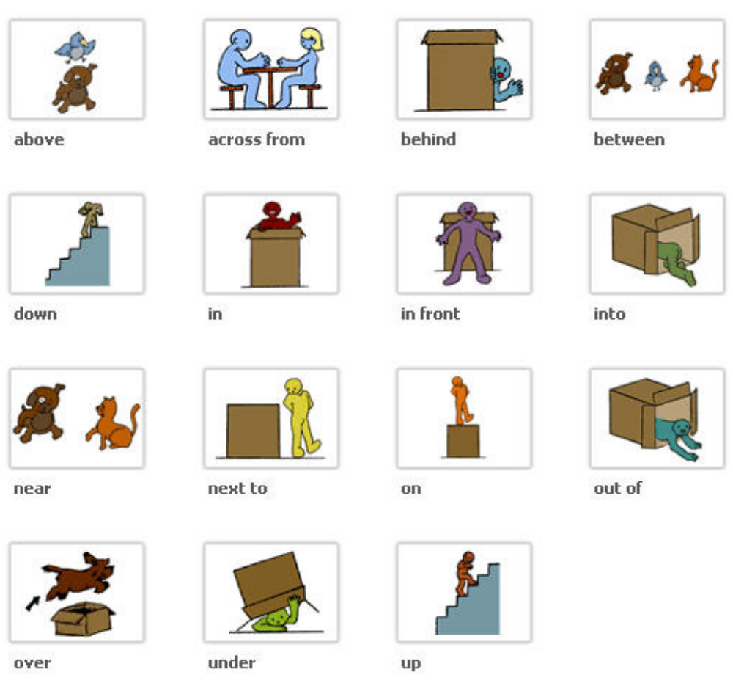

#2 Idioms worksheets
- Fill in the blank with correct location words

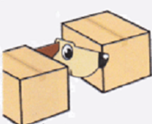

1) The dog is __________ the box. 2) The dog is __________ the boxes.

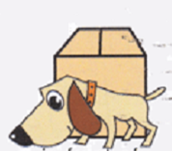

3) The dog is __________ the box. 4) The dog is __________ the box.

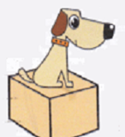

5) The dog is __________ the box. 6) The dog is __________ the box.

- Expressions of direction.
- How can I get to (the place)?
- Go straight for one / two / three / four block(s).
- Turn left / right.
- At the corner.
- It’s on your left / right.
- You can’t miss it.

- Vocabularies
- Street
- Avenue
- Block

#3 Maps with various destinations
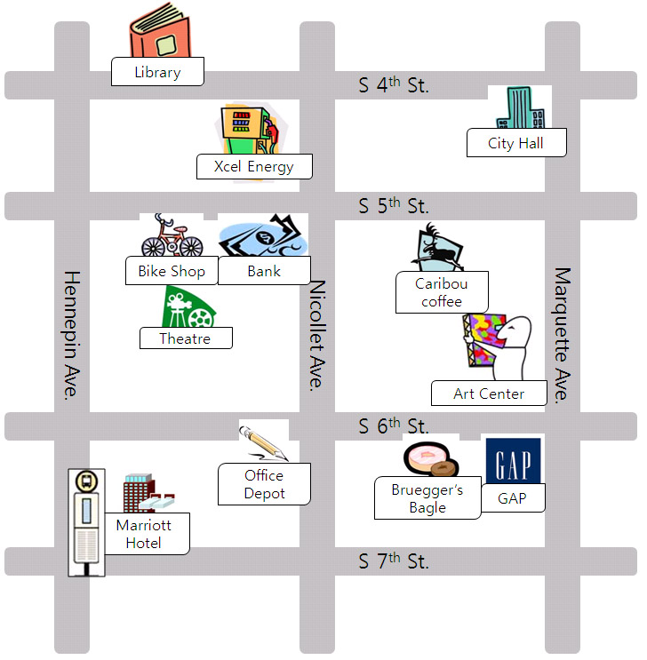
#4 Listening worksheets
Situation #1
A: Excuse me. I’m a stranger here. ( ) can I get to the city hall?
B: Oh, city hall? We are at Kim’s house at Nicollet Ave. now. Go ( ) for 4 blocks
and turn right at the ( ). Go straight more the city hall is on your ( ).
A: Go straight 4 blocks and turn right and go straight more?
B: Yes, then city hall is on your right. You can’t ( ) it.
A: Thank you.

Situation #2
A: Good morning, Sol.
B: Goon morning, Kim. ( ) are you going?
A: I’m going to the ( ). How can I ( ) the library?
B: Oh, library from your house? First, go straight ( ) 4 blocks.
Then turn left at S 4th ( ). Go straight a little more and it’s on your right.
A: Thank you. It sounds simple.
B: You can’t miss it.

Situation #3
A: Hi, Kim. What’s wrong with your bike?
B: My bike was broken so I want to go to the bike shop. How can I get there?
A: Well, go straight for 3 ( ) and ( ) left ( ) S 5th street.
B: And then?
A: There is a bank ( ) your left and the bike shop is ( ) the bank.
B: Oh, I see. Thank you.
A: My pleasure.

#5 Listening Script
Situation #1
A: Excuse me. I’m a stranger here. How can I get to the city hall?
B: Oh, city hall? We are at Kim’s house at Nicollet Ave. now. Go straight for 4 blocks
and turn right at the corner. Go straight more the city hall is on your right.
A: Go straight 4 blocks and turn right and go straight more?
B: Yes, then city hall is on your right. You can’t miss it.
A: Thank you.

Situation #2
A: Good morning, Sol.
B: Goon morning, Kim. Where are you going?
A: I’m going to the library. How can I get to the library?
B: Oh, library from your house? First, go straight 4 blocks. Then turn left at S 4th street.
Go straight a little more and it’s on your right.
A: Thank you. It sounds simple.
B: You can’t miss it. Excuse me.

Situation #3
A: Hi, Kim. What’s wrong with your bike?
B: My bike was broken so I want to go to the bike shop. How can I get there?
A: Well, go straight for 4 blocks and turn left at S 5th street.
B: And then?
A: There is a bank on your left and the bike shop is next to the bank.
B: Oh, I see. Thank you.
A: My pleasure.

