First Essay
Class – 78th Weekdays TESOL for Children
Name – Lami Noh
Teacher – Tobin Stutler
Date – 2012-07-18

I want to be a great teacher
like Maria of “The Sound of Music”
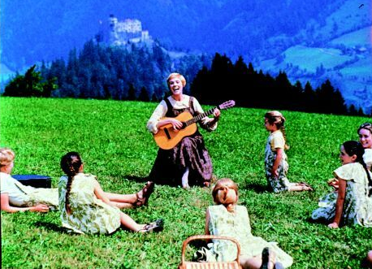

Do you know the “Do, Re, Mi” song? We can learn about music with the song merrily. I want to be a great teacher like Maria of “The Sound of Music”. Because I think that I have to encourage children to open their mind first to teach them effectively. Maria of “The Sound of Music” could open children’s mind with beautiful songs. Learning English through songs is effective functionally as well as emotionally because English and music have something in common. For example, rhythm, accent, intonation, and so on. I will try to develop interesting songs to increase effectiveness of my class.
I want to teach children especially. The most important reason is that I love children very much. Whenever I see their pure smile and cute voice, I am very happy. Great teachers love their students. I am sure that I can be a great teacher for children because I love them. When I feel that teaching children is not easy, I will be able to overcome difficulties with love for them.
The next reason is that I can teach children with more activities compared to teenagers or adults. I am very sensitive and I love music and dance especially. I want to teach children using music and dance. Therefore, I can encourage them to enjoy activities.
Another reason is that I prefer a fun teaching environment because I like to make people laugh. I will do fun activities to encourage children to concentrate on my class effectively.
To be a great teacher, I have to know about the current education system in Korea. The education system in Korea has only focused on Listening and Reading until now. Consequently, most Koreans can’t speak English fluently and write it well. Fortunately, KICE (Korea Institute for Curriculum and Evaluation) started NEAT (National English Ability Test) to solve these problems this year. NEAT can evaluate not only Listening and Reading but also Speaking and Writing. I expect that communication skills of students will be improved and the value of TESOL will be increased through NEAT.
I hope I can gain followings from the TESOL for Children course. I want to understand children and learn effective teaching skills for them. I hope I can get confidence for speaking and teaching English. Through Micro Teaching, I want to strengthen my strengths and make up for my weaknesses. I expect that I will be able to be a great teacher like Maria through this course.

