Listening Speaking Reading Grammar Writing

Topic: The Olympian God

Instructor:  So Young Kim | Level:  Intermediate | Students:  4 students | Length:  40 Minutes

Materials
- Board and board marker
- Pictures(Nike logo, Pandora’s Box)
- Creative grouping techniques(Zeus & Poseidon)
- 4 copies of Pandora’s box story
- 4 copies of Worksheet #1(fill out the blank)
- 4 copies of Worksheet #2 (writing activity)
- 4 copies of Worksheet #3 (SOS1: bingo)
- 4 copies of Worksheet #4 (SOS2: word-search)

Aims
- Main Aim: Students will improve their reading skills by having students talk about
“the Olympian God.”
- Second Aim: Students will talk about Olympian Gods, by having students guess who the god is, read the story about Pandora’s box and make own questions, and writing about create a god.
- Personal Aim: I want to speak louder, make error correction at the end of lesson, and prepare interesting and enjoyable materials for students.

Language Skills
- Reading: Students will read the main text related to the Olympian God.
- Listening: Students will listen to the classmates’ opinions.
- Speaking: Students will speak their thought based on what they write and will have conversation in pairs.
- Writing: Students will practice writing by create their own god/goodness.

Language Systems
- Phonology: Students will be distinguished Nike can be said differently.
- Lexis: Students will learn some new words about the Olympus gods.
- Grammar: None to discuss
- Function: Students will write about creating own new god/goddess.
- Discourse: Students will share their thoughts in class.

Assumptions
- Students already know how the class is set up and run.
- Students already know the rule of English Only in the class.
- Students already know the teacher’s style of teaching and the pace of the course.
- All students are intermediate level of students.
Anticipated Problems and Solutions:
Anticipated Problems | Solutions
- Students may have trouble to understand what to do and how to do the activities  - Students may take longer time than I expected in activities.  - Time might be short than I expected | - Teacher will repeat the instructions and make it clear with explain and demonstration.  - Teacher will give time warning to students consistently.  - Teacher will prepare for SOS activity related to the Olympic true or false questions.

References:
- http://www.wartgames.com/themes/myths/greek.html
- http://greece.mrdonn.org/myths.html
- http://printouts.pppst.com/ancient-bingo.html
- http://greece.mrdonn.org/greekgods/pandora.html

Lead-In
Materials: N/A
Time | Set Up | Student Activity | Teacher Talk
1-2 min | Whole Class | “Good/Ok.”  S1 answers.  S2 answers. | Greets students  Hello, everyone. How’s everyone doing today? (2 guide questions) S1, Have you read any good books lately? S2, How many books do you read in a year?

Pre-Activity
Materials: 4 copies of Worksheet #1, board and board marker, Nike logo picture, creative grouping technique picture
Time | Set Up | Student Activity | Teacher Talk
1-2  min  1 min  1 min  4 min  3 min | Whole Class  Pair work  Pair work | “Nike.”  “Nike(Neekae).”  “No.”  “Yes.”  “Zeus, Poseidon...”  “Name the god.”  “No.”  “4 minutes.”  “No.”  Students read the questions and answer the questions. | Procedure  Prediction and Eliciting  (Show ‘Nike’)  “Can you tell me what the picture is?”  (Nike Logo)  “Yes, this is the logo of Nike. But, how Nike can be said (pronunciation) differently?  Is there any name related to the gods in real world other than this?  (Students answer)  CCQs  -In this context, is God a human?  -In this context, is Zeus considered to be a God?  Creative grouping technique  “Pick a paper. You are… (Students answer). Please find your partner.”  (Zeus & Poseidon)  Give instructions  “I am going to give you a worksheet. You will see 14 names of the Olympus gods in the box. As a team, I want you to read all the sentences and name the god/goddess.  For example, number 1, this god’s Roman name is Neptune. The answer is Poseidon.  If you don’t know the answer, just guess who it would be. I am going to give you 4 minutes. Please do not start before I say go.”  ICQs  -What are you going to do?  -Are you working alone?  -How many minutes do you have?  -Are you going to start when I give you handout?  Distribute Worksheet  “go”  Monitor Discreetly  Answer the students if they have any question.  Give Time warning  “2 minutes left… 1 minute left… 30 seconds left…and times up.”  Check Answers with students  Let students read the question 2 through 20(Start from S1 to S4, question number 1 already answered by the teacher)  “Good job, everyone.”

Main Activity
Materials: Reading material (Pandora’s Box), Picture(pandora’s box), board and board marker, 2 boxes, papers.
Time | Set Up |  | Student Activity |  | Teacher Talk
1-2 min  3 min  1-2 min  5 min | Whole Class  Individual Work  Pair Work  Pair Work |  | Open Class Participation  “Pandora’s Box.”  “Read the story about  Pandora’s Box.”  “3 minutes.”  “No.”  “Make own questions as many as possible.”  “5 minutes.”  “No.”  Two groups switch the boxes and read the questions and answer to the questions. |  | Procedure  Prediction and Eliciting  “What’s the box called that you are not supposed to open? (Pandora’s Box) Yes, it’s Pandora’s box. We are going to read the story about Pandora’s box. I am going to give you 3 minutes to read the story.”  ICQs  -What are you going to do?  -How many minutes do you have?  -Please do not start before I say go. Are you going to start before I say go?  “Go.”  Give Time Warning  “2minutes…1 minute... 30 seconds, and times up.”  Creative grouping technique  “Pandora’s, Box, Pandora’s, Box.”  Find your partner.  “I am going to give you a box for each team. Now, you are going to make your own questions as many as possible in 5 minutes. After 5 minutes, put the questions in the box.”  ICQs  -What are you going to do?  -Are you working individually?  -How many minutes do you have?  - Please do not start before I say go. Are you going to start before I say go?  “Go.”  Monitor Discreetly  Answer the students if they have any question.  Give Time warning  “3 minutes left… 1 minute…..30 seconds left…and times up.”  “Now, switch the boxes and each group has to pick a question and answer it within 10 seconds. If you get the answer, you will get a point.”  Who has shortest hair in this class?  Ok, Inhyuck, could you start first?
Post Activity
Materials: 4 copies of worksheet #2 (Create your own god/goddess), board and board marker.
Time |  | Set Up |  | Student Activity |  | Teacher Talk
1-2 min  5 min  4 min |  | Whole class  Individual Work  Individual work |  | Get instructions  “Create a new Olympian god/goddess.”  “5 minutes.”  “Yes.”  Students writing on the worksheet  S1 answer….S4 answers.  “Pandora.” |  | Procedure  Give instructions  We are going to create a new Olympian god/goddess. (show the worksheet) I will give you 5 minutes. After you are done with writing, we are going to share ideas in class.  ICQs  -What are you going to do?  -How many minutes do you have?  -Are you working individually?  “Please do not starts before I say go. Are you going to start before I say go? Ok, go.”  Monitoring discreetly  Give Time warning  “3 minutes left ...2 minutes…1 minute…. and times up.”  “S1, who did you create? S2, S3, S4.”  “Thanks for sharing your ideas.”  Error Correction  Can you unscramble this word?  “Pandora”  “Good job everyone, today. I hope you enjoyed today’s class. I will see you tomorrow.”
SOS Activity(1)
Materials: 4 copies of Worksheet #3 (Bingo form), board and board marker
Time |  | Set Up |  | Student Activity |  | Teacher Talk
1 min  3 min |  | Whole class  Individual Work |  | Get instructions  “Bingo.”  “Yes.”  “Bingo.”  “1 minute.”  “3 lines.”  “Yes.”  “Zeus, Hera……..”  “Bingo” |  | Procedure  Give instructions  (Draw bingo form on the board)  “What’s this called? Good. Have you ever played Bingo before? Good. Filled out all the blanks by using god/goddess name we learned today. I will give you 1 minute to fill out the blanks. The person who makes 3 bingo lines first will be the winner. Please do not starts before I say go.”  ICQs  -What are we going to do?  -How many minutes do you have to fill out the blank?  -How many bingo lines do you need to make to be a winner?  -Are you working individually?  Distribute worksheet  “Go.”  “Who is the tallest person in the class? Ok, you are going to start first and going to the clockwise.”  Play Bingo activity.  “Good job, Student1. You are the winner.” (give a candy)
SOS Activity (2)
Materials: 4 copies of worksheet #4 (word-search), board and board marker
Time |  | Set Up |  | Student Activity |  | Teacher Talk
1 min  3 min  1 min |  | Whole class  Pair work |  | Get instructions  “Searching words related to the Olympus gods.”  “No.”  “3 minutes.”  “No.”  Students start searching words.  Student from each team come to board and write down the words they found. |  | Procedure  Give instructions  Now, I am going to distribute a worksheet. As a team, find hidden words related to the Olympus gods/goddesses. You have 3 minutes to find words and it words every direction.  ICQs  -What are you going to do?  -Are you working individually?  -How many minutes do you have?  “Please do not start before I say god. Are you going to starts before I say go?”  Distribute worksheet #4  “Go.”  Monitoring discreetly.  Give time warning  “2 minutes left, 1 minute left, 30 seconds left, and times up.”  One person from each team writes down the words that they found in the searching box.  “Good job everyone. I hope you enjoyed today’s class.”

Worksheet #1
Olympians Quiz
Guess name of the Olympus god/goddess. Answers may be used more than once ☺
Zeus, Hera, Poseidon, Hades, Athena, Apollo, Artemis, Aphrodite, Hermes, Ares, Hephaestus, Hestia, Demeter, Dionysus
- Name the goddess of war.
- His symbol is the thunderbolt.
- Her roman name was Juno, and her symbol was the peacock.
- Name the god of the underworld.
- Name the twin of Artemis
- Name the goddess of wisdom.
- Name the very jealous wife of Zeus.
- Name the god of the sun, poetry, music and medicine.
- His roman name is Jupiter.
- This god is anti-social and doesn’t like people.
- Name the wealthiest god.
- Name the goddess of hunting and twin of Apollo.
- Name the goddess of hearth and home who gave up her throne for Dionysus.
- Name the mother of Persephone; her Roman name is Ceres.
- His symbols are winged sandals and a winged helmet.
- Name the only handicapped god.
- This god’s Roman name is Mars, and he is the god of war.
- His symbol is fire and a hammer, and his roman name is Vulcan.
- His roman name is mercury, and he is the messenger of the gods.
- Name the god of wine.
- She was the goddess of love and beauty.

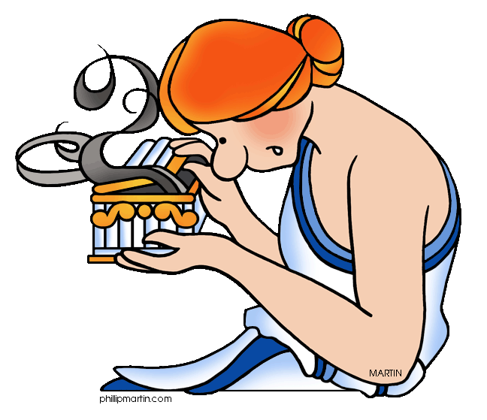
Pandora's Box
Once up a time, a long time ago, Zeus ordered Hephaestus (Aphrodite's husband) to make him a daughter. It was the first woman made out of clay. Hephaestus made a beautiful woman and named her Pandora.
Zeus sent his new daughter, Pandora, down to earth so that she could marry Epimetheus, who was a gentle but lonely man.
Zeus was not being kind. He was getting even. Epimetheus and Prometheus were brothers. Zeus was mad at one of the brothers, Prometheus, for giving people fire without asking Zeus first.
Zeus gave Pandora a little box with a big heavy lock on it. He made her promise never to open the box. He gave the key to Pandora’s husband and told him to never open the box. Zeus was sure that Epimetheus' curiosity would get the better of him, and that either Epimetheus or his brother would open the box.
Pandora was very curious. She wanted to see what was inside the box, but Epimetheus said no. Better not. "You know your father," Epimetheus sighed, referring to Zeus. "He’s a tricky one."
One day, when Epimetheus lay sleeping, Pandora stole the key and opened the box.
Out flew every kind of disease and sickness, hate and envy, and all the bad things that people had never experienced before. Pandora slammed the lid closed, but it was too late. All the bad things were already out of the box. They flew away, out into the world.
Epimetheus woke up at the sound of her sobbing. “I opened the box and all these ugly things flew out,” she cried. “I tried to catch them, but they all got out.” Pandora opened the box to show him how empty it was. But the box was not quite empty. One tiny bug flew quickly out before Pandora could slam the lid shut again.
“Hello, Pandora,” said the bug, hovering just out of reach. “My name is Hope.” With a nod of thanks for being set free, Hope flew out into the world, a world that now held Envy, Crime, Hate, and Disease – and Hope.
Worksheet #2
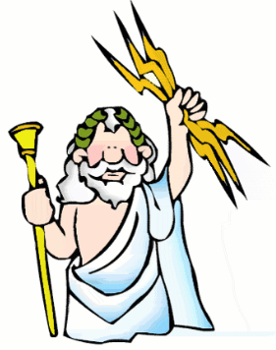
Imagine that Zeus has come to you and said that Olympus is lacking a god or goddess, and he needs you to help. Invent a new Olympian and describe him or her below.
- Name:
- Connection to Olympus (related to another god or goddess? Married to a god or goddess?)

- Powers:
- Symbol:
- Personality traits:

- Friends:
- Enemies:

Worksheet #3
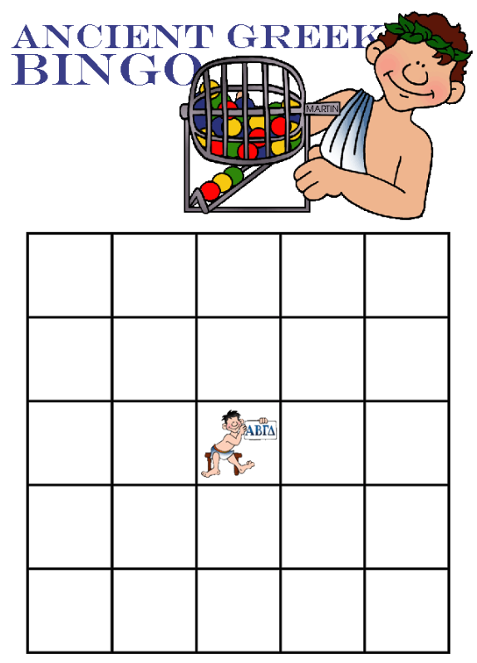
Worksheet #4
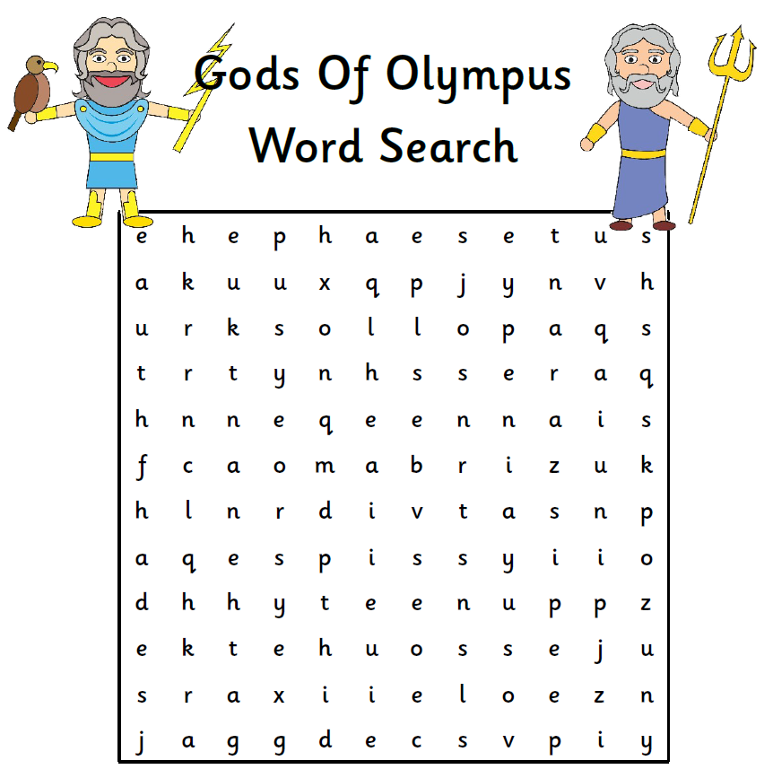

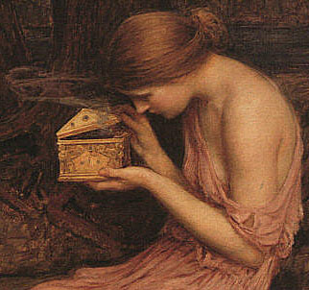

Creating Grouping Activity
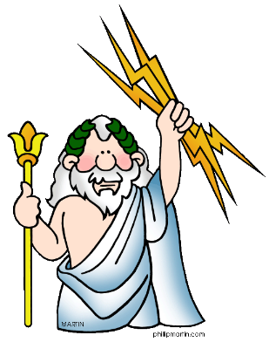
Zeus Zeus
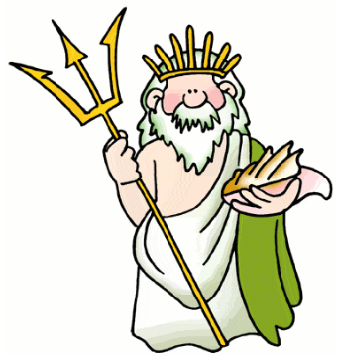
Poseidon Poseidon

