Listening Speaking Reading Grammar Writing

Topic: Countable and Uncountable Nouns

Instructor:  So Young Kim | Level:  Intermediate | Students:  4 students | Length:  40 Minutes

Materials:
- Board and board marker
- Pictures(apple, banana, water, salt, grocery shopping list, refrigerator, shopping cart)
- Worksheet #1(countable and uncountable nouns: 4 copies)
- Role-playing card (husband and wife, customer and clerk)
- Board game map(Wall-chart)
- 4 different color pens
- A dice
- A piece of paper to prepare a dialogue(each team)
- Worksheets (word-searching: 4 copies)

Aims:
- Main Aim: To enable students to improve their grammar skills by having student talk about countable and uncountable words.
- Secondary Aim: Students will use the countable and uncountable structure by having students do a worksheet, role playing, and board game activity.
- Personal Aim: I want to deliver my CCQs and ICQs clearly to the students.

Language Skills:
- Speaking Skills: Students will do role-playing activity in class and board game activity which have to say either countable or uncountable.
- Listening Skills: Students will listen to the other group’s role-playing.
- Reading Skills: Students will read worksheet.
- Writing Skills: Students will practice writing answers on worksheet.

Language Systems:
- Lexis: Students will use the countable and uncountable words.
- Function: Students will do role-playing
- Grammar: Students will learn about countable and uncountable nouns.
- Phonology: Students will use s/es at the end of countable and uncountable nouns.
- Discourse: Students will share their idea in class.

Assumptions:
- Students already know how the class is set up and run.
- Students already know the rule of English Only in the class.
- Students already know the teacher’s style of teaching and the pace of the course
- All students are intermediate level of students.

Anticipated Problems and Solutions:
Anticipated Problems | Solutions
- Students may have trouble to understand what to do and how to do the activities  - Students may take longer time than I expected in activities.  - Time might be short than I expected | - Teacher will repeat the instructions and make it clear with explain and demonstration.  - Teacher will give time warning to students consistently.  - Teacher will prepare for SOS activity related to the Olympic true or false questions.

References:
- http://www.scribd.com/doc/21349490/Elementary-Grammar-Games-Jill-Hadfield
- http://web2.uvcs.uvic.ca/elc/studyzone/330/grammar/index.htm
- http://www.englishforeveryone.org/Topics/Count-and-Non-Count.htm

Lead-In
Materials: N/A
Time | Set Up | Student Activity | Teacher Talk
1-2  min | Whole class | Open class participation  “Good/Not good/Fine.”  “Yes/No.”  “Milk, bread, cookies, etc.”  (answers may various) | Procedure  Greets everyone  “Hello, everyone. How’s everyone doing today? Have you recently been to the grocery store? What did you buy? Is anyone going to a restaurant this evening?”

Pre-Activity
[Is the Word Countable or Non-countable?]
Materials: Board and board marker, pictures(apples, pencils, water, sugar, salt), worksheet #1(countable and uncountable nouns)
Time | Set Up | Student Activity | Teacher Talk
2 min  1 min  3 min  2 min | Whole Class  Individual Work  Whole Class | Answer to the questions  “Apples.”  “Yes.”  “Banana.”  “Yes.”  “No. No.”  “Countable nouns.”  “Uncountable nouns.”  “Yes.”  “No.”  Receive instructions  Students start working individually  Students come up front and check their answers  “Apple, orange, cookie, egg, carrot, pea, watermelon, peanut, cherry, banana, potato, strawberry, and tomato.”  “Water, juice, cereal, sugar, butter, cheese, pasta, meat, milk, soup, flower, oil, salt, jam, rice, and honey.” | Procedure  Prediction & Eliciting the pre-activity  Show pictures to the students  “Can you tell me what the picture is?”  (Picture1: Apples)  “Can you count them?”  “What about this one? What is it”  (Picture2: Banana)  “Can you count these?”  “Can you count water? Sugar? Salt?”  (Picture 3-5: water, salt)  “What do we call the nouns that we can count? What about the nouns that we cannot count?”  CCQs  “Is a pencil a countable word?”  “Is sugar a countable word?”  Give instructions about the pre-activity  I am going to give you a worksheet. In the worksheet, you will see some words either countable or uncountable nouns. Put the words under the right section. You are working individually and I will give you 3 minutes. Please do not start before I say ‘go’.  ICQ’s  - What are you going to do?  - Are you working alone?  - How many minutes do you have?  - Are you going to go to start before I say ‘go’?  Distribute worksheet to students  “Go.”  Monitor discreetly  Answer the students if they have any question.  Give time warning  “2 minutes left… 1 minute left…30 seconds left… and times up.”  Check answers with students  Ask each student.  “S1, what are the words that you put under countable nouns.”  “S2, what are the words that you put under uncountable nouns.”  (*If there is any error putting words in the right section, correct them right away.)  “Good job.”

Main Activity
[Role Playing]
Materials: Role-playing card (husband and wife, customer and clerk), board and board marker, pictures (grocery shopping list, refrigerator, shopping cart), a piece of paper to write down dialogue.
Time | Set Up | Student Activity | Teacher Talk
1 min  1 min  1 min  2 min  5 min  1 min  4-5 min | Whole Class  Pair Work | Students answer  “Bread, ice-cream, fruit, etc.”  “List”  “Grocery shopping lists.”  “Refrigerator.”  “Shopping cart.”  Students find their partner  Get instructions  “No.”  “5 minutes.”  “Prepare for dialogue for role-play.”  “No.”  Take role-play cards  “Yes.”  Students do rock paper scissors.  “1-2 minutes.”  Team1 do the role-play  Team2 do the role-play | Procedure  “Shopping! Everyone loves shopping, right? Well, maybe not everyone. But everyone has to do it from time to time to buy the necessities of life- like food. If you are going to grocery shopping, what would you like to buy?”  Eliciting vocabulary: grocery lists, shopping cart, refrigerator  “Before you go to grocery shopping, you write down something. What is it? How do we call the lists?(Grocery lists)  “Where do we usually put the list on?”  (Refrigerator)”  “What about the thing we carry in the grocery market while we are shopping? What’s the thing called?”  (Shopping cart)  Making pairs  Let each student pick a paper and make pair with related pictures.  (husband and wife V.S. customer and clerk)  “Please pick a paper.”  “Find your pair.”  Give instructions  “I am going to give you role-play card. You are going to read the role play card and prepare 1-2 minutes dialogue with your partner. I will give you 5 minutes to prepare. You and your partner will do role-playing in front of class when you are done. Do not start before I say ‘go’.”  ICQs  -Are you working individually?  -How many minutes do you have?  -What are you going to do?  -Are you going to start before I say ‘go’?  Distribute Role-play cards  (give a piece of paper to write down the dialogue)  “Are you guys ready? Go”  Monitor discreetly  Answer students if they ask questions.  Give time warning.  “3 minutes left, 2 minute left, 1 minute left … 30 seconds left, times up.”  “Now, we are going to do 1-2 minute role-play. Please do rock, scissors, paper. Winner team will do the first.”  (Students do rock, scissor, and paper)  ICQ’s  -How many minutes to do role-play?  “Ok, so please come up team .”  “Next, team , please come up.”  Watch the students’ role-playing  “Good job, everyone.”

Post Activity
[Board Game Activity]
Materials: board and board marker, board game map, 4 different color pens, a dice.
Time | Set Up | Student Activity | Teacher Talk
2 min  1 min  8-10 min | Whole Class | Get instructions  “Play board game.”  “No.”  “No.”  Students roll a dice | Procedure  Give instructions  We are going to do another activity called ‘Roll a Dice’. (Put the wall chart on the board) Every student has a chance to roll a dice. Wherever you stop, there will be a picture. He/she has to make a full sentence correctly using the picture. For example, if I role ‘1’ which is strawberry, I have to make a sentence by using strawberry. Like ‘My mom’s favorite fruit is strawberry.’ If you can’t say or answer incorrectly, you will stay there and the next person will roll the dice. There is also lottery, which you have one more chance to go, and go to jail, which you need to stay there till you roll a 6. Let’s see who is going to be the winner.  ICQ’s  - What are we going to do?  - Can you move if you say a full sentence incorrectly by using the word?  - Are you playing as a team?  “Ok, now, everyone pick a color as a token. (Students pick colors) Roll the dice and the person who gets the highest number will start first and going to the clockwise.”  Monitor students discreetly  Tracking the board game map with students’ colors.  Error Correction if there is any.  “Good job everyone. I hope you enjoyed today’s class.”
SOS Activities 1
[Word-Search]
Materials: Board and board marker, worksheet(word-searching: 4 worksheeets)
Time | Set Up | Student Activity | Teacher Talk
1min  1 min  3 min | Individual Work  Pair work | Students sit together with partner  Get instructions  “Find words in the box.”  “No.”  “3 minutes.”  “No.”  “Watermelon, butter, etc.” | Procedure  Creative grouping technique  Simply, “countable, uncountable, countable, uncountable.”  “Countable are this side, uncountable are this side.”  Give instructions  Now, I am going to distribute a worksheet. As a team, find hidden words in the box either vertically or horizontally (Present these on the board). You have 3 minutes to do the activity.  ICQs  - What are you going to do?  - Are you working individually?  - How many minutes do you have?  - Are you going to start before I say go?  Distribute handout  “Go.”  Monitor discreetly  Give time warning  “2 minutes left, 1 minute left, 30 seconds left, and times up.”  Ask students what words they found.
SOS Activities 1
[Scavenger Hunt]
Materials: N/A
Time | Set up | Student Activity | Teacher Talk
2 min  1 min | Whole Class  Pair work | Get instructions  “Find countable and uncountable objects.”  “1 minute.”  “No.”  “No.”  “No.” | Procedure  Give instructions  Have you ever heard Scavenger hunt? It’s like find something.  As a team, fine countable and uncountable objects as many as possible only in the classroom. I will give you 1 minute.  ICQs  - What are you going to do?  - How many minutes do you have?  - Are you working individually?  - Can you go outside of the classroom?  - Do you start before I say go?  “Good. Go.”  Give time warning  “30 seconds left, 10 seconds left, times up”  Count how many items they found.  “Good job everyone. I hope you enjoyed today’s class.”

Role-Play (Husband and Wife)

Working with a partner, make a dialogue based on the given situation.

The roles: husband and wife

The situation: They went to the grocery store. The wife prepared a grocery shopping lists which are five items (the wife’s choice of 5 items: it can be anything). However, the husband wants to buy something else other than those five items that the wife chose. You can’t buy everything you want, because you have only $30. Discuss which items you want to buy and pick only 5 items and put those in the shopping cart.

Role-Play (Customer and Clerk)

Working with a partner, make a dialogue based on the given situation.

The roles: a clerk, a customer

The situation: A customer just moved into the town. He/she wanted to go to the grocery store and prepared a grocery shopping lists which are five items (the customer’s choice of 5 items). The customer was looking for the items, but he/she couldn’t find those. The customer asked a clerk where he/she can find the items. The clerk was trying to find what the customer wants, but everything was out of stock. So, the clerk suggested the customers to buy substitute items. Every item should be replaced by another item you can find in the grocery store.

Worksheet #1
- Place the words below in the right section.
water, cereal, apple, juice, orange, sugar, cookie, butter, egg, carrot, pea, oil, flour, salt, jam, watermelon, peanut, pasta, milk, cherry, banana, cheese, soup, potato, meat, strawberry, tomato, rice, honey
COUNTABLE NOUNS UNCOUNTABLE NOUNS

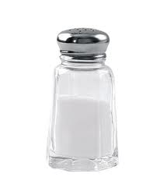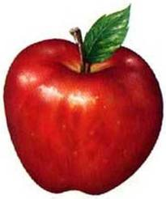
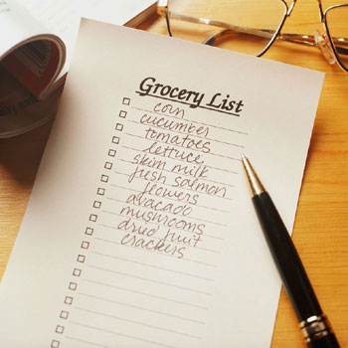

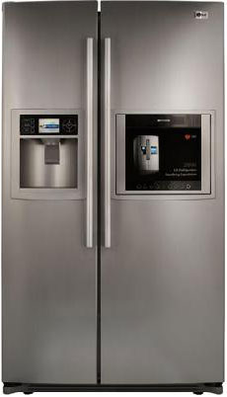
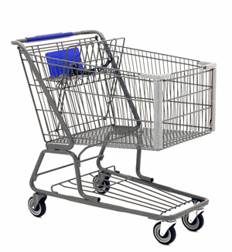

Creative Grouping Techniques
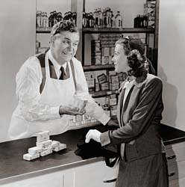

SOS Activity 1
Word-Search: Countable and Uncountable Nouns
- Find word in the box below as many as you can. There are total 25 hidden words.
A | W | A | T | E | R | M | E | L | O | N | B | D | L | O | J | L | I | Y | O
D | I | Y | Y | Y | T | I | T | Y | Z | T | K | O | R | A | N | G | E | D | I
K | W | I | B | K | B | L | K | P | B | N | B | I | J | T | W | T | H | Z | L
F | P | E | A | R | M | K | E | O | S | L | T | J | B | U | T | T | E | R | D
K | F | W | C | Z | R | C | T | T | W | B | Y | C | R | T | Z | T | S | W | R
J | B | P | D | F | P | N | I | A | M | P | S | Z | E | N | D | H | B | Y | M
U | O | Z | F | I | M | M | C | T | Z | C | M | K | A | Y | B | W | R | L | I
I | C | R | W | T | W | C | O | O | K | I | E | N | D | R | N | R | I | Z | L
C | E | R | E | A | L | C | N | R | J | P | A | Z | T | Y | P | H | C | O | K
E | W | B | O | R | F | I | W | W | J | Z | T | K | Y | C | W | T | E | R | W
K | I | S | R | C | A | R | R | O | T | P | I | Z | P | N | G | I | W | I | F
E | T | C | T | I | W | F | W | N | Z | E | R | Y | C | R | K | Y | H | L | Y
S | G | C | O | Y | Z | N | P | J | E | E | J | A | M | D | E | S | O | U | P
S | K | B | A | N | A | N | A | R | B | I | G | P | D | C | T | P | Z | I | P
U | Z | K | M | Y | R | M | S | O | A | H | C | P | R | H | R | W | H | C | G
G | S | W | Y | J | G | B | T | W | D | B | S | L | B | Y | K | R | L | O | W
A | M | W | C | E | M | T | A | J | C | H | E | E | S | E | B | O | C | C | G
R | G | S | P | Z | R | S | P | Z | O | W | Z | O | R | G | W | I | O | P | Z
Y | I | H | O | N | E | Y | W | I | B | P | T | I | W | G | T | K | I | W | I
Q | M | Y | E | I | Y | M | E | W | A | T | E | R | I | D | P | I | L | K | L

