“Listening Lesson Plan”
Title: Great Apartment living

Instructor:  J | Level:  Intermediate | Students:  10 students | Length:  55 minutes

Materials:
- # 1. Script for instructor
- # 2. Pictures for different house
- # 3. 10 copies of vocabulary matching worksheets
- # 4. 10 copies of filling the blank worksheets
- White board, markers, audio player

Aims:
- To learn vocabulary and expression through showing pictures and matching vocabulary
worksheet.
- To be able to describe details about what kind of factors you’re going to ask by role play
- To predict what problems you can come across when you’re looking for a house through
sharing experience
(ex : location, size, utility, fee, rules, furniture etc)
- To practice speaking by renting a house with partners (role play)

Language Skills
- Reading : meaning of words in worksheet
- Listening : the speaker’s conversation about looking for a house
- Speaking : describing what is important when renting a house
Asking what they want to know
- Writing : taking key words from script
Language Systems
- Lexis : proper vocabulary and expressions used in renting a house
- Function : asking the questions they want to know

Assumptions about Students:
Students already know
- How to role play
- Many students have been looking for a house when they were in foreign country
- the teacher’s style of teaching and pace of the course

Possible Problems and Solutions:
- Students may not be able to follow the long conversation
→ Follow the task-feedback circle : let them listen conversation over and over until they get the gist of the content
- students may not be able to get the details from listening
→ Chunk the listening (pause-play-pause-play)
- some students don’t have any experiences of renting a house
→ Imagine you’re going to move you house so should find new house.
What factors can you think of ?
Or ask them preference like bigger or small house, allowing smoking or not, furnished
Or unfurnished etc..
- If time is short.
→ Cut post-activity role play short and only ask 2~3 students to share their opinion
- If students finish their task earlier than anticipated
→ ask about differences between what house they want to live in future and what house
They live in present.

References
- Listening script (http://www.esl-lab.com “great apartment living”
- Pictures from google’s image
- Student book

Lead-in
Materials: Board and Markers, picture
Time | Set Up | Procedure
5 min | Whole class | [ Greeting ]  Hello, everyone! How was yesterday?  Any particular things while you’re coming to the class?  My house is far from here so it takes one and half hours to get here.  These days, I really want to get a house near the gang-nam.  So I want to talk about house when you are looking for new one. What kind of house are you living and what is important to you?  ( showing students a picture )  Look at the picture.(Picture shows some different houses)  Ask following questions  1. Can you pick up the house you are living in?  - Ss almost say ‘apartment’  - Let them guess different names of houses in the pictures  2. And in the pictures, is there any house you want to live?  - Ss will pick up whatever they want to live.  GOOD!  So, Imagine, you are going to look for new house today.  What words can be used?

Pre-activity
Materials: Board and Markers, picture , Vocabulary Worksheet
Time | Set Up | Procedure
5 min  5 min | Individual  Whole class | 1. vocabulary (pre teach vocabulary prepared)  [ Instructions ]  I want you to work alone. I’ll give you worksheet and there are meaning of words written down. Matching proper meaning each vocabulary. You have 5 minutes.  Distribute the worksheet.  [ CCQ ]  1. Are you working along?  2. How much time do you have?  3. What are you going to do in paper?  Monitor quietly. Answer questions if they ask.  Give time warning : you have 1 more minute..  Flexible time : If you want more time, I’ll give you 1 more min.  Check the answers with students.  - Make the students tell their answer word by word.  - explain the meaning additionally.  2. prediction  Ask to Ss :  If you are going to look over a new house,  What kind of questions do you want to ask?  Ss answer :  Utilities, size, locations etc.  And we are going to listen to conversation. One person is a Apartment’s owner and the other caller is a person who wants to rent a house.  I want you to figure out 2 following questions.  [guiding questions ]  -What are they talking about on the phone?  -Does the caller want a big house or small house?  Keep in mind what we’ve discussed, and listen carefully.

Main Activity
Material: Audio Player
Time | Set Up | Procedure
10 min  10 min | Whole class  Whole class | 1.Listening for the main idea. ( general understanding )  [ instruction ]  You don’t need to write down the conversation.  I’ll play audio just one time and it lasts 3 minutes.  Don’t memorize everything, just catch 2 answers I give you  [ CCQs]  1. Can you take notes?  2. How many times can you hear?  3. How many questions do you find answers and  What is the questions?  [ play the audio ]  -Answering the guiding question  Ask answers the guiding question one by one and ask another students if agree or not.  If there are any mistakes, correct the answer.  2. Listening for Details  [ Instruction]  Now listen to the speakers again.  Take a note for key words the caller asked to owner.  After then, I’ll ask you what factors the caller wants to know.  [guiding questions]  - Is the house furnished or not?  - How much is rent?  - Does it need to pay deposit?  - Can it be contracted by month to month?  [ CCQs ]  1. What are you supposed to do?  2. Can we take a note ?  After finishing listening, ask students how many factors you can hear and what it is

Post-activity
Materials: NO
Time | Set Up | Procedure
20 min | pairs | [ Instructions 1 ]  Before we move on to role play,  We’ll fill the blank using the words we’ve just learned.  Distribute material to students.  You can work with your next partner and find answers.  You get 3 minutes.  Monitor quietly. Answer questions if they ask.  Give time warning : you have 1 more minute..  Flexible time : If you want more time, I’ll give you 1 more min.  Check the answers with students.  - Make the students tell their answer word by word.  [ Instructions 2 ]  With this information, we are going to role play and work pairs.  One acts as landlord and the other wants to rent a house.  Ask landlord what you want to know.  You have 10 minutes.  [ CCQs]  -Are you working alone?  -How much time do you have?  Monitor students,  Participate in conversation if necessary.  [ Closing ]  Today you did good job.  So did you get good check lists when you look for a house?  Do you thing it will be helpful in real life?  If you have any questions, let me know.  Ok, then, see you next class.

Material # 1. [ Listening Script]
Apartment Owner: Hello.
Caller: Hi. I'm calling about the ad for the apartment found in today's newspaper.
Apartment Owner: Okay.
Caller: I'm kind of desperate, and I need something right away.
Apartment Owner: Okay. What would you like to know?
Caller: First of all, how big is it?
Apartment Owner: It's a two-bedroom apartment with a living room, dining room and kitchen, and one bathroom. There's also a place for a washer and dryer.
Caller: Okay, and how old is the apartment complex?
Apartment Owner: Well, let's just say it has a lot of history. To be honest, my great grandfather built it during the 1920s, but it's a very sturdy and sound structure.
Caller: Oh, and . . . so, is the apartment furnished at all?
Apartment Owner: Oh, yeah. The apartment is partially furnished with a refrigerator, stove, and my grandmother's old dishwasher.
Caller: Your grandmother's old dishwasher? Okay. What's the rent?
Apartment Owner: It's $950 a month.
Apartment Owner: Whoa. That is a little steep for me.
Caller: But you could always split the cost with a roommate.
Caller: Perhaps. Does that include utilities?
Caller: Well, the rent includes gas and electricity, but not the phone bill. And the water pump is right out the back door.
Caller: Water pump! [Yeah.] Oh, yeah. Well, can I rent month-to-month, or do I have to sign a lease for a longer period of time?
Apartment Owner: We require a 6-month commitment for the apartment, and if you cancel the agreement anytime during that period, hey . . . you lose your deposit.
Caller: Oh, and how much is the deposit?
Apartment Owner: It's $400, and, of course, this money is used to repair damage or general wear and tear on our apartment, like the leaks in the old roof from last year's snow storm. Man, that was ugly. Plaster falling down from the ceiling. And I didn't even know there was a rat's nest up there, but we got that taken care of.
Caller: A what? Do I get my deposit back after I move out? That's assuming that I even move in.
Apartment Owner: Generally speaking, we return the deposit, minus a small fee for, you know, cleaning the apartment for the next tenant, but if you trash the place, then don't expect to get anything back.
Caller: Okay. Oh, um . . . how close is the apartment to the university campus?
Apartment Owner: It's about eight blocks from campus, but you can catch a number of busses right out in front.
Caller: Oh, so, then, if there's a busy road out front, is it noisy?
Apartment Owner: Well, there are always trade-offs: it's a little noisy with the road outside and the airport behind you, but the place is really convenient because there's a supermarket and shopping center right across the street. Just keep the windows closed and a pair of ear plugs handy, and you'll be fine.
Caller: Okay, and one last question. Are there parking spaces for tenants?
Apartment Owner: Yeah. The apartment has two covered parking spaces, which are really convenient during certain times of the year.
Caller: Uh . . . I don't know. Is it possible for me to drop by and visit the apartment tomorrow morning?
Apartment Owner: Sure, but just remember we rent the apartment on a first-come, first-serve basis, so there's no guarantee it'll still be available then.
Caller: Okay. Thanks. Um . . . and where exactly is the apartment located?
Apartment Owner: It's one block west of the waste water treatment plant.
Caller: Ah . . . . Are pets allowed?
Apartment Owner: Well, you can keep small pets like a hamster in a small cage, but we don't allow larger animals like dogs, cats, or snakes. Things like that.
Caller: Um, I have a rat . . .
Apartment Owner: You don't have anything like that, do you?
Caller: Well, I have a rat that I keep in a cage. Will that be okay?
Apartment Owner: Well, as long it doesn't escape, I guess that's okay.
Caller: And what's your name?
Apartment Owner: It's Norman. Norman Bates.
Caller: Alright, Mr. Bates. I'll see you tomorrow. Bye.
Apartment Owner: Bye.

Material # 2. [ Pictures ]
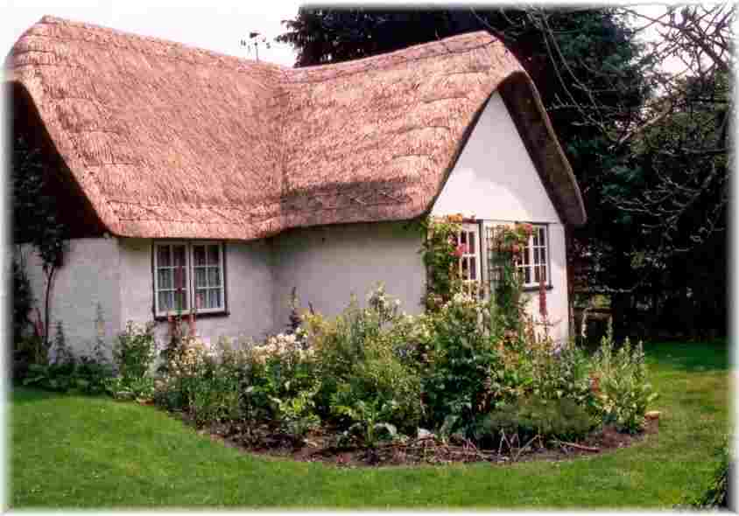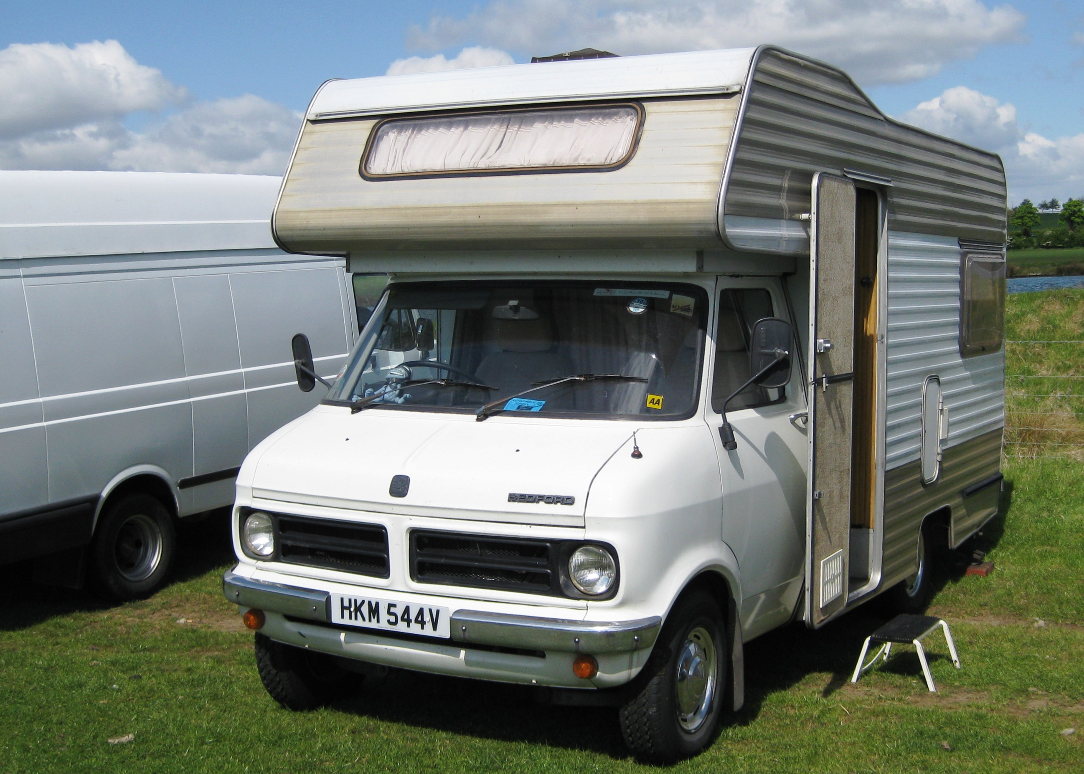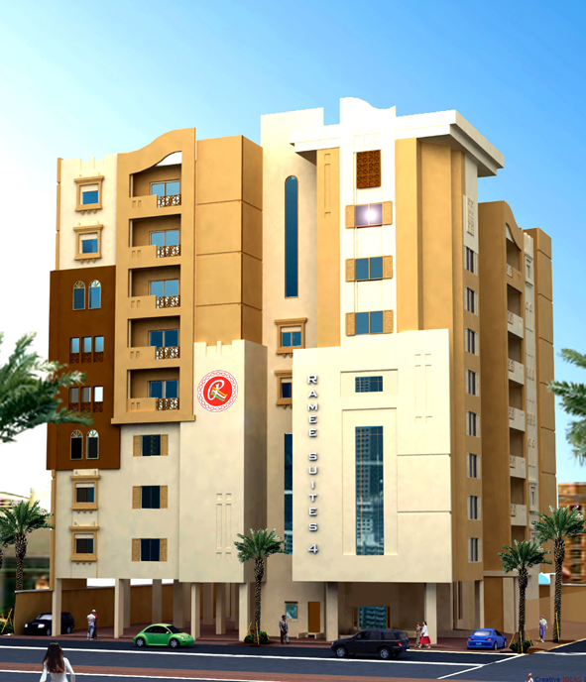

Material # 3. [ Vocabulary worksheet]
- furnished
- steep
- split
- utilities
- lease
- deposit
- wear and tear
- tenant
- trash
- trade-off
[meaning]
A. having furniture in a living area such as an apartment
B. money given as security to use something temporarily
C. destroy something through carelessness
D. services such as electricity, gas, and water
E. someone who rents a house or an apartment
F. expensive
G. the amount of expected damage of something from normal use
H. divide and share something
I. a legal agreement giving permission to use something for a specific period of time
J. a balance or exchange between options requiring compromise

Material # 4. [ Fill the blank]
- Our first apartment wasn't with any appliances, so we had to buy them.
- The rent for the condo we looked at this morning was a little , so we decided to look for something else instead.
- The rent for housing near campus was a little steeper than I expected, so I decided to find a roommate to the costs.
- I'm looking for a place where the are included in the cost of the rent.
- Be sure to read carefully the terms of the before you sign it because you will be bound to the agreement.
- Don't expect to get your back when you move out if you haven't taken good care of the place.
- A certain amount of is pretty normal when renting an apartment.
- The next door always holds wild parties on the weekends, and I never can get any sleep.
- My roommate our place while I was gone on vacation.
- There is often a between living on campus and renting an apartment off campus.

