READING LESSON PLAN

Topic: The Very Hungry Caterpillar

Instructor:  Yeny Seo | Level:  Beginner  (Kindergarten-  4th grade) | Students:  9 | Length:  30 minutes

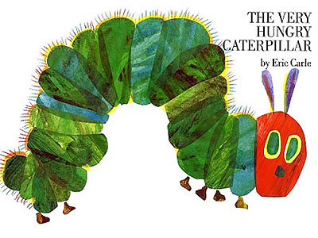
Materials:

- Caterpillar
- Story book: The very Hungry Caterpillar by Eric Carle
- Vocabulary worksheet (9 copies)
- Reading material with guiding question (9 copies)
- Reading worksheet 1-3 (each 9 copies)
- white board and markers

Aims:

- To learn the days of the week, name of the fruits and new vocabulary by matching the vocabulary worksheet
- To get the main idea through picture walk after reading the questions first and answering the guiding question
- To improve Ss reading comprehension skills by skimming/chunking words
- To improve Ss’ speaking and listening skill by sharing opinions with their partners

Language Skills:

- Listening: T’s explanation, demonstration, instruction, classmate’s ideas and pronunciation skills by reading aloud to other classmates
- Writing: Filling the vocabulary worksheet and complete the sentences work sheet
- Reading: Reading the book, The Very Hungry Caterpillar, worksheet
- Speaking: Discussion with partner to answer the vocabulary work sheet, sharing the opinions

Language Systems:

- Phonology: Practicing new vocabulary (antioxidant, provider, reduce, caffeinated)
- Function : Question & Answer between teacher and Ss

Assumptions about Students:

- Ss know what the term fruit means
- Ss should be familiar with the days of the week in their native language
- Ss should know the term life cycle (of the caterpillar—butterfly)
- Ss know they should speak only English in the class

Possible Problems and Solutions:

- Ss may need more time to answer the worksheet.
- If it takes more than 3 minutes, share the answers as a class
- Ss may have difficulty to understand new vocabulary
- Explain with example sentences
- If time is short,
- Take 1~2 volunteers in the post-activity
- If the Ss finish the worksheet earlier than expected,
- Ask various question about coffee

References:
- http://www.slideshare.net/gabner/the-very-hungry-caterpillar-presentation-691778
- http://www.makinglearningfun.com/themepages/HungryCaterpillarLiteracyIdeas.htm

Main Activity
Materials: Reading material, reading worksheet, caterpillar, white board and markers
Time  4 min  min | Set Up  Whole Class  Individually  Whole  Class  Pairs  Whole Class | Procedure:  PPT and all the materials to be ready to use in class  1.Guiding questions  (T hands out days of the week cards to each Ss)  (T showing the caterpillar doll)  -Can someone tell me what this is?  (T showing the pictures and write the word on the board)  *Reviewing days of the week and names of the fruits  -What is this? What do we call this? How do you spell it? i.e. P-L-U-M  *Reviewing Vocabulary  (Distribute reading material and reading worksheet)  Instructions  First, read the five questions. You have 5 seconds to read and understand each question. (T write down Qs)  Then, read the reading worksheet by each given time. Remember to check a mark where you stopped.  Overall, you have 3 chances to answer the questions correctly.  - Start reading the story of The Very Hungry Caterpillar by Eric Carle (Within 10 sec. & Mark where you stopped reading)  - Read again from the beginning (Within 5 sec. & Mark)  - Skimming for the main point in order to answer the question (Within 3 sec.)  Finally, answer the question.  Complete the reading comprehension worksheet 1&2  Work individually. You have about 2minutes.  -If you have any questions, raise your hand.  *(T gives an extra worksheet to the Ss who finished early)  CCQ  Do we read aloud with your partner?  How many questions do we have to read in 5 sec?  Are we answering the worksheet at first?  How many chances do we have?  Do we continue reading after the 1st chance or after I said stop?  - Complete the Worksheet 2 with your partner  *Do we need more time? –30 sec. given  (Run the task)  Monitor class. Answer the Ss question.  -Let’s check our answers together.  Feedback  Share and summarize Ss’ answers.  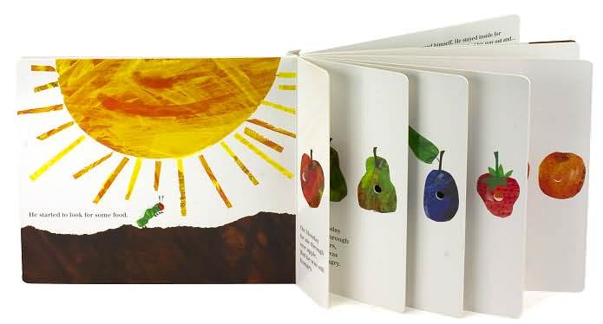  2. Reading detail  Instructions  (T will go through the picture walk with a caterpillar doll as reading)  Look at the screen, we will read aloud this story together. (T show the fruit cards) First, I have the days of week cards. Whenever I read or see days on the screen/ PPT, I will raise the card and stand and say the words.  You will work with your groups. (T assigned groups)  -Each group will get points if they say the word correctly and fast  Demonstration  Let’s read the first paragraph together. Ss hold the cards up and read the correct fruit word out loud as they read.  CCQ  Are we working together?  What do we do with the cards?  -Let’s begin. (T start the video)

Post - Activity
Materials: N/A
Time  10min | Set Up  Whole Class  Individually  / Pairs  Whole class  Whole class | Procedure:  I. Free production : sharing with class  Instructions  -Create “Class Storybook”  -I want all of you guys to think of something that you ate as many foods as you had on the given days.  Demonstration  (T write the sentence on the board)  -On Sunday, I ate a bowl of HaeMulTang, a bag of popcorn and an ice-cream.  -You have 3 minutes to finish your storybook.  -Share with your partner once you are done.  CCQ  Are we working this activity alone?  How much time do you have to finish your diary?  What are you going to talk about?  Monitor the students and answer if Ss have questions.  Fun Activity:  ***(T hands out the days of week cards to each Ss)  -Let’s create our storybook  -Come up and write your given day on the board  -Read the class storybook all together  *If the time is short, take 2 ~ 3 volunteers to read.  II. Conclude Lesson  (T elicits today’s key point from the students)  -You did all very well today!  -On our next lesson, we will learn Grammar.  -See next time!

Reading worksheet 1
The Very Hungry Caterpillar — Presentation Transcript
1. The Very Hungry Caterpillar By Eric Carle
2. In the light on the moon a little egg lay on a leaf.
3. One Sunday morning, the warm sun came up and POP! – out of the egg came a tiny and very hungry caterpillar.
4. He started to look for some food. On Monday he ate through one apple, But he was still hungry .
5. On Tuesday, he ate through two pears, But he was still hungry .
6. On Wednesday, he ate through three plums, But he was still hungry .
7. But he was still hungry . On Thursday, he ate through four strawberries,
8. But he was still hungry . On Friday, he ate through five oranges,
9. On Saturday he ate through one piece of chocolate cake, one ice-cream cone, one pickle, one slice of swiss cheese, one slice of salami, one lollipop, one piece of cherry pie, one sausage, one cupcake, and one slice of watermelon. That night he had a stomachache!
10. The next day was Sunday again. The caterpillar ate through one nice green leaf, And after that he felt much better.
11. But now he wasn’t hungry anymore. And he wasn’t a little caterpillar anymore. He was a big fat caterpillar.
12. He built a small house around himself, called a Cocoon, And he stayed inside for more than two weeks .
13. Then he nibbled a hole in the cocoon, pushed his way out, and
14. He was a beautiful butterfly.
15. The End

