Listening Lesson Plan

Instructor:
EstherSong

Level:
Intermediate
Students:
16 students
Length:
40 minutes
A healthy lifestyle

Materials:
Picture
Vocabulary worksheet (16 copies)
Listening mp3 file & notebook, speaker
Listening worksheet (16 copies each)
Group activity worksheet (16 copies each)
White board, board markers

Aims:
Students will learn vocabulary and expressions by completing worksheet.
Students will practice speaking by answering details questions and discussing with group members.
Students will practice listening to the real-life talk by picking up details.
Language Skills:
Listening: two speakers are talking about a healthy lifestyle.
Reading: vocabulary worksheet
Speaking: partner discussion to answer the comprehension questions and group activities.
Writing: details, completing a worksheet
Language Systems:
Lexis : key vocabulary
Function& Discourse: Giving advice for a healthy lifestyle
Structure: should/ shouldn’t
Assumptions:
How the class is up and run (there will be 4 student groups at each table)
The teacher’s style of teaching and the pace of the course.
All students are 3rd grade in the middle school. (Boys $ girls mixed)
Most students have been interested in appearance and diet, but don’t care about the healthy lifestyle.
Ss can speak and write in English, but not fluently.
Ss know help-verb usage.

Anticipated Errors and Solutions:
- Students may not be able to pick up details from the listening.
- Chunk the listening (pause-play-pause-play)
- Students may prefer to work individually.
- Ss need to be encouraged to work in pairs or join group discussion.
- Student may need more time to work on details questions.
- If it talks longer than 13 minutes, cut answer-checking short by verbally sharing the answers instead of presentation. If they still don’t know, give some help.
- If time is short
- Cut post-activity discussion short and only ask 2~3 students to share opinions.
- If students finish their tasks earlier than anticipated
- Ask many students as possible about their idea of the healthy lifestyle, and having them make their own plan.

References:
http://www.esl-lab.com/health/healrd1.htm
http://www.doctorsecrets.com
http://www.simpleesl.com

www.simplee니.com

Lead-In
Materials: Board, picture(1)
Time  3 min | Set Up  Whole class | Procedure:  Hello, everyone. How are you?  Look at the picture together. What can you see?  [Ss answer: vegetables, water, bikini girl, hamburgers, potato chips, coke, fat/healthy woman]  Can you guess what the picture means?  [Let Ss talk about what they think]  Have you done or tried anything else to be healthy?  [Let Ss talk about what they think]  [Elicit the healthy lifestyle & write them on the board]  OK. So today we will listen to two speakers talking about healthy lifestyle.  Before we listen, we will learn key vocabulary they use.

Pre-Activity
Materials: Board, vocabulary worksheet, pictures of worksheet
Time  7min | Set Up  Whole class  Pairs  Whole class | Procedure:  1. Vocabulary  Eliciting  Look at the first picture. What happened to him? What’s wrong with him?  [Ss answer: He has a heart problem.]  Good. What is the heart doing?  [Ss answer: hitting, attacking.]  Yes. We can make a word. Heart + attack = heart attack  Let’s look at the second picture …  Instructions  Work in pairs. Fill in the blank with key vocabulary we’ve learned. You have 3 minutes.  [Distribute the worksheet]  Demonstration  Let’s look at the picture number A together. What is number A?  [Ss answer: heart attack]  Right. Write down ‘ heart attack’ in the blank.  ICQ  Who are you working with?  What do you write in the blank?  How much time do you have?  Monitor discreetly. Answer students if they ask questions.  Give time warning: 1 minute left.  Be flexible with time. Give 1 more minute if they need it.  Check answers: go through the vocabulary pairs by pairs. Let students write the correct vocabulary on the board.  Explain the meaning if necessary.  (#A already written by teacher)  Repeat after teacher speaks each vocabulary.  CCQ  1. What kind of fatty foods do you usually have?  2. When the heart attack occurs, what matters might happen?  3. When you’re out of shape, what do you usually do?  4. What activities do you want to take up to be healthy?  2. Prediction  What do you expect to listen?  [Ss answer: healthy lifestyle]  Very good. Let’s start listening ‘healthy lifestyle’.
Main Activity
Materials: notebook, mp3 file, speaker, listening worksheet, Board
Time  10min  13min | Set Up  Whole class  Whole class  Individually  Group  Whole class | Procedure:  1. Listening for the main idea(general understanding)  Instructions  Put your pens down. Close your eyes. Listen to the talk between man and woman. Think about the questions on the board while listening.  1) What does the man think?  2) What is the woman concerned about?  [Write them on the board]  CCQ  1. Can you take notes?  2. What are you supposed to think about?  [Play file without stopping]  Do you want to listen again?  Yes -> Have them listen one more time.  No -> Have them share their thoughts.  Now, answer the questions on the board together.  What does the man think?  [Ss answer: He wants to join a basketball team.]  What is the woman concerned about?  [Ss answer: She is concerned about his health.]  CCQ  1. Is he going to join a baseball team?  2. Does she care about his spending habit?  2. Listening for details  Instruction  Now listen again and answer the questions on the worksheet. Write short sentences and work individually.  [Distribute the worksheet]  Demonstration  Let’s look at the worksheet together.  What is the question number 1and 2?  [Ss answer: what problems does the man have?, what does the woman suggest?]  Right. You need to write short sentences, not words. Fill in the blank on Q1&Q2.  CCQ  1. What are you supposed to do?  2. Do you write down words on a worksheet?  3. Are you working alone?  [Play file without stopping]  Let students write answers as they listen.  Do you need to listen again?  Yes -> Play, pause, and play again.  No -> Have them write down answers.  [Follow the same cycle until finished the worksheet]  Now let us divide into 4 groups. Compare the answers with your group members. When you have an agreement, send one representative up front and give us presentation. You have 7 minutes.  Group 1, fill out the problems & suggestions on food.  Group 2, fill out the problems & suggestions on health.  Group 3, fill out the problems & suggestions on bad habits.  Group 4, answer the questions # 3, 4.  CCQ  1. What are we supposed to do?  2. Do your group answer all questions?  3. How much time do you have?  Monitor discreetly. Answer students if they ask questions.  Give time warning: 1 minute left.  Be flexible with time. Give 1 more minute if they need it.  Let us check answers as a whole class. The representative in each group will give us a presentation.  [Ss: check the answers]  Listen one last time.  If there is anything missing: pause the file and let students say it out loud.

Post-Activity
Materials: speaking activity worksheet, board
Time  7 min | Set Up  Whole class  Pairs  Whole class | Procedure:  1. Free production  Instruction  Walk around the room. Talk to different classmates about a problem you have. Your classmates will give you advice on what you should or shouldn’t do. Remember to use the expression “should/ shouldn’t” Write down the advice in the blank. I will give you 5 minutes.  [Distribute the worksheet]  [Demonstration]  Let’s look at the worksheet. What is the # 1?  [Ss answer: I have a stomachache.]  Yes, it is the problem I have. Give me advice what I should or shouldn’t.  [Ss answer: You shouldn’t eat anything.]  Very good.  ICQ  1. Are you working in sitting chairs?  2. What are you supposed to do?  3. What do you write down?  4. How much time do you have?  [Ss move to find the partner and talk to each other]  Monitor discreetly. Answer students if they ask questions.  Give time warning: 1 minute left.  Be flexible with time. Give 1 more minute if they need it.  Share student’s advices.  Take 2~3 volunteers if running out of time.  2. Conclusion lesson  Review  What is the today’s topic?  [Ss answer: healthy lifestyle]  What vocabulary have you learned in listening?  [Let Ss answer]  What should we do for a healthy lifestyle?  [Let Ss answer]  Which form have you learned for giving advice?  [Ss answer: should/ shouldn’t]  Very good.  Give homework  Write down your own problems and make suggestions for your healthy lifestyle. Use the vocabulary you learned today and make 5~10 sentences in your notebook by next class.  Good job today. See you guys tomorrow.
[Picture 1]

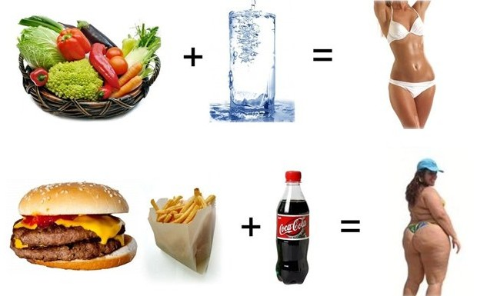

Vocabulary worksheet
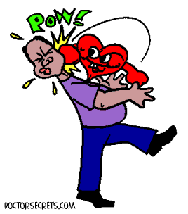 |  | 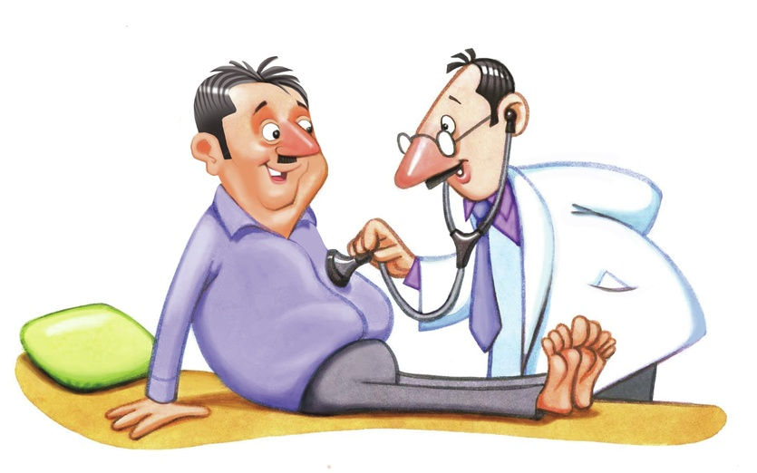
(A) | (B) | (C)
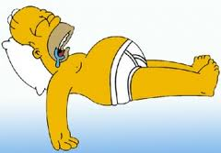 | 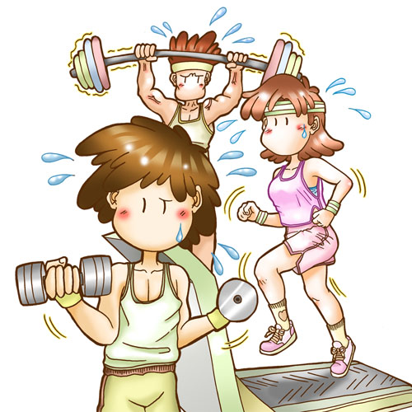 | 
(D) | (E) | (F)

Fill in the blank

1. _____________: a sudden severe instance of abnormal heart function

2. ____________ : To develop or increase in stages or by degrees

3. _____________________ : (Medicine) of or relating to the heart and the blood vessels

4. ____________ : not in good physical condition. I get out of breath when I run because

I'm _______________. Keep exercising regularly, or you'll get out of condition.

5. ____________To begin again; resume: Let's . ____________ where we left off.

6. ____________ the process of examining the body

I had a ____________ examination last month

7. You need to cut back on ____________ such as butter, bacon, and meat

Listening worksheet

1) What problems does the man have?

2) What does the woman suggest the man to do?
 | Problems |  | Suggestions
Food
Health
Bad
habits

3) What do you think of his attitude when the woman gives suggestions?

4) How does the woman feel in this situation?

[Script]
A Healthy Lifestyle (01:18)
Man: Honey, the basketball game is about to start. And could you bring some chips and a bowl of ice cream? And . . . uh . . . a slice of pizza from the fridge.
Woman: Anything else?
Man: Nope, that's all for now. Hey, hon, you know, they're organizing a company basketball team, and I'm thinking about joining. What do you think?
Woman: Humph
Man: "Humph" What do you mean "Humph." I was the star player in high school.
Woman: Yeah, twenty-five years ago. Look, I just don't want you having a heart attack running up and down the court.
Man: So, what are you suggesting? Should I just abandon the idea? I'm not that out of shape.
Woman: Well . . . you ought to at least have a physical before you begin. I mean, it HAS been at least five years since you played at all.
Man:Well, okay, but . . .
Woman: And you need to watch your diet and cut back on the fatty foods, like ice cream. And you should try eating more fresh fruits and vegetables.
Man: Yeah, you're probably right.
Woman: And you should take up a little weight training to strengthen your muscles or perhaps try cycling to build up your cardiovascular system. Oh, and you need to go to bed early instead of watching TV half the night.
Man: Hey, you're starting to sound like my personal fitness instructor!
Woman: No, I just love you, and I want you to be around for a long, long time.

Vocabulary worksheet(Teacher’s)
(A) heart attack | (B) build up a cardiovascular system | (C) physical (examination)
(D) out of shape | (E) take up a weight training | (F) cut back on the fatty foods

Fill in the blank

1. heart attack : a sudden severe instance of abnormal heart function

2. build up: To develop or increase in stages or by degrees

3. cardiovascular system: (Medicine) of or relating to the heart and the blood vessels

4. out of shape : not in good physical condition. I get out of breath when I run because

I'm out of shape. Keep exercising regularly, or you'll get out of condition.

5. take up : To begin again; resume: Let's take up where we left off.

6. physics: the process of examining the body

I had a physics examination last month

7. You need to cut back on fatty foods such as butter, bacon, and meat

Listening worksheet (Teacher’s)

1) What problems does the man have?

2) What does the woman suggest the man to do?
 |  | Problems | Suggestions
Food | - He eats fatty foods too much. |  | - He should cut back on the fatty goods.  - He should eat fresh fruits and vegetables.
Health | - He’s got heart attack.  - He doesn’t check up his physical regularly  - He isn’t in a good condition.  - He doesn’t exercise. |  | - He should have a physical-check up  - He should try cycling  - He should start weight training
Bad  Habits | - He watches TV half the night.  - He eats foods while watching TV. |  | - He should go to bed early

3) What do you think of his attitude when the woman gives suggestions?
He hardly accepts the advice the woman gives.
He doesn’t recognize his physical conditions.

4) How does the woman feel in this situation?
She would feel angry/upset/worried/anxious/….

