Listening Lesson Plan

Instructors:

So Young Lee (Candy)
Level:

Pre-intermediate
Students:

16
Length:

40 minutes
Tina

Materials:
Listening CD & CD player (total about 1’10’’ , Tracks 1~5 mp3)
Picture about Thumbelina ( task before audio)
Questions about Top-down, Guiding, Details
16 copies of the Listen and number worksheets and listening sheet
Board & Markets (16 students)

Aims:
to develop intensive Listening skill by listening an audio, and teacher’s explanations.
to develop intensive Speaking skill by answering a guiding question to find the main idea and answering of detailed questions, answering concept questions and the free discourse.
Language Skills:

Listening: mp3 & the teacher’s explanation about new vocabulary and partner discussion
Speaking: to answer the Top-down questions, the guiding questions, the Detail questions and the free talking.
Reading: the text (It is not important this lesson)
Writing: write the number (It is not important this lesson)
Language Systems:
Lexis: meaning of words (thumb, ladder, giant, block, drinking fountain, drain)
Grammar: S + be- verb + going to~ (= plan)
Discourse: answer the Top-down questions, the guiding questions, the Detail questions and the free talking
Discourse:
Assumptions:

1. Ss know what Thumbelina story.
2. Ss can listen and speak in English but not very accurately.
3. Ss don’t know how to skim and scan, and so Ss need to be directed what and when to skim and scan.
4. Ss know the teacher’s style of teaching.

Anticipated Errors and Solutions:

If time is running out, shorten the discussion time.
If there is more time than expected, give students more time for the discussion.
If they do not understand to listen, give students more time for the listening each part.

References:

- Hip hip Horray 4 (Second Edition ,PEARLSON ,LONMAN)

Lead-In
Materials: Picture I about Thumbelina ( task before audio)
Time  5min | Set Up  Whole class | Procedure:  Hello everyone, how was your Friday meeting after class? How did it go? I heard it was great time.  Activity Schemada (elicting, prediction, activating of students)  -Have you ever seen or read it?(show the Thumbelina story book picture)?  -show the picture and talking about the Thumbelina  (Students will be ready to participate in the lesson.)

Pre-Activity
Materials: Board & Markets (16 students)
Time  10min | Set Up  Whole class | Procedure:  : Stage of presenting vocabulary  Key Vocabulary: (explain in drawing)  - Elicit -> Write Words on the board -> Analyze: part of speech -> CCQ  - Thumb: n. big finger, big(great) toe  - Ladder : n. steps consisting of two parallel members connected by rungs  - Giant : adj. of great mass, huge and bulky  - Block : v. hinder or prevent the progress or accomplishment of  - drinking fountain : n, a public fountain to provide a jet of drinking water  - drain : n, emptying something accomplished by allowing liquid to run out of it  - Show me your thumb finger - Thumb up.  - When do you use the ladder and who used the ladder?  - If you are going to the drinking fountain, what can you do?  - If you fix the clogged drain, what can you find it and how do you feel?  - Is bee giant?  - If nobody blocks you when you are playing basketball, can your team win?  (Students will be ready to participate in the lesson.)
Main Activity
Materials: Listening CD & CD player (total about 1’10’’ , Tracks 1~5 mp3)
Picture II about Story Board,
Listening Worksheet
Time  1min  4min  3min  7min | Set Up  Whole class  Whole class  Group  Individually | Procedure:  Listening for the Main Idea(general understanding, Top- down Question)  Instructions  Put your pens down. Close your eyes. Listen to the speakers. Think about the scene about the Story.  Guiding Question  - What is main character’s name?  - What happen to him or her?  - What does she or he look like?  1st Listening and check understanding  - Order each pictures on the board.  CCQ : Are you working alone?  what do you have to use it?  2nd Listening and check understanding(bottom-up questions): Listening Worksheet (Detail Question)  CCQ : How much time do I give to you?  - Who is Tina in this story?  - Who does Tina calling with?  - Why does Tina climb the ladder?  - What is Tina doing with Jimmy?  - Where is Tina going down at the drinking fountain?

Post-Activity
Materials: Listening CD & CD player (total about 1’10’’ , Tracks 1~5 mp3)
Time  10min | Set Up  Whole class | Procedure:  Free discourse question  Instructions  Put your pens down. Close your eyes. Listen to the speakers. Think about the scene about the nest Story.  3rd Listening and check understanding  - Make a next Story what will happen.  - Share the Story  CCQ:  - What are you think about?  - What will happen next?  Monitor actively and participate within whole class.

Picture I about Thumbelina
(Task before audio)

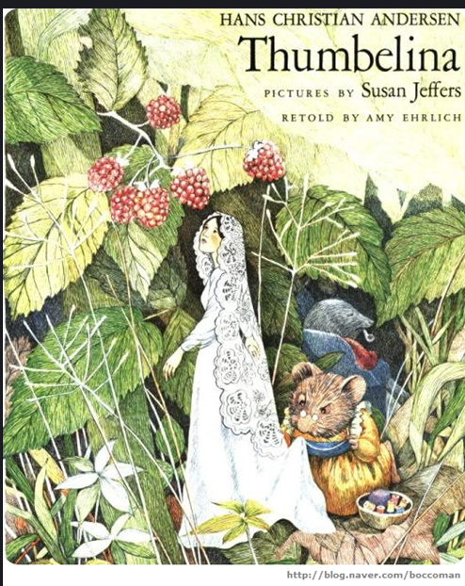

Tina

Tina is a very, very small girl. She is the size of a thumb.
Tina’s mom: “Tina! Telephone! It’s Scott.”
Tina: “OK, I’m coming.”
Tina climbs the ladder. She talks into a giant phone. She makes plants with Scott. Scott is her best friend.
Tina: “Hey, Scott! What’s up?”
Scott: “Hi, Tina. I’m going to play basketball. Would you like to join me?”
Tina: “Sure, That sounds like fun. How about Jimmy?”
Scott: “He’s going to play basketball, too.”
Tina: “Cool! See you soon. Bye.” (Turn off the phone)
Tina, Scott and Jimmy are playing basketball. Jimmy shoots the ball. Scott and Tina block the ball! They are having fun!
Scott: “I’m thirty. Is there any water?”
Tina: “Yes, there is. There’s a drinking fountain over there. I’m thirty, too.”
“Scott, help!”
Scott: Tina!
Jimmy: “Oh, no! She’s going down the drain!”

Picture II about Story Board  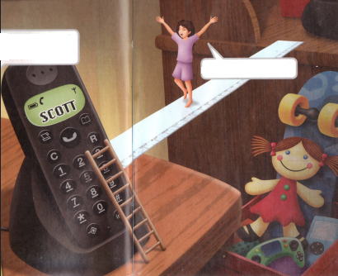 | 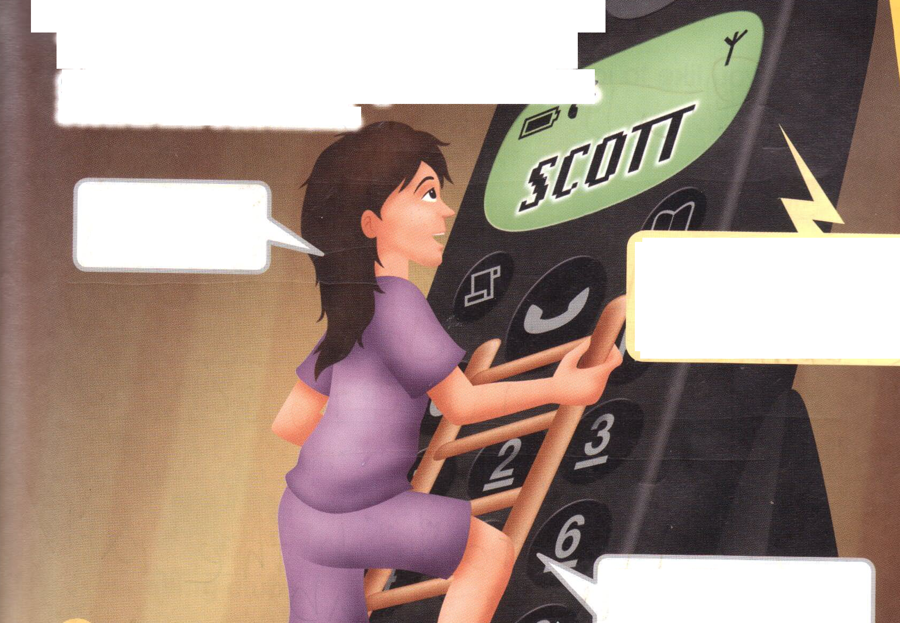
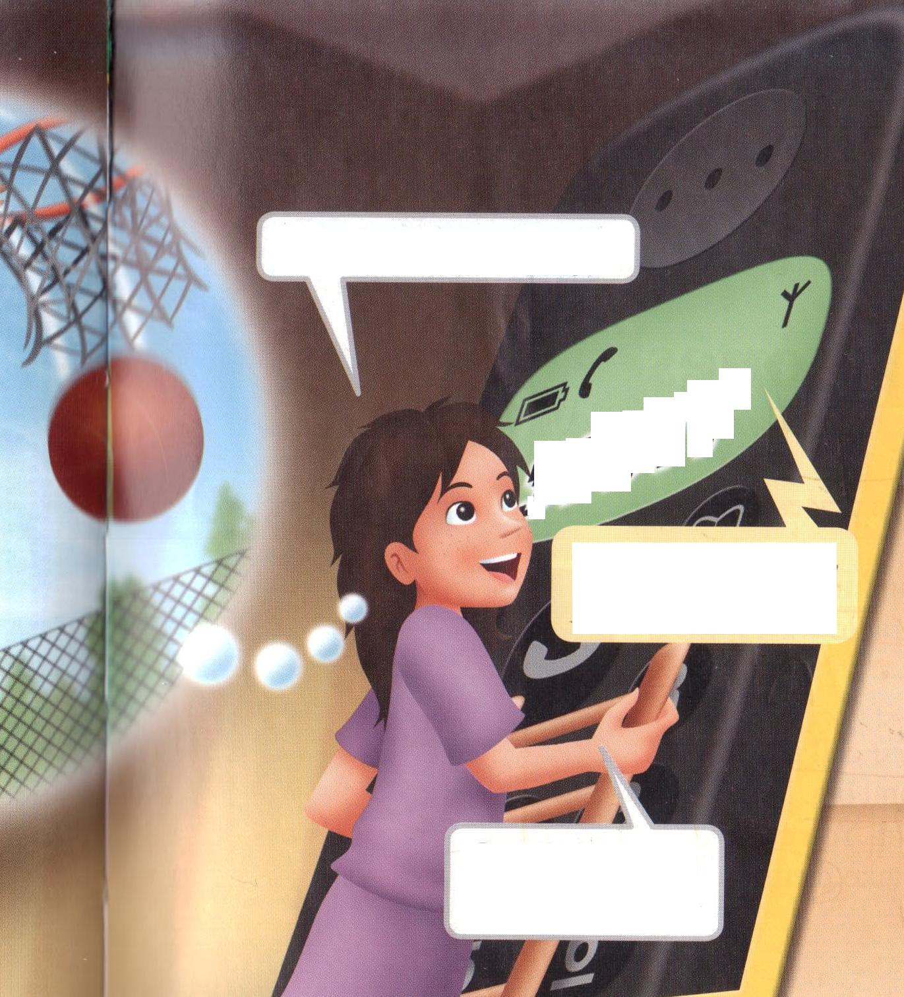 | 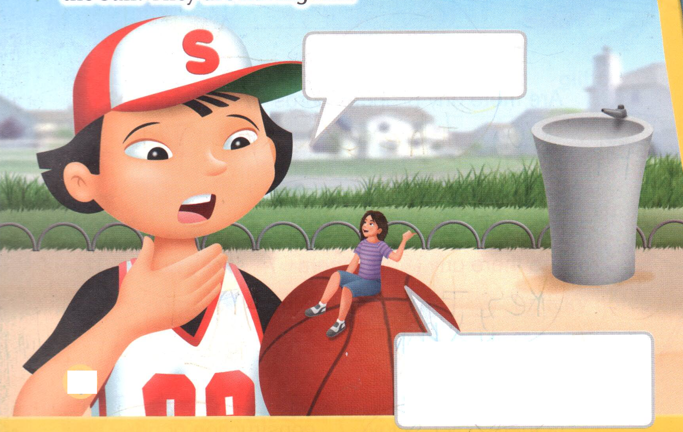
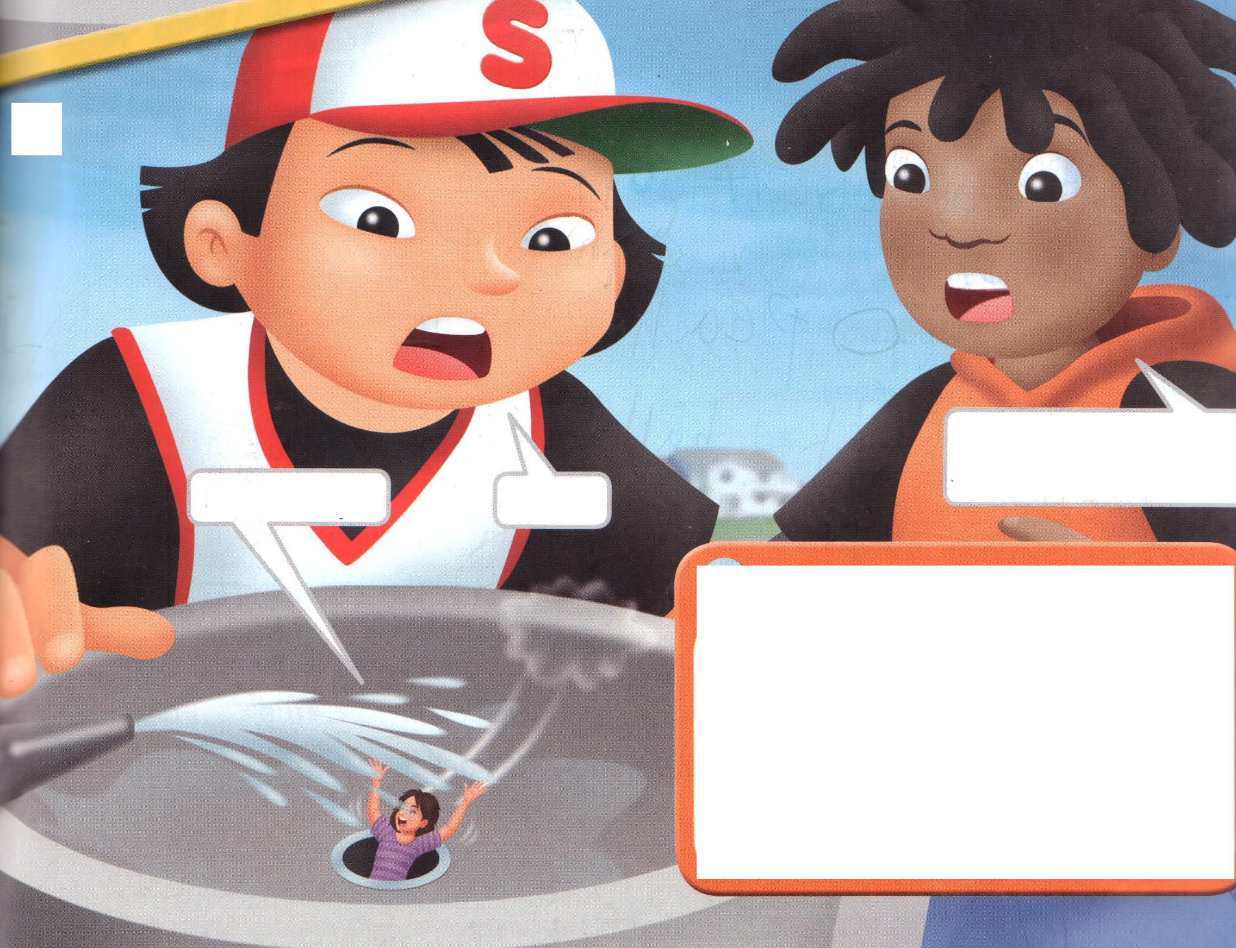 | Vocabulary: (explain in drawing)  Thumb: n. big finger, big(great) toe  Ladder: n. steps consisting of two parallel members connected by rungs  Giant: adj. of great mass, huge and bulky  Block: v. hinder or prevent the progress or accomplishment of  drinking fountain: n, a public fountain to provide a jet of drinking water  drain: n, emptying something accomplished by allowing liquid to run out of it  Grammar:  : S + be- verb + going to~ (= plan)  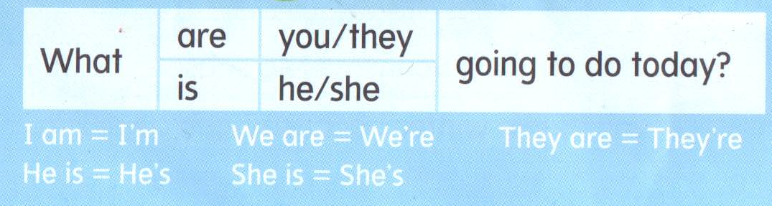  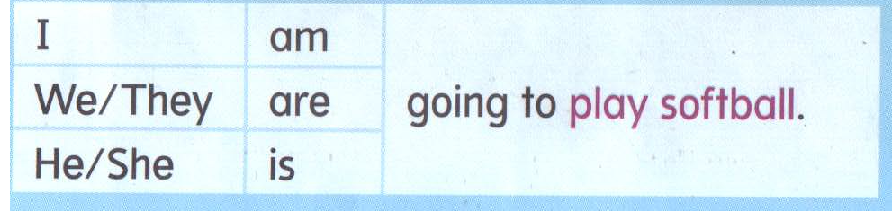
Listening worksheet
Extra worksheet - Listening Activity is not a memorial test, but checking understanding.

Listen the Tina story and answer the following questions.

- Who is Tina in this story?

a. A tiny girl
b. A giant girl
c. A fairy girl

- Who does Tina calling with?
a. Tina’s mom
b. Scott
c. Jimmy

3. Why does Tina climb the ladder?
- Get the phone
- To drink some water
- To go down the drain

4. What is Tina doing with Jimmy?
- Play basketball
- Calling the phone
- Climb the ladder

5. Where is Tina going down at the drinking fountain?
- plughole
- brain
- rain

