Worksheet 1 – Find someone who
Cards for print

Find someone who……

Q. Do you have ……...?

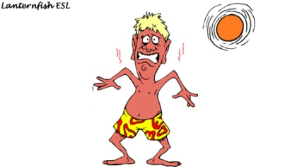 |  | 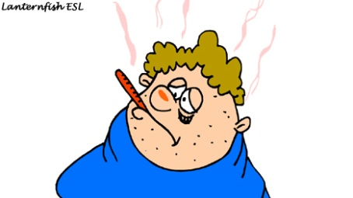
A sunburn |  | A fever |  | The flu
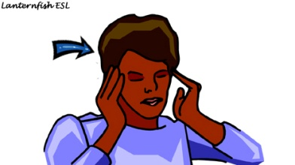 |  | 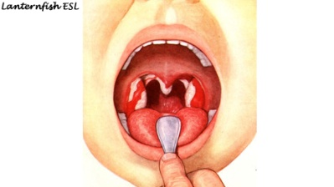 |  | 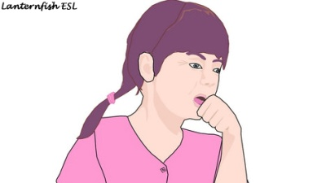
A headache |  | A sore throat |  | A cough
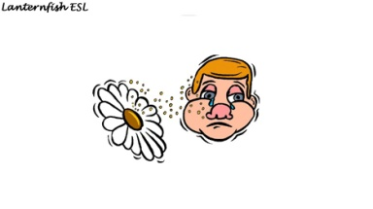 |  | 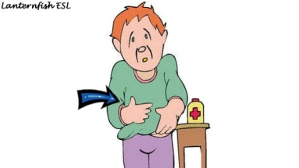 |  | 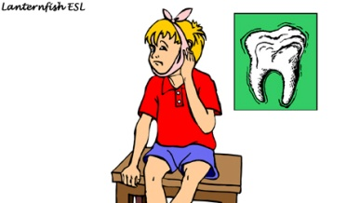
An allegy |  | A stomachache |  | A toothache
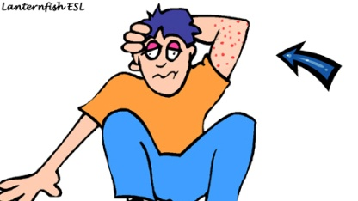 |  | 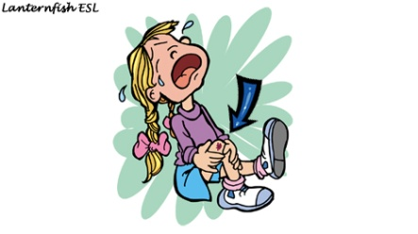 |  | 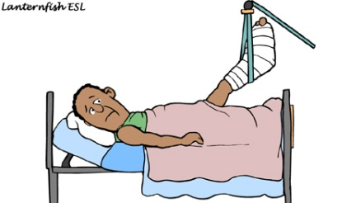
A rash |  | A cut |  | A broken leg
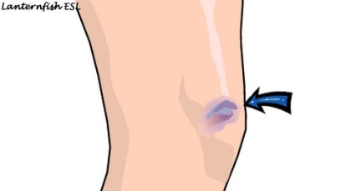 |  | 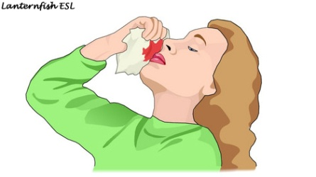
A bruise |  | A nosebleed |  | A bump

Worksheet 1 – find someone who
Student

Find someone who……

Q. Do you have ……...?

A sunburn ……..……………… | A fever | The flu
A headache | A sore throat | A cough
An allegy | A stomackache | A toothache
A rash | A cut | A broken leg
A bruise | A nosebleed | A bump

Worksheet 2 – Visit to the Doctor’s
Student A

Doctor Treatment List

Ailment: rash  Prescribe: an ointment. Apply four times a day.  Extra Advice:  (a) Avoid scratching your skin.  (b) Use as little soap as possible. |  |  |  |  | Ailment: diarrhoea  Prescribe: some medicine  Take twice daily.  Extra Advice:  (a) Drink plenty of fluids.  (b) Avoid foods containing milk. |  |  |  | Ailment: flu  Prescribe: antiviral medication. Take three times daily after meals.  Extra Advice:  (a) Get lots of rest.  (b) Drink plenty of fluids
 |  |  |  |  | Ailment: sprained ankle  Prescribe: some pain killers  Take whenever you have pain. (maximum five times daily)  Extra Advice:  (a) Keep your foot elevated.  (b) Keep ice on it for 24 hours. |  |  |  | Ailment: sore throat  Prescribe: some medication  Take every four hours.  Extra Advice:  (a) Drink plenty of liquids.  (b) Drink warm tea with honey.
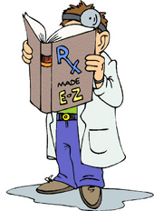
Doctor’s Activity Sheet
 |  |  | You are a doctor and patients are going to come into your office. Ask them about their condition, prescribe some medicine, and give them some advice.
 | Name | Medical Condition | Duration |  |  | Prior Medication |  | Allergic to Medication? Y/N
 | Mary | rash | 1 week |  |  | cream |  | No

Worksheet 2 – Visit to the Doctor’s
Student B

Patient’s Role Cards

Ailment: You have a rash on your arms and legs.  Duration: You have had it for about four days.  Previous Medication: You have put a cream on it. |  | Ailment: You have diarrhoea.  Duration: You have had it for three days.  Previous Medication: You have taken some pills that you bought at the drugstore, but they didn’t help. |  | Ailment: You have the flu.  Duration: Two days.  Previous Medication: You took some aspirin.
 |  | Ailment: You sprained your ankle.  Duration: You sprained this morning.  Previous Medication: You took a painkiller. |  | Ailment: You have a sore throat  Duration: You have had it for two days.  Previous Medication: You have been taking some throat lozenges (throat candies).

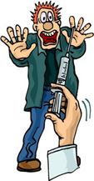
Patient’s Activity Sheet
 |  | You are a patient. Visit your doctor and tell them about your condition. Write down your doctor’s recommendations in the table below.
Doctor’s Name | Medical Condition | Prescription | Prescription Directions | Other Advice
Dr. Jung | rash | ointment | apply three times a day. | Avoid scratching skin. Don’t use soap

Worksheet 2 – Visit to the Doctor’s
For wall chart

Visit to the Doctor’s office

A = Doctor B= Patient

A: Hi. Come on in and have a seat.
Now what seems to be the problem?

B: I have a rash on my arm.

A: How long have you had the rash?

B: It’s been about a week.

A: Are you taking anything for it?

B: I put some cream on it but it doesn’t seem to be helping.

A: I see. Are you allergic to any medications?

B: Not that I know of.

A: I’m going to give you a prescription for some ointment.
I want you to apply it three times a day.
You should also avoid scratching your skin.
And it’s important to use as little soap as possible.
Make an appointment to see me next week if it doesn’t get
better over the next few days.

Worksheet 3
For print

Bee stings and insect bites.

Wash first. Put some meat tenderizer on a handkerchief and then put the handkerchief on the area for half an hour. To avoid this situation, it’s helpful to eat garlic or take garlic pills.

Burns

Put the area under cold water or put a cold handkerchief on it. It’s important not to put ice on the area.

Colds

Lots of people eat hot chicken soup. They find it clears the head and the nose. Some people rub oil on their chest. Other people drink a mixture of red pepper, hot water, sugar, lemon juice, and milk or vinegar.

Cough

Drink warm liquids or take some honey.

Headaches

Apply an ice pack or cold cloth to there or splash your face with cold water. Also, you shouldn’t read or watch TV.

Insomnia

Drink a large glass of warm milk. It’s also a good idea to soak in a warm bath.

Worksheet 3
Teacher

Home Remedy

Bee stings and insect bites.
Wash first. Put some meat tenderizer on a handkerchief and then put the handkerchief on the area for half an hour. To avoid this situation, it’s helpful to eat garlic or take garlic pills.

Burns
Put the area under cold water or put a cold handkerchief on it. It’s important not to put ice on the area.

Colds
Lots of people eat hot chicken soup. They find it clears the head and the nose. Some people rub oil on their chest. Other people drink a mixture of red pepper, hot water, sugar, lemon juice, and milk or vinegar.

Cough
Drink warm liquids or take some honey.

Headaches
Apply an ice pack or cold cloth to there or splash your face with cold water. Also, you shouldn’t read or watch TV.

Insomnia
Drink a large glass of warm milk. It’s also a good idea to soak in a warm bath.

Worksheet 4 - Wordsearch
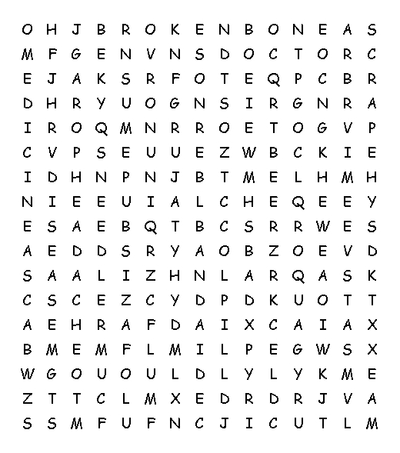 |  |  | Find the words below in the grid to the left.  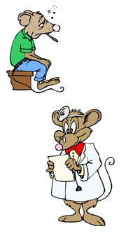
bruise  cold  cut  doctor | headache  medicine  nosebleed  pill | sore throat  stomachache  flu

Visual aids 1
Doctor

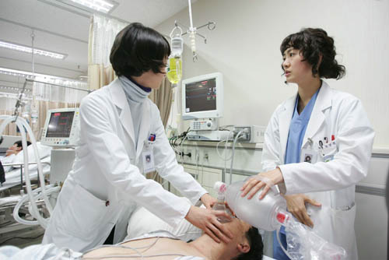

Visual aids 2
Drugstore

