Grammar Lesson Plan

□ Listening □ Speaking □ Reading ■ Grammar □ Writing

Adjective

Instructor:  Erin Moon | Level:  Upper intermediate | Students:  15 | Length:  30 Minutes

Materials:
▷Worksheet (Fill in the blanks_15 copies)
▷Wall chart for explaining about adjective
▷Adjective order
▷Pictures of describing emotions
▷Empty papers
▷White board, markers and tape

Aims:
Main aim
Students will improve their grammar skill by having students tall about adjective
Secondary aims
Students will talk about adjective by having students do worksheet
Personal aim
I want to improve my teaching pace

Language Skills:
Reading All students are going to read the blank worksheet
Listening All students are listening to others diary and partner’s opinion
Speaking Students are going to talk with their partner to discuss writing diary and
present their diary to all students.
Writing All students are going to fill in the blank on worksheet.

Language Systems:
Lexix Many words used in explaining about adjective
Functional Making conversation with partner
Phonology (None to discuss)
Grammatical Teacher will explain the rule of position and using order
Discourse (None to discuss)

Assumptions:
All students are elementary school students
All students don’t know what is adjective

Anticipated Errors and Solutions:  Errors  ▷Students may have difficulty in understanding the meaning | Solutions  ▶Teacher provides more examples
▷If students need more time to finish their activity | ▶Teacher can be flexible with the time as giving students more time to finish their activity
▷If students finish their tasks earlier than  Anticipated. | ▶Teacher can do SOS activity

References:
▷ Grammar in use intermediate_Cambridge
▷ www.Google.co.kr

Lead-In
Materials: Board, marker, pictures of describing something (angry, cold)

Time | Set Up | Procedure
2min | Whole class | Hello! How’s your dinner everyone?  .  Lead-in  Chloe! How’s whether today?  Julie! When you fight with your friends, how do you feel?  Ann! Could you tell me one thing about your personality?

Pre-Activity
Materials: worksheet for fill in the blank, white board, markers, wall charts

Time | Set Up | Procedure
6min  3min  2min | Whole class  Individual work  Individual work | Expliciting  I have a question.  What do you call a grammar element which describe feeling or whether or personality like this?  Yes, that’s right. That is an Adjective.  Here is one sentence.  “ Marcelo looks quite serious, but he is very humorous. “  In this sentence, what is adjective?  Yes, serious and humorous are adjective.  An adjective is a word such as ‘big’, ‘pretty’ or ‘financial’  that describes a person or thing or give extra information about them.  And an adjective modifies a noun or a pronoun by describing, identifying or quantifying words.  For example, cute, happy, exhausted etcetera.  And by adding –able, -ly, -ous, -ive, -ful, -al at the end of noun or verb, can make an adjective.  CCQ  I have a question.  Is perfectly an adjective?  Is friendly an adjective?  Sometimes this is confusing, but friendly, lovely, lonely, costly are an adjective not adverb.  The adjective usually come before nouns or after linking verb.  If you use several adjective at the same time, you need to follow this order.  I’ll show you one example.  I want to buy one nice big round new white Korean brick house.  CCQ  If I say “I want to eat one red small apple.” Is it right?  Or If I say “I want to eat one small red apple” is it right?  Yeah~ very good.  OK. from now on, we are going to fill in the blank on worksheet about appropriate adjective.  Instruction  After I finish passing the worksheet, you can start to fill in the blanks Individually. I’ll give you 2 minutes.  ICQS  What are you going to do?  Are you working individually?  How much time do you have?  I don’t want you to start, until I finish passing worksheet.  Explicit icqs  Are you going to start when I say go?  Are you going to start before I passing the worksheet?  Ok. Go!  Time management  1minutes left!  30 seconds!  10 seconds! Finished~!  Mary, can you read the number one first?  All students read the one question by turn.  Good job everybody. IS there a question?
Main Activity
Materials: empty papers, marker
Time | Set Up | Procedure
2min  5min  3min | Whole class  Pair work | There are some adjective.  Read adjective  Instruction  Using these, make a short diary with your partner.  __,__ together…….  Any contents are OK. I’ll give you 5minutes.  ICQS  What are you going to do?  Are you working individually?  How much time do you have?  OK.  I don’t want you to start, until I finish passing the papers.  Explicit icqs  Are you going to start as soon as you got the paper?  Are you going to start when I say go?  Go!  Time management  3minutes left!  1minutes left!  10 seconds! Finished~!  Ann and judy, can you share your diary?  Wow well done guys.

Post Activity
Materials: rolling…..something(I don’t know what it’s called)
Time | Set Up | Procedure
5min | Individually | Expliciting  Do you know what is it?  It is ____________. (I don’t know what it’s called..)  There are some adjective.  Like this, snap your finger and make arrow spin.  Then, you make a one sentence by using chosen word on the spot.  ICQS  What are you going to do?  Are you working individually?  Justin, you want to be a first?  Very good job! Students.

SOS Activity
Materials: board, marker

Time | Set Up | Procedure
2min | Whole class | Do you know “Hang man” game?  It’s kind of guessing game.  I’ll give the number of letters and category of the word,  You can guess whole word by selecting any letters  Like this way you complete the word.  If you suggest letter does not occur in the word, I’ll draw one element of the hanged man.  How many letters are there?  Ok. Cherry start!  No… there is not… sorry….  Yes! The answer is AWESOME.  Today you are a very awesome.  And I didn’t hear any mistake.  So, thank you for your participating.

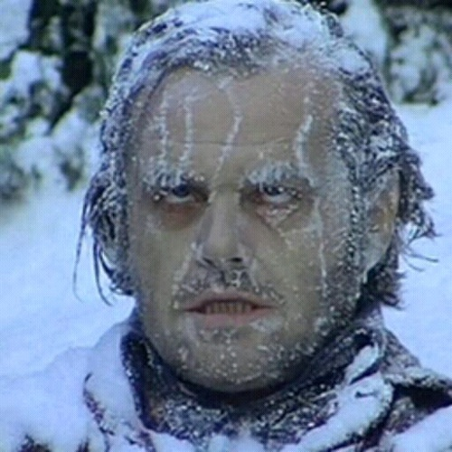

Cold

Angry
Fill in the blanks by choosing the appropriate adjective.

1. Your mistake is ____________ (understandable / understanding)

2. You should be __________of others. (considerable / considerate)

happy natural expensive useful

gorgeous tired capable friendly

3. This picture looks more _________than that one.

4. advertising cost seems relatively __________in the long run.

5. Our employees are ___________ of dealing with customer complaints politely.

6. I’m looking for someone who should be _________ and kind.

7. Naver is ________website providing all of information.

8. Erin teacher is so__________. (lol)

9. what’s wrong with you? You look _______.

10. I always feel ________ when the sun is shining.

Put an adjective in the appropriate position.

11.A beautiful table. (wooden / round) _____________________________

12.A new sweater (green) ________________________________

13.An old painting (interesting / Japanese)____________________________

14. A small umbrella (red / yellow) ____________________________

15. A red car (old / little)________________________

